

3 September 2025

SUMMARY OF PRODUCT CHARACTERISTICS

for

Dapagliflozin "Elpen", film-coated tablets

0. D.SP.NO.
34039

1. NAME OF THE MEDICINAL PRODUCT
Dapagliflozin "Elpen"

2. QUALITATIVE AND QUANTITATIVE COMPOSITION

Dapagliflozin "Elpen" 5 mg film-coated tablets
Each tablet contains 5 mg of dapagliflozin.

Excipient with known effect
Each 5 mg tablet contains 55.05 mg of lactose monohydrate.

Dapagliflozin "Elpen" 10 mg film-coated tablets
Each tablet contains 10 mg of dapagliflozin.

Excipient with known effect
Each 10 mg tablet contains 110.10 mg of lactose monohydrate.

For the full list of excipients, see section 6.1.

3. PHARMACEUTICAL FORM
Film-coated tablets (tablets)

Dapagliflozin "Elpen" 5 mg film-coated tablets
Yellow colored, biconvex, round shaped, film coated tablets engraved with ‘5’ on one side and plain on other side and with diameter 7.2 mm approximately.

Dapagliflozin "Elpen" 10 mg film-coated tablets
Yellow colored, biconvex, diamond shaped, film coated tablets engraved with ‘10’ on one side and score line on other side and with dimensions 11.1 × 8.1 mm approximately.
The tablet can be divided into equal doses.

4. CLINICAL PARTICULARS

4.1 Therapeutic indications

Type 2 diabetes mellitus

Dapagliflozin "Elpen" is indicated in adults and children aged 10 years and above for the treatment of insufficiently controlled type 2 diabetes mellitus as an adjunct to diet and exercise
- as monotherapy when metformin is considered inappropriate due to intolerance.
- in addition to other medicinal products for the treatment of type 2 diabetes.

For study results with respect to combination of therapies, effects on glycaemic control, cardiovascular and renal events, and the populations studied, see sections 4.4, 4.5 and 5.1.

Heart failure

Dapagliflozin "Elpen" is indicated in adults for the treatment of symptomatic chronic heart failure.

Chronic kidney disease

Dapagliflozin "Elpen" is indicated in adults for the treatment of chronic kidney disease.

4.2 Posology and method of administration

Posology

Type 2 diabetes mellitus
The recommended dose is 10 mg dapagliflozin once daily.

When dapagliflozin is used in combination with insulin or an insulin secretagogue, such as a sulphonylurea, a lower dose of insulin or insulin secretagogue may be considered to reduce the risk of hypoglycaemia (see sections 4.5 and 4.8).

Heart failure
The recommended dose is 10 mg dapagliflozin once daily.

Chronic kidney disease
The recommended dose is 10 mg dapagliflozin once daily.

Special populations
Renal impairment
No dose adjustment is required based on renal function.

Due to limited experience, it is not recommended to initiate treatment with dapagliflozin in patients with GFR < 25 mL/min.

In patients with type 2 diabetes mellitus, the glucose lowering efficacy of dapagliflozin is reduced when the glomerular filtration rate (GFR) is < 45 mL/min and is likely absent in patients with severe renal impairment. Therefore, if GFR falls below 45 mL/min, additional glucose lowering treatment should be considered in patients with type 2 diabetes mellitus if further glycaemic control is needed (see sections 4.4, 4.8, 5.1 and 5.2).

Hepatic impairment
No dose adjustment is necessary for patients with mild or moderate hepatic impairment. In patients with severe hepatic impairment, a starting dose of 5 mg is recommended. If well tolerated, the dose may be increased to 10 mg (see sections 4.4 and 5.2).

Elderly (≥ 65 years)
No dose adjustment is recommended based on age.

Paediatric population
No dose adjustment is required for the treatment of type 2 diabetes mellitus in children aged 10 years and above (see sections 5.1 and 5.2). No data are available for children below 10 years of age.

The safety and efficacy of dapagliflozin for the treatment of heart failure or for the treatment of chronic kidney disease in children < 18 years have not yet been established. No data are available.

Method of administration

Dapagliflozin "Elpen" can be taken orally once daily at any time of day with or without food. Tablets are to be swallowed whole. Alternatively, only for the 10 mg strength, use the score line to break the tablet into two equal halves.

4.3 Contraindications
Hypersensitivity to the active substance or to any of the excipients listed in section 6.1.

4.4 Special warnings and precautions for use

General

Dapagliflozin should not be used in patients with type 1 diabetes mellitus (see “Diabetic ketoacidosis” in section 4.4).

Renal impairment

Due to limited experience, it is not recommended to initiate treatment with dapagliflozin in patients with GFR < 25 mL/min.

The glucose lowering efficacy of dapagliflozin is dependent on renal function and is reduced in patients with GFR < 45 mL/min and is likely absent in patients with severe renal impairment (see sections 4.2, 5.1 and 5.2).

In one study in patients with type 2 diabetes mellitus with moderate renal impairment (GFR < 60 mL/min), a higher proportion of patients treated with dapagliflozin had adverse reactions of increase in creatinine, phosphorus, parathyroid hormone (PTH) and hypotension, compared with placebo.

Hepatic impairment

There is limited experience in clinical studies in patients with hepatic impairment. Dapagliflozin exposure is increased in patients with severe hepatic impairment (see sections 4.2 and 5.2).

Use in patients at risk for volume depletion and/or hypotension

Due to its mechanism of action, dapagliflozin increases diuresis which may lead to the modest decrease in blood pressure observed in clinical studies (see section 5.1). It may be more pronounced in patients with very high blood glucose concentrations.

Caution should be exercised in patients for whom a dapagliflozin-induced drop in blood pressure could pose a risk, such as patients on anti-hypertensive therapy with a history of hypotension or elderly patients.

In case of intercurrent conditions that may lead to volume depletion (e.g. gastrointestinal illness), careful monitoring of volume status (e.g. physical examination, blood pressure measurements, laboratory tests including haematocrit and electrolytes) is recommended. Temporary interruption of treatment with dapagliflozin is recommended for patients who develop volume depletion until the depletion is corrected (see section 4.8).

Diabetic ketoacidosis

Rare cases of diabetic ketoacidosis (DKA), including life-threatening and fatal cases, have been reported in patients treated with sodium-glucose co-transporter 2 (SGLT2) inhibitors, including dapagliflozin. In a number of cases, the presentation of the condition was atypical with only moderately increased blood glucose values, below 14 mmol/L (250 mg/dL).

The risk of diabetic ketoacidosis must be considered in the event of non-specific symptoms such as nausea, vomiting, anorexia, abdominal pain, excessive thirst, difficulty breathing, confusion, unusual fatigue or sleepiness. Patients should be assessed for ketoacidosis immediately if these symptoms occur, regardless of blood glucose level.

In patients where DKA is suspected or diagnosed, dapagliflozin treatment should be stopped immediately.

Treatment should be interrupted in patients who are hospitalised for major surgical procedures or acute serious medical illnesses. Monitoring of ketones is recommended in these patients. Measurement of blood ketone levels is preferred to urine. Treatment with dapagliflozin may be restarted when the ketone values are normal and the patient’s condition has stabilised.

Before initiating dapagliflozin, factors in the patient history that may predispose to ketoacidosis should be considered.

Patients who may be at higher risk of DKA include patients with a low beta-cell function reserve (e.g. type 2 diabetes patients with low C-peptide or latent autoimmune diabetes in adults (LADA) or patients with a history of pancreatitis), patients with conditions that lead to restricted food intake or severe dehydration, patients for whom insulin doses are reduced and patients with increased insulin requirements due to acute medical illness, surgery or alcohol abuse. SGLT2 inhibitors should be used with caution in these patients.

Restarting SGLT2 inhibitor treatment in patients experiencing a DKA while on SGLT2 inhibitor treatment is not recommended, unless another clear precipitating factor is identified and resolved.

In type 1 diabetes mellitus studies with dapagliflozin, DKA was reported with common frequency.
Dapagliflozin should not be used for treatment of patients with type 1 diabetes.

Necrotising fasciitis of the perineum (Fournier’s gangrene)

Postmarketing cases of necrotising fasciitis of the perineum (also known as Fournier’s gangrene) have been reported in female and male patients taking SGLT2 inhibitors (see section 4.8). This is a rare but serious and potentially life-threatening event that requires urgent surgical intervention and antibiotic treatment.

Patients should be advised to seek medical attention if they experience a combination of symptoms of pain, tenderness, erythema, or swelling in the genital or perineal area, with fever or malaise. Be aware that either uro-genital infection or perineal abscess may precede necrotising fasciitis. If Fournier’s gangrene is suspected, Dapagliflozin "Elpen" should be discontinued and prompt treatment (including antibiotics and surgical debridement) should be instituted.

Urinary tract infections

Urinary glucose excretion may be associated with an increased risk of urinary tract infection; therefore, temporary interruption of dapagliflozin should be considered when treating pyelonephritis or urosepsis.

Elderly (≥ 65 years)

Elderly patients may be at a greater risk for volume depletion and are more likely to be treated with diuretics.

Elderly patients are more likely to have impaired renal function, and/or to be treated with anti-hypertensive medicinal products that may cause changes in renal function such as angiotensin-converting enzyme inhibitors (ACE-I) and angiotensin II type 1 receptor blockers (ARB).
The same recommendations for renal function apply to elderly patients as to all patients (see sections 4.2, 4.4, 4.8 and 5.1).

Cardiac failure

Experience with dapagliflozin in NYHA class IV is limited.

Infiltrative cardiomyopathy

Patients with infiltrative cardiomyopathy have not been studied.

Chronic kidney disease

There is no experience with dapagliflozin for the treatment of chronic kidney disease in patients without diabetes who do not have albuminuria. Patients with albuminuria may benefit more from treatment with dapagliflozin.

Increased haematocrit

Increased haematocrit has been observed with dapagliflozin treatment (see section 4.8). Patients with pronounced elevations in haematocrit should be monitored and investigated for underlying haematological disease.

Lower limb amputations

An increase in cases of lower limb amputation (primarily of the toe) has been observed in long-term, clinical studies in type 2 diabetes mellitus with SGLT2 inhibitors. It is unknown whether this constitutes a class effect. It is important to counsel patients with diabetes on routine preventative foot care.

Urine laboratory assessments

Due to its mechanism of action, patients taking Dapagliflozin "Elpen" will test positive for glucose in their urine.

Lactose
The tablets contain lactose. Patients with rare hereditary problems of galactose intolerance, total lactase deficiency or glucose-galactose malabsorption should not take this medicinal product.

4.5 Interaction with other medicinal products and other forms of interaction

Pharmacodynamic interactions

Diuretics
Dapagliflozin may add to the diuretic effect of thiazide and loop diuretics and may increase the risk of dehydration and hypotension (see section 4.4).

Insulin and insulin secretagogues
Insulin and insulin secretagogues, such as sulphonylureas, cause hypoglycaemia. Therefore, a lower dose of insulin or an insulin secretagogue may be required to reduce the risk of hypoglycaemia when used in combination with dapagliflozin in patients with type 2 diabetes mellitus (see sections 4.2 and 4.8).

Pharmacokinetic interactions

The metabolism of dapagliflozin is primarily via glucuronide conjugation mediated by UDP glucuronosyltransferase 1A9 (UGT1A9).

In in vitro studies, dapagliflozin neither inhibited cytochrome P450 (CYP) 1A2, CYP2A6, CYP2B6, CYP2C8, CYP2C9, CYP2C19, CYP2D6, CYP3A4, nor induced CYP1A2, CYP2B6 or CYP3A4. Therefore, dapagliflozin is not expected to alter the metabolic clearance of coadministered medicinal products that are metabolised by these enzymes.

Effect of other medicinal products on dapagliflozin

Interaction studies conducted in healthy subjects, using mainly a single-dose design, suggest that the pharmacokinetics of dapagliflozin are not altered by metformin, pioglitazone, sitagliptin, glimepiride, voglibose, hydrochlorothiazide, bumetanide, valsartan, or simvastatin.

Following coadministration of dapagliflozin with rifampicin (an inducer of various active transporters and drug-metabolising enzymes) a 22% decrease in dapagliflozin systemic exposure (AUC) was observed, but with no clinically meaningful effect on 24-hour urinary glucose excretion. No dose adjustment is recommended. A clinically relevant effect with other inducers (e.g. carbamazepine, phenytoin, phenobarbital) is not expected.

Following coadministration of dapagliflozin with mefenamic acid (an inhibitor of UGT1A9), a 55% increase in dapagliflozin systemic exposure was seen, but with no clinically meaningful effect on 24-hour urinary glucose excretion. No dose adjustment is recommended.

Effect of dapagliflozin on other medicinal products

Dapagliflozin may increase renal lithium excretion and the blood lithium levels may be decreased. Serum concentration of lithium should be monitored more frequently after dapagliflozin initiation and dose changes. Please refer the patient to the lithium prescribing doctor in order to monitor serum concentration of lithium.

In interaction studies conducted in healthy subjects, using mainly a single-dose design, dapagliflozin did not alter the pharmacokinetics of metformin, pioglitazone, sitagliptin, glimepiride, hydrochlorothiazide, bumetanide, valsartan, digoxin (a P-gp substrate) or warfarin (S-warfarin, a CYP2C9 substrate), or the anticoagulatory effects of warfarin as measured by INR. Combination of a single dose of dapagliflozin 20 mg and simvastatin (a CYP3A4 substrate) resulted in a 19% increase in AUC of simvastatin and 31% increase in AUC of simvastatin acid. The increase in simvastatin and simvastatin acid exposures are not considered clinically relevant.

Interference with 1,5-anhydroglucitol (1,5-AG) assay

Monitoring glycaemic control with 1,5-AG assay is not recommended as measurements of 1,5-AG are unreliable in assessing glycaemic control in patients taking SGLT2 inhibitors. Use of alternative methods to monitor glycaemic control is advised.

Paediatric population

Interaction studies have only been performed in adults.

4.6 Fertility, pregnancy and lactation

Pregnancy

There are no data from the use of dapagliflozin in pregnant women. Studies in rats have shown toxicity to the developing kidney in the time period corresponding to the second and third trimesters of human pregnancy (see section 5.3). Therefore, the use of dapagliflozin is not recommended during the second and third trimesters of pregnancy.

When pregnancy is detected, treatment with dapagliflozin should be discontinued.

Breast-feeding

It is unknown whether dapagliflozin and/or its metabolites are excreted in human milk. Available pharmacodynamic/toxicological data in animals have shown excretion of dapagliflozin/metabolites in milk, as well as pharmacologically-mediated effects in nursing offspring (see section 5.3). A risk to the newborns/infants cannot be excluded. Dapagliflozin should not be used while breast-feeding.

Fertility

The effect of dapagliflozin on fertility in humans has not been studied. In male and female rats, dapagliflozin showed no effects on fertility at any dose tested.

4.7 Effects on ability to drive and use machines
No traffic warning.
Dapagliflozin "Elpen" has no or negligible influence on the ability to drive and use machines. Patients should be alerted to the risk of hypoglycaemia when dapagliflozin is used in combination with a sulphonylurea or insulin.

4.8 Undesirable effects

Summary of the safety profile

Type 2 diabetes mellitus
In the clinical studies in type 2 diabetes, more than 15,000 patients have been treated with dapagliflozin.

The primary assessment of safety and tolerability was conducted in a pre-specified pooled analysis of 13 short-term (up to 24 weeks) placebo-controlled studies with 2,360 subjects treated with dapagliflozin 10 mg and 2,295 treated with placebo.

In the dapagliflozin cardiovascular outcomes study in type 2 diabetes mellitus (DECLARE study, see section 5.1), 8,574 patients received dapagliflozin 10 mg and 8,569 received placebo for a median exposure time of 48 months. In total, there were 30,623 patient-years of exposure to dapagliflozin.

The most frequently reported adverse reactions across the clinical studies were genital infections.

Heart failure
In the dapagliflozin cardiovascular outcome study in patients with heart failure with reduced ejection fraction (DAPA-HF study), 2,368 patients were treated with dapagliflozin 10 mg and 2,368 patients with placebo for a median exposure time of 18 months. The patient population included patients with type 2 diabetes mellitus and without diabetes, and patients with eGFR ≥ 30 mL/min/1.73 m². In the dapagliflozin cardiovascular outcome study in patients with heart failure with left ventricular ejection fraction > 40% (DELIVER), 3,126 patients were treated with dapagliflozin 10 mg and 3,127 patients with placebo for a median exposure time of 27 months. The patient population included patients with type 2 diabetes mellitus and without diabetes, and patients with eGFR ≥ 25 mL/min/1.73 m².

The overall safety profile of dapagliflozin in patients with heart failure was consistent with the known safety profile of dapagliflozin.

Chronic kidney disease
In the dapagliflozin renal outcome study in patients with chronic kidney disease (DAPA-CKD), 2,149 patients were treated with dapagliflozin 10 mg and 2,149 patients with placebo for a median exposure time of 27 months. The patient population included patients with type 2 diabetes mellitus and without diabetes, with eGFR ≥ 25 to ≤ 75 mL/min/1.73 m², and albuminuria (urine albumin creatinine ratio [UACR] ≥ 200 and ≤ 5000 mg/g). Treatment was continued if eGFR fell to levels below 25 mL/min/1.73 m².

The overall safety profile of dapagliflozin in patients with chronic kidney disease was consistent with the known safety profile of dapagliflozin.

Tabulated list of adverse reactions

The following adverse reactions have been identified in the placebo-controlled clinical studies and postmarketing surveillance. None were found to be dose-related. Adverse reactions listed below are classified according to frequency and system organ class (SOC). Frequency categories are defined according to the following convention: very common (≥ 1/10), common (≥ 1/100 to < 1/10), uncommon (≥ 1/1,000 to < 1/100), rare (≥ 1/10,000 to < 1/1,000), very rare (< 1/10,000), and not known (cannot be estimated from the available data).

Table 1. Adverse reactions in placebo-controlled clinical studiesª and postmarketing experience
System organ  class | Very common | Common* | Uncommon** | Rare | Very rare
Infections and infestations |  | Vulvovaginitis, balanitis and related genital infections^{*,b,c} Urinary tract infection^{*,b,d} | Fungal infection** |  | Necrotising fasciitis of the perineum (Fournier's gangrene)^{b,i}
Metabolism and nutrition disorders | Hypoglycaemia (when used with SU or insulin)^{b} |  | Volume depletion^{b,e} Thirst** | Diabetic ketoacidosis (when used in type 2 diabetes mellitus)^{b,i,k}
Nervous system disorders |  | Dizziness
Gastrointestinal disorders |  |  | Constipation** Dry mouth**
Skin and subcutaneous tissue disorders |  | Rash^{j} |  |  | Angioedema
Musculoskeletal and connective tissue disorders |  | Back pain*
Renal and urinary disorders |  | Dysuria Polyuria*,^{f} | Nocturia** |  | Tubulointerstitial nephritis
Reproductive system and breast disorders |  |  | Vulvovaginal pruritus** Pruritus genital**
Investigations |  | Haematocrit increased^{g} Creatinine renal clearance decreased during initial treatment^{b} Dyslipidaemia^{h} | Blood creatinine increased during initial treatment**,^{b} Blood urea increased** Weight decreased**
ª The table shows up to 24-week (short-term) data regardless of glycaemic rescue.
^{b} See corresponding subsection below for additional information.
^{c} Vulvovaginitis, balanitis and related genital infections includes, e.g. the predefined preferred terms: vulvovaginal mycotic infection, vaginal infection, balanitis, genital infection fungal, vulvovaginal candidiasis, vulvovaginitis, balanitis candida, genital candidiasis, genital infection, genital infection male, penile infection, vulvitis, vaginitis bacterial, vulval abscess.
^{d} Urinary tract infection includes the following preferred terms, listed in order of frequency reported: urinary tract infection, cystitis, Escherichia urinary tract infection, genitourinary tract infection, pyelonephritis, trigonitis, urethritis, kidney infection and prostatitis.
^{e} Volume depletion includes, e.g. the predefined preferred terms: dehydration, hypovolaemia, hypotension.
^{f} Polyuria includes the preferred terms: pollakiuria, polyuria, urine output increased.
^{g} Mean changes from baseline in haematocrit were 2.30% for dapagliflozin 10 mg versus –0.33% for placebo. Haematocrit values >55% were reported in 1.3% of the subjects treated with dapagliflozin 10 mg versus 0.4% of placebo subjects.
^{h} Mean percent change from baseline for dapagliflozin 10 mg versus placebo, respectively, was: total cholesterol 2.5% versus 0.0%; HDL cholesterol 6.0% versus 2.7%; LDL cholesterol 2.9% versus -1.0%; triglycerides -2.7% versus -0.7%.
^{i} See section 4.4.
^{j} Adverse reaction was identified through postmarketing surveillance. Rash includes the following preferred terms, listed in order of frequency in clinical studies: rash, rash generalised, rash pruritic, rash macular, rash maculo-papular, rash pustular, rash vesicular, and rash erythematous. In active- and placebo-controlled clinical studies (dapagliflozin, N=5936, All control, N=3403), the frequency of rash was similar for dapagliflozin (1.4%) and all control (1.4%), respectively.
^{k} Reported in the cardiovascular outcomes study in patients with type 2 diabetes (DECLARE). Frequency is based on annual rate.
* Reported in ≥ 2% of subjects and ≥ 1% more and at least 3 more subjects treated with dapagliflozin 10 mg compared to placebo.
** Reported by the investigator as possibly related, probably related or related to study treatment and reported in ≥ 0.2% of subjects and ≥ 0.1% more and at least 3 more subjects treated with dapagliflozin 10 mg compared to placebo.

Description of selected adverse reactions

Vulvovaginitis, balanitis and related genital infections
In the 13-study safety pool, vulvovaginitis, balanitis and related genital infections were reported in 5.5% and 0.6% of subjects who received dapagliflozin 10 mg and placebo, respectively. Most infections were mild to moderate, and subjects responded to an initial course of standard treatment and rarely resulted in discontinuation from dapagliflozin treatment. These infections were more frequent in females (8.4% and 1.2% for dapagliflozin and placebo, respectively), and subjects with a prior history were more likely to have a recurrent infection.

In the DECLARE study, the numbers of patients with serious adverse events of genital infections were few and balanced: 2 patients in each of the dapagliflozin and placebo groups.

In the DAPA-HF study, no patient reported serious adverse events of genital infections in the dapagliflozin group and one in the placebo group. There were 7 (0.3%) patients with adverse events leading to discontinuations due to genital infections in the dapagliflozin group and none in the placebo group. In the DELIVER study, one (< 0.1%) patient in each treatment group reported a serious adverse event of genital infections. There were 3 (0.1%) patients with adverse events leading to discontinuations due to genital infection in the dapagliflozin group and none in the placebo group.

In the DAPA-CKD study, there were 3 (0.1%) patients with serious adverse events of genital infections in the dapagliflozin group and none in the placebo group. There were 3 (0.1%) patients with adverse events leading to discontinuation due to genital infections in the dapagliflozin group and none in the placebo group. Serious adverse events of genital infections or adverse events leading to discontinuation due to genital infections were not reported for any patients without diabetes.

Cases of phimosis/acquired phimosis have been reported concurrent with genital infections and in some cases, circumcision was required.

Necrotising fasciitis of the perineum (Fournier’s gangrene)
Cases of Fournier’s gangrene have been reported postmarketing in patients taking SGLT2 inhibitors, including dapagliflozin (see section 4.4).

In the DECLARE study with 17,160 type 2 diabetes mellitus patients and a median exposure time of 48 months, a total of 6 cases of Fournier’s gangrene were reported, one in the dapagliflozin-treated group and 5 in the placebo group.

Hypoglycaemia
The frequency of hypoglycaemia depended on the type of background therapy used in the clinical studies in diabetes mellitus.

For studies of dapagliflozin in monotherapy, as add-on to metformin or as add-on to sitagliptin (with or without metformin), the frequency of minor episodes of hypoglycaemia was similar (< 5%) between treatment groups, including placebo up to 102 weeks of treatment. Across all studies, major events of hypoglycaemia were uncommon and comparable between the groups treated with dapagliflozin or placebo. Studies with add-on sulphonylurea and add-on insulin therapies had higher rates of hypoglycaemia (see section 4.5).

In an add-on to glimepiride study, at weeks 24 and 48, minor episodes of hypoglycaemia were reported more frequently in the group treated with dapagliflozin 10 mg plus glimepiride (6.0% and 7.9%, respectively) than in the placebo plus glimepiride group (2.1% and 2.1%, respectively).

In an add-on to insulin study, episodes of major hypoglycaemia were reported in 0.5% and 1.0% of subjects treated with dapagliflozin 10 mg plus insulin at weeks 24 and 104, respectively, and in 0.5% of subjects treated with placebo plus insulin groups at weeks 24 and 104. At weeks 24 and 104, minor episodes of hypoglycaemia were reported, respectively, in 40.3% and 53.1% of subjects who received dapagliflozin 10 mg plus insulin and in 34.0% and 41.6% of the subjects who received placebo plus insulin.

In an add-on to metformin and a sulphonylurea study, up to 24 weeks, no episodes of major hypoglycaemia were reported. Minor episodes of hypoglycaemia were reported in 12.8% of subjects who received dapagliflozin 10 mg plus metformin and a sulphonylurea and in 3.7% of subjects who received placebo plus metformin and a sulphonylurea.

In the DECLARE study, no increased risk of major hypoglycaemia was observed with dapagliflozin therapy compared with placebo. Major events of hypoglycaemia were reported in 58 (0.7%) patients treated with dapagliflozin and 83 (1.0%) patients treated with placebo.

In the DAPA-HF study, major events of hypoglycaemia were reported in 4 (0.2%) patients in both the dapagliflozin and placebo treatment groups. In the DELIVER study, major events of hypoglycaemia were reported in 6 (0.2%) patients in the dapagliflozin group and 7 (0.2%) in the placebo group. Major events of hypoglycaemia were only observed in patients with type 2 diabetes mellitus.

In the DAPA-CKD study, major events of hypoglycaemia were reported in 14 (0.7%) patients in the dapagliflozin group and 28 (1.3%) patients in the placebo group and observed only in patients with type 2 diabetes mellitus.

Volume depletion
In the 13-study safety pool, reactions suggestive of volume depletion (including, reports of dehydration, hypovolaemia or hypotension) were reported in 1.1% and 0.7% of subjects who received dapagliflozin 10 mg and placebo, respectively; serious reactions occurred in < 0.2% of subjects balanced between dapagliflozin 10 mg and placebo (see section 4.4).

In the DECLARE study, the numbers of patients with events suggestive of volume depletion were balanced between treatment groups: 213 (2.5%) and 207 (2.4%) in the dapagliflozin and placebo groups, respectively. Serious adverse events were reported in 81 (0.9%) and 70 (0.8%) in the dapagliflozin and placebo group, respectively. Events were generally balanced between treatment groups across subgroups of age, diuretic use, blood pressure and angiotensin converting enzyme inhibitors (ACE-I)/angiotensin II type 1 receptor blockers (ARB) use. In patients with eGFR < 60 mL/min/1.73 m² at baseline, there were 19 events of serious adverse events suggestive of volume depletion in the dapagliflozin group and 13 events in the placebo group.

In the DAPA-HF study, the numbers of patients with events suggestive of volume depletion were 170 (7.2%) in the dapagliflozin group and 153 (6.5%) in the placebo group. There were fewer patients with serious events of symptoms suggestive of volume depletion in the dapagliflozin group (23 [1.0%]) compared with the placebo group (38 [1.6%]). Results were similar irrespective of presence of diabetes at baseline and baseline eGFR. In the DELIVER study, the numbers of patients with serious events of symptoms suggestive of volume depletion were 35 (1.1%) in the dapagliflozin group and 31 (1.0%) in the placebo group.

In the DAPA-CKD study, the numbers of patients with events suggestive of volume depletion were 120 (5.6%) in the dapagliflozin group and 84 (3.9%) in the placebo group. There were 16 (0.7%) patients with serious events of symptoms suggestive of volume depletion in the dapagliflozin group and 15 (0.7%) patients in the placebo group.

Diabetic ketoacidosis in type 2 diabetes mellitus
In the DECLARE study, with a median exposure time of 48 months, events of DKA were reported in 27 patients in the dapagliflozin 10 mg group and 12 patients in the placebo group. The events occurred evenly distributed over the study period. Of the 27 patients with DKA events in the dapagliflozin group, 22 had concomitant insulin treatment at the time of the event. Precipitating factors for DKA were as expected in a type 2 diabetes mellitus population (see section 4.4).

In the DAPA-HF study, events of DKA were reported in 3 patients with type 2 diabetes mellitus in the dapagliflozin group and none in the placebo group. In the DELIVER study, events of DKA were reported in 2 patients with type 2 diabetes mellitus in the dapagliflozin group and none in the placebo group.

In the DAPA-CKD study, events of DKA were not reported in any patient in the dapagliflozin group and in 2 patients with type 2 diabetes mellitus in the placebo group.

Urinary tract infections
In the 13-study safety pool, urinary tract infections were more frequently reported for dapagliflozin 10 mg compared to placebo (4.7% versus 3.5%, respectively; see section 4.4). Most infections were mild to moderate, and subjects responded to an initial course of standard treatment and rarely resulted in discontinuation from dapagliflozin treatment. These infections were more frequent in females, and subjects with a prior history were more likely to have a recurrent infection.

In the DECLARE study, serious events of urinary tract infections were reported less frequently for dapagliflozin 10 mg compared with placebo, 79 (0.9%) events versus 109 (1.3%) events, respectively.

In the DAPA-HF study, the numbers of patients with serious adverse events of urinary tract infections were 14 (0.6%) in the dapagliflozin group and 17 (0.7%) in the placebo group. There were 5 (0.2%) patients with adverse events leading to discontinuations due to urinary tract infections in each of the dapagliflozin and placebo groups. In the DELIVER study the numbers of patients with serious adverse events of urinary tract infections were 41 (1.3%) in the dapagliflozin group and 37 (1.2%) in the placebo group. There were 13 (0.4%) patients with adverse events leading to discontinuations due to urinary tract infections in the dapagliflozin group and 9 (0.3%) in the placebo group.

In the DAPA-CKD study, the numbers of patients with serious adverse events of urinary tract infections were 29 (1.3%) in the dapagliflozin group and 18 (0.8%) in the placebo group. There were 8 (0.4%) patients with adverse events leading to discontinuations due to urinary tract infections in the dapagliflozin group and 3 (0.1%) in the placebo group. The numbers of patients without diabetes reporting serious adverse events of urinary tract infections or adverse events leading to discontinuation due to urinary tract infections were similar between treatment groups (6 [0.9%] versus 4 [0.6%] for serious adverse events, and 1 [0.1%] versus 0 for adverse events leading to discontinuation, in the dapagliflozin and placebo groups, respectively).

Increased creatinine
Adverse reactions related to increased creatinine were grouped (e.g. decreased renal creatinine clearance, renal impairment, increased blood creatinine and decreased glomerular filtration rate). In the 13-study safety pool, this grouping of reactions was reported in 3.2% and 1.8% of patients who received dapagliflozin 10 mg and placebo, respectively. In patients with normal renal function or mild renal impairment (baseline eGFR ≥ 60 mL/min/1.73 m²) this grouping of reactions were reported in 1.3% and 0.8% of patients who received dapagliflozin 10 mg and placebo, respectively. These reactions were more common in patients with baseline eGFR ≥ 30 and < 60 mL/min/1.73 m² (18.5% dapagliflozin 10 mg versus 9.3% placebo).

Further evaluation of patients who had renal-related adverse events showed that most had serum creatinine changes of ≤ 44 micromoles/L (≤ 0.5 mg/dL) from baseline. The increases in creatinine were generally transient during continuous treatment or reversible after discontinuation of treatment.

In the DECLARE study, including elderly patients and patients with renal impairment (eGFR less than 60 mL/min/1.73 m²), eGFR decreased over time in both treatment groups. At 1 year, mean eGFR was slightly lower, and at 4 years, mean eGFR was slightly higher in the dapagliflozin group compared with the placebo group.

In the DAPA-HF and DELIVER studies, eGFR decreased over time in both the dapagliflozin group and the placebo group. In DAPA-HF, the initial decrease in mean eGFR was -4.3 mL/min/1.73 m² in the dapagliflozin group and -1.1 mL/min/1.73 m² in the placebo group. At 20 months, change from baseline in eGFR was similar between the treatment groups: -5.3 mL/min/1.73 m² for dapagliflozin and -4.5 mL/min/1.73 m² for placebo. In DELIVER, the decrease in mean eGFR at one month was -3.7 mL/min/1.73 m² in the dapagliflozin group and -0.4 mL/min/1.73 m² in the placebo group. At 24 months, change from baseline in eGFR was similar between treatment groups: -4.2 mL/min/1.73 m² in the dapagliflozin group and -3.2 mL/min/1.73 m² in the placebo group.

In the DAPA-CKD study, eGFR decreased over time in both the dapagliflozin group and the placebo group. The initial (day 14) decrease in mean eGFR was -4.0 mL/min/1.73 m² in the dapagliflozin group and -0.8 mL/min/1.73 m² in the placebo group. At 28 months, change from baseline in eGFR was -7.4 mL/min/1.73 m² in the dapagliflozin group and -8.6 mL/min/1.73 m² in the placebo group.

Paediatric population

The dapagliflozin safety profile observed in a clinical study in children aged 10 years and above with type 2 diabetes mellitus (see section 5.1) was similar to that observed in the studies in adults.

Reporting of suspected adverse reactions
Reporting suspected adverse reactions after authorisation of the medicinal product is important. It allows continued monitoring of the benefit/risk balance of the medicinal product. Healthcare professionals are asked to report any suspected adverse reactions via:

Lægemiddelstyrelsen
Axel Heides Gade 1
DK-2300 København S
Website: www.meldenbivirkning.dk

4.9 Overdose
Dapagliflozin did not show any toxicity in healthy subjects at single oral doses up to 500 mg (50 times the maximum recommended human dose). These subjects had detectable glucose in the urine for a dose-related period of time (at least 5 days for the 500 mg dose), with no reports of dehydration, hypotension or electrolyte imbalance, and with no clinically meaningful effect on QTc interval. The incidence of hypoglycaemia was similar to placebo. In clinical studies where once-daily doses of up to 100 mg (10 times the maximum recommended human dose) were administered for 2 weeks in healthy subjects and type 2 diabetes subjects, the incidence of hypoglycaemia was slightly higher than placebo and was not dose-related. Rates of adverse events including dehydration or hypotension were similar to placebo, and there were no clinically meaningful dose-related changes in laboratory parameters, including serum electrolytes and biomarkers of renal function.

In the event of an overdose, appropriate supportive treatment should be initiated as dictated by the patient’s clinical status. The removal of dapagliflozin by haemodialysis has not been studied.

4.10 Legal status
B

5. PHARMACOLOGICAL PROPERTIES

5.1 Pharmacodynamic properties
Pharmacotherapeutic group: Drugs used in diabetes, sodium-glucose co-transporter 2 (SGLT2) inhibitors, ATC code: A10BK01

Mechanism of action

Dapagliflozin is a highly potent (Ki: 0.55 nM), selective and reversible inhibitor of SGLT2.

Inhibition of SGLT2 by dapagliflozin reduces reabsorption of glucose from the glomerular filtrate in the proximal renal tubule with a concomitant reduction in sodium reabsorption leading to urinary excretion of glucose and osmotic diuresis. Dapagliflozin therefore increases the delivery of sodium to the distal tubule which increases tubuloglomerular feedback and reduces intraglomerular pressure. This combined with osmotic diuresis leads to a reduction in volume overload, reduced blood pressure, and lower preload and afterload, which may have beneficial effects on cardiac remodelling and diastolic function, and preserve renal function. The cardiac and renal benefits of dapagliflozin are not solely dependent on the blood glucose-lowering effect and not limited to patients with diabetes as demonstrated in the DAPA-HF, DELIVER and DAPA-CKD studies. Other effects include an increase in haematocrit and reduction in body weight.

Dapagliflozin improves both fasting and post-prandial plasma glucose levels by reducing renal glucose reabsorption leading to urinary glucose excretion. This glucose excretion (glucuretic effect) is observed after the first dose, is continuous over the 24-hour dosing interval and is sustained for the duration of treatment. The amount of glucose removed by the kidney through this mechanism is dependent upon the blood glucose concentration and GFR. Thus, in subjects with normal blood glucose, dapagliflozin has a low propensity to cause hypoglycaemia. Dapagliflozin does not impair normal endogenous glucose production in response to hypoglycaemia. Dapagliflozin acts independently of insulin secretion and insulin action. Improvement in homeostasis model assessment for beta cell function (HOMA beta-cell) has been observed in clinical studies with dapagliflozin.

The SGLT2 is selectively expressed in the kidney. Dapagliflozin does not inhibit other glucose transporters important for glucose transport into peripheral tissues and is > 1,400 times more selective for SGLT2 versus SGLT1, the major transporter in the gut responsible for glucose absorption.

Pharmacodynamic effects

Increases in the amount of glucose excreted in the urine were observed in healthy subjects and in subjects with type 2 diabetes mellitus following the administration of dapagliflozin. Approximately 70 g of glucose was excreted in the urine per day (corresponding to 280 kcal/day) at a dapagliflozin dose of 10 mg/day in subjects with type 2 diabetes mellitus for 12 weeks. Evidence of sustained glucose excretion was seen in subjects with type 2 diabetes mellitus given dapagliflozin 10 mg/day for up to 2 years.

This urinary glucose excretion with dapagliflozin also results in osmotic diuresis and increases in urinary volume in subjects with type 2 diabetes mellitus. Urinary volume increases in subjects with type 2 diabetes mellitus treated with dapagliflozin 10 mg were sustained at 12 weeks and amounted to approximately 375 mL/day. The increase in urinary volume was associated with a small and transient increase in urinary sodium excretion that was not associated with changes in serum sodium concentrations.

Urinary uric acid excretion was also increased transiently (for 3-7 days) and accompanied by a sustained reduction in serum uric acid concentration. At 24 weeks, reductions in serum uric acid concentrations ranged from -48.3 to -18.3 micromoles/L (-0.87 to -0.33 mg/dL).

Clinical efficacy and safety

Type 2 diabetes mellitus

Improvement of glycaemic control and reduction of cardiovascular and renal morbidity and mortality are integral parts of the treatment of type 2 diabetes.

Fourteen double-blind, randomised, controlled clinical studies were conducted with 7,056 adult subjects with type 2 diabetes to evaluate the glycaemic efficacy and safety of dapagliflozin; 4,737 subjects in these studies were treated with dapagliflozin. Twelve studies had a treatment period of 24 weeks duration, 8 with long-term extensions ranging from 24 to 80 weeks (up to a total study duration of 104 weeks), one study had a 28-week treatment period, and one study was 52 weeks in duration with long-term extensions of 52 and 104 weeks (total study duration of 208 weeks). Mean duration of diabetes ranged from 1.4 to 16.9 years. Fifty percent (50%) had mild renal impairment and 11% had moderate renal impairment. Fifty-one percent (51%) of the subjects were men, 84% were White, 8% were Asian, 4% were Black and 4% were of other racial groups. Eighty-one percent (81%) of the subjects had a body mass index (BMI) ≥ 27. Furthermore, two 12-week, placebo-controlled studies were conducted in patients with inadequately controlled type 2 diabetes and hypertension.

A cardiovascular outcomes study (DECLARE) was conducted with dapagliflozin 10 mg compared with placebo in 17,160 patients with type 2 diabetes mellitus with or without established cardiovascular disease to evaluate the effect on cardiovascular and renal events.

Glycaemic control
Monotherapy
A double-blind, placebo-controlled study of 24-week duration (with an additional extension period) was conducted to evaluate the safety and efficacy of monotherapy with dapagliflozin in subjects with inadequately controlled type 2 diabetes mellitus. Once-daily treatment with dapagliflozin resulted in statistically significant (p < 0.0001) reductions in HbA1c compared to placebo (Table 2).

In the extension period, HbA1c reductions were sustained through week 102 (-0.61%,
and -0.17% adjusted mean change from baseline for dapagliflozin 10 mg and placebo, respectively).

Table 2. Results at week 24 (LOCFª) of a placebo-controlled study of dapagliflozin as monotherapy
 |  | Monotherapy
 | Dapagliflozin 10 mg |  | Placebo
N^{b} | 70 |  | 75
HbA1c (%)  Baseline (mean)  Change from baseline^{c}  Difference from placebo^{c}  (95% CI) | 8.01  -0.89  -0.66*  (-0.96, -0.36) |  | 7.79  -0.23
Subjects (%) achieving:  HbA1c < 7%  Adjusted for baseline | 50.8§ |  | 31.6
Body weight (kg)  Baseline (mean)  Change from baseline^{c}  Difference from placebo^{c}  (95% CI) | 94.13  -3.16  -0.97  (-2.20, 0.25) |  | 88.77  -2.19
ª LOCF: Last observation (prior to rescue for rescued subjects) carried forward
^{b} All randomised subjects who took at least one dose of double-blind study medicinal product during the short-term double-blind period
^{c} Least squares mean adjusted for baseline value
* p-value < 0.0001 versus placebo
§ Not evaluated for statistical significance as a result of the sequential testing procedure for secondary end points

Add-on combination therapy
In a 52-week, active-controlled non-inferiority study (with 52- and 104-week extension periods), dapagliflozin was evaluated as add-on therapy to metformin compared with a sulphonylurea (glipizide) as add-on therapy to metformin in subjects with inadequate glycaemic control (HbA1c > 6.5% and ≤ 10%). The results showed a similar mean reduction in HbA1c from baseline to week 52, compared to glipizide, thus demonstrating non-inferiority (Table 3). At week 104, adjusted mean change from baseline in HbA1c was -0.32% for dapagliflozin and -0.14% for glipizide. At week 208, adjusted mean change from baseline in HbA1c was -0.10% for dapagliflozin and 0.20% for glipizide. At 52, 104 and 208 weeks, a significantly lower proportion of subjects in the group treated with dapagliflozin (3.5%, 4.3% and 5.0%, respectively) experienced at least one event of hypoglycaemia compared to the group treated with glipizide (40.8%, 47.0% and 50.0%, respectively). The proportion of subjects remaining in the study at week 104 and week 208 was 56.2% and 39.7% for the group treated with dapagliflozin and 50.0% and 34.6% for the group treated with glipizide.

Table 3. Results at week 52 (LOCFª) in an active-controlled study comparing dapagliflozin to glipizide as add-on to metformin
Parameter | Dapagliflozin + metformin | Glipizide  + metformin
N^{b} | 400 | 401
HbA1c (%)  Baseline (mean)  Change from baseline^{c}  Difference from glipizide + metformin^{c}  (95% CI) | 7.69  -0.52  0.00^{d}  (-0.11, 0.11) | 7.74  -0.52
Body weight (kg)  Baseline (mean)  Change from baseline^{c}  Difference from glipizide + metformin^{c}  (95% CI) | 88.44  -3.22  -4.65*  (-5.14, -4.17) | 87.60  1.44
ª LOCF: Last observation carried forward
^{b} Randomised and treated subjects with baseline and at least 1 post-baseline efficacy measurement
^{c} Least squares mean adjusted for baseline value
^{d} Non-inferior to glipizide + metformin
* p-value < 0.0001

Dapagliflozin as an add-on with either metformin, glimepiride, metformin and a sulphonylurea, sitagliptin (with or without metformin) or insulin resulted in statistically significant reductions in HbA1c at 24 weeks compared with subjects receiving placebo (p < 0.0001; Tables 4, 5 and 6).

The reductions in HbA1c observed at week 24 were sustained in add-on combination studies (glimepiride and insulin) with 48-week data (glimepiride) and up to 104-week data (insulin). At week 48 when added to sitagliptin (with or without metformin), the adjusted mean change from baseline for dapagliflozin 10 mg and placebo was -0.30% and 0.38%, respectively. For the add-on to metformin study, HbA1c reductions were sustained through week 102 (-0.78% and 0.02% adjusted mean change from baseline for 10 mg and placebo, respectively). At week 104 for insulin (with or without additional oral glucose-lowering medicinal products), the HbA1c reductions were -0.71% and -0.06% adjusted mean change from baseline for dapagliflozin 10 mg and placebo, respectively. At weeks 48 and 104, the insulin dose remained stable compared to baseline in subjects treated with dapagliflozin 10 mg at an average dose of 76 IU/day. In the placebo group there was a mean increase of 10.5 IU/day and 18.3 IU/day from baseline (mean average dose of 84 and 92 IU/day) at weeks 48 and 104, respectively. The proportion of subjects remaining in the study at week 104 was 72.4% for the group treated with dapagliflozin 10 mg and 54.8% for the placebo group.

Table 4. Results of 24-week (LOCFª) placebo-controlled studies of dapagliflozin in add-on combination with metformin or sitagliptin (with or without metformin)
Add-on combination
Metformin¹ |  |  | DPP-4 inhibitor  (sitagliptin²) ± metformin¹
 | Dapagliflozin 10 mg | Placebo |  | Dapagliflozin 10 mg | Placebo
N^{b} | 135 | 137 |  | 223 | 224
HbA1c (%)  Baseline (mean)  Change from baseline^{c}  Difference from placebo^{c}  (95% CI) | 7.92  -0.84  -0.54*  (-0.74, -0.34) | 8.11  -0.30 |  | 7.90  -0.45  -0.48*  (-0.62, -0.34) | 7.97  0.04
Subjects (%) achieving:  HbA1c < 7%  Adjusted for baseline | 40.6** | 25.9
Body weight (kg)  Baseline (mean)  Change from baseline^{c}  Difference from placebo^{c}  (95% CI) | 86.28  -2.86  -1.97*  (-2.63, -1.31) | 87.74  -0.89 |  | 91.02  -2.14  -1.89*  (-2.37, -1.40) | 89.23  -0.26
¹ Metformin ≥ 1500 mg/day;
² Sitagliptin 100 mg/day
ª LOCF: Last observation (prior to rescue for rescued subjects) carried forward
^{b} All randomised subjects who took at least one dose of double-blind study medicinal product during the short-term double-blind period
^{c} Least squares mean adjusted for baseline value
* p-value < 0.0001 versus placebo + oral glucose-lowering medicinal product
** p-value < 0.05 versus placebo + oral glucose-lowering medicinal product
Table 5. Results of 24-week placebo-controlled studies of dapagliflozin in add-on combination
with sulphonylurea (glimepiride) or metformin and a sulphonylurea
Add-on combination
Sulphonylurea (glimepiride¹) |  |  | Sulphonylurea  + metformin²
 | Dapagliflozin 10 mg | Placebo |  | Dapagliflozin 10 mg | Placebo
Nª | 151 | 145 |  | 108 | 108
HbA1c (%)^{b}  Baseline (mean)  Change from baseline^{c}  Difference from placebo^{c}  (95% CI) | 8.07  -0.82  -0.68*  (-0.86, -0.51) | 8.15  -0.13 |  | 8.08  -0.86  −0.69*  (−0.89, −0.49) | 8.24  -0.17
Subjects (%) achieving: HbA1c < 7% (LOCF)^{d}  Adjusted for baseline | 31.7* | 13.0 |  | 31.8* | 11.1
Body weight (kg)  (LOCF)^{d}  Baseline (mean)  Change from baseline^{c}  Difference from placebo^{c}  (95% CI) | 80.56  -2.26  -1.54*  (-2.17, -0.92) | 80.94  -0.72 |  | 88.57  -2.65  −2.07*  (−2.79, −1.35) | 90.07  -0.58
¹ Glimepiride 4 mg/day;
² Metformin (immediate- or extended-release formulations) ≥1500 mg/day plus maximum tolerated dose, which must be at least half maximum dose, of a sulphonylurea for at least 8 weeks prior to enrolment.
ª Randomised and treated patients with baseline and at least 1 post-baseline efficacy measurement.
^{b} Columns 1 and 2, HbA1c analysed using LOCF (see footnote d); Columns 3 and 4, HbA1c analysed using LRM (see footnote e)
^{c} Least squares mean adjusted for baseline value
^{d} LOCF: Last observation (prior to rescue for rescued subjects) carried forward
^{e} LRM: Longitudinal repeated measures analysis
* p-value < 0.0001 versus placebo + oral glucose-lowering medicinal product(s)
Table 6. Results at week 24 (LOCFª) in a placebo-controlled study of dapagliflozin in combination with insulin (alone or with oral glucose-lowering medicinal products)
Parameter | Dapagliflozin 10 mg + insulin ± oral glucose-lowering medicinal products² | Placebo  + insulin ± oral glucose-lowering medicinal products²
N^{b} | 194 | 193
HbA1c (%)  Baseline (mean)  Change from baseline^{c}  Difference from placebo^{c}  (95% CI) | 8.58  -0.90  -0.60*  (-0.74, -0.45) | 8.46  -0.30
Body weight (kg)  Baseline (mean)  Change from baseline^{c}  Difference from placebo^{c}  (95% CI) | 94.63  -1.67  -1.68*  (-2.19, -1.18) | 94.21  0.02
Mean daily insulin dose (IU)¹  Baseline (mean)  Change from baselinec  Difference from placebo^{c}  (95% CI)  Subjects with mean daily  insulin dose reduction of at  least 10% (%) | 77.96  -1.16  -6.23*  (-8.84, -3.63)  19.7** | 73.96  5.08  11.0
ª LOCF: Last observation (prior to or on the date of the first insulin up-titration, if needed) carried forward
^{b} All randomised subjects who took at least one dose of double-blind study medicinal product during the short-term double-blind period
^{c} Least squares mean adjusted for baseline value and presence of oral glucose-lowering medicinal product
* p-value < 0.0001 versus placebo + insulin ± oral glucose-lowering medicinal product
** p-value < 0.05 versus placebo + insulin ± oral glucose-lowering medicinal product
¹ Up-titration of insulin regimens (including short-acting, intermediate, and basal insulin) was only allowed if subjects met pre-defined FPG criteria.
² Fifty percent of subjects were on insulin monotherapy at baseline; 50% were on 1 or 2 oral glucose-lowering medicinal product(s) in addition to insulin: Of this latter group, 80% were on metformin alone, 12% were on metformin plus sulphonylurea therapy, and the rest were on other oral glucose-lowering medicinal products.

In combination with metformin in drug-naive patients
A total of 1,236 drug-naive patients with inadequately controlled type 2 diabetes (HbA1c ≥ 7.5% and ≤ 12%) participated in two active-controlled studies of 24 weeks duration to evaluate the efficacy and safety of dapagliflozin (5 mg or 10 mg) in combination with metformin in drug-naive patients versus therapy with the monocomponents.

Treatment with dapagliflozin 10 mg in combination with metformin (up to 2000 mg per day) provided significant improvements in HbA1c compared to the individual components (Table 7), and led to greater reductions in fasting plasma glucose (FPG) (compared to the individual components) and body weight (compared to metformin).

Table 7. Results at week 24 (LOCFª) in an active-controlled study of dapagliflozin and metformin combination therapy in drug-naive patients
Parameter | Dapagliflozin 10 mg  +  metformin | Dapagliflozin 10 mg | Metformin
N^{b} | 211^{b} | 219^{b} | 208^{b}
HbA1c (%)  Baseline (mean)  Change from baseline^{c}  Difference from dapagliflozin^{c}  (95% CI)  Difference from metformin^{c}  (95% CI) | 9.10  -1.98  −0.53*  (−0.74, −0.32)  −0.54*  (−0.75, −0.33) | 9.03  -1.45  −0.01  (−0.22, 0.20) | 9.03  -1.44
ª LOCF: last observation (prior to rescue for rescued patients) carried forward.
^{b} All randomised patients who took at least one dose of double-blind study medicinal product during the short-term double-blind period.
^{c} Least squares mean adjusted for baseline value.
* p-value <0.0001.

Combination therapy with prolonged-release exenatide
In a 28-week, double-blind, active comparator-controlled study, the combination of dapagliflozin and prolonged-release exenatide (a GLP-1 receptor agonist) was compared to dapagliflozin alone and prolonged-release exenatide alone in subjects with inadequate glycaemic control on metformin alone (HbA1c ≥ 8% and ≤ 12%). All treatment groups had a reduction in HbA1c compared to baseline. The combination treatment with dapagliflozin 10 mg and prolonged-release exenatide group showed superior reductions in HbA1c from baseline compared to dapagliflozin alone and prolonged-release exenatide alone (Table 8).

Table 8. Results of one 28-week study of dapagliflozin and prolonged-release exenatide versus dapagliflozin alone and prolonged-release exenatide alone, in combination with metformin (intent to treat patients)
Parameter | Dapagliflozin 10 mg  QD  +  prolonged-release  exenatide 2 mg QW | Dapagliflozin 10 mg  QD  +  placebo QW | Prolonged-release  exenatide 2 mg  QW  +  placebo QD
N | 228 | 230 | 227
HbA1c (%)  Baseline (mean)  Change from baselineª  Mean difference in change  from baseline between  combination and single  medicinal product (95% CI) | 9.29  -1.98 | 9.25  -1.39  -0.59*  (-0.84, -0.34) | 9.26  -1.60  -0.38**  (-0.63, -0.13)
Subjects (%) achieving  HbA1c < 7% | 44.7 | 19.1 | 26.9
Body weight (kg)  Baseline (mean)  Change from baselineª  Mean difference in change  from baseline between  combination and single  medicinal product (95% CI) | 92.13  -3.55 | 90.87  -2.22  -1.33*  (-2.12, -0.55) | 89.12  -1.56  -2.00*  (-2.79, -1.20)
QD=once daily, QW=once weekly, N=number of patients, CI=confidence interval.
ª Adjusted least squares means (LS Means) and treatment group difference(s) in the change from baseline values at week 28 are modelled using a mixed model with repeated measures (MMRM) including treatment, region, baseline HbA1c stratum (< 9.0% or ≥ 9.0%), week, and treatment by week interaction as fixed factors, and baseline value as a covariate.
* p < 0.001, **p < 0.01.
P-values are all adjusted p-values for multiplicity.
Analyses exclude measurements post rescue therapy and post premature discontinuation of study medicinal product.

Fasting plasma glucose
Treatment with dapagliflozin 10 mg as a monotherapy or as an add-on to either metformin, glimepiride, metformin and a sulphonylurea, sitagliptin (with or without metformin) or insulin resulted in statistically significant reductions in FPG (-1.90 to -1.20 mmol/L [-34.2 to -21.7 mg/dL]) compared to placebo (-0.33 to 0.21 mmol/L [-6.0 to 3.8 mg/dL]). This effect was observed at week 1 of treatment and maintained in studies extended through week 104.

Combination therapy of dapagliflozin 10 mg and prolonged-release exenatide resulted in significantly greater reductions in FPG at week 28: -3.66 mmol/L (-65.8 mg/dL), compared to -2.73 mmol/L (-49.2 mg/dL) for dapagliflozin alone (p < 0.001) and -2.54 mmol/L (-45.8 mg/dL) for exenatide alone (p < 0.001).

In a dedicated study in diabetic patients with an eGFR ≥ 45 to < 60 mL/min/1.73 m², treatment with dapagliflozin demonstrated reductions in FPG at week 24: -1.19 mmol/L (-21.46 mg/dL) compared to -0.27 mmol/L (-4.87 mg/dL) for placebo (p=0.001).

Post-prandial glucose
Treatment with dapagliflozin 10 mg as an add-on to glimepiride resulted in statistically significant reductions in 2-hour post-prandial glucose at 24 weeks that were maintained up to week 48.

Treatment with dapagliflozin 10 mg as an add-on to sitagliptin (with or without metformin) resulted in reductions in 2-hour post-prandial glucose at 24 weeks that were maintained up to week 48.

Combination therapy of dapagliflozin 10 mg and prolonged-release exenatide resulted in significantly greater reductions in 2-hour post-prandial glucose at week 28 compared to either medicinal product alone.

Body weight
Dapagliflozin 10 mg as an add-on to metformin, glimepiride, metformin and a sulphonylurea, sitagliptin (with or without metformin) or insulin resulted in statistically significant body weight reduction at 24 weeks (p < 0.0001, Tables 4 and 5). These effects were sustained in longer-term studies. At 48 weeks, the difference for dapagliflozin as add-on to sitagliptin (with or without metformin) compared with placebo was -2.22 kg. At 102 weeks, the difference for dapagliflozin as add-on to metformin compared with placebo, or as add-on to insulin compared with placebo was -2.14 and -2.88 kg, respectively.

As an add-on therapy to metformin in an active-controlled non-inferiority study, dapagliflozin resulted in a statistically significant body weight reduction compared with glipizide of -4.65 kg at 52 weeks (p < 0.0001, Table 3) that was sustained at 104 and 208 weeks (-5.06 kg and –4.38 kg, respectively).

The combination of dapagliflozin 10 mg and prolonged-release exenatide demonstrated significantly greater weight reductions compared to either medicinal product alone (Table 8).

A 24-week study in 182 diabetic subjects using dual energy X-ray absorptiometry (DXA) to evaluate body composition demonstrated reductions with dapagliflozin 10 mg plus metformin compared with placebo plus metformin, respectively, in body weight and body fat mass as measured by DXA rather than lean tissue or fluid loss. Treatment with dapagliflozin plus metformin showed a numerical decrease in visceral adipose tissue compared with placebo plus metformin treatment in a magnetic resonance imaging substudy.

Blood pressure
In a pre-specified pooled analysis of 13 placebo-controlled studies, treatment with dapagliflozin 10 mg resulted in a systolic blood pressure change from baseline of –3.7 mmHg and diastolic blood pressure of –1.8 mmHg versus –0.5 mmHg systolic and -0.5 mmHg diastolic blood pressure for placebo group at week 24. Similar reductions were observed up to 104 weeks.

Combination therapy of dapagliflozin 10 mg and prolonged-release exenatide resulted in a significantly greater reduction in systolic blood pressure at week 28 (-4.3 mmHg) compared to dapagliflozin alone (-1.8 mmHg, p < 0.05) and prolonged-release exenatide alone (-1.2 mmHg, p < 0.01).

In two 12-week, placebo-controlled studies a total of 1,062 patients with inadequately controlled type 2 diabetes and hypertension (despite pre-existing stable treatment with an ACE-I or ARB in one study and an ACE-I or ARB plus one additional antihypertensive treatment in another study) were treated with dapagliflozin 10 mg or placebo. At week 12 for both studies, dapagliflozin 10 mg plus usual antidiabetic treatment provided improvement in HbA1c and decreased the placebo-corrected systolic blood pressure on average by 3.1 and 4.3 mmHg, respectively.

In a dedicated study in diabetic patients with an eGFR ≥ 45 to < 60 mL/min/1.73 m², treatment with dapagliflozin demonstrated reductions in seated systolic blood pressure at week 24: -4.8 mmHg compared to -1.7 mmHg for placebo (p < 0.05).

Glycaemic control in patients with moderate renal impairment CKD 3A (eGFR ≥ 45 to < 60 mL/min/1.73 m²)
The efficacy of dapagliflozin was assessed in a dedicated study in diabetic patients with an eGFR ≥ 45 to < 60 mL/min/1.73 m² who had inadequate glycaemic control on usual care. Treatment with dapagliflozin resulted in reductions in HbA1c and body weight compared with placebo (Table 9).

Table 9. Results at week 24 of a placebo-controlled study of dapagliflozin in diabetic patients with an eGFR ≥ 45 to < 60 mL/min/1.73 m²
 | Dapagliflozinª  10 mg | Placeboª
N^{b} | 159 | 161
HbA1c (%)  Baseline (mean)  Change from baseline^{c}  Difference from placebo^{c}  (95% CI) | 8.35  -0.37  -0.34*  (-0.53, -0.15) | 8.03  -0.03
Body weight (kg)  Baseline (mean)  Percent change from baseline^{c}  Difference in percent change from placebo^{c}  (95% CI) | 92.51  -3.42  -1.43*  (-2.15, -0.69) | 88.30  -2.02
ª Metformin or metformin hydrochloride were part of the usual care in 69.4% and 64.0% of the patients for the dapagliflozin and placebo groups, respectively.
^{b} Least squares mean adjusted for baseline value
^{c} Derived from least squares mean adjusted for baseline value
* p<0.001

Patients with baseline HbA1c ≥ 9%
In a pre-specified analysis of subjects with baseline HbA1c ≥ 9.0%, treatment with dapagliflozin 10 mg resulted in statistically significant reductions in HbA1c at week 24 as a monotherapy (adjusted mean change from baseline: -2.04% and 0.19% for dapagliflozin 10 mg and placebo, respectively) and as an add-on to metformin (adjusted mean change from baseline: -1.32% and -0.53% for dapagliflozin and placebo, respectively).

Cardiovascular and renal outcomes
Dapagliflozin Effect on Cardiovascular Events (DECLARE) was an international, multicentre, randomised, double-blind, placebo-controlled clinical study conducted to determine the effect of dapagliflozin compared with placebo on cardiovascular outcomes when added to current background therapy. All patients had type 2 diabetes mellitus and either at least two additional cardiovascular risk factors (age ≥ 55 years in men or ≥ 60 years in women and one or more of dyslipidaemia, hypertension or current tobacco use) or established cardiovascular disease.

Of 17,160 randomised patients, 6,974 (40.6%) had established cardiovascular disease and 10,186 (59.4%) did not have established cardiovascular disease. 8,582 patients were randomised to dapagliflozin 10 mg and 8,578 to placebo, and were followed for a median of 4.2 years.

The mean age of the study population was 63.9 years, 37.4% were female. In total, 22.4% had had diabetes for ≤ 5 years, mean duration of diabetes was 11.9 years. Mean HbA1c was 8.3% and mean BMI was 32.1 kg/m².

At baseline, 10.0% of patients had a history of heart failure. Mean eGFR was 85.2 mL/min/1.73 m², 7.4% of patients had eGFR < 60 mL/min/1.73 m², and 30.3% of patients had micro- or macroalbuminuria (UACR ≥ 30 to ≤ 300 mg/g or > 300 mg/g, respectively).

Most patients (98%) used one or more diabetic medicinal products at baseline, including metformin (82%), insulin (41%) and sulfonylurea (43%).

The primary endpoints were time to first event of the composite of cardiovascular death, myocardial infarction or ischaemic stroke (MACE) and time to first event of the composite of hospitalisation for heart failure or cardiovascular death. The secondary endpoints were a renal composite endpoint and all-cause mortality.

Major adverse cardiovascular events
Dapagliflozin 10 mg demonstrated non-inferiority versus placebo for the composite of cardiovascular death, myocardial infarction or ischaemic stroke (one-sided p < 0.001).

Heart failure or cardiovascular death
Dapagliflozin 10 mg demonstrated superiority versus placebo in preventing the composite of hospitalisation for heart failure or cardiovascular death (Figure 1). The difference in treatment effect was driven by hospitalisation for heart failure, with no difference in cardiovascular death (Figure 2).

The treatment benefit of dapagliflozin over placebo was observed both in patients with and without established cardiovascular disease, with and without heart failure at baseline, and was consistent across key subgroups, including age, gender, renal function (eGFR) and region.

Figure 1: Time to first occurrence of hospitalisation for heart failure or cardiovascular death
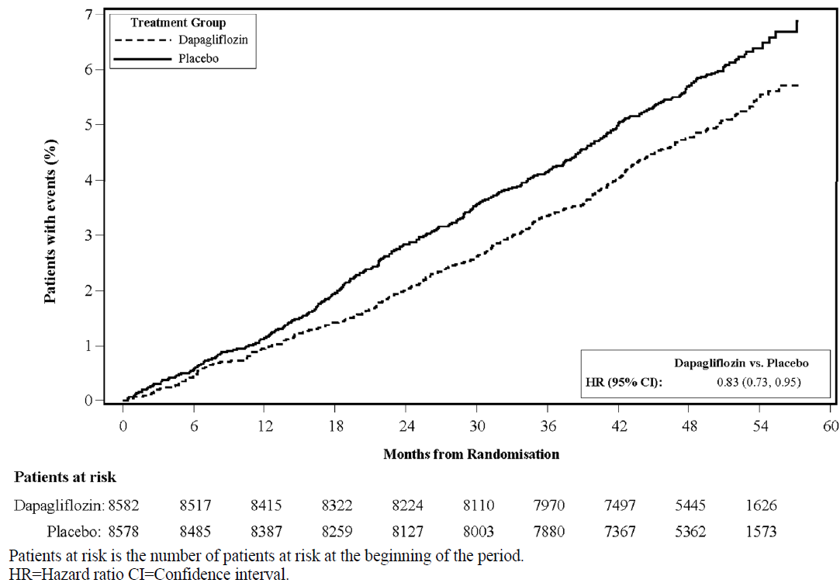

Results on primary and secondary endpoints are displayed in Figure 2. Superiority of dapagliflozin over placebo was not demonstrated for MACE (p=0.172). The renal composite endpoint and all-cause mortality were therefore not tested as part of the confirmatory testing procedure.

Figure 2 Treatment effects for the primary composite endpoints and their components, and the secondary endpoints and components
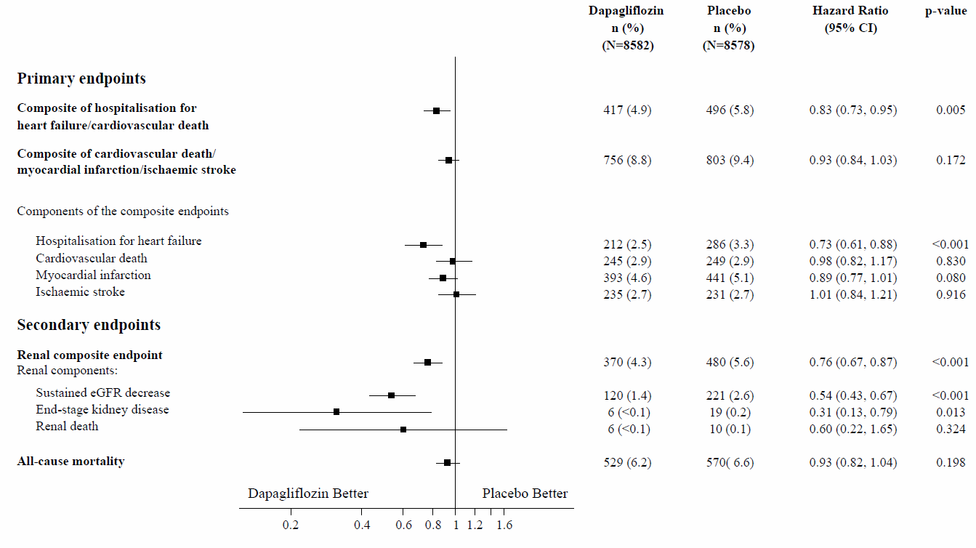
Renal composite endpoint defined as: sustained confirmed ≥ 40% decrease in eGFR to eGFR <60 mL/min/1.73 m² and/or end-stage kidney disease (dialysis ≥ 90 days or kidney transplantation, sustained confirmed eGFR < 15 mL/min/1.73 m²) and/or renal or cardiovascular death. p-values are two-sided. p-values for the secondary endpoints and for single components are nominal. Time to first event was analysed in a Cox proportional hazards model. The number of first events for the single components are the actual number of first events for each component and does not add up to the number of events in the composite endpoint.
CI=confidence interval.

Nephropathy
Dapagliflozin reduced the incidence of events of the composite of confirmed sustained eGFR decrease, end-stage kidney disease, renal or cardiovascular death. The difference between groups was driven by reductions in events of the renal components; sustained eGFR decrease, end-stage kidney disease and renal death (Figure 2).

The hazard ratio (HR) for time to nephropathy (sustained eGFR decrease, end-stage kidney disease and renal death) was 0.53 (95% CI 0.43, 0.66) for dapagliflozin versus placebo.

In addition, dapagliflozin reduced the new onset of sustained albuminuria (HR 0.79 [95% CI 0.72, 0.87]) and led to greater regression of macroalbuminuria (HR 1.82 [95% CI 1.51, 2.20]) compared with placebo.

Heart failure

DAPA-HF study: Heart failure with reduced ejection fraction (LVEF ≤ 40%)
Dapagliflozin And Prevention of Adverse outcomes in Heart Failure (DAPA-HF) was an international, multicentre, randomised, double-blind, placebo-controlled study in patients with heart failure (New York Heart Association [NYHA] functional class II-IV) with reduced ejection fraction (left ventricular ejection fraction [LVEF] ≤ 40%) to determine the effect of dapagliflozin compared with placebo, when added to background standard of care therapy, on the incidence of cardiovascular death and worsening heart failure.

Of 4,744 patients, 2,373 were randomised to dapagliflozin 10 mg and 2,371 to placebo and followed for a median of 18 months. The mean age of the study population was 66 years, 77% were male.

At baseline, 67.5% of the patients were classified as NYHA class II, 31.6% class III and 0.9% class IV, median LVEF was 32%, 56% of the heart failures were ischaemic, 36% were non-ischaemic and 8% were of unknown aetiology. In each treatment group, 42% of the patients had a history of type 2 diabetes mellitus, and an additional 3% of the patients in each group were classified as having type 2 diabetes mellitus based on a HbA1c ≥ 6.5% at both enrolment and randomisation. Patients were on standard of care therapy; 94% of patients were treated with ACE-I, ARB or angiotensin receptor-neprilysin inhibitor (ARNI, 11%), 96% with beta-blocker, 71% with mineralocorticoid receptor antagonist (MRA), 93% with diuretic and 26% had an implantable device (with defibrillator function).

Patients with eGFR ≥ 30 mL/min/1.73 m² at enrolment were included in the study. The mean eGFR was 66 mL/min/1.73 m², 41% of patients had eGFR < 60mL/min/1.73 m² and 15% had eGFR < 45 mL/min/1.73 m².

Cardiovascular death and worsening heart failure
Dapagliflozin was superior to placebo in preventing the primary composite endpoint of cardiovascular death, hospitalisation for heart failure or urgent heart failure visit (HR 0.74 [95% CI 0.65, 0.85], p < 0.0001). The effect was observed early and was sustained throughout the duration of the study (Figure 3).

Figure 3: Time to first occurrence of the composite of cardiovascular death, hospitalisation for heart failure or urgent heart failure visit
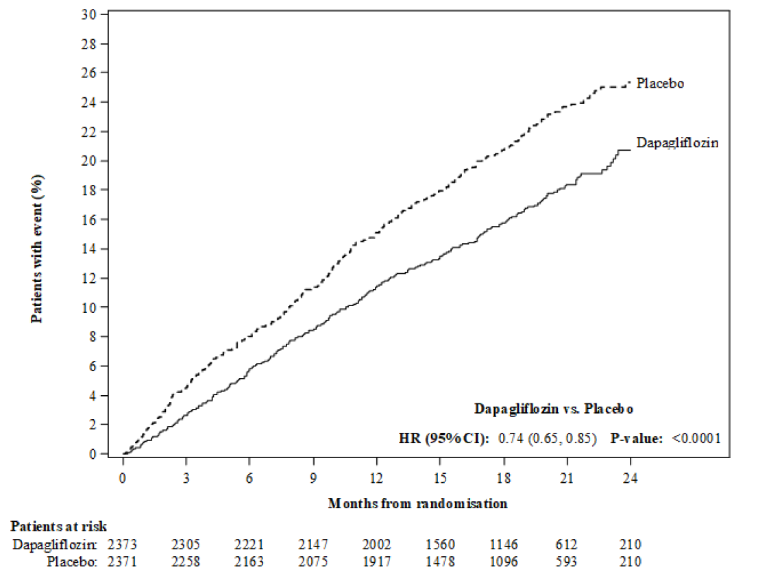

An urgent heart failure visit was defined as an urgent, unplanned, assessment by a physician, e.g. in an Emergency Department, and requiring treatment for worsening heart failure (other than just an increase in oral diuretics).
Patients at risk is the number of patients at risk at the beginning of the period.

All three components of the primary composite endpoint individually contributed to the treatment effect (Figure 4). There were few urgent heart failure visits.

Figure 4: Treatment effects for the primary composite endpoint, its components and all-cause mortality
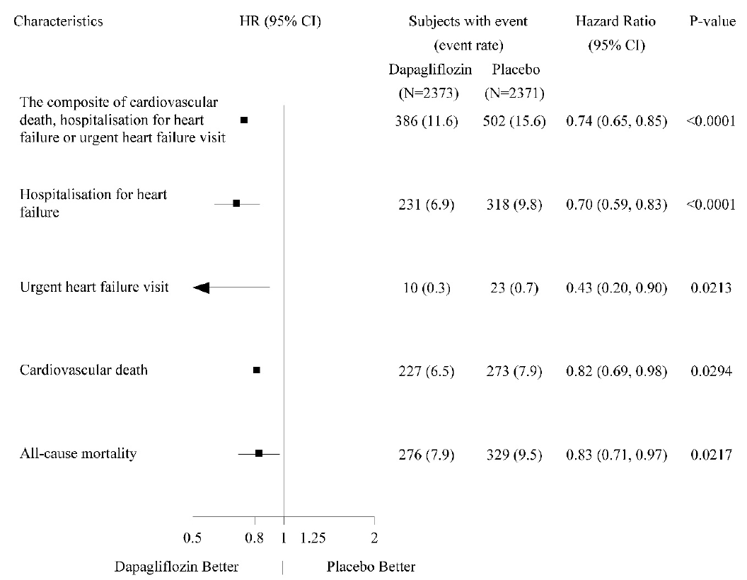

An urgent heart failure visit was defined as an urgent, unplanned, assessment by a physician, e.g. in an Emergency Department, and requiring treatment for worsening heart failure (other than just an increase in oral diuretics).
The number of first events for the single components are the actual number of first events for each component and does not add up to the number of events in the composite endpoint.
Event rates are presented as the number of subjects with event per 100 patient years of follow-up.
p-values for single components and all-cause mortality are nominal.

Dapagliflozin also reduced the total number of events of hospitalisations for heart failure (first and recurrent) and cardiovascular death; there were 567 events in the dapagliflozin group versus 742 events in the placebo group (Rate Ratio 0.75 [95% CI 0.65, 0.88]; p=0.0002).

The treatment benefit of dapagliflozin was observed in heart failure patients both with type 2 diabetes mellitus and without diabetes. Dapagliflozin reduced the primary composite endpoint of incidence of cardiovascular death and worsening heart failure with a HR of 0.75 (95% CI 0.63, 0.90) in patients with diabetes and 0.73 (95% CI 0.60, 0.88) in patients without diabetes.

The treatment benefit of dapagliflozin over placebo on the primary endpoint was also consistent across other key subgroups, including concomitant heart failure therapy, renal function (eGFR), age, gender, and region.

Patient reported outcome – heart failure symptoms
The treatment effect of dapagliflozin on heart failure symptoms was assessed by the Total Symptom Score of the Kansas City Cardiomyopathy Questionnaire (KCCQ-TSS), which quantifies heart failure symptom frequency and severity, including fatigue, peripheral oedema, dyspnoea and orthopnoea. The score ranges from 0 to 100, with higher scores representing better health status.

Treatment with dapagliflozin resulted in a statistically significant and clinically meaningful benefit over placebo in heart failure symptoms, as measured by change from baseline at month 8 in the KCCQ-TSS, (Win Ratio 1.18 [95% CI 1.11, 1.26]; p < 0.0001). Both symptom frequency and symptom burden contributed to the results. Benefit was seen both in improving heart failure symptoms and in preventing deterioration of heart failure symptoms.

In responder analyses, the proportion of patients with a clinically meaningful improvement on the KCCQ-TSS from baseline at 8 months, defined as 5 points or more, was higher for the dapagliflozin treatment group compared with placebo. The proportion of patients with a clinically meaningful deterioration, defined as 5 points or more, was lower for the dapagliflozin treatment group compared to placebo. The benefits observed with dapagliflozin remained when applying more conservative cutoffs for larger clinically meaningful change (Table 10).

Table 10. Number and percent of patients with clinically meaningful improvement and deterioration on the KCCQ-TSS at 8 months
Change from baseline at 8 months: | Dapagliflozin  10 mg  nª=2086 | Placebo  nª=2062
Improvement | n (%)  improved^{b} | n (%)  improved^{b} | Odds ratio^{c}  (95% CI) | p-value^{f}
≥ 5 points  ≥ 10 points  ≥ 15 points | 933 (44.7)  689 (33.0)  474 (22.7) | 794 (38.5)  579 (28.1)  406 (19.7) | 1.14  (1.06, 1.22)  1.13  (1.05, 1.22)  1.10  (1.01, 1.19) | 0.0002  0.0018  0.0300
Deterioration | n (%)  deteriorated^{d} | n (%)  deteriorated^{d} | Odds ratio^{e}  (95% CI) | p-value^{f}
≥ 5 points  ≥ 10 points | 537 (25.7)  395 (18.9) | 693 (33.6)  506 (24.5) | 0.84  (0.78, 0.89)  0.85  (0.79, 0.92) | <0.0001  <0.0001
ª Number of patients with an observed KCCQ-TSS or who died prior to 8 months.
^{b} Number of patients who had an observed improvement of at least 5, 10 or 15 points from baseline. Patients who died prior to the given timepoint are counted as not improved.
^{c} For improvement, an odds ratio > 1 favours dapagliflozin 10 mg.
^{d} Number of patients who had an observed deterioration of at least 5 or 10 points from baseline. Patients who died prior to the given timepoint are counted as deteriorated.
^{e} For deterioration, an odds ratio < 1 favours dapagliflozin 10 mg.
^{f} p-values are nominal.

Nephropathy
There were few events of the renal composite endpoint (confirmed sustained ≥ 50% eGFR decrease, ESKD, or renal death); the incidence was 1.2% in the dapagliflozin group and 1.6% in the placebo group.

DELIVER study: Heart failure with left ventricular ejection fraction > 40%
Dapagliflozin Evaluation to Improve the LIVEs of Patients with PReserved Ejection Fraction Heart Failure (DELIVER) was an international, multicentre, randomised, double-blind, placebo-controlled study in patients aged ≥ 40 years with heart failure (NYHA class II-IV) with LVEF > 40% and evidence of structural heart disease, to determine the effect of dapagliflozin compared with placebo on the incidence of cardiovascular death and worsening heart failure.

Of 6,263 patients, 3,131 were randomised to dapagliflozin 10 mg and 3,132 to placebo and followed for a median of 28 months. The study included 654 (10%) subacute heart failure patients (defined as randomised during hospitalisation for heart failure or within 30 days of discharge). The mean age of the study population was 72 years and 56% were male.

At baseline, 75% patients were classified as NYHA class II, 24% class III and 0.3% class IV. Median LVEF was 54%, 34% of the patients had LVEF ≤ 49%, 36% had LVEF 50-59% and 30% had LVEF ≥ 60%. In each treatment group, 45% had a history of type 2 diabetes mellitus. Baseline therapy included ACEi/ARB/ARNI (77%), beta-blockers (83%) diuretics (98%) and MRA (43%).

The mean eGFR was 61 mL/min/1.73 m², 49% of patients had eGFR < 60mL/min/1.73 m², 23% had eGFR < 45 mL/min/1.73 m², and 3% had eGFR < 30 mL/min/1.73 m².

Dapagliflozin was superior to placebo in reducing the incidence of the primary composite endpoint of cardiovascular death, hospitalisation for heart failure or urgent heart failure visit (HR 0.82 [95% CI 0.73, 0.92]; p=0.0008) (Figure 5).

Figure 5: Time to first occurrence of the composite of cardiovascular death, hospitalisation for heart failure or urgent heart failure visit
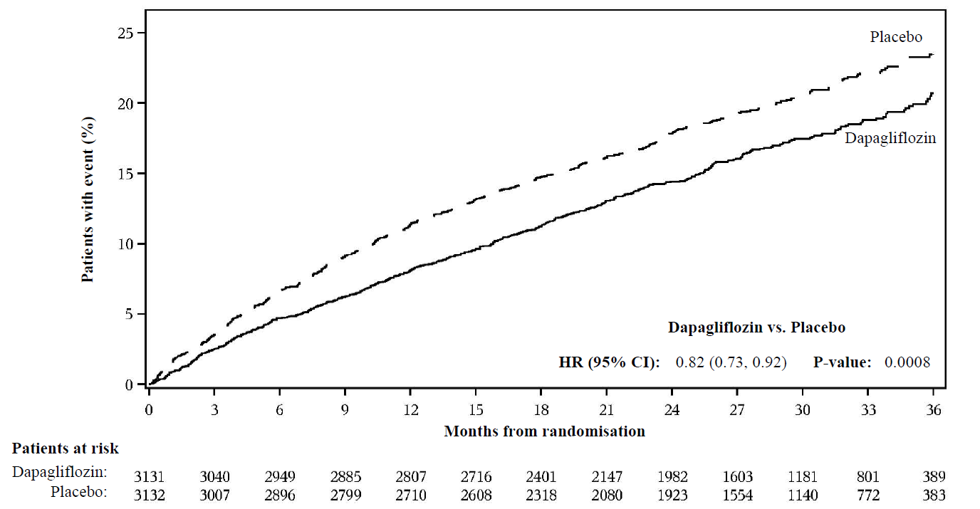

An urgent heart failure visit was defined as an urgent, unplanned, assessment by a physician, e.g. in an Emergency Department, and requiring treatment for worsening heart failure (other than just an increase in oral diuretics). Patients at risk is the number of patients at risk at the beginning of the period.

Figure 6 presents the contribution of the three components of the primary composite endpoint to the treatment effect.

Figure 6: Treatment effects for the primary composite endpoint and its components
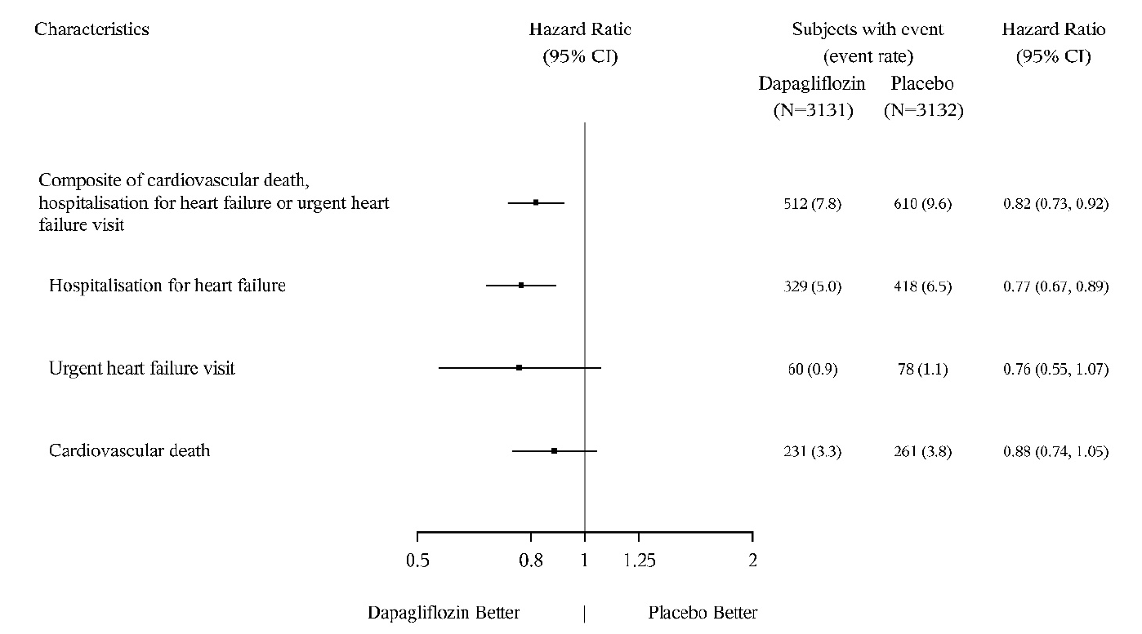

An urgent heart failure visit was defined as an urgent, unplanned, assessment by a physician, e.g. in an Emergency Department, and requiring treatment for worsening heart failure (other than just an increase in oral diuretics). The number of first events for the single components are the actual number of first events for each component and does not add up to the number of events in the composite endpoint.
Event rates are presented as the number of subjects with event per 100 patient years of follow-up. Cardiovascular death, here presented as a component of the primary endpoint, was also tested under formal Type 1 error control as a secondary endpoint.

Dapagliflozin was superior to placebo in reducing the total number of heart failure events (defined as first and recurrent hospitalisation for heart failure or urgent heart failure visits) and cardiovascular death; there were 815 events in the dapagliflozin group versus 1057 events in the placebo group (Rate Ratio 0.77 [95% CI 0.67, 0.89]; p=0.0003).

The treatment benefit of dapagliflozin over placebo on the primary endpoint was observed across subgroups of patients with LVEF ≤ 49%, 50–59%, and ≥ 60%. Effects were also consistent across other key subgroups categorised by e.g. age, gender, NYHA class, NT-proBNP level, subacute status, and type 2 diabetes mellitus status.

Patient reported outcome – heart failure symptoms
Treatment with dapagliflozin resulted in a statistically significant benefit over placebo in heart failure symptoms, as measured by change from baseline at month 8 in the KCCQ-TSS, (Win Ratio 1.11 [95% CI 1.03, 1.21]; p=0.0086). Both symptom frequency and symptom burden contributed to the results.

In responder analyses, the proportion of patients who experienced a moderate (≥ 5 points) or large (≥ 14 points) deterioration on the KCCQ-TSS from baseline at 8 months was lower in the dapagliflozin treatment group; 24.1% of patients on dapagliflozin versus 29.1% on placebo experienced a moderate deterioration (Odds Ratio 0.78 [95% CI 0.64, 0.95]) and 13.5% of patients on dapagliflozin versus 18.4% on placebo experienced a large deterioration (Odds Ratio 0.70 [95% CI 0.55, 0.88]). The proportion of patients with a small to moderate improvement (≥ 13 points) or a large improvement (≥ 17 points) did not differ between treatment groups.

Heart failure across DAPA-HF and DELIVER studies
In a pooled analysis of DAPA-HF and DELIVER, the HR for dapagliflozin versus placebo on the composite endpoint of cardiovascular death, hospitalisation for heart failure or urgent heart failure visit was 0.78 (95% CI 0.72, 0.85), p < 0.0001. The treatment effect was consistent across the LVEF range, without attenuation of effect by LVEF.

In a pre-specified subject level pooled analysis of the DAPA-HF and DELIVER studies, dapagliflozin compared with placebo reduced the risk of cardiovascular death (HR 0.85 [95% CI 0.75, 0.96], p=0.0115). Both studies contributed to the effect.

Chronic kidney disease

The Study to Evaluate the Effect of Dapagliflozin on Renal Outcomes and Cardiovascular Mortality in Patients with Chronic Kidney Disease (DAPA-CKD) was an international, multicentre, randomised, double-blind, placebo-controlled study in patients with chronic kidney disease (CKD) with eGFR ≥ 25 to ≤ 75 mL/min/1.73 m² and albuminuria (UACR ≥ 200 and ≤ 5000 mg/g) to determine the effect of dapagliflozin compared with placebo, when added to background standard of care therapy, on the incidence of the composite endpoint of ≥ 50% sustained decline in eGFR, end-stage kidney disease (ESKD) (defined as sustained eGFR < 15 mL/min/1.73 m², chronic dialysis treatment or receiving a renal transplant), cardiovascular or renal death.

Of 4,304 patients, 2,152 were randomised to dapagliflozin 10 mg and 2,152 to placebo and followed for a median of 28.5 months. Treatment was continued if eGFR fell to levels below 25 mL/min/1.73 m² during the study and could be continued in cases when dialysis was needed.

The mean age of the study population was 61.8 years, 66.9% were male. At baseline, mean eGFR was 43.1 mL/min/1.73 m² and median UACR was 949.3 mg/g, 44.1% of patients had eGFR 30 to < 45 mL/min/1.73 m² and 14.5% had eGFR < 30 mL/min/1.73 m². 67.5% of the patients had type 2 diabetes mellitus. Patients were on standard of care (SOC) therapy; 97.0% of patients were treated with an angiotensin-converting enzyme inhibitor (ACEi) or angiotensin receptor blocker (ARB).

The study was stopped early for efficacy prior to the planned analysis based on a recommendation by the independent Data Monitoring Committee. Dapagliflozin was superior to placebo in preventing the primary composite endpoint of ≥ 50% sustained decline in eGFR, reaching end-stage kidney disease, cardiovascular or renal death. Based on the Kaplan-Meier plot for the time to first occurrence of the primary composite endpoint, the treatment effect was evident beginning at 4 months and was maintained through the end of study (Figure 7).

Figure 7: Time to first occurrence of the primary composite endpoint, ≥ 50% sustained decline in eGFR, end-stage kidney disease, cardiovascular or renal death
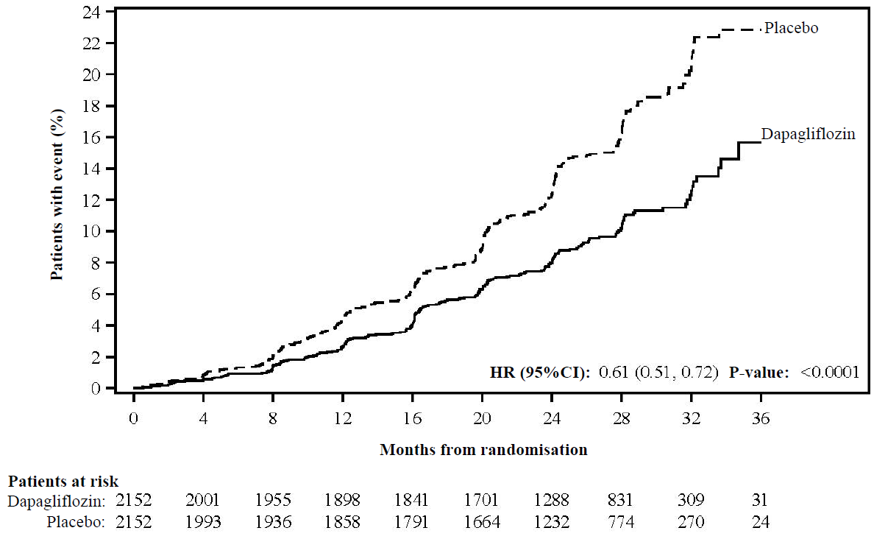

Patients at risk is the number of patients at risk at the beginning of the period.

All four components of the primary composite endpoint individually contributed to the treatment effect. Dapagliflozin also reduced the incidence of the composite endpoint of ≥ 50% sustained decline in eGFR, end-stage kidney disease or renal death and the composite endpoint of cardiovascular death and hospitalisation for heart failure. Treatment with dapagliflozin improved overall survival in chronic kidney disease patients with a significant reduction in all-cause mortality (Figure 8).

Figure 8: Treatment effects for the primary and secondary composite endpoints, their individual components, and all-cause mortality
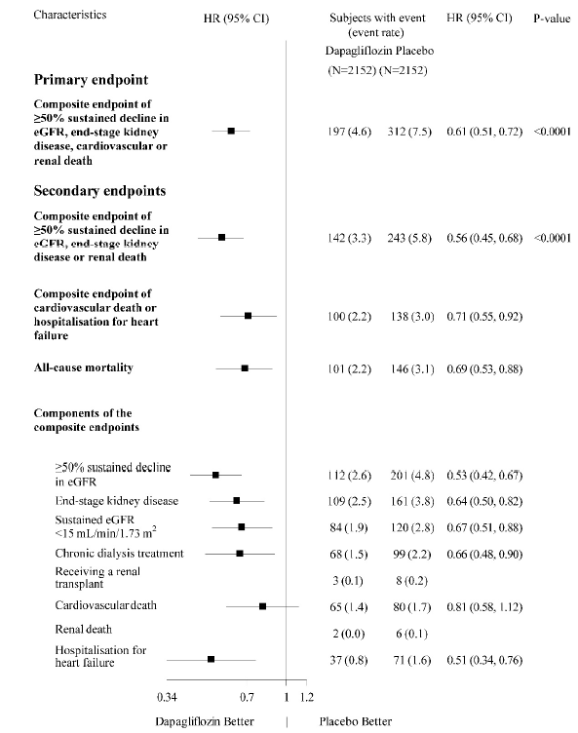
The number of first events for the single components are the actual number of first events for each component and does not add up to the number of events in the composite endpoint.
Event rates are presented as the number of subjects with event per 100 patient years of follow-up.
Hazard ratio estimates are not presented for subgroups with less than 15 events in total, both arms combined.

The treatment benefit of dapagliflozin was consistent in chronic kidney disease patients with type 2 diabetes mellitus and without diabetes. Dapagliflozin reduced the primary composite endpoint of ≥ 50% sustained decline in eGFR, reaching end-stage kidney disease, cardiovascular or renal death with a HR of 0.64 (95% CI 0.52, 0.79) in patients with type 2 diabetes mellitus and 0.50 (95% CI 0.35, 0.72) in patients without diabetes.

The treatment benefit of dapagliflozin over placebo on the primary endpoint was also consistent across other key subgroups, including eGFR, age, gender, and region.

Paediatric population

Type 2 diabetes mellitus
In a clinical study in children and adolescents aged 10-24 years with type 2 diabetes mellitus, 39 patients were randomised to dapagliflozin 10 mg and 33 to placebo, as add-on to metformin, insulin or a combination of metformin and insulin. At randomisation, 74% of the patients were < 18 years of age. The adjusted mean change in HbA1c for dapagliflozin relative to placebo from baseline to week 24 was -0.75% (95% CI -1.65, 0.15). In the age group < 18 years the adjusted mean change in HbA1c for dapagliflozin relative to placebo was -0.59% (95% CI -1.66, 0.48). In the age group ≥ 18 years, the mean change from baseline in HbA1c was -1.52% in the dapagliflozin treated group (n=9) and 0.17% in the placebo treated group (n=6). Efficacy and safety were similar to that observed in the adult population treated with dapagliflozin. Safety and tolerability were further confirmed in a 28-week safety extension of the study.

Heart failure and chronic kidney disease
The European Medicines Agency has waived the obligation to submit the results of studies with dapagliflozin in all subsets of the paediatric population in the prevention of cardiovascular events in patients with chronic heart failure and in the treatment of chronic kidney disease (see section 4.2 for information on paediatric use).

5.2 Pharmacokinetic properties

Absorption

Dapagliflozin was rapidly and well absorbed after oral administration. Maximum dapagliflozin plasma concentrations (C_{max}) were usually attained within 2 hours after administration in the fasted state. Geometric mean steady-state dapagliflozin Cmax and AUCτ values following once daily 10 mg doses of dapagliflozin were 158 ng/mL and 628 ng h/mL, respectively. The absolute oral bioavailability of dapagliflozin following the administration of a 10 mg dose is 78%. Administration with a high-fat meal decreased dapagliflozin C_{max} by up to 50% and prolonged Tmax by approximately 1 hour, but did not alter AUC as compared with the fasted state. These changes are not considered to be clinically meaningful. Hence, Dapagliflozin "Elpen" can be administered with or without food.

Distribution

Dapagliflozin is approximately 91% protein bound. Protein binding was not altered in various disease states (e.g. renal or hepatic impairment). The mean steady-state volume of distribution of dapagliflozin was 118 liters.

Biotransformation

Dapagliflozin is extensively metabolised, primarily to yield dapagliflozin 3-O-glucuronide, which is an inactive metabolite. Dapagliflozin 3-O-glucuronide or other metabolites do not contribute to the glucose-lowering effects. The formation of dapagliflozin 3-O-glucuronide is mediated by UGT1A9, an enzyme present in the liver and kidney, and CYP-mediated metabolism was a minor clearance pathway in humans.

Elimination

The mean plasma terminal half-life (t1/2) for dapagliflozin was 12.9 hours following a single oral dose of dapagliflozin 10 mg to healthy subjects. The mean total systemic clearance of dapagliflozin administered intravenously was 207 mL/min. Dapagliflozin and related metabolites are primarily eliminated via urinary excretion with less than 2% as unchanged dapagliflozin. After administration of a 50 mg [14C]-dapagliflozin dose, 96% was recovered, 75% in urine and 21% in faeces. In faeces, approximately 15% of the dose was excreted as parent drug.

Linearity

Dapagliflozin exposure increased proportional to the increment in dapagliflozin dose over the range of 0.1 to 500 mg and its pharmacokinetics did not change with time upon repeated daily dosing for up to 24 weeks.

Special populations

Renal impairment
At steady-state (20 mg once-daily dapagliflozin for 7 days), subjects with type 2 diabetes mellitus and mild, moderate or severe renal impairment (as determined by iohexol plasma clearance) had mean systemic exposures of dapagliflozin of 32%, 60% and 87% higher, respectively, than those of subjects with type 2 diabetes mellitus and normal renal function. The steady-state 24-hour urinary glucose excretion was highly dependent on renal function and 85, 52, 18 and 11 g of glucose/day was excreted by subjects with type 2 diabetes mellitus and normal renal function or mild, moderate or severe renal impairment, respectively. The impact of haemodialysis on dapagliflozin exposure is not known. The effect of reduced renal function on systemic exposure was evaluated in a population pharmacokinetic model. Consistent with previous results, model predicted AUC was higher in patients with chronic kidney disease compared with patients with normal renal function, and was not meaningfully different in chronic kidney disease patients with type 2 diabetes mellitus and without diabetes.

Hepatic impairment
In subjects with mild or moderate hepatic impairment (Child-Pugh classes A and B), mean C_{max} and AUC of dapagliflozin were up to 12% and 36% higher, respectively, compared to healthy matched control subjects. These differences were not considered to be clinically meaningful. In subjects with severe hepatic impairment (Child-Pugh class C) mean C_{max} and AUC of dapagliflozin were 40% and 67% higher than matched healthy controls, respectively.

Elderly (≥ 65 years)
There is no clinically meaningful increase in exposure based on age alone in subjects up to 70 years old. However, an increased exposure due to age-related decrease in renal function can be expected. There are insufficient data to draw conclusions regarding exposure in patients > 70 years old.

Paediatric population
Pharmacokinetics and pharmacodynamics (glucosuria) in children with type 2 diabetes mellitus aged 10-17 years were similar to those observed in adults with type 2 diabetes mellitus.

Gender
The mean dapagliflozin AUCss in females was estimated to be about 22% higher than in males.

Race
There were no clinically relevant differences in systemic exposures between White, Black or Asian races.

Body weight
Dapagliflozin exposure was found to decrease with increased weight. Consequently, low-weight patients may have somewhat increased exposure and patients with high weight somewhat decreased exposure. However, the differences in exposure were not considered clinically meaningful.

5.3 Preclinical safety data
Non-clinical data reveal no special hazard for humans based on conventional studies of safety pharmacology, repeated dose toxicity, genotoxicity, carcinogenic potential and fertility. Dapagliflozin did not induce tumours in either mice or rats at any of the doses evaluated in two-year carcinogenicity studies.

Reproductive and developmental toxicity

Direct administration of dapagliflozin to weanling juvenile rats and indirect exposure during late pregnancy (time periods corresponding to the second and third trimesters of pregnancy with respect to human renal maturation) and lactation are each associated with increased incidence and/or severity of renal pelvic and tubular dilatations in progeny.

In a juvenile toxicity study, when dapagliflozin was dosed directly to young rats from postnatal day 21 until postnatal day 90, renal pelvic and tubular dilatations were reported at all dose levels; pup exposures at the lowest dose tested were ≥ 15 times the maximum recommended human dose. These findings were associated with dose-related increases in kidney weight and macroscopic kidney enlargement observed at all doses. The renal pelvic and tubular dilatations observed in juvenile animals did not fully reverse within the approximate 1-month recovery period.

In a separate study of pre- and postnatal development, maternal rats were dosed from gestation day 6 through postnatal day 21, and pups were indirectly exposed in utero and throughout lactation. (A satellite study was conducted to assess dapagliflozin exposures in milk and pups.) Increased incidence or severity of renal pelvic dilatation was observed in adult offspring of treated dams, although only at the highest dose tested (associated maternal and pup dapagliflozin exposures were 1,415 times and 137 times, respectively, the human values at the maximum recommended human dose). Additional developmental toxicity was limited to dose-related reductions in pup body weights and observed only at doses ≥ 15 mg/kg/day (associated with pup exposures that are ≥ 29 times the human values at the maximum recommended human dose). Maternal toxicity was evident only at the highest dose tested and limited to transient reductions in body weight and food consumption at dose. The no observed adverse effect level (NOAEL) for developmental toxicity, the lowest dose tested, is associated with a maternal systemic exposure multiple that is approximately 19 times the human value at the maximum recommended human dose.

In additional studies of embryo-foetal development in rats and rabbits, dapagliflozin was administered for intervals coinciding with the major periods of organogenesis in each species. Neither maternal nor developmental toxicities were observed in rabbits at any dose tested; the highest dose tested is associated with a systemic exposure multiple of approximately 1,191 times the maximum recommended human dose. In rats, dapagliflozin was neither embryolethal nor teratogenic at exposures up to 1,441 times the maximum recommended human dose.

6. PHARMACEUTICAL PARTICULARS

6.1 List of excipients

Tablet core
Lactose monohydrate
Starch, pregelatinised
Cellulose, microcrystalline 102
Croscarmellose sodium
Silica, colloidal anhydrous
Magnesium stearate

Film-coating
Polyvinyl alcohol (E1203)
Calcium carbonate (E170)
Macrogol 3350 (E1521)
Talc (E553b)
Iron oxide yellow (E172)
Iron oxide black (E172)
Iron oxide red (E172)

6.2 Incompatibilities
Not applicable.

6.3 Shelf life
30 months

6.4 Special precautions for storage
This medicinal product does not require any special storage conditions.

6.5 Nature and contents of container
OPA/Aluminum/PVC//Aluminum blister

Dapagliflozin "Elpen" 5 mg film-coated tablets

Pack sizes of 14, 28 and 98 film-coated tablets in non-perforated plain or calendar blisters packed in a carton.
Pack sizes of 30×1 and 90×1 film-coated tablets in perforated unit dose blisters packed in a carton.

Dapagliflozin "Elpen" 10 mg film-coated tablets

Pack sizes of 14, 28 and 98 film-coated tablets in non-perforated plain or calendar blisters packed in a carton.
Pack sizes of 10×1, 30×1 and 90×1 film-coated tablets in perforated unit dose blisters packed in a carton.

Not all pack sizes may be marketed.

6.6 Special precautions for disposal and other handling
Any unused medicinal product or waste material should be disposed of in accordance with local requirements.

7. MARKETING AUTHORISATION HOLDER
Elpen Pharmaceutical Co. Inc.
Marathonos Avenue 95
190 09 Pikermi, Attiki
Greece

8. MARKETING AUTHORISATION NUMBER(S)
5 mg: 71858
10 mg: 71861

9. DATE OF FIRST AUTHORISATION
3 September 2025

10. DATE OF REVISION OF THE TEXT
-

