

21 May 2026

SUMMARY OF PRODUCT CHARACTERISTICS

for

Elemio, film-coated tablets

0. D.SP.NO.
34629

1. NAME OF THE MEDICINAL PRODUCT
Elemio

2. QUALITATIVE AND QUANTITATIVE COMPOSITION

Elemio 10 mg film-coated tablets
Each tablet contains 10 mg empagliflozin.

Excipients with known effect
Each tablet contains 146.25 mg of lactose monohydrate.

Elemio 25 mg film-coated tablets
Each tablet contains 25 mg empagliflozin.

Excipients with known effect
Each tablet contains 100.00 mg of lactose monohydrate.
For the full list of excipients, see section 6.1.

3. PHARMACEUTICAL FORM
Film-coated tablets (tablet)

Elemio 10 mg film-coated tablets
Pale yellow, round (diameter of approx. 9.1 mm), biconvex film coated tablets, with “10” debossed on one side.

Elemio 25 mg film-coated tablets
Pale yellow, oval (approx. 11.1 mm × 5.6 mm), biconvex film coated tablets debossed with “25” on one side.

4. CLINICAL PARTICULARS

4.1 Therapeutic indications

Type 2 diabetes mellitus
Elemio is indicated in adults and children aged 10 years and above for the treatment of insufficiently controlled type 2 diabetes mellitus as an adjunct to diet and exercise
    - as monotherapy when metformin is considered inappropriate due to intolerance
    - in addition to other medicinal products for the treatment of diabetes
For study results with respect to combination of therapies, effects on glycaemic control, cardiovascular and renal events, and the populations studied, see sections 4.4, 4.5 and 5.1.

Heart failure
Elemio is indicated in adults for the treatment of symptomatic chronic heart failure.

Chronic kidney disease
Elemio is indicated in adults for the treatment of chronic kidney disease.

4.2 Posology and method of administration

Posology

Type 2 diabetes mellitus
The recommended starting dose is 10 mg empagliflozin once daily for monotherapy and add-on combination therapy with other medicinal products for the treatment of diabetes. In patients tolerating empagliflozin 10 mg once daily who have an eGFR ≥ 60 mL/min/1.73 m² and need tighter glycaemic control, the dose can be increased to 25 mg once daily. The maximum daily dose is 25 mg (see below and section 4.4).

Heart failure
The recommended dose is 10 mg empagliflozin once daily.

Chronic kidney disease
The recommended dose is 10 mg empagliflozin once daily.

All indications
When empagliflozin is used in combination with a sulphonylurea or with insulin, a lower dose of the sulphonylurea or insulin may be considered to reduce the risk of hypoglycaemia (see sections 4.5 and 4.8).

If a dose is missed, it should be taken as soon as the patient remembers; however, a double dose should not be taken on the same day.

Special populations
Renal impairment
Due to limited experience, it is not recommended to initiate treatment with empagliflozin in patients with an eGFR < 20 mL/min/1.73 m².

In patients with an eGFR < 60 mL/min/1.73 m² the daily dose of empagliflozin is 10 mg.

In patients with type 2 diabetes mellitus, the glucose lowering efficacy of empagliflozin is reduced in patients with an eGFR < 45 mL/min/1.73 m² and likely absent in patients with an eGFR < 30 mL/min/1.73 m². Therefore, if eGFR falls below 45 mL/min/1.73 m², additional glucose lowering treatment should be considered if needed (see sections 4.4, 4.8, 5.1 and 5.2).

Hepatic impairment
No dose adjustment is required for patients with hepatic impairment. Empagliflozin exposure is increased in patients with severe hepatic impairment. Therapeutic experience in patients with severe hepatic impairment is limited and therefore not recommended for use in this population (see section 5.2).

Elderly
No dose adjustment is recommended based on age. In patients 75 years and older, an increased risk for volume depletion should be taken into account (see sections 4.4 and 4.8).

Paediatric population
The recommended starting dose is 10 mg empagliflozin once daily. In patients tolerating empagliflozin 10 mg once daily and requiring additional glycaemic control, the dose can be increased to 25 mg once daily (see sections 5.1 and 5.2). No data are available for children with eGFR < 60 mL/min/1.73 m² and children below 10 years of age.

The safety and efficacy of empagliflozin for the treatment of heart failure or for the treatment of chronic kidney disease in children under 18 years of age have not been established. No data are available.

Method of administration
The tablets can be taken with or without food, swallowed whole with water.

4.3 Contraindications
Hypersensitivity to the active substance or to any of the excipients listed in section 6.1.

4.4 Special warnings and precautions for use

General
Empagliflozin should not be used in patients with type 1 diabetes mellitus (see “Ketoacidosis” in section 4.4).

Ketoacidosis
Cases of ketoacidosis, including life-threatening and fatal cases, have been reported in patients with diabetes mellitus treated with SGLT2 inhibitors, including empagliflozin. In a number of cases, the presentation of the condition was atypical with only moderately increased blood glucose values, below 14 mmol/L (250 mg/dL). It is not known if ketoacidosis is more likely to occur with higher doses of empagliflozin. Although ketoacidosis is less likely to occur in patients without diabetes mellitus, cases have also been reported in these patients.

The risk of ketoacidosis must be considered in the event of non-specific symptoms such as nausea, vomiting, anorexia, abdominal pain, excessive thirst, difficulty breathing, confusion, unusual fatigue or sleepiness. Patients should be assessed for ketoacidosis immediately if these symptoms occur, regardless of blood glucose level.

In patients where ketoacidosis is suspected or diagnosed, treatment with empagliflozin should be discontinued immediately.

Treatment should be interrupted in patients who are hospitalised for major surgical procedures or acute serious medical illnesses. Monitoring of ketones is recommended in these patients. Measurement of blood ketone levels is preferred to urine. Treatment with empagliflozin may be restarted when the ketone values are normal and the patient’s condition has stabilised.

Before initiating empagliflozin, factors in the patient history that may predispose to ketoacidosis should be considered.

Prolonged ketoacidosis and prolonged glucosuria have been observed with empagliflozin. Ketoacidosis may last longer after discontinuation of empagliflozin than expected from the plasma half-life (see section 5.2). Empagliflozin-independent factors, such as insulin deficiency, might be involved in prolonged periods of ketoacidosis.

Patients who may be at higher risk of ketoacidosis include patients with a low beta-cell function reserve (e.g. type 2 diabetes patients with low C-peptide or latent autoimmune diabetes in adults (LADA) or patients with a history of pancreatitis), patients with conditions that lead to restricted food intake or severe dehydration, patients for whom insulin doses are reduced and patients with increased insulin requirements due to acute medical illness, surgery or alcohol abuse. SGLT2 inhibitors should be used with caution in these patients.

Restarting SGLT2 inhibitor treatment in patients with previous ketoacidosis while on SGLT2 inhibitor treatment is not recommended, unless another clear precipitating factor is identified and resolved.

Empagliflozin should not be used in patients with type 1 diabetes. Data from a clinical trial program in patients with type 1 diabetes showed increased ketoacidosis occurrence with common frequency in patients treated with empagliflozin 10 mg and 25 mg as an adjunct to insulin compared to placebo.

Renal impairment
Due to limited experience, it is not recommended to initiate treatment with empagliflozin in patients with an eGFR < 20 mL/min/1.73 m².

In patients with an eGFR < 60 mL/min/1.73 m² the daily dose of empagliflozin is 10 mg (see section 4.2).

The glucose lowering efficacy of empagliflozin is dependent on renal function and is reduced in patients with an eGFR < 45 mL/min/1.73 m² and is likely absent in patients with an eGFR < 30 mL/min/1.73 m² (see section 4.2, 5.1 and 5.2).

Monitoring of renal function
Assessment of renal function is recommended as follows:
- Prior to empagliflozin initiation and periodically during treatment, i.e. at least yearly (see sections 4.2, 4.8, 5.1 and 5.2).
- Prior to initiation of any concomitant medicinal product that may have a negative impact on renal function.

Risk for volume depletion
Based on the mode of action of SGLT2 inhibitors, osmotic diuresis accompanying glucosuria may lead to a modest decrease in blood pressure (see section 5.1). Therefore, caution should be exercised in patients for whom an empagliflozin-induced drop in blood pressure could pose a risk, such as patients with known cardiovascular disease, patients on anti-hypertensive therapy with a history of hypotension or patients aged 75 years and older.

In case of conditions that may lead to fluid loss (e.g. gastrointestinal illness), careful monitoring of volume status (e.g. physical examination, blood pressure measurements, laboratory tests including haematocrit) and electrolytes is recommended for patients receiving empagliflozin. Temporary interruption of treatment with empagliflozin should be considered until the fluid loss is corrected.

Elderly
The effect of empagliflozin on urinary glucose excretion is associated with osmotic diuresis, which could affect the hydration status. Patients aged 75 years and older may be at an increased risk of volume depletion. A higher number of these patients treated with empagliflozin had adverse reactions related to volume depletion as compared to placebo (see section 4.8). Therefore, special attention should be given to their volume intake in case of co-administered medicinal products which may lead to volume depletion (e.g. diuretics, ACE inhibitors).

Complicated urinary tract infections
Cases of complicated urinary tract infections including pyelonephritis and urosepsis have been reported in patients treated with empagliflozin (see section 4.8). Temporary interruption of empagliflozin should be considered in patients with complicated urinary tract infections.

Necrotising fasciitis of the perineum (Fournier’s gangrene)
Cases of necrotising fasciitis of the perineum, (also known as Fournier’s gangrene), have been reported in female and male patients taking SGLT2 inhibitors, including empagliflozin. This is a rare but serious and potentially life-threatening event that requires urgent surgical intervention and antibiotic treatment.

Patients should be advised to seek medical attention if they experience a combination of symptoms of pain, tenderness, erythema, or swelling in the genital or perineal area, with fever or malaise. Be aware that either uro-genital infection or perineal abscess may precede necrotising fasciitis. If Fournier´s gangrene is suspected, Elemio should be discontinued and prompt treatment (including antibiotics and surgical debridement) should be instituted.

Lower limb amputations
An increase in cases of lower limb amputation (primarily of the toe) has been observed in long-term clinical studies with another SGLT2 inhibitor. It is unknown whether this constitutes a class effect. Like for all diabetic patients it is important to counsel patients on routine preventative foot-care.

Hepatic injury
Cases of hepatic injury have been reported with empagliflozin in clinical trials. A causal relationship between empagliflozin and hepatic injury has not been established.

Elevated haematocrit
Haematocrit increase was observed with empagliflozin treatment (see section 4.8). Patients with pronounced elevations in haematocrit should be monitored and investigated for underlying haematological disease.

Chronic kidney disease
Patients with albuminuria may benefit more from treatment with empagliflozin.

Infiltrative disease or Takotsubo cardiomyopathy
Patients with infiltrative disease or with Takotsubo cardiomyopathy have not been specifically studied. Therefore, efficacy in these patients has not been established.

Urine laboratory assessments
Due to its mechanism of action, patients taking Elemio will test positive for glucose in their urine.

Interference with 1,5-anhydroglucitol (1,5-AG) assay
Monitoring glycaemic control with 1,5-AG assay is not recommended as measurements of 1,5-AG are unreliable in assessing glycaemic control in patients taking SGLT2 inhibitors. Use of alternative methods to monitor glycaemic control is advised.

Lactose
The tablets contain lactose. Patients with rare hereditary problems of galactose intolerance, total lactase deficiency, or glucose-galactose malabsorption should not take this medicinal product.

Sodium
Each tablet contains less than 1 mmol sodium (23 mg), that is to say essentially ‘sodium free’.

4.5 Interaction with other medicinal products and other forms of interaction

Pharmacodynamic interactions

Diuretics
Empagliflozin may add to the diuretic effect of thiazide and loop diuretics and may increase the risk of dehydration and hypotension (see section 4.4).

Insulin and insulin secretagogues
Insulin and insulin secretagogues, such as sulphonylureas, may increase the risk of hypoglycaemia. Therefore, a lower dose of insulin or an insulin secretagogue may be required to reduce the risk of hypoglycaemia when used in combination with empagliflozin (see sections 4.2 and 4.8).

Pharmacokinetic interactions

Effects of other medicinal products on empagliflozin
In vitro data suggest that the primary route of metabolism of empagliflozin in humans is glucuronidation by uridine 5'-diphosphoglucuronosyltransferases UGT1A3, UGT1A8, UGT1A9, and UGT2B7. Empagliflozin is a substrate of the human uptake transporters OAT3, OATP1B1, and OATP1B3, but not OAT1 and OCT2. Empagliflozin is a substrate of P-glycoprotein (P-gp) and breast cancer resistance protein (BCRP).

Co-administration of empagliflozin with probenecid, an inhibitor of UGT enzymes and OAT3, resulted in a 26% increase in peak empagliflozin plasma concentrations (Cmax) and a 53% increase in area under the concentration-time curve (AUC). These changes were not considered to be clinically meaningful.

The effect of UGT induction (e.g. induction by rifampicin or phenytoin) on empagliflozin has not been studied. Co-treatment with known inducers of UGT enzymes is not recommended due to a potential risk of decreased efficacy. If an inducer of these UGT enzymes must be co-administered, monitoring of glycaemic control to assess response to Elemio is appropriate.

An interaction study with gemfibrozil, an in vitro inhibitor of OAT3 and OATP1B1/1B3 transporters, showed that empagliflozin Cmax increased by 15% and AUC increased by 59% following co- administration. These changes were not considered to be clinically meaningful.

Inhibition of OATP1B1/1B3 transporters by co-administration with rifampicin resulted in a 75% increase in Cmax and a 35% increase in AUC of empagliflozin. These changes were not considered to be clinically meaningful.

Empagliflozin exposure was similar with and without co-administration with verapamil, a P-gp inhibitor, indicating that inhibition of P-gp does not have any clinically relevant effect on empagliflozin.

Interaction studies suggest that the pharmacokinetics of empagliflozin were not influenced by co- administration with metformin, glimepiride, pioglitazone, sitagliptin, linagliptin, warfarin, verapamil, ramipril, simvastatin, torasemide and hydrochlorothiazide.

Effects of empagliflozin on other medicinal products
Empagliflozin may increase renal lithium excretion and the blood lithium levels may be decreased. Serum concentration of lithium should be monitored more frequently after empagliflozin initiation and dose changes. Please refer the patient to the lithium prescribing doctor in order to monitor serum concentration of lithium.

Based on in vitro studies, empagliflozin does not inhibit, inactivate, or induce CYP450 isoforms. Empagliflozin does not inhibit UGT1A1, UGT1A3, UGT1A8, UGT1A9, or UGT2B7. Drug-drug interactions involving the major CYP450 and UGT isoforms with empagliflozin and concomitantly administered substrates of these enzymes are therefore considered unlikely.

Empagliflozin does not inhibit P-gp at therapeutic doses. Based on in vitro studies, empagliflozin is considered unlikely to cause interactions with active substances that are P-gp substrates. Co-administration of digoxin, a P-gp substrate, with empagliflozin resulted in a 6% increase in AUC and 14% increase in Cmax of digoxin. These changes were not considered to be clinically meaningful.

Empagliflozin does not inhibit human uptake transporters such as OAT3, OATP1B1, and OATP1B3 in vitro at clinically relevant plasma concentrations and, as such, drug-drug interactions with substrates of these uptake transporters are considered unlikely.

Interaction studies conducted in healthy volunteers suggest that empagliflozin had no clinically relevant effect on the pharmacokinetics of metformin, glimepiride, pioglitazone, sitagliptin, linagliptin, simvastatin, warfarin, ramipril, digoxin, diuretics and oral contraceptives.

Paediatric population
Interaction studies have only been performed in adults.

4.6 Fertility, pregnancy and lactation

Pregnancy
There are no data from the use of empagliflozin in pregnant women. Animal studies show that empagliflozin crosses the placenta during late gestation to a very limited extent but do not indicate direct or indirect harmful effects with respect to early embryonic development. However, animal studies have shown adverse effects on postnatal development (see section 5.3). As a precautionary measure, it is preferable to avoid the use of Elemio during pregnancy.

Breast-feeding
No data in humans are available on excretion of empagliflozin into milk. Available toxicological data in animals have shown excretion of empagliflozin in milk. A risk to the newborns/infants cannot be excluded. Elemio should not be used during breast-feeding.

Fertility
No studies on the effect on human fertility have been conducted for Empagliflozin. Animal studies do not indicate direct or indirect harmful effects with respect to fertility (see section 5.3).

4.7 Effects on ability to drive and use machines
No traffic warning.
Elemio has minor influence on the ability to drive and use machines. Patients should be advised to take precautions to avoid hypoglycaemia while driving and using machines, in particular when Elemio is used in combination with a sulphonylurea and/or insulin.

4.8 Undesirable effects

Summary of the safety profile

Type 2 diabetes mellitus
A total of 15 582 patients with type 2 diabetes were included in clinical studies to evaluate the safety of empagliflozin, of which 10 004 patients received empagliflozin, either alone or in combination with metformin, a sulphonylurea, pioglitazone, DPP-4 inhibitors, or insulin.
In 6 placebo-controlled trials of 18 to 24 weeks duration, 3 534 patients were included of which 1 183 were treated with placebo and 2 351 with empagliflozin. The overall incidence of adverse events in patients treated with empagliflozin was similar to placebo. The most frequently reported adverse reaction was hypoglycaemia when used with sulphonylurea or insulin (see description of selected adverse reactions).

Heart failure
The EMPEROR studies included patients with heart failure and either reduced ejection fraction (N = 3 726) or preserved ejection fraction (N = 5 985) treated with empagliflozin 10 mg or placebo.
Approximately half of the patients had type 2 diabetes mellitus. The most frequent adverse reaction of the pooled EMPEROR-Reduced and EMPEROR-Preserved studies was volume depletion (empagliflozin 10 mg: 11.4%. placebo: 9.7%).

Chronic kidney disease
The EMPA-KIDNEY study included patients with chronic kidney disease (N = 6 609) treated with 10 mg empagliflozin or placebo. About 44% of the patients had type 2 diabetes mellitus. The most frequent adverse events in the EMPA-KIDNEY study were gout (empagliflozin 7.0% vs placebo 8.0%), and acute kidney injury (empagliflozin 2.8% vs placebo 3.5%) which were more frequently reported in patients on placebo.

The overall safety profile of empagliflozin was generally consistent across the studied indications.

Tabulated list of adverse reactions
Adverse reactions classified by system organ class and MedDRA preferred terms reported in patients who received empagliflozin in placebo-controlled studies are presented in the table below (Table 1).

The adverse reactions are listed by absolute frequency. Frequencies are defined as very common (≥ 1/10), common (≥ 1/100 to < 1/10), uncommon (≥ 1/1 000 to < 1/100), rare (≥ 1/10 000 to < 1/1 000), or very rare (< 1/10 000), and not known (cannot be estimated from the available data).

Table 1: Tabulated list of adverse reactions (MedDRA) from reported placebo-controlled studies and from post-marketing experience
System organ class | Very common | Common | Uncommon | Rare | Very Rare
Infections and infestations |  | Vaginal moniliasis, vulvovaginitis, balanitis and other genital infectionª Urinary tract infection (including pyelonephritis  and urosepsis)ª |  | Necrotising fasciitis of the perineum (Fournier´s gangrene)*
Metabolism and nutrition disorders | Hypoglycaemia (when used with sulphonylurea  or insulin)ª | Thirst | Ketoacidosis*
Gastrointestinal disorders |  | Constipation
Skin and subcutaneous tissue disorders |  | Pruritus  (generalised) Rash | Urticaria Angioedema
Vascular disorders | Volume depletionª
Renal and urinary disorders |  | Increased urinationª | Dysuria |  | Tubulo- interstitial nephritis
Investigations |  | Serum lipids increasedª | Blood creatinine increased/ Glomerular filtration rate decreasedª Haematocrit  increasedª
ª see subsections below for additional information
* see section 4.4

Description of selected adverse reactions

Hypoglycaemia
The frequency of hypoglycaemia depended on the background therapy in the respective studies and was similar for empagliflozin and placebo as monotherapy, add-on to metformin, add-on to pioglitazone with or without metformin, as add-on to linagliptin and metformin, and as adjunct to standard care therapy and for the combination of empagliflozin with metformin in drug-naïve patients compared to those treated with empagliflozin and metformin as individual components. An increased frequency was noted when given as add-on to metformin and a sulphonylurea (empagliflozin 10 mg: 16.1%, empagliflozin 25 mg: 11.5%, placebo: 8.4%), add-on to basal insulin with or without metformin and with or without a sulphonylurea (empagliflozin 10 mg: 19.5%, empagliflozin 25 mg: 28.4%, placebo: 20.6% during initial 18 weeks treatment when insulin could not be adjusted; empagliflozin 10 mg and 25 mg: 36.1%, placebo 35.3% over the 78-week trial), and add-on to MDI insulin with or without metformin (empagliflozin 10 mg: 39.8%, empagliflozin 25 mg: 41.3%, placebo: 37.2% during initial 18 weeks treatment when insulin could not be adjusted; empagliflozin 10 mg: 51.1%, empagliflozin 25 mg: 57.7%, placebo: 58% over the 52-week trial).

In the EMPEROR heart failure studies, similar frequency of hypoglycaemia was noted when used add-on to sulphonylurea or insulin (empagliflozin 10 mg: 6.5%, placebo: 6.7%).

Major hypoglycaemia (events requiring assistance)
No increase in major hypoglycaemia was observed with empagliflozin compared to placebo as monotherapy, add-on to metformin, add-on to metformin and a sulphonylurea, add-on to pioglitazone with or without metformin, add-on to linagliptin and metformin, as adjunct to standard care therapy and for the combination of empagliflozin with metformin in drug-naïve patients compared to those treated with empagliflozin and metformin as individual components. An increased frequency was noted when given as add-on to basal insulin with or without metformin and with or without a sulphonylurea (empagliflozin 10 mg: 0%, empagliflozin 25 mg: 1.3%, placebo: 0% during initial 18 weeks treatment when insulin could not be adjusted; empagliflozin 10 mg: 0%, empagliflozin 25 mg: 1.3%, placebo 0% over the 78-week trial), and add-on to MDI insulin with or without metformin (empagliflozin 10 mg: 0.5%, empagliflozin 25 mg: 0.5%, placebo: 0.5% during initial 18 weeks treatment when insulin could not be adjusted; empagliflozin 10 mg: 1.6%, empagliflozin 25 mg: 0.5%, placebo: 1.6% over the 52-week trial).

In the EMPEROR heart failure studies, major hypoglycaemia was observed at similar frequencies in patients with diabetes mellitus when treated with empagliflozin and placebo as add-on to sulphonylurea or insulin (empagliflozin 10 mg: 2.2%, placebo: 1.9%).

Vaginal moniliasis, vulvovaginitis, balanitis and other genital infection
Vaginal moniliasis, vulvovaginitis, balanitis and other genital infections were reported more frequently in patients treated with empagliflozin (empagliflozin 10 mg: 4.0%, empagliflozin 25 mg: 3.9%) compared to placebo (1.0%). These infections were reported more frequently in females treated with empagliflozin compared to placebo, and the difference in frequency was less pronounced in males. The genital tract infections were mild or moderate in intensity.

In the EMPEROR heart failure studies, the frequency of these infections was more pronounced in patients with diabetes mellitus (empagliflozin 10 mg: 2.3%; placebo: 0.8%) than in patients without diabetes mellitus (empagliflozin 10 mg: 1.7%; placebo: 0.7%) when treated with empagliflozin compared to placebo.

Cases of phimosis/acquired phimosis have been reported concurrent with genital infections and in some cases, circumcision was required.

Increased urination
Increased urination (including the predefined terms pollakiuria, polyuria, and nocturia) was observed at higher frequencies in patients treated with empagliflozin (empagliflozin 10 mg: 3.5%, empagliflozin 25 mg: 3.3%) compared to placebo (1.4%). Increased urination was mostly mild or moderate in intensity. The frequency of reported nocturia was similar for placebo and empagliflozin (< 1%).

In the EMPEROR heart failure studies, increased urination was observed at similar frequencies in patients treated with empagliflozin and placebo (empagliflozin 10 mg: 0.9%, placebo 0.5%).

Urinary tract infection
The overall frequency of urinary tract infection reported as adverse event was similar in patients treated with empagliflozin 25 mg and placebo (7.0% and 7.2%) and higher in empagliflozin 10 mg (8.8%). Similar to placebo, urinary tract infection was reported more frequently for empagliflozin in patients with a history of chronic or recurrent urinary tract infections. The intensity (mild, moderate, severe) of urinary tract infection was similar in patients treated with empagliflozin and placebo.
Urinary tract infection was reported more frequently in females treated with empagliflozin compared to placebo; there was no difference in males.

Volume depletion
The overall frequency of volume depletion (including the predefined terms blood pressure (ambulatory) decreased, blood pressure systolic decreased, dehydration, hypotension, hypovolaemia, orthostatic hypotension, and syncope) was similar in patients treated with empagliflozin (empagliflozin 10 mg: 0.6%, empagliflozin 25 mg: 0.4%) and placebo (0.3%). The frequency of volume depletion events was increased in patients 75 years and older treated with empagliflozin 10 mg (2.3%) or empagliflozin 25 mg (4.3%) compared to placebo (2.1%).

Blood creatinine increased/Glomerular filtration rate decreased
The overall frequency of patients with increased blood creatinine and decreased glomerular filtration rate were similar between empagliflozin and placebo (blood creatinine increased: empagliflozin 10 mg 0.6%, empagliflozin 25 mg 0.1%, placebo 0.5%; glomerular filtration rate decreased: empagliflozin 10 mg 0.1%, empagliflozin 25 mg 0%, placebo 0.3%).
Initial increases in creatinine and initial decreases in estimated glomerular filtration rates in patients treated with empagliflozin were generally transient during continuous treatment or reversible after drug discontinuation of treatment.
Consistently, in the EMPA-REG OUTCOME study, patients treated with empagliflozin experienced an initial fall in eGFR (mean: 3 mL/min/1.73 m²). Thereafter, eGFR was maintained during continued treatment. Mean eGFR returned to baseline after treatment discontinuation suggesting acute haemodynamic changes may play a role in these renal function changes. This phenomenon is also observed in the EMPEROR heart failure studies and the EMPA-KIDNEY study.

Serum lipids increased
Mean percent increases from baseline for empagliflozin 10 mg and 25 mg versus placebo, respectively, were total cholesterol 4.9% and 5.7% versus 3.5%; HDL-cholesterol 3.3% and 3.6% versus 0.4%; LDL-cholesterol 9.5% and 10.0% versus 7.5%; triglycerides 9.2% and 9.9% versus 10.5%.

Haematocrit increased
Mean changes from baseline in haematocrit were 3.4% and 3.6% for empagliflozin 10 mg and 25 mg, respectively, compared to 0.1% for placebo. In the EMPA-REG Outcome study, haematocrit values returned towards baseline values after a follow-up period of 30 days after treatment stop.

Paediatric population

In the DINAMO trial 157 children aged 10 years and above with type 2 diabetes were treated, in which 52 patients received empagliflozin, 52 linagliptin and 53 placebo (see section 5.1).
During the placebo-controlled phase, the most frequent adverse drug reaction was hypoglycaemia with higher overall rates for patients in the empagliflozin pooled group compared with placebo (empagliflozin 10 mg and 25 mg, pooled: 23.1%, placebo: 9.4%). None of these events was severe or required assistance.

Overall, the safety profile in children was similar to the safety profile in adults with type 2 diabetes mellitus.

Reporting of suspected adverse reactions
Reporting suspected adverse reactions after authorisation of the medicinal product is important. It allows continued monitoring of the benefit/risk balance of the medicinal product. Healthcare professionals are asked to report any suspected adverse reactions via:

Lægemiddelstyrelsen
Axel Heides Gade 1
DK-2300 København S
Website: www.meldenbivirkning.dk

4.9 Overdose

Symptoms
In controlled clinical studies single doses of up to 800 mg empagliflozin in healthy volunteers and multiple daily doses of up to 100 mg empagliflozin in patients with type 2 diabetes did not show any toxicity. Empagliflozin increased urine glucose excretion leading to an increase in urine volume. The observed increase in urine volume was not dose-dependent and is not clinically meaningful. There is no experience with doses above 800 mg in humans.

Therapy
In the event of an overdose, treatment should be initiated as appropriate to the patient‘s clinical status. The removal of empagliflozin by haemodialysis has not been studied.

4.10 Legal status
B

5. PHARMACOLOGICAL PROPERTIES

5.1 Pharmacodynamic properties
Pharmacotherapeutic group: Drugs used in diabetes, Sodium-glucose co-transporter 2 (SGLT2) inhibitors, ATC code: A10BK03

Mechanism of action
Empagliflozin is a reversible, highly potent (IC50 of 1.3 nmol) and selective competitive inhibitor of sodium-glucose co-transporter 2 (SGLT2). Empagliflozin does not inhibit other glucose transporters important for glucose transport into peripheral tissues and is 5 000 times more selective for SGLT2 versus SGLT1, the major transporter responsible for glucose absorption in the gut. SGLT2 is highly expressed in the kidney, whereas expression in other tissues is absent or very low. It is responsible, as the predominant transporter, for the reabsorption of glucose from the glomerular filtrate back into the circulation. In patients with type 2 diabetes and hyperglycaemia a higher amount of glucose is filtered and reabsorbed.

Empagliflozin improves glycaemic control in patients with type 2 diabetes by reducing renal glucose reabsorption. The amount of glucose removed by the kidney through this glucuretic mechanism is dependent on blood glucose concentration and GFR. Inhibition of SGLT2 in patients with type 2 diabetes and hyperglycaemia leads to excess glucose excretion in the urine. In addition, initiation of empagliflozin increases excretion of sodium resulting in osmotic diuresis and reduced intravascular volume.

In patients with type 2 diabetes, urinary glucose excretion increased immediately following the first dose of empagliflozin and is continuous over the 24 hour dosing interval. Increased urinary glucose excretion was maintained at the end of the 4-week treatment period, averaging approximately 78 g/day. Increased urinary glucose excretion resulted in an immediate reduction in plasma glucose levels in patients with type 2 diabetes.

Empagliflozin improves both fasting and post-prandial plasma glucose levels. The mechanism of action of empagliflozin is independent of beta cell function and insulin pathway and this contributes to a low risk of hypoglycaemia. Improvement of surrogate markers of beta cell function including Homeostasis Model Assessment-β (HOMA-β) was noted. In addition, urinary glucose excretion triggers calorie loss, associated with body fat loss and body weight reduction. The glucosuria observed with empagliflozin is accompanied by diuresis which may contribute to sustained and moderate reduction of blood pressure.

Empagliflozin also reduces sodium reabsorption and increases the delivery of sodium to the distal tubule. This may influence several physiological functions including, but not restricted to: increasing tubuloglomerular feedback and reducing intraglomerular pressure, lowering both pre- and afterload of the heart, downregulating of sympathetic activity and reducing left ventricular wall stress as evidenced by lower NT-proBNP values which may have beneficial effects on cardiac remodeling, filling pressures and diastolic function as well as preserving kidney structure and function. Other effects such as an increase in haematocrit, a reduction in body weight and blood pressure may further contribute to the beneficial cardiac and renal effects.

Clinical efficacy and safety

Type 2 diabetes mellitus
Both improvement of glycaemic control and reduction of cardiovascular morbidity and mortality are an integral part of the treatment of type 2 diabetes.
Glycaemic efficacy and cardiovascular outcomes have been assessed in a total of 14 663 patients with type 2 diabetes who were treated in 12 double-blind, placebo- and active-controlled clinical studies, of which 9 295 received empagliflozin (empagliflozin 10 mg: 4 165 patients; empagliflozin 25 mg: 5 130 patients). Five studies had treatment durations of 24 weeks; extensions of those and other studies had patients exposed to empagliflozin for up to 102 weeks.

Treatment with empagliflozin as monotherapy and in combination with metformin, pioglitazone, a sulphonylurea, DPP-4 inhibitors, and insulin lead to clinically relevant improvements in HbA1c, fasting plasma glucose (FPG), body weight, and systolic and diastolic blood pressure. Administration of empagliflozin 25 mg resulted in a higher proportion of patients achieving HbA1c goal of less than 7% and fewer patients needing glycaemic rescue compared to empagliflozin 10 mg and placebo. Higher baseline HbA1c was associated with a greater reduction in HbA1c. In addition, empagliflozin as adjunct to standard care therapy reduced cardiovascular mortality in patients with type 2 diabetes and established cardiovascular disease.

Monotherapy
The efficacy and safety of empagliflozin as monotherapy was evaluated in a double-blind,
placebo- and active-controlled study of 24 weeks duration in treatment-naïve patients. Treatment with empagliflozin resulted in a statistically significant (p < 0.0001) reduction in HbA1c compared to placebo (Table 2) and a clinically meaningful decrease in FPG.
In a pre-specified analysis of patients (N = 201) with a baseline HbA1c ≥ 8.5%, treatment resulted in a reduction in HbA1c from baseline of -1.44% for empagliflozin 10 mg, -1.43% for empagliflozin 25 mg, -1.04% for sitagliptin, and an increase of 0.01% for placebo.
In the double-blind placebo-controlled extension of this study, reductions of HbA1c, body weight and blood pressure were sustained up to Week 76.

Table 2: Efficacy results of a 24 week placebo-controlled study of empagliflozin as monotherapyª
 | Placebo | Empagliflozin |  | Sitagliptin
 | Placebo | 10 mg | 25 mg | 100 mg
N | 228 | 224 | 224 | 223
HbA1c (%)
Baseline (mean) | 7.91 | 7.87 | 7.86 | 7.85
Change from baseline¹ | 0.08 | -0.66 | -0.78 | -0.66
Difference from placebo¹ (97.5% CI) |  | -0.74*  (-0.90, -0.57) | -0.85*  (-1.01, -0.69) | -0.73  (-0.88, -0.59)³
N | 208 | 204 | 202 | 200
Patients (%) achieving HbA1c < 7% with  baseline HbA1c ≥ 7%² | 12.0 | 35.3 | 43.6 | 37.5
N | 228 | 224 | 224 | 223
Body Weight (kg)
Baseline (mean) | 78.23 | 78.35 | 77.80 | 79.31
Change from baseline¹ | -0.33 | -2.26 | -2.48 | 0.18
Difference from placebo¹ (97.5% CI) |  | -1.93*  (-2.48, -1.38) | -2.15*  (-2.70, -1.60) | 0.52  (-0.04, 1.00)³
N | 228 | 224 | 224 | 223
SBP (mmHg)⁴
Baseline (mean) | 130.4 | 133.0 | 129.9 | 132.5
Change from baseline¹ | -0.3 | -2.9 | -3.7 | 0.5
Difference from placebo¹ (97.5% CI) |  | -2.6* (-5.2, -0.0) | -3.4* (-6.0,  -0.9) | 0.8 (-1.4, 3.1)³
ª Full analysis set (FAS) using last observation carried forward (LOCF) prior to glycaemic rescue therapy
¹ Mean adjusted for baseline value
² Not evaluated for statistical significance as a result of the sequential confirmatory testing procedure
³ 95% CI
⁴ LOCF, values after antihypertensive rescue censored
* p-value < 0.0001

Combination therapy

Empagliflozin as add-on to metformin, sulphonylurea, pioglitazone
Empagliflozin as add-on to metformin, metformin and a sulphonylurea, or pioglitazone with or without metformin resulted in statistically significant (p < 0.0001) reductions in HbA1c and body weight compared to placebo (Table 3). In addition, it resulted in a clinically meaningful reduction in FPG, systolic and diastolic blood pressure compared to placebo.
In the double-blind placebo-controlled extension of these studies, reduction of HbA1c, body weight and blood pressure were sustained up to Week 76.

Table 3: Efficacy results of 24 week placebo-controlled studiesª
Add-on to metformin therapy
 | Placebo | Empagliflozin
 | Placebo | 10 mg | 25 mg
N | 207 | 217 | 213
HbA1c (%)
Baseline (mean) | 7.90 | 7.94 | 7.86
Change from baseline¹ | -0.13 | -0.70 | -0.77
Difference from placebo¹ (97.5% CI) |  | -0.57* (-0.72, -0.42) | -0.64* (-0.79, -0.48)
N | 184 | 199 | 191
Patients (%) achieving  HbA1c < 7% with baseline HbA1c ≥ 7%² | 12.5 | 37.7 | 38.7
N | 207 | 217 | 213
Body Weight (kg)
Baseline (mean) | 79.73 | 81.59 | 82.21
Change from baseline¹ | -0.45 | -2.08 | -2.46
Difference from placebo¹ (97.5% CI) |  | -1.63* (-2.17, -1.08) | -2.01* (-2.56, -1.46)
N | 207 | 217 | 213
SBP (mmHg)²
Baseline (mean) | 128.6 | 129.6 | 130.0
Change from baseline¹ | -0.4 | -4.5 | -5.2
Difference from placebo¹ (95% CI) |  | -4.1* (-6.2, -2.1) | -4.8* (-6.9, -2.7)
Add-on to metformin and a sulphonylurea therapy
 | Placebo | Empagliflozin
 | Placebo | 10 mg | 25 mg
N | 225 | 225 | 216
HbA1c (%)
Baseline (mean) | 8.15 | 8.07 | 8.10
Change from baseline¹ | -0.17 | -0.82 | -0.77
Difference from placebo¹ (97.5% CI) |  | -0.64* (-0.79, -0.49) | -0.59* (-0.74, -0.44)
N | 216 | 209 | 202
Patients (%) achieving  HbA1c < 7% with baseline HbA1c ≥ 7%² | 9.3 | 26.3 | 32.2
N | 225 | 225 | 216
Body Weight (kg)
Baseline (mean) | 76.23 | 77.08 | 77.50
Change from baseline¹ | -0.39 | -2.16 | -2.39
Difference from placebo¹ (97.5% CI) |  | -1.76* (-2.25, -1.28) | -1.99* (-2.48, -1.50)
N | 225 | 225 | 216
SBP (mmHg)²
Baseline (mean) | 128.8 | 128.7 | 129.3
Change from baseline¹ | -1.4 | -4.1 | -3.5
Difference from placebo¹ (95% CI) |  | -2.7 (-4.6, -0.8) | -2.1 (-4.0, -0.2)
Add-on to pioglitazone +/- metformin therapy
 | Placebo | Empagliflozin
 | Placebo | 10 mg | 25 mg
N | 165 | 165 | 168
HbA1c (%)
Baseline (mean) | 8.16 | 8.07 | 8.06
Change from baseline¹ | -0.11 | -0.59 | -0.72
Difference from placebo¹ (97.5% CI) |  | -0.48* (-0.69, -0.27) | -0.61* (-0.82, -0.40)
N | 155 | 151 | 160
Patients (%) achieving  HbA1c < 7% with baseline HbA1c ≥ 7%² | 7.7 | 24 | 30
N | 165 | 165 | 168
Body Weight (kg)
Baseline (mean) | 78.1 | 77.97 | 78.93
Change from baseline¹ | 0.34 | -1.62 | -1.47
Difference from placebo¹ (97.5% CI) |  | -1.95* (-2.64, -1.27) | -1.81* (-2.49, -1.13)
N | 165 | 165 | 168
SBP (mmHg)³
Baseline (mean) | 125.7 | 126.5 | 126
Change from baseline¹ | 0.7 | -3.1 | -4.0
Difference from placebo¹ (95% CI) |  | -3.9 (-6.23, -1.50) | -4.7 (-7.08, -2.37)
ª Full analysis set (FAS) using last observation carried forward (LOCF) prior to glycaemic rescue therapy
¹ Mean adjusted for baseline value
² Not evaluated for statistical significance as a result of the sequential confirmatory testing procedure
³ LOCF, values after antihypertensive rescue censored
* p-value < 0.0001

In combination with metformin in drug-naïve patients
A factorial design study of 24 weeks duration was conducted to evaluate the efficacy and safety of empagliflozin in drug-naïve patients. Treatment with empagliflozin in combination with metformin (5 mg and 500 mg; 5 mg and 1 000 mg; 12.5 mg and 500 mg, and 12.5 mg and 1 000 mg given twice daily) provided statistically significant improvements in HbA1c (Table 4) and led to greater reductions in FPG (compared to the individual components) and body weight (compared to metformin).

Table 4: Efficacy results at 24 week comparing empagliflozin in combination with metformin to the individual componentsª
 | Empagliflozin 10 mg^{b} |  |  | Empagliflozin 25 mg^{b} |  |  | Metformin^{c}
 | + Met  1 000 mg^{c} | + Met  2 000 mg^{c} | No Met | + Met  1 000 mg^{c} | + Met  2 000 mg^{c} | No Met | 1 000  mg | 2 000  mg
N | 161 | 167 | 169 | 165 | 169 | 163 | 167 | 162
HbA1c (%)
Baseline (mean) | 8.68 | 8.65 | 8.62 | 8.84 | 8.66 | 8.86 | 8.69 | 8.55
Change from  baseline¹ | -1.98 | -2.07 | -1.35 | -1.93 | -2.08 | -1.36 | -1.18 | -1.75
Comparison vs. empa (95% CI)¹ | -0.63*  (-0.86,  -0.40) | -0.72*  (-0.96,  -0.49) |  | -0.57*  (-0.81,  -0.34) | -0.72*  (-0.95,  -0.48)
Comparison vs. met (95% CI)¹ | -0.79*  (-1.03,  -0.56) | -0.33*  (-0.56,  -0.09) |  | -0.75*  (-0.98  -0.51) | -0.33*  (-0.56,  -0.10)
Met = metformin; empa = empagliflozin
¹ mean adjusted for baseline value
ª Analyses were performed on the full analysis set (FAS) using an observed cases (OC) approach
^{b} Given in two equally divided doses per day when given together with metformin
^{c} Given in two equally divided doses per day
* p ≤ 0.0062 for HbA1c

Empagliflozin in patients inadequately controlled with metformin and linagliptin
In patients inadequately controlled with metformin and linagliptin 5 mg, treatment with both empagliflozin 10 mg or 25 mg resulted in statistically significant (p < 0.0001) reductions in HbA1c and body weight compared to placebo (Table 5). In addition it resulted in clinically meaningful reductions in FPG, systolic and diastolic blood pressure compared to placebo.

Table 5: Efficacy results of a 24 week placebo-controlled study in patients inadequately controlled with metformin and linagliptin 5 mg
Add-on to metformin and linagliptin 5 mg
 | Placebo⁵ | Empagliflozin⁶
 |  | 10 mg | 25 mg
N | 106 | 109 | 110
HbA1c (%)³
Baseline (mean) | 7.96 | 7.97 | 7.97
Change from baseline¹ | 0.14 | -0.65 | -0.56
Difference from placebo (95% CI) |  | -0.79* (-1.02, -0.55) | -0.70* (-0.93, -0.46)
N | 100 | 100 | 107
Patients (%) achieving HbA1c < 7% with baseline  HbA1c ≥ 7%² | 17.0 | 37.0 | 32.7
N | 106 | 109 | 110
Body Weight (kg)³
Baseline (mean) | 82.3 | 88.4 | 84.4
Change from baseline¹ | -0.3 | -3.1 | -2.5
Difference from placebo (95% CI) |  | -2.8* (-3.5, -2.1) | -2.2* (-2.9, -1.5)
N | 106 | 109 | 110
SBP (mmHg)⁴
Baseline (mean) | 130.1 | 130.4 | 131.0
Change from baseline¹ | -1.7 | -3.0 | -4.3
Difference from placebo (95% CI) |  | -1.3 (-4.2, 1.7) | -2.6 (-5.5, 0.4)
¹ Mean adjusted for baseline value
² Not evaluated for statistical significance; not part of sequential testing procedure for the secondary endpoints
³ MMRM model on FAS (OC) included baseline HbA1c, baseline eGFR (MDRD), geographical region, visit, treatment, and treatment by visit interaction. For weight, baseline weight was included.
⁴ MMRM model included baseline SBP and baseline HbA1c as linear covariate(s), and baseline eGFR, geographical region, treatment, visit, and visit by treatment interaction as fixed effects.
⁵ Patients randomised to the placebo group were receiving the placebo plus linagliptin 5 mg with background metformin
⁶ Patients randomised to the empagliflozin 10 mg or 25 mg groups were receiving empagliflozin 10 mg or 25 mg and linagliptin 5 mg with background metformin
* p-value < 0.0001

In a pre-specified subgroup of patients with baseline HbA1c greater or equal than 8.5% the reduction from baseline in HbA1c was -1.3% with empagliflozin 10 mg or 25 mg at 24 weeks (p < 0.0001) compared to placebo.

Empagliflozin 24 months data, as add-on to metformin in comparison to glimepiride
In a study comparing the efficacy and safety of empagliflozin 25 mg versus glimepiride (up to 4 mg per day) in patients with inadequate glycaemic control on metformin alone, treatment with empagliflozin daily resulted in superior reduction in HbA1c (Table 6), and a clinically meaningful reduction in FPG, compared to glimepiride. Empagliflozin daily resulted in a statistically significant reduction in body weight, systolic and diastolic blood pressure and a statistically significantly lower proportion of patients with hypoglycaemic events compared to glimepiride (2.5% for empagliflozin, 24.2% for glimepiride, p < 0.0001).

Table 6: Efficacy results at 104 week in an active controlled study comparing empagliflozin to glimepiride as add-on to metforminª
 | Empagliflozin 25 mg | Glimepiride^{b}
N | 765 | 780
HbA1c (%)
Baseline (mean) | 7.92 | 7.92
Change from baseline¹ | -0.66 | -0.55
Difference from glimepiride¹ (97.5% CI) | -0.11* (-0.20, -0.01)
N | 690 | 715
Patients (%) achieving HbA1c < 7% with baseline HbA1c ≥ 7%² | 33.6 | 30.9
N | 765 | 780
Body Weight (kg)
Baseline (mean) | 82.52 | 83.03
Change from baseline¹ | -3.12 | 1.34
Difference from glimepiride¹ (97.5% CI) | -4.46** (-4.87, -4.05)
N | 765 | 780
SBP (mmHg)²
Baseline (mean) | 133.4 | 133.5
Change from baseline¹ | -3.1 | 2.5
Difference from glimepiride¹ (97.5% CI) | -5.6** (-7.0,-4.2)
ª Full analysis set (FAS) using last observation carried forward (LOCF) prior to glycaemic rescue therapy
^{b} Up to 4 mg glimepiride
¹ Mean adjusted for baseline value
² LOCF, values after antihypertensive rescue censored
- p-value < 0.0001 for non-inferiority, and p-value = 0.0153 for superiority
** p-value < 0.0001

Add-on to insulin therapy
Empagliflozin as add-on to multiple daily insulin
The efficacy and safety of empagliflozin as add-on to multiple daily insulin with or without concomitant metformin therapy was evaluated in a double-blind, placebo-controlled trial of 52 weeks duration. During the initial 18 weeks and the last 12 weeks, the insulin dose was kept stable, but was adjusted to achieve pre-prandial glucose levels < 100 mg/dL [5.5 mmol/L], and post-prandial glucose levels < 140 mg/dL [7.8 mmol/L] between Weeks 19 and 40.
At Week 18, empagliflozin provided statistically significant improvement in HbA1c compared with placebo (Table 7).
At Week 52, treatment with empagliflozin resulted in a statistically significant decrease in HbA1c and insulin sparing compared with placebo and a reduction in FPG and body weight.

Table 7: Efficacy results at 18 and 52 weeks in a placebo-controlled study of empagliflozin as add on to multiple daily doses of insulin with or without metformin
 | Placebo | Empagliflozin
 | Placebo | 10 mg | 25 mg
N | 188 | 186 | 189
HbA1c (%) at week 18
Baseline (mean) | 8.33 | 8.39 | 8.29
Change from baseline¹ | -0.50 | -0.94 | -1.02
Difference from placebo¹  (97.5% CI) |  | -0.44* (-0.61, -0.27) | -0.52* (-0.69, -0.35)
N | 115 | 119 | 118
HbA1c (%) at week 52²
Baseline (mean) | 8.25 | 8.40 | 8.37
Change from baseline¹ | -0.81 | -1.18 | -1.27
Difference from placebo¹  (97.5% CI) |  | -0.38*** (-0.62, -0.13) | -0.46* (-0.70, -0.22)
N | 113 | 118 | 118
Patients (%) achieving HbA1c < 7% with baseline HbA1c ≥ 7% at  week 52 | 26.5 | 39.8 | 45.8
N | 115 | 118 | 117
Insulin dose (IU/day)
at week 52²
Baseline (mean) | 89.94 | 88.57 | 90.38
Change from baseline¹ | 10.16 | 1.33 | -1.06
Difference from placebo¹  (97.5% CI) |  | -8.83# (-15.69, -1.97) | -11.22** (-18.09, -4.36)
N | 115 | 119 | 118
Body Weight (kg)
at week 52²
Baseline (mean) | 96.34 | 96.47 | 95.37
Change from baseline¹ | 0.44 | -1.95 | -2.04
Difference from placebo¹  (97.5% CI) |  | -2.39* (-3.54, -1.24) | -2.48* (-3.63, -1.33)
¹ Mean adjusted for baseline value
² Week 19-40: treat-to-target regimen for insulin dose adjustment to achieve predefined glucose target levels (pre-prandial < 100 mg/dL (5.5 mmol/L), post-prandial < 140 mg/dL (7.8 mmol/L)
- p-value < 0.0001
** p-value = 0.0003
*** p-value = 0.0005 # p-value = 0.0040

Empagliflozin as add-on to basal insulin
The efficacy and safety of empagliflozin as add-on to basal insulin with or without metformin and/or a sulphonylurea was evaluated in a double-blind, placebo-controlled trial of 78 weeks duration. During the initial 18 weeks the insulin dose was kept stable, but was adjusted to achieve a FPG < 110 mg/dL in the following 60 weeks.
At week 18, empagliflozin provided statistically significant improvement in HbA1c (Table 8).
At 78 weeks, empagliflozin resulted in a statistically significant decrease in HbA1c and insulin sparing compared to placebo. Furthermore, empagliflozin resulted in a reduction in FPG, body weight, and blood pressure.

Table 8: Efficacy results at 18 and 78 weeks in a placebo-controlled study of empagliflozin as add-on to basal insulin with or without metformin or a sulphonylureaª
 | Placebo | Empagliflozin 10 mg | Empagliflozin 25 mg
N | 125 | 132 | 117
HbA1c (%) at week 18
Baseline (mean) | 8.10 | 8.26 | 8.34
Change from baseline¹ | -0.01 | -0.57 | -0.71
Difference from placebo¹ (97.5% CI) |  | -0.56* (-0.78, -0.33) | -0.70* (-0.93, -0.47)
N | 112 | 127 | 110
HbA1c (%) at week 78
Baseline (mean) | 8.09 | 8.27 | 8.29
Change from baseline¹ | -0.02 | -0.48 | -0.64
Difference from placebo¹ (97.5% CI) |  | -0.46* (-0.73, -0.19) | -0.62* (-0.90, -0.34)
N | 112 | 127 | 110
Basal insulin dose (IU/day) at week 78
Baseline (mean) | 47.84 | 45.13 | 48.43
Change from baseline¹ | 5.45 | -1.21 | -0.47
Difference from placebo¹ (97.5% CI) |  | -6.66** (-11.56, -1.77) | -5.92** (-11.00, -0.85)
ª Full analysis set (FAS) - Completers using last observation carried forward (LOCF) prior to glycaemic rescue therapy
¹ mean adjusted for baseline value
- p-value < 0.0001
** p-value < 0.025

Patients with renal impairment, 52 week placebo controlled data
The efficacy and safety of empagliflozin as add-on to antidiabetic therapy was evaluated in patients with renal impairment in a double-blind, placebo-controlled study for 52 weeks. Treatment with empagliflozin led to a statistically significant reduction of HbA1c (Table 9) and clinically meaningful improvement in FPG compared to placebo at Week 24. The improvement in HbA1c, body weight, and blood pressure was sustained up to 52 weeks.

Table 9: Results at 24 week in a placebo-controlled study of empagliflozin in renally impaired type 2 diabetes patientsª
 | Placebo | Empagliflozin 10 mg | Empagliflozin 25 mg | Placebo | Empagliflozin 25 mg
 | eGFR ≥ 60 to < 90 mL/min/1.73 m² |  |  | eGFR ≥ 30 to  < 60 mL/min/1.73 m²
N | 95 | 98 | 97 | 187 | 187
HbA1c (%)
Baseline (mean) | 8.09 | 8.02 | 7.96 | 8.04 | 8.03
Change from baseline¹ | 0.06 | -0.46 | -0.63 | 0.05 | -0.37
Difference from placebo¹ (95% CI) |  | -0.52*  (-0.72, -0.32) | -0.68*  (-0.88, -0.49) |  | -0.42*  (-0.56, -0.28)
N | 89 | 94 | 91 | 178 | 175
Patients (%) achieving HbA1c  < 7% with baseline HbA1c ≥ 7%² | 6.7 | 17.0 | 24.2 | 7.9 | 12.0
N | 95 | 98 | 97 | 187 | 187
Body Weight (kg)²
Baseline (mean) | 86.00 | 92.05 | 88.06 | 82.49 | 83.22
Change from baseline¹ | -0.33 | -1.76 | -2.33 | -0.08 | -0.98
Difference from placebo¹ (95% CI) |  | -1.43  (-2.09, -0.77) | -2.00  (-2.66, -1.34) |  | -0.91  (-1.41, -0.41)
N | 95 | 98 | 97 | 187 | 187
SBP (mmHg)²
Baseline (mean) | 134.69 | 137.37 | 133.68 | 136.38 | 136.64
Change from baseline¹ | 0.65 | -2.92 | -4.47 | 0.40 | -3.88
Difference from placebo¹ (95% CI) |  | -3.57  (-6.86, -0.29) | -5.12  (-8.41, -1.82) |  | -4.28  (-6.88, -1.68)
ª Full analysis set (FAS) using last observation carried forward (LOCF) prior to glycaemic rescue therapy
¹ Mean adjusted for baseline value
² Not evaluated for statistical significance as a result of the sequential confirmatory testing procedure
- p < 0.0001

Cardiovascular outcome
The double-blind, placebo-controlled EMPA-REG OUTCOME study compared pooled doses of empagliflozin 10 mg and 25 mg with placebo as adjunct to standard care therapy in patients with type 2 diabetes and established cardiovascular disease. A total of 7 020 patients were treated (empagliflozin 10 mg: 2 345, empagliflozin 25 mg: 2 342, placebo: 2 333) and followed for a median of 3.1 years. The mean age was 63 years, the mean HbA1c was 8.1%, and 71.5% were male. At baseline, 74% of patients were being treated with metformin, 48% with insulin, and 43% with a sulphonylurea. About half of the patients (52.2%) had an eGFR of 60-90 mL/min/1.73 m², 17.8% of 45-60 mL/min/1.73 m² and 7.7% of 30-45 mL/min/1.73 m².

At week 12, an adjusted mean (SE) improvement in HbA1c when compared to baseline of 0.11% (0.02) in the placebo group, 0.65% (0.02) and 0.71% (0.02) in the empagliflozin 10 and 25 mg groups was observed. After the first 12 weeks glycaemic control was optimized independent of investigative treatment. Therefore, the effect was attenuated at week 94, with an adjusted mean (SE) improvement in HbA1c of 0.08% (0.02) in the placebo group, 0.50% (0.02) and 0.55% (0.02) in the empagliflozin 10 and 25 mg groups.

Empagliflozin was superior in preventing the primary combined endpoint of cardiovascular death, non-fatal myocardial infarction, or non-fatal stroke, as compared with placebo. The treatment effect was driven by a significant reduction in cardiovascular death with no significant change in non-fatal myocardial infarction, or non-fatal stroke. The reduction of cardiovascular death was comparable for empagliflozin 10 mg and 25 mg (Figure 1) and confirmed by an improved overall survival (Table 10).
The effect of empagliflozin on the primary combined endpoint of CV death, non-fatal MI, or non-fatal stroke was largely independent of glycaemic control or renal function (eGFR) and generally consistent across eGFR categories down to an eGFR of 30 mL/min/1.73 m² in the EMPA-REG OUTCOME study.

The efficacy for preventing cardiovascular mortality has not been conclusively established in patients using empagliflozin concomitantly with DPP-4 inhibitors or in Black patients because the representation of these groups in the EMPA-REG OUTCOME study was limited.

Table 10: Treatment effect for the primary composite endpoint, its components and mortalityª
 | Placebo | Empagliflozin^{b}
N | 2 333 | 4 687
Time to first event of CV death, non-fatal MI, or non-fatal stroke N (%) | 282 (12.1) | 490 (10.5)
Hazard ratio vs. placebo (95.02% CI)* |  | 0.86 (0.74, 0.99)
p-value for superiority |  | 0.0382
CV Death N (%) | 137 (5.9) | 172 (3.7)
Hazard ratio vs. placebo (95% CI) |  | 0.62 (0.49, 0.77)
p-value |  | < 0.0001
Non-fatal MI N (%) | 121 (5.2) | 213 (4.5)
Hazard ratio vs. placebo (95% CI) |  | 0.87 (0.70, 1.09)
p-value |  | 0.2189
Non-fatal stroke N (%) | 60 (2.6) | 150 (3.2)
Hazard ratio vs. placebo (95% CI) |  | 1.24 (0.92, 1.67)
p-value |  | 0.1638
All-cause mortality N (%) | 194 (8.3) | 269 (5.7)
Hazard ratio vs. placebo (95% CI) |  | 0.68 (0.57, 0.82)
p-value |  | < 0.0001
Non-CV mortality N (%) | 57 (2.4) | 97 (2.1)
Hazard ratio vs. placebo (95% CI) |  | 0.84 (0.60, 1.16)
CV = cardiovascular, MI = myocardial infarction
ª Treated set (TS), i.e. patients who had received at least one dose of study drug
^{b} Pooled doses of empagliflozin 10 mg and 25 mg
- Since data from the trial were included in an interim analysis, a two-sided 95.02% confidence interval applied which corresponds to a p-value of less than 0.0498 for significance.

Figure 1 Time to occurrence of cardiovascular death in the EMPA-REG OUTCOME study
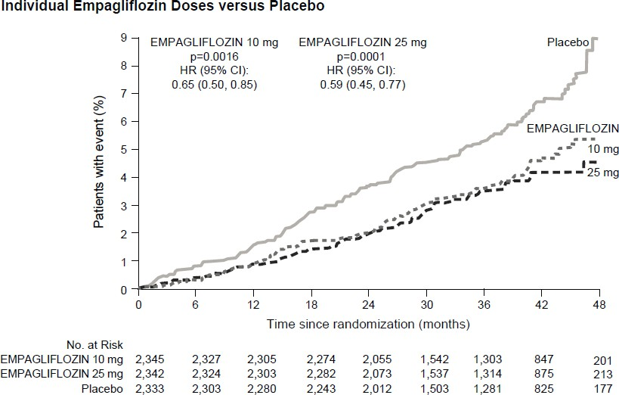
Heart failure requiring hospitalisation
In the EMPA-REG OUTCOME study, empagliflozin reduced the risk of heart failure requiring hospitalisation compared with placebo (empagliflozin 2.7%; placebo 4.1%; HR 0.65, 95% CI 0.50, 0.85).

Nephropathy
In the EMPA-REG OUTCOME study, for time to first nephropathy event, the HR was 0.61 (95% CI 0.53, 0.70) for empagliflozin (12.7%) vs placebo (18.8%).

In addition, empagliflozin showed a higher (HR 1.82, 95% CI 1.40, 2.37) occurrence of sustained normo- or micro-albuminuria (49.7%) in patients with baseline macro-albuminuria compared with placebo (28.8%).

Fasting plasma glucose
In four placebo-controlled studies, treatment with empagliflozin as monotherapy or add-on therapy to metformin, pioglitazone, or metformin plus a sulphonylurea resulted in mean changes from baseline in FPG of -20.5 mg/dL [-1.14 mmol/L] for empagliflozin 10 mg and -23.2 mg/dL [-1.29 mmol/L] for empagliflozin 25 mg compared to placebo (7.4 mg/dL [0.41 mmol/L]). This effect was observed after 24 weeks and maintained for 76 weeks.

2-hour post-prandial glucose
Treatment with empagliflozin as add-on to metformin or metformin and a sulphonylurea resulted in a clinically meaningful reduction of 2-hour post-prandial glucose (meal tolerance test) at 24 weeks (add-on to metformin: placebo +5.9 mg/dL, empagliflozin 10 mg: -46.0 mg/dL, empagliflozin
25 mg: -44.6 mg/dL, add-on to metformin and a sulphonylurea: placebo -2.3 mg/dL, empagliflozin 10 mg: -35.7 mg/dL, empagliflozin 25 mg: -36.6 mg/dL).

Patients with high baseline HbA1c > 10%
In a pre-specified pooled analysis of three phase 3 studies, treatment with open-label empagliflozin 25 mg in patients with severe hyperglycaemia (N = 184, mean baseline HbA1c 11.15%) resulted in a clinically meaningful reduction in HbA1c from baseline of 3.27% at week 24; no placebo or empagliflozin 10 mg arms were included in these studies.

Body weight
In a pre-specified pooled analysis of 4 placebo-controlled studies, treatment with empagliflozin resulted in body weight reduction (-0.24 kg for placebo, -2.04 kg for empagliflozin 10 mg
and -2.26 kg for empagliflozin 25 mg) at week 24 that was maintained up to week 52 (-0.16 kg for placebo, -1.96 kg for empagliflozin 10 mg and -2.25 kg for empagliflozin 25 mg).

Blood pressure
The efficacy and safety of empagliflozin was evaluated in a double-blind, placebo-controlled study of 12 weeks duration in patients with type 2 diabetes and high blood pressure on different antidiabetic and up to 2 antihypertensive therapies. Treatment with empagliflozin once daily resulted in statistically significant improvement in HbA1c, and 24 hour mean systolic and diastolic blood pressure as determined by ambulatory blood pressure monitoring (Table 11). Treatment with empagliflozin provided reductions in seated SBP and DBP.

Table 11: Efficacy results at 12 week in a placebo-controlled study of empagliflozin in patients with type 2 diabetes and uncontrolled blood pressureª
 | Placebo | Empagliflozin
 | Placebo | 10 mg | 25 mg
N | 271 | 276 | 276
HbA1c (%) at week 12¹
Baseline (mean) | 7.90 | 7.87 | 7.92
Change from baseline² | 0.03 | -0.59 | -0.62
Difference from placebo² (95% CI) |  | -0.62* (-0.72, -0.52) | -0.65* (-0.75, -0.55)
24 hour SBP at week 12³
Baseline (mean) | 131.72 | 131.34 | 131.18
Change from baseline⁴ | 0.48 | -2.95 | -3.68
Difference from placebo⁴ (95% CI) |  | -3.44* (-4.78, -2.09) | -4.16* (-5.50, -2.83)
24 hour DBP at week 12³
Baseline (mean) | 75.16 | 75.13 | 74.64
Change from baseline⁵ | 0.32 | -1.04 | -1.40
Difference from placebo⁵ (95% CI) |  | -1.36** (-2.15, -0.56) | -1.72* (-2.51, -0.93)
ª Full analysis set (FAS)
¹ LOCF, values after taking antidiabetic rescue therapy censored
² Mean adjusted for baseline HbA1c, baseline eGFR, geographical region and number of antihypertensive medicinal products
³ LOCF, values after taking antidiabetic rescue therapy or changing antihypertensive rescue therapy censored
⁴ Mean adjusted for baseline SBP, baseline HbA1c, baseline eGFR, geographical region and number of antihypertensive medicinal products
⁵ Mean adjusted for baseline DBP, baseline HbA1c, baseline eGFR, geographical region and number of antihypertensive medicinal products
- p-value < 0.0001
** p-value < 0.001

In a pre-specified pooled analysis of 4 placebo-controlled studies, treatment with empagliflozin resulted in a reduction in systolic blood pressure (empagliflozin 10 mg: -3.9 mmHg; empagliflozin 25 mg: -4.3 mmHg) compared with placebo (-0.5 mmHg) and in diastolic blood pressure (empagliflozin 10 mg: -1.8 mmHg; empagliflozin 25 mg: -2.0 mmHg) compared with placebo (-0.5 mmHg) at week 24 that were maintained up to week 52.

Heart failure

Empagliflozin in patients with heart failure and reduced ejection fraction
A randomised, double-blind, placebo-controlled study (EMPEROR-Reduced) was conducted in 3 730 patients with chronic heart failure (New York Heart Association [NYHA] II-IV) and reduced ejection fraction (LVEF ≤ 40%) to evaluate the efficacy and safety of empagliflozin 10 mg once daily as adjunct to standard of care heart failure therapy. The primary endpoint was the time to adjudicated first event of either cardiovascular (CV) death or hospitalisation for heart failure (HHF). Occurrence of adjudicated HHF (first and recurrent) and eGFR (CKD-EPI)cr slope of change from baseline were included in the confirmatory testing. Heart Failure therapy at baseline included ACE inhibitors/angiotensin receptor blockers/angiotensin receptor-neprilysin inhibitor (88.3%), beta blockers (94.7%), mineralocorticoid receptor antagonists (71.3%) and diuretics (95.0%).

A total of 1 863 patients were randomised to empagliflozin 10 mg (placebo: 1 867) and followed for a median of 15.7 months. The study population consisted of 76.1% men and 23.9% women with a mean age of 66.8 years (range: 25-94 years), 26.8% were 75 years of age or older. 70.5% of the study population were White, 18.0% Asian and 6.9% Black/African American. At randomisation, 75.1% of patients were NYHA class II, 24.4% were class III and 0.5% were class IV. The mean LVEF was 27.5%. At baseline, the mean eGFR was 62.0 mL/min/1.73 m² and the median urinary albumin to creatinine ratio (UACR) was 22 mg/g. About half of the patients (51.7%) had an eGFR of ≥ 60 mL/min/1.73 m², 24.1% of 45 to < 60 mL/min/1.73 m², 18.6% of 30 to < 45 mL/min/1.73 m² and 5.3% 20 to < 30 mL/min/1.73 m².

Empagliflozin was superior in reducing the risk of the primary composite endpoint of cardiovascular death or hospitalisation for heart failure compared with placebo. Additionally, empagliflozin significantly reduced the risk of occurrence of HHF (first and recurrent) and significantly reduced the rate of eGFR decline (Table 12; Figure 2).

Table 12: Treatment effect for the primary composite endpoint, its components and the two key secondary endpoints included in the pre-specified confirmatory testing
 | Placebo | Empagliflozin 10 mg
N | 1 867 | 1 863
Time to first event of CV death or HHF, N (%) | 462 (24.7) | 361 (19.4)
Hazard ratio vs. placebo (95% CI)* |  | 0.75 (0.65, 0.86)
p-value for superiority |  | < 0.0001
CV Death, N (%) | 202 (10.8) | 187 (10.0)
Hazard ratio vs. placebo (95% CI) |  | 0.92 (0.75, 1.12)
HHF (first occurrence), N (%) | 342 (18.3) | 246 (13.2)
Hazard ratio vs. placebo (95% CI) |  | 0.69 (0.59, 0.81)
HHF (first and recurrent), N of events | 553 | 388
Hazard ratio vs. placebo (95% CI)* |  | 0.70 (0.58, 0.85)
p-value |  | 0.0003
eGFR (CKD-EPI)cr slope**, Rate of decline (mL/min/1.73 m²/year) | -2.28 | -0.55
Treatment difference vs. placebo (95% CI) |  | 1.73 (1.10, 2.37)
p-value |  | < 0.0001
CV = cardiovascular, HHF = hospitalisation for heart failure, eGFR = Estimated glomerular filtration rate, CKD-EPI = Chronic kidney disease epidemiology collaboration equation
- CV death and HHF events were adjudicated by an independent clinical event committee and analysed based on the randomised set.
** eGFR slope was analysed based on the treated set. Intercept is -0.95 mL/min/1.73 m² for placebo and -3.02 mL/min/1.73 m² for empagliflozin. The intercept represents the acute effect on eGFR while the slope represents the long-term effect.

Figure 2 Time to first event of adjudicated CV death or HHF
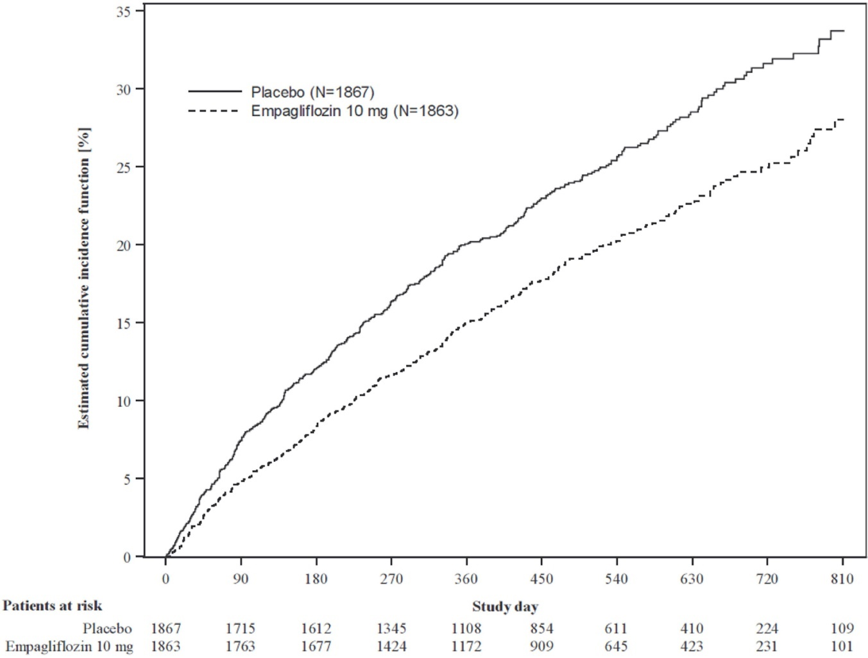

The results of the primary composite endpoint were generally consistent with a hazard ratio (HR) below 1 across the pre-specified subgroups, including patients with heart failure, with or without type 2 diabetes mellitus and with or without renal impairment (down to an eGFR of 20 mL/min/1.73 m²).

Empagliflozin in patients with heart failure and preserved ejection fraction
A randomised, double-blind, placebo-controlled study (EMPEROR-Preserved) was conducted in 5 988 patients with chronic heart failure (NYHA II-IV) and preserved ejection fraction (LVEF > 40%) to evaluate the efficacy and safety of empagliflozin 10 mg once daily as adjunct to standard of care therapy. The primary endpoint was the time to adjudicated first event of either cardiovascular (CV) death or hospitalisation for heart failure (HHF). Occurrence of adjudicated HHF (first and recurrent), and eGFR (CKD-EPI)cr slope of change from baseline were included in the confirmatory testing.
Baseline therapy included ACE inhibitors/angiotensin receptor blockers/angiotensin receptor- neprilysin inhibitor (80.7%), beta blockers (86.3%), mineralocorticoid receptor antagonists (37.5%) and diuretics (86.2%).

A total of 2 997 patients were randomised to empagliflozin 10 mg (placebo: 2 991) and followed for a median of 26.2 months. The study population consisted of 55.3% men and 44.7% women with a mean age of 71.9 years (range: 22-100 years), 43.0% were 75 years of age or older. 75.9% of the study population were White, 13.8% Asian and 4.3% Black/African American. At randomisation, 81.5% of patients were NYHA class II, 18.1% were class III and 0.3% were class IV. The EMPEROR- Preserved study population included patients with a LVEF < 50% (33.1%), with a LVEF 50 to < 60% (34.4%) and a LVEF ≥ 60% (32.5%). At baseline, the mean eGFR was 60.6 mL/min/1.73 m² and the median urinary albumin to creatinine ratio (UACR) was 21 mg/g. About half of the patients (50.1%) had an eGFR of ≥ 60 mL/min/1.73 m², 26.1% of 45 to < 60 mL/min/1.73 m², 18.6% of 30 to < 45 mL/min/1.73 m² and 4.9% 20 to < 30 mL/min/1.73 m².

Empagliflozin was superior in reducing the risk of the primary composite endpoint of cardiovascular death or hospitalisation for heart failure compared with placebo. Additionally, empagliflozin significantly reduced the risk of occurrence of HHF (first and recurrent) and significantly reduced the rate of eGFR decline (Table 13; Figure 3).

Table 13: Treatment effect for the primary composite endpoint, its components and the two key secondary endpoints included in the pre-specified confirmatory testing
 | Placebo | Empagliflozin 10 mg
N | 2 991 | 2 997
Time to first event of CV death or HHF, N (%) | 511 (17.1) | 415 (13.8)
Hazard ratio vs. placebo (95% CI)* |  | 0.79 (0.69, 0.90)
p-value for superiority |  | 0.0003
CV Death, N (%) | 244 (8.2) | 219 (7.3)
Hazard ratio vs. placebo (95% CI) |  | 0.91 (0.76, 1.09)
HHF (first occurrence), N (%) | 352 (11.8) | 259 (8.6)
Hazard ratio vs. placebo (95% CI) |  | 0.71 (0.60, 0.83)
HHF (first and recurrent), N of events | 541 | 407
Hazard ratio vs. placebo (95% CI)* |  | 0.73 (0.61, 0.88)
p-value |  | 0.0009
eGFR (CKD-EPI)cr slope**, Rate of decline (mL/min/1.73 m²/year) | -2.62 | -1.25
Treatment difference vs. placebo (95% CI) |  | 1.36 (1.06, 1.66)
p-value |  | < 0.0001
CV = cardiovascular, HHF = hospitalisation for heart failure, eGFR = Estimated glomerular filtration rate, CKD-EPI = Chronic kidney disease epidemiology collaboration equation
- CV death and HHF events were adjudicated by an independent clinical event committee and analysed based on the randomised set.
** eGFR slope was analysed based on the treated set. Intercept is -0.18 mL/min/1.73 m² for placebo and -3.02 mL/min/1.73 m² for empagliflozin. The intercept represents the acute effect on eGFR while the slope represents the long-term effect.

Figure 3 Time to first event of adjudicated CV death or HHF
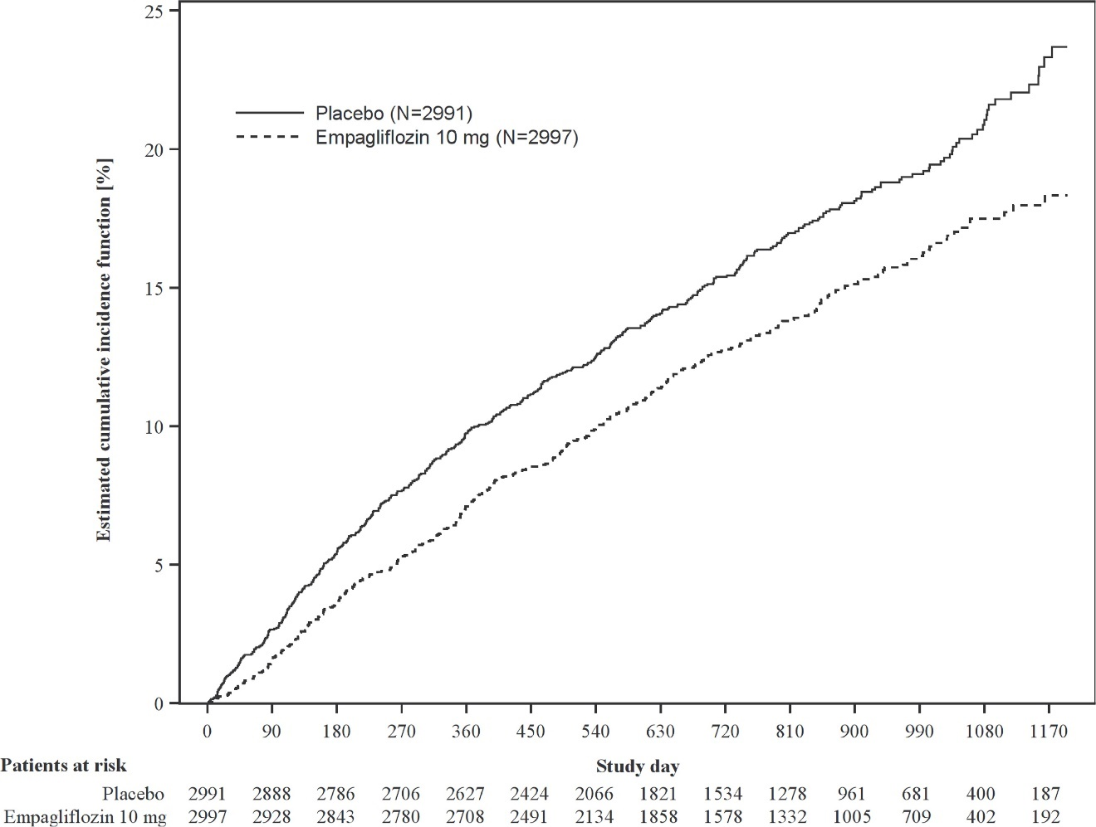

The results of the primary composite endpoint were consistent across each of the pre-specified subgroups categorized by e.g., LVEF, diabetes status or renal function (down to an eGFR of 20 mL/min/1.73 m²).

Chronic kidney disease

A randomised, double-blind, placebo-controlled study of empagliflozin 10 mg once daily (EMPA-KIDNEY) was conducted in 6 609 patients with chronic kidney disease (eGFR ≥ 20 - < 45 mL/min/1.73 m²; or eGFR ≥ 45 - < 90 mL/min/1.73 m² with urinary albumin to creatinine ratio (UACR) ≥ 200 mg/g) to assess cardio-renal outcomes as adjunct to standard of care therapy. The primary endpoint was the time to first occurrence of kidney disease progression (sustained ≥ 40% eGFR decline from randomisation, sustained eGFR < 10 mL/min/1.73 m², end-stage kidney disease, or renal death) or CV death. First occurrence of hospitalisation for heart failure or CV death, all-cause hospitalisation (first and recurrent), and all-cause mortality were included in the confirmatory testing. Baseline therapy included an appropriate use of a RAS-inhibitor (85.2% ACE inhibitor or angiotensin receptor blocker).

A total of 3 304 patients were randomised to empagliflozin 10 mg (placebo: 3 305) and followed for a median of 24.3 months. The study population consisted of 66.8% men and 33.2% women with a mean age of 63.3 years (range: 18-94 years), 23.0% were 75 years of age or older. 58.4% of the study population were White, 36.2% Asian and 4.0% Black/African American.

At baseline, the mean eGFR was 37.3 mL/min/1.73 m², 21.2% patients had an eGFR of
≥ 45 mL/min/1.73 m², 44.3% of 30 to < 45 mL/min/1.73 m² and 34.5% < 30 mL/min/1.73 m² including 254 patients with an eGFR < 20 mL/min /1.73 m². The median UACR was 329 mg/g, 20.1% patients had an UACR < 30 mg/g, 28.2% had an UACR 30 to ≤ 300 mg/g and 51.7% had an UACR > 300 mg/g; 41.1% of patients had an UACR < 200 mg/g. Primary causes of CKD were diabetic nephropathy/diabetic kidney disease (31%), glomerular disease (25%), hypertensive/renovascular disease (22%) and other/unknown (22%).

Empagliflozin was superior in reducing the risk of the primary composite endpoint of kidney disease progression or CV death compared with placebo (see Table 14). Additionally, empagliflozin significantly reduced the risk of all-cause hospitalisation (first and recurrent).

Table 14: Treatment effect for the primary composite and key secondary endpoints included in the pre-specified confirmatory testing and its components
 | Placebo | Empagliflozin 10 mg
N | 3 305 | 3 304
Time to first occurrence of kidney disease progression (sustained ≥ 40% eGFR decline from randomisation, sustained eGFR < 10 mL/min/1.73 m², end-stage kidney disease* (ESKD), or renal death)  or CV death, N (%) | 558 (16.9) | 432 (13.1)
Hazard ratio vs. placebo (99.83% CI) |  | 0.72 (0.59, 0.89)
p-value for superiority |  | < 0.0001
Sustained ≥ 40% eGFR decline from randomisation, N (%) | 474 (14.3) | 359 (10.9)
Hazard ratio vs. placebo (95% CI) |  | 0.70 (0.61, 0.81)
p-value |  | < 0.0001
ESKD* or sustained eGFR  < 10 mL/min/1.73 m², N (%) | 221 (6.7) | 157 (4.8)
Hazard ratio vs. placebo (95% CI) |  | 0.69 (0.56, 0.84)
p-value |  | 0.0003
Renal death, N (%)** | 4 (0.1) | 4 (0.1)
Hazard ratio vs. placebo (95% CI)
p-value
CV Death, N (%) | 69 (2.1) | 59 (1.8)
Hazard ratio vs. placebo (95% CI) |  | 0.84 (0.60, 1.19)
p-value |  | 0.3366
ESKD or CV Death, N (%)# | 217 (6.6) | 163 (4.9)
Hazard ratio vs. placebo (95% CI) |  | 0.73 (0.59, 0.89)
p-value |  | 0.0023
Occurrence of all-cause hospitalisation (first and recurrent), N of events | 1 895 | 1 611
Hazard ratio vs. placebo (99.03% CI) |  | 0.86 (0.75, 0.98)
p-value |  | 0.0025
CV = cardiovascular, eGFR = Estimated glomerular filtration rate
- End-stage kidney disease (ESKD) is defined as the initiation of maintenance dialysis or receipt of a kidney transplant.
** There were too few events of renal death to compute a reliable hazard ratio.
# Predefined as one of the two stopping criteria in the pre-planned interim analysis.

Figure 4 Time to first event of kidney disease progression or adjudicated CV death, estimated cumulative incidence function
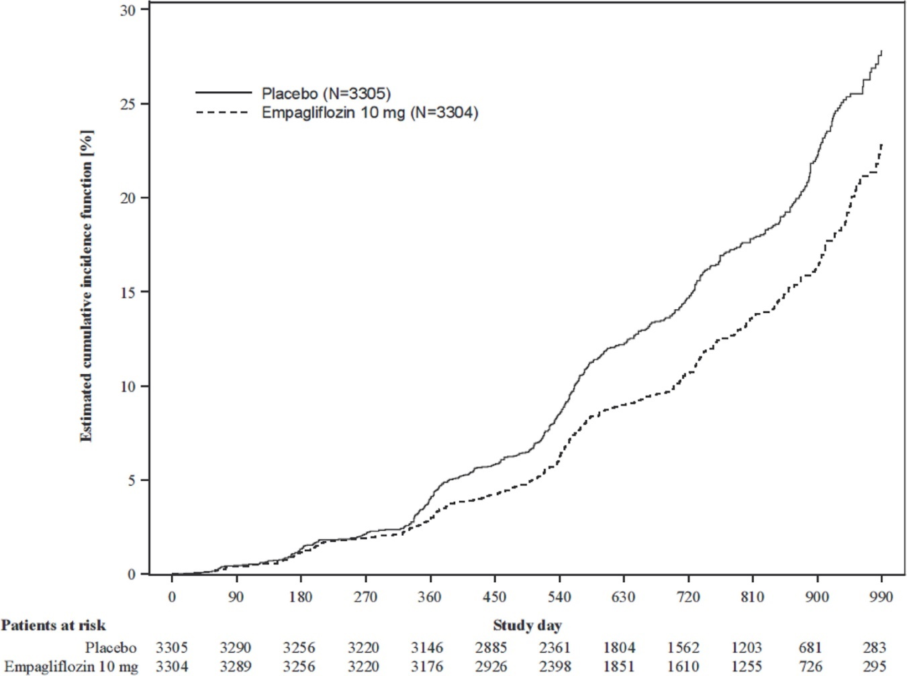

The results of the primary composite endpoint were generally consistent across the pre-specified subgroups, including eGFR categories, underlying cause of renal disease, diabetes status, or background use of RAS inhibitors. Treatment benefits were more clearly evident in patients with higher levels of albuminuria.

During treatment, eGFR decline over time was slower in the empagliflozin group compared to the placebo group (Figure 5). Empagliflozin slowed the annual rate of eGFR decline compared to placebo by 1.37 mL/min/1.73 m²/year (95% CI 1.16, 1.59), based on a pre-specified analysis of all eGFR measurements taken from the 2-month visit to the final follow-up visit. Patients treated with empagliflozin experienced an initial drop in eGFR which returned towards baseline after treatment discontinuation as demonstrated in several of the empagliflozin studies, supporting that haemodynamic changes play a role in the acute effects of empagliflozin on eGFR.

Figure 5 Change in eGFR over time*
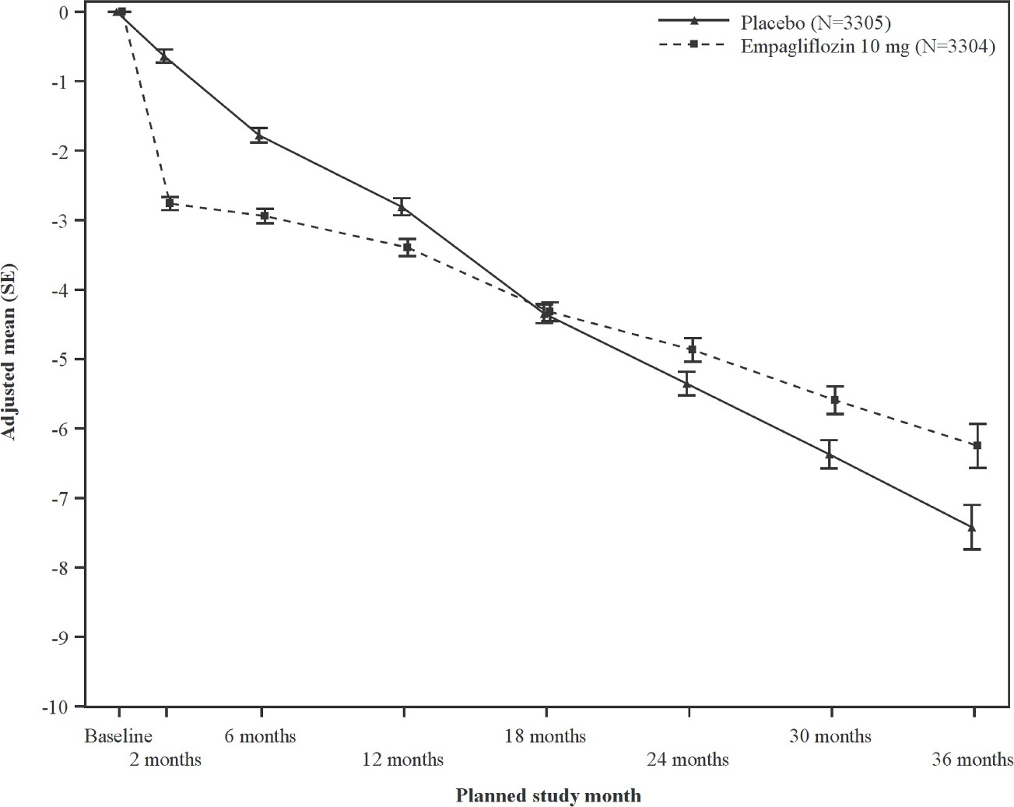
* eGFR (CKD-EPI) (mL/min/1.73 m²) MMRM results over time - randomised set.

Paediatric population

Type 2 diabetes mellitus
The clinical efficacy and safety of empagliflozin (10 mg with a possible dose-increase to 25 mg) and linagliptin (5 mg) once daily has been studied in children and adolescents from 10 to 17 years of age with type 2 diabetes mellitus in a placebo-controlled study (DINAMO) over 26 weeks, with a safety extension period up to 52 weeks. Background therapies as adjunct to diet and exercise included metformin (51%), a combination of metformin and insulin (40.1%), insulin (3.2%), or none (5.7%).

The adjusted mean change in HbA1c at week 26 between empagliflozin (N = 52) and placebo (N = 53) of -0.84% was clinically meaningful and statistically significant (95% CI -1.50, -0.19; p = 0.0116). In addition, treatment with empagliflozin versus placebo resulted in a clinically meaningful adjusted mean change in FPG of -35.2 mg/dL (95% CI -58.6, -11.7) [-1.95 mmol/L (-3.25, -0.65)].

Heart failure and chronic kidney disease
The European Medicines Agency has waived the obligation to submit the results of studies with empagliflozin in all subsets of the paediatric population in heart failure and in the treatment of chronic kidney disease (see section 4.2 for information on paediatric use).

5.2 Pharmacokinetic properties

Absorption
The pharmacokinetics of empagliflozin have been extensively characterised in healthy volunteers and patients with type 2 diabetes. After oral administration, empagliflozin was rapidly absorbed with peak plasma concentrations occurring at a median tmax of 1.5 hours post-dose. Thereafter, plasma concentrations declined in a biphasic manner with a rapid distribution phase and a relatively slow terminal phase. The steady state mean plasma AUC and Cmax were 1 870 nmol.h/L and 259 nmol/L with empagliflozin 10 mg and 4 740 nmol.h/L and 687 nmol/L with empagliflozin 25 mg once daily.
Systemic exposure of empagliflozin increased in a dose-proportional manner. The single-dose and steady-state pharmacokinetic parameters of empagliflozin were similar suggesting linear pharmacokinetics with respect to time. There were no clinically relevant differences in empagliflozin pharmacokinetics between healthy volunteers and patients with type 2 diabetes.

Administration of empagliflozin 25 mg after intake of a high-fat and high calorie meal resulted in slightly lower exposure; AUC decreased by approximately 16% and Cmax by approximately 37% compared to fasted condition. The observed effect of food on empagliflozin pharmacokinetics was not considered clinically relevant and empagliflozin may be administered with or without food.

Distribution
The apparent steady-state volume of distribution was estimated to be 73.8 L based on the population pharmacokinetic analysis. Following administration of an oral [¹⁴C]-empagliflozin solution to healthy volunteers, the red blood cell partitioning was approximately 37% and plasma protein binding was 86%.

Biotransformation
No major metabolites of empagliflozin were detected in human plasma and the most abundant metabolites were three glucuronide conjugates (2-, 3-, and 6-O glucuronide). Systemic exposure of each metabolite was less than 10% of total drug-related material. In vitro studies suggested that the primary route of metabolism of empagliflozin in humans is glucuronidation by the uridine 5'-diphospho-glucuronosyltransferases UGT2B7, UGT1A3, UGT1A8, and UGT1A9.

Elimination
Based on the population pharmacokinetic analysis, the apparent terminal elimination half-life of empagliflozin was estimated to be 12.4 hours and apparent oral clearance was 10.6 L/hour. The inter-subject and residual variabilities for empagliflozin oral clearance were 39.1% and 35.8%, respectively. With once-daily dosing, steady-state plasma concentrations of empagliflozin were reached by the fifth dose. Consistent with the half-life, up to 22% accumulation, with respect to plasma AUC, was observed at steady-state. Following administration of an oral [¹⁴C]-empagliflozin solution to healthy volunteers, approximately 96% of the drug-related radioactivity was eliminated in faeces (41%) or urine (54%). The majority of drug-related radioactivity recovered in faeces was unchanged parent drug and approximately half of drug related radioactivity excreted in urine was unchanged parent drug.

Special populations
Renal impairment
In patients with mild, moderate or severe renal impairment (eGFR < 30 - < 90 mL/min/1.73 m²) and patients with kidney failure/end stage kidney disease (ESKD), AUC of empagliflozin increased by approximately 18%, 20%, 66%, and 48%, respectively compared to subjects with normal renal function. Peak plasma levels of empagliflozin were similar in subjects with moderate renal impairment and kidney failure/ESKD compared to patients with normal renal function. Peak plasma levels of empagliflozin were roughly 20% higher in subjects with mild and severe renal impairment as compared to subjects with normal renal function. The population pharmacokinetic analysis showed that the apparent oral clearance of empagliflozin decreased with a decrease in eGFR leading to an increase in drug exposure.

Hepatic impairment
In subjects with mild, moderate, and severe hepatic impairment according to the Child-Pugh classification, AUC of empagliflozin increased approximately by 23%, 47%, and 75% and Cmax by approximately 4%, 23%, and 48%, respectively, compared to subjects with normal hepatic function.

Body Mass Index
Body mass index had no clinically relevant effect on the pharmacokinetics of empagliflozin based on the population pharmacokinetic analysis. In this analysis, AUC was estimated to be 5.82%, 10.4%, and 17.3% lower in subjects with BMI of 30, 35, and 45 kg/m², respectively, compared to subjects with a body mass index of 25 kg/m².

Gender
Gender had no clinically relevant effect on the pharmacokinetics of empagliflozin based on the population pharmacokinetic analysis.

Race
In the population pharmacokinetic analysis, AUC was estimated to be 13.5% higher in Asians with a body mass index of 25 kg/m² compared to non-Asians with a body mass index of 25 kg/m².

Elderly
Age did not have a clinically meaningful impact on the pharmacokinetics of empagliflozin based on the population pharmacokinetic analysis.

Paediatric population
A paediatric phase 1 study examined the pharmacokinetics and pharmacodynamics of empagliflozin (5 mg, 10 mg and 25 mg) in children and adolescents ≥ 10 to < 18 years of age with type 2 diabetes mellitus. The observed pharmacokinetic and pharmacodynamic responses were consistent with those found in adult subjects.

A paediatric phase 3 study examined the pharmacokinetics and pharmacodynamics (HbA1c change from baseline) of empagliflozin 10 mg with a possible dose-increase to 25 mg in children and adolescents 10 to 17 years of age with type 2 diabetes mellitus. The observed exposure-response relationship was overall comparable in adults and children and adolescents. Oral administration of empagliflozin resulted in an exposure within the range observed in adult patients.
The observed geometric mean trough concentrations and geometric mean concentrations at 1.5 hours post-administration at steady state were 26.6 nmol/L and 308 nmol/L with empagliflozin 10 mg once daily and 67.0 nmol/L and 525 nmol/L with empagliflozin 25 mg once daily.

5.3 Preclinical safety data
Non-clinical data reveal no special hazard for humans based on conventional studies of safety pharmacology, genotoxicity, fertility and early embryonic development.

In long term toxicity studies in rodents and dogs, signs of toxicity were observed at exposures greater than or equal to 10-times the clinical dose of empagliflozin. Most toxicity was consistent with secondary pharmacology related to urinary glucose loss and electrolyte imbalances including decreased body weight and body fat, increased food consumption, diarrhoea, dehydration, decreased serum glucose and increases in other serum parameters reflective of increased protein metabolism and gluconeogenesis, urinary changes such as polyuria and glucosuria, and microscopic changes including mineralisation in kidney and some soft and vascular tissues. Microscopic evidence of the effects of exaggerated pharmacology on the kidney observed in some species included tubular dilatation, and tubular and pelvic mineralisation at approximately 4-times the clinical AUC exposure of empagliflozin associated with the 25 mg dose.
Empagliflozin is not genotoxic.

In a 2 year carcinogenicity study, empagliflozin did not increase the incidence of tumours in female rats up to the highest dose of 700 mg/kg/day, which corresponds to approximately 72-times the maximal clinical AUC exposure to empagliflozin. In male rats, treatment-related benign vascular proliferative lesions (haemangiomas) of the mesenteric lymph node were observed at the highest dose, but not at 300 mg/kg/day, which corresponds to approximately 26-times the maximal clinical exposure to empagliflozin. Interstitial cell tumours in the testes were observed with a higher incidence in rats at 300 mg/kg/day and above, but not at 100 mg/kg/day which corresponds to approximately 18-times the maximal clinical exposure to empagliflozin. Both tumours are common in rats and are unlikely to be relevant to humans.

Empagliflozin did not increase the incidence of tumours in female mice at doses up to
1 000 mg/kg/day, which corresponds to approximately 62-times the maximal clinical exposure to empagliflozin. Empagliflozin induced renal tumours in male mice at 1 000 mg/kg/day, but not at 300 mg/kg/day, which corresponds to approximately 11-times the maximal clinical exposure to empagliflozin. The mode of action for these tumours is dependent on the natural predisposition of the male mouse to renal pathology and a metabolic pathway not reflective of humans. The male mouse renal tumours are considered not relevant to humans.

At exposures sufficiently in excess of exposure in humans after therapeutic doses, empagliflozin had no adverse effects on fertility or early embryonic development. Empagliflozin administered during the period of organogenesis was not teratogenic. Only at maternally toxic doses, empagliflozin also caused bent limb bones in the rat and increased embryofetal loss in the rabbit.

In pre- and postnatal toxicity studies in rats, reduced weight gain of offspring was observed at maternal exposures approximately 4-times the maximal clinical exposure to empagliflozin. No such effect was seen at systemic exposure equal to the maximal clinical exposure to empagliflozin. The relevance of this finding to humans is unclear.

In a juvenile toxicity study in the rat, when empagliflozin was administered from postnatal day 21 until postnatal day 90, non-adverse, minimal to mild renal tubular and pelvic dilation in juvenile rats was seen only at 100 mg/kg/day, which approximates 11-times the maximum clinical dose of 25 mg. These findings were absent after a 13 weeks drug-free recovery period.

6. PHARMACEUTICAL PARTICULARS

6.1 List of excipients

Tablet core
Lactose monohydrate
Microcrystalline cellulose
Hydroxypropylcellulose
Croscarmellose sodium

Colloidal anhydrous silica
Magnesium stearate

Film coating

10 mg: Opadry Yellow 03B220113

Hypromellose
Titanium dioxide (E171) Talc
Macrogol
Iron oxide yellow (E172)

25 mg: Opadry Yellow 03B220114

Hypromellose
Titanium dioxide (E171) Talc
Macrogol
Iron oxide yellow (E172)

6.2 Incompatibilities
Not applicable.

6.3 Shelf life
30 months

6.4 Special precautions for storage
This medicinal product does not require any special storage conditions.

6.5 Nature and contents of container
PVC/aluminium blisters of 7, 10, 14, 28, 30, 56, 60 film-coated tablets.

Not all pack sizes may be marketed.

6.6 Special precautions for disposal and other handling
Any unused medicinal product or waste material should be disposed of in accordance with local requirements.

7. MARKETING AUTHORISATION HOLDER
Innovis Pharma S.A.
Marathonos Avenue 144
153 51 Pallini Attica
Greece

Representative
Innovis Pharma SA
44, Kifisias Ave.
15125 Marousi
Greece

8. MARKETING AUTHORISATION NUMBER(S)
10 mg: 74086
25 mg: 74089

9. DATE OF FIRST AUTHORISATION
21 May 2026

10. DATE OF REVISION OF THE TEXT
-

