

**4. April 2025**

**SUMMARY OF PRODUCT CHARACTERISTICS**

**for**

**Enzalutamide "Hexal", film-coated tablets**

**0. D.SP.NO.**

33512

**1. NAME OF THE MEDICINAL PRODUCT**

Enzalutamide "Hexal"

**2. QUALITATIVE AND QUANTITATIVE COMPOSITION**

Enzalutamide "Hexal" 40 mg film-coated tablets

Each film-coated tablet contains 40 mg of enzalutamide.

Enzalutamide "Hexal" 80 mg film-coated tablets

Each film-coated tablet contains 80 mg of enzalutamide.

For the full list of excipients, see section 6.1.

**3. PHARMACEUTICAL FORM**

Film-coated tablets (tablet)

Enzalutamide "Hexal" 40 mg film-coated tablets

Yellow, round, film-coated tablets, debossed with “40” on one side, with diameter 10 mm.

Enzalutamide "Hexal" 80 mg film-coated tablets

Yellow, oval, film-coated tablets, debossed with “80” on one side, with dimensions 17 mm×9 mm.

**4. CLINICAL PARTICULARS**

**4.1 Therapeutic indications**

Enzalutamide "Hexal" is indicated:

* as monotherapy or in combination with androgen deprivation therapy for the treatment of adult men with high-risk biochemical recurrent (BCR) non-metastatic hormone-sensitive prostate cancer (nmHSPC) who are unsuitable for salvage-radiotherapy (see section 5.1).
* in combination with androgen deprivation therapy for the treatment of adult men with metastatic hormone-sensitive prostate cancer (mHSPC) (see section 5.1).
* for the treatment of adult men with high-risk non-metastatic castration-resistant prostate cancer (CRPC) (see section 5.1).
* for the treatment of adult men with metastatic CRPC who are asymptomatic or mildly symptomatic after failure of androgen deprivation therapy in whom chemotherapy is not yet clinically indicated (see section 5.1).
* for the treatment of adult men with metastatic CRPC whose disease has progressed on or after docetaxel therapy.

**4.2 Posology and method of administration**

Treatment with enzalutamide should be initiated and supervised by specialist physicians experienced in the medical treatment of prostate cancer.

Posology

The recommended dose is 160 mg enzalutamide (four 40 mg film-coated tablets or two 80 mg film-coated tablets) as a single oral daily dose.

Medical castration with a luteinising hormone-releasing hormone (LHRH) analogue should be continued during treatment of patients with CRPC or mHSPC who are not surgically castrated.

Patients with high-risk BCR nmHSPC may be treated with Enzalutamide "Hexal" with or without a LHRH analogue. For patients who receive Enzalutamide "Hexal" with or without a LHRH analogue, treatment can be suspended if PSA is undetectable (< 0.2 ng/mL) after 36 weeks of therapy. Treatment should be reinitiated when PSA has increased to ≥ 2.0 ng/mL for patients who had prior radical prostatectomy or ≥ 5.0 ng/mL for patients who had prior primary radiation therapy. If PSA is detectable (≥ 0.2 ng/mL) after 36 weeks of therapy, treatment should continue (see section 5.1).

If a patient misses taking Enzalutamide "Hexal" at the usual time, the prescribed dose should be taken as close as possible to the usual time. If a patient misses a dose for a whole day, treatment should be resumed the following day with the usual daily dose. If a patient experiences a ≥ Grade 3 toxicity or an intolerable adverse reaction, dosing should be withheld for one week or until symptoms improve to ≤ Grade 2, then resumed at the same or a reduced dose (120 mg or 80 mg) if warranted.

*Concomitant use with strong CYP2C8 inhibitors*

The concomitant use of strong CYP2C8 inhibitors should be avoided if possible. If patients must be co-administered a strong CYP2C8 inhibitor, the dose of enzalutamide should be reduced to 80 mg once daily. If co-administration of the strong CYP2C8 inhibitor is discontinued, the enzalutamide dose should be returned to the dose used prior to initiation of the strong CYP2C8 inhibitor (see section 4.5).

*Elderly*

No dose adjustment is necessary for elderly patients (see sections 5.1 and 5.2).

*Hepatic impairment*

No dose adjustment is necessary for patients with mild, moderate or severe hepatic impairment (Child- Pugh Class A, B or C, respectively). An increased half-life of enzalutamide has however been observed in patients with severe hepatic impairment (see sections 4.4 and 5.2).

*Renal impairment*

No dose adjustment is necessary for patients with mild or moderate renal impairment (see section 5.2). Caution is advised in patients with severe renal impairment or end-stage renal disease (see section 4.4).

*Paediatric population*

There is no relevant use of enzalutamide in the paediatric population in the indication of treatment of adult men with CRPC, mHSPC, or high-risk BCR nmHSPC.

Method of administration

Enzalutamide "Hexal" is for oral use. The film-coated tablets should not be cut, crushed or chewed but should be swallowed whole with water, and can be taken with or without food.

**4.3 Contraindications**

Hypersensitivity to the active substance or to any of the excipients listed in section 6.1. Women who are or may become pregnant (see sections 4.6 and 6.6).

**4.4 Special warnings and precautions for use**

Risk of seizure

Use of enzalutamide has been associated with seizure (see section 4.8). The decision to continue treatment in patients who develop seizures should be taken case by case.

Posterior reversible encephalopathy syndrome

There have been rare reports of posterior reversible encephalopathy syndrome (PRES) in patients receiving enzalutamide (see section 4.8). PRES is a rare, reversible, neurological disorder which can present with rapidly evolving symptoms including seizure, headache, confusion, blindness, and other visual and neurological disturbances, with or without associated hypertension. A diagnosis of PRES requires confirmation by brain imaging, preferably magnetic resonance imaging (MRI). Discontinuation of enzalutamide in patients who develop PRES is recommended.

Second Primary Malignancies

Cases of second primary malignancies have been reported in patients treated with enzalutamide in clinical studies. In phase 3 clinical studies, the most frequently reported events in enzalutamide treated patients, and greater than placebo, were bladder cancer (0.3%), adenocarcinoma of the colon (0.2%), transitional cell carcinoma (0.2%) and malignant melanoma (0.2%).

Patients should be advised to promptly seek the attention of their physician if they notice signs of gastrointestinal bleeding, macroscopic haematuria, or other symptoms such as dysuria or urinary urgency develop during treatment with enzalutamide.

Concomitant use with other medicinal products

Enzalutamide is a potent enzyme inducer and may lead to loss of efficacy of many commonly used medicinal products (see examples in section 4.5). A review of concomitant medicinal products should therefore be conducted when initiating enzalutamide treatment. Concomitant use of enzalutamide with medicinal products that are sensitive substrates of many metabolising enzymes or transporters (see section 4.5) should generally be avoided if their therapeutic effect is of large importance to the patient, and if dose adjustments cannot easily be performed based on monitoring of efficacy or plasma concentrations.

Co-administration with warfarin and coumarin-like anticoagulants should be avoided. If Enzalutamide "Hexal" is co-administered with an anticoagulant metabolised by CYP2C9 (such as warfarin or acenocoumarol), additional International Normalised Ratio (INR) monitoring should be conducted (see section 4.5).

Renal impairment

Caution is required in patients with severe renal impairment as enzalutamide has not been studied in this patient population.

Severe hepatic impairment

An increased half-life of enzalutamide has been observed in patients with severe hepatic impairment, possibly related to increased tissue distribution. The clinical relevance of this observation remains unknown. A prolonged time to reach steady state concentrations is however anticipated, and the time to maximum pharmacological effect as well as time for onset and decline of enzyme induction (see section 4.5) may be increased.

Recent cardiovascular disease

The phase 3 studies excluded patients with recent myocardial infarction (in the past 6 months) or unstable angina (in the past 3 months), New York Heart Association Class (NYHA) III or IV heart failure except if Left Ventricular Ejection Fraction (LVEF) ≥ 45%, bradycardia or uncontrolled hypertension. This should be taken into account if enzalutamide is prescribed in these patients.

Androgen deprivation therapy may prolong the QT interval

In patients with a history of or risk factors for QT prolongation and in patients receiving concomitant medicinal products that might prolong the QT interval (see section 4.5) physicians should assess the benefit risk ratio including the potential for Torsade de pointes prior to initiating enzalutamide.

Use with chemotherapy

The safety and efficacy of concomitant use of enzalutamide with cytotoxic chemotherapy has not been established. Co-administration of enzalutamide has no clinically relevant effect on the pharmacokinetics of intravenous docetaxel (see section 4.5); however, an increase in the occurrence of docetaxel-induced neutropenia cannot be excluded.

Severe skin reactions

Severe cutaneous adverse reactions (SCARs), including Stevens-Johnson syndrome, which can be

life threatening or fatal, have been reported with enzalutamide treatment.

At the time of prescription, patients should be advised of the signs and symptoms and monitored

closely for skin reactions.

If signs and symptoms suggestive of this reaction appear, enzalutamide should be withdrawn

immediately and an alternative treatment considered (as appropriate).

Hypersensitivity reactions

Hypersensitivity reactions manifested by symptoms including, but not limited to, rash, or face, tongue, lip, or pharyngeal oedema, have been observed with enzalutamide (see section 4.8).

Enzalutamide "Hexal" as monotherapy in patients with high-risk BCR nmHSPC

Results of the EMBARK study suggest that enzalutamide as monotherapy and in combination with androgen deprivation therapy are not equivalent treatment options in patients with high-risk BCR nmHSPC (see sections 4.8 and 5.1). Enzalutamide "Hexal" in combination with androgen deprivation therapy is considered the preferred treatment option except for cases in which the addition of androgen deprivation therapy may result in unacceptable toxicity or risk.

Information about excipients

This medicine contains less than 1 mmol sodium (23 mg) per film-coated tablet, that is to say essentially ‘sodium-free’.

**4.5 Interaction with other medicinal products and other forms of interaction**

Potential for other medicinal products to affect enzalutamide exposures

*CYP2C8 inhibitors*

CYP2C8 plays an important role in the elimination of enzalutamide and in the formation of its active metabolite. Following oral administration of the strong CYP2C8 inhibitor gemfibrozil (600 mg twice daily) to healthy male subjects, the AUC of enzalutamide increased by 326% while Cmax of enzalutamide decreased by 18%. For the sum of unbound enzalutamide plus the unbound active metabolite, the AUC increased by 77% while Cmax decreased by 19%. Strong inhibitors (e.g. gemfibrozil) of CYP2C8 are to be avoided or used with caution during enzalutamide treatment. If patients must be co-administered a strong CYP2C8 inhibitor, the dose of enzalutamide should be reduced to 80 mg once daily (see section 4.2).

*CYP3A4 inhibitors*

CYP3A4 plays a minor role in the metabolism of enzalutamide. Following oral administration of the strong CYP3A4 inhibitor itraconazole (200 mg once daily) to healthy male subjects, the AUC of enzalutamide increased by 41% while Cmax was unchanged. For the sum of unbound enzalutamide plus the unbound active metabolite, the AUC increased by 27% while Cmax was again unchanged. No dose adjustment is necessary when enzalutamide is co-administered with inhibitors of CYP3A4.

*CYP2C8 and CYP3A4 inducers*

Following oral administration of the moderate CYP2C8 and strong CYP3A4 inducer rifampin (600 mg once daily) to healthy male subjects, the AUC of enzalutamide plus the active metabolite decreased by 37% while Cmax remained unchanged. No dose adjustment is necessary when enzalutamide is co- administered with inducers of CYP2C8 or CYP3A4.

Potential for enzalutamide to affect exposures to other medicinal products

*Enzyme induction*

Enzalutamide is a potent enzyme inducer and increases the synthesis of many enzymes and transporters; therefore, interaction with many common medicinal products that are substrates of enzymes or transporters is expected. The reduction in plasma concentrations can be substantial, and lead to lost or reduced clinical effect. There is also a risk of increased formation of active metabolites. Enzymes that may be induced include CYP3A in the liver and gut, CYP2B6, CYP2C9, CYP2C19, and uridine 5'-diphospho-glucuronosyltransferase (UGTs - glucuronide conjugating enzymes). Some transporters may also be induced, e.g. multidrug resistance-associated protein 2 (MRP2) and the organic anion transporting polypeptide 1B1 (OATP1B1).

*In vivo* studies have shown that enzalutamide is a strong inducer of CYP3A4 and a moderate inducer of CYP2C9 and CYP2C19. Co-administration of enzalutamide (160 mg once daily) with single oral doses of sensitive CYP substrates in prostate cancer patients resulted in an 86% decrease in the AUC of midazolam (CYP3A4 substrate), a 56% decrease in the AUC of S-warfarin (CYP2C9 substrate), and a 70% decrease in the AUC of omeprazole (CYP2C19 substrate). UGT1A1 may have been induced as well. In a clinical study in patients with metastatic CRPC, enzalutamide (160 mg once daily) had no clinically relevant effect on the pharmacokinetics of intravenously administered docetaxel (75 mg/m2 by infusion every 3 weeks). The AUC of docetaxel decreased by 12% [geometric mean ratio (GMR) = 0.882 (90% CI: 0.767, 1.02)] while Cmax decreased by 4% [GMR = 0.963 (90% CI: 0.834, 1.11)].

Interactions with certain medicinal products that are eliminated through metabolism or active transport are expected. If their therapeutic effect is of large importance to the patient, and dose adjustments are not easily performed based on monitoring of efficacy or plasma concentrations, these medicinal products are to be avoided or used with caution. The risk for liver injury after paracetamol administration is suspected to be higher in patients concomitantly treated with enzyme inducers.

Groups of medicinal products that can be affected include, but are not limited to:

* Analgesics (e.g. fentanyl, tramadol)
* Antibiotics (e.g. clarithromycin, doxycycline)
* Anticancer agents (e.g. cabazitaxel)
* Antiepileptics (e.g. carbamazepine, clonazepam, phenytoin, primidone, valproic acid)
* Antipsychotics (e.g. haloperidol)
* Antithrombotics (e.g. acenocoumarol, warfarin, clopidogrel)
* Betablockers (e.g. bisoprolol, propranolol)
* Calcium channel blockers (e.g. diltiazem, felodipine, nicardipine, nifedipine, verapamil)
* Cardiac glycosides (e.g. digoxin)
* Corticosteroids (e.g. dexamethasone, prednisolone)
* HIV antivirals (e.g. indinavir, ritonavir)
* Hypnotics (e.g. diazepam, midazolam, zolpidem)
* Immunosuppressant (e.g. tacrolimus)
* Proton pump inhibitor (e.g. omeprazole)
* Statins metabolised by CYP3A4 (e.g. atorvastatin, simvastatin)
* Thyroid agents (e.g. levothyroxine)

The full induction potential of enzalutamide may not occur until approximately 1 month after the start of treatment, when steady-state plasma concentrations of enzalutamide are reached, although some induction effects may be apparent earlier. Patients taking medicinal products that are substrates of CYP2B6, CYP3A4, CYP2C9, CYP2C19 or UGT1A1 should be evaluated for possible loss of pharmacological effects (or increase in effects in cases where active metabolites are formed) during the first month of enzalutamide treatment and dose adjustment should be considered as appropriate. In consideration of the long half-life of enzalutamide (5.8 days, see section 5.2), effects on enzymes may persist for one month or longer after stopping enzalutamide. A gradual dose reduction of the concomitant medicinal product may be necessary when stopping enzalutamide treatment.

*CYP1A2 and CYP2C8 substrates*

Enzalutamide (160 mg once daily) did not cause a clinically relevant change in the AUC or Cmax of caffeine (CYP1A2 substrate) or pioglitazone (CYP2C8 substrate). The AUC of pioglitazone increased by 20% while Cmax decreased by 18%. The AUC and Cmax of caffeine decreased by 11% and 4%, respectively. No dose adjustment is indicated when a CYP1A2 or CYP2C8 substrate is co-administered with enzalutamide.

*P-gp substrates*

*In vitro* data indicate that enzalutamide may be an inhibitor of the efflux transporter P-gp. A mild inhibitory effect of enzalutamide, at steady-state, on P-gp was observed in a study in patients with prostate cancer that received a single oral dose of the probe P-gp substrate digoxin before and concomitantly with enzalutamide (concomitant administration followed at least 55 days of once daily dosing of 160 mg enzalutamide). The AUC and Cmax of digoxin increased by 33% and 17%, respectively. Medicinal products with a narrow therapeutic range that are substrates for P-gp (e.g. colchicine, dabigatran etexilate, digoxin) should be used with caution when administered concomitantly with enzalutamide and may require dose adjustment to maintain optimal plasma concentrations.

*BCRP substrates*

At steady-state, enzalutamide did not cause a clinically meaningful change in exposure to the probe breast cancer resistance protein (BCRP) substrate rosuvastatin in patients with prostate cancer that received a single oral dose of rosuvastatin before and concomitantly with enzalutamide (concomitant administration followed at least 55 days of once daily dosing of 160 mg enzalutamide). The AUC of rosuvastatin decreased by 14% while Cmax increased by 6%. No dose adjustment is necessary when a BCRP substrate is co-administered with enzalutamide.

*MRP2, OAT3 and OCT1 substrates*

Based on *in vitro* data, inhibition of MRP2 (in the intestine), as well as organic anion transporter 3 (OAT3) and organic cation transporter 1 (OCT1) (systemically) cannot be excluded. Theoretically, induction of these transporters is also possible, and the net effect is presently unknown.

*Medicinal products which prolong the QT interval*

Since androgen deprivation treatment may prolong the QT interval, the concomitant use of enzalutamide with medicinal products known to prolong the QT interval or medicinal products able to induce Torsade de pointes such as class IA (e.g. quinidine, disopyramide) or class III (e.g. amiodarone, sotalol, dofetilide, ibutilide) antiarrhythmic medicinal products, methadone, moxifloxacin, antipsychotics, etc. should be carefully evaluated (see section 4.4).

Effect of food on enzalutamide exposures

Food has no clinically significant effect on the extent of exposure to enzalutamide. In clinical trials, enzalutamide was administered without regard to food.

**4.6 Fertility, pregnancy and lactation**

Women of childbearing potential

There are no human data on the use of enzalutamide in pregnancy and this medicinal product is not for use in women of childbearing potential. This medicine may cause harm to the unborn child or potential loss of pregnancy if taken by women who are pregnant (see sections 4.3, 5.3, and 6.6).

Contraception in males and females

It is not known whether enzalutamide or its metabolites are present in semen. A condom is required during and for 3 months after treatment with enzalutamide if the patient is engaged in sexual activity with a pregnant woman. If the patient engages in sexual intercourse with a woman of childbearing potential, a condom and another form of birth control must be used during and for 3 months after treatment. Studies in animals have shown reproductive toxicity (see section 5.3).

Pregnancy

Enzalutamide is not for use in women. Enzalutamide is contraindicated in women who are or may become pregnant (see sections 4.3, 5.3, and 6.6).

Breastfeeding

Enzalutamide is not for use in women. It is not known if enzalutamide is present in human milk. Enzalutamide and/or its metabolites are secreted in rat milk (see section 5.3).

Fertility

Animal studies showed that enzalutamide affected the reproductive system in male rats and dogs (see section 5.3).

**4.7 Effects on ability to drive and use machines**

No traffic warning.

Enzalutamide "Hexal" may have moderate influence on the ability to drive and use machines as psychiatric and neurologic events including seizure have been reported (see section 4.8). Patients should be advised of the potential risk of experiencing a psychiatric or neurological event while driving or operating machines. No studies to evaluate the effects of enzalutamide on the ability to drive and use machines have been conducted.

**4.8 Undesirable effects**

Summary of the safety profile

The most common adverse reactions are asthenia/fatigue, hot flush, hypertension, fractures, and fall. Other important adverse reactions include ischemic heart disease and seizure.

Seizure occurred in 0.6% of enzalutamide-treated patients, 0.1% of placebo-treated patients and 0.3% in bicalutamide-treated patients.

Rare cases of posterior reversible encephalopathy syndrome have been reported in enzalutamide- treated patients (see section 4.4).

Stevens-Johnson syndrome has been reported with enzalutamide treatment (see section 4.4).

Tabulated list of adverse reactions

Adverse reactions observed during clinical studies are listed below by frequency category. Frequency categories are defined as follows: very common (≥ 1/10); common (≥ 1/100 to < 1/10); uncommon (≥ 1/1 000 to < 1/100); rare (≥ 1/10 000 to < 1/1 000); very rare (< 1/10 000); not known (cannot be estimated from the available data). Within each frequency grouping, adverse reactions are presented in order of decreasing seriousness.

**Table 1: Adverse reactions identified in controlled clinical trials and post-marketing**

|  |  |
| --- | --- |
| **MedDRA System organ class** | **Adverse reaction and frequency** |
| Blood and lymphatic system  disorders | Uncommon: leucopenia, neutropenia  Not known*: thrombocytopenia |
| Immune system disorders | Not known*: face oedema, tongue oedema, lip oedema, pharyngeal oedema |
| Psychiatric disorders | Common: anxiety  Uncommon: visual hallucination |
| Nervous system disorders | Common: headache, memory impairment, amnesia, disturbance in attention, dysgeusia, restless legs syndrome, cognitive disorder,  Uncommon: seizure¥  Not known*: posterior reversible encephalopathy syndrome |
| Cardiac disorders | Common: ischemic heart disease†  Not known*: QT-prolongation (see sections 4.4 and 4.5) |
| Vascular disorders | Very common: hot flush, hypertension |
| Gastrointestinal disorders | Not known*: nausea, vomiting, diarrhoea |
| Hepatobiliary disorders | Uncommon: hepatic enzymes increased |
| Skin and subcutaneous tissue disorders | Common: dry skin, pruritus  Not known*: erythema multiforme, Stevens-Johnson syndrome, rash |
| Musculoskeletal and connective tissue disorders | Very common: fractures‡  Not known*: myalgia, muscle spasms, muscular weakness, back pain |
| Reproductive system and breast disorder | Common: gynaecomastia, nipple pain#, breast tenderness# |
| General disorders and administration site conditions | Very common: asthenia, fatigue |
| Injury, poisoning and procedural complications | Very common: fall |

* Spontaneous reports from post-marketing experience.

¥ As evaluated by narrow SMQs of ‘Convulsions’ including convulsion, grand mal convulsion, complex partial seizures, partial seizures, and status epilepticus. This includes rare cases of seizure with complications leading to death.

† As evaluated by narrow SMQs of ‘Myocardial Infarction’ and ‘Other Ischemic Heart Disease’ including the following preferred terms observed in at least two patients in randomized placebo-controlled phase 3 studies: angina pectoris, coronary artery disease, myocardial infarctions, acute myocardial infarction, acute coronary syndrome, angina unstable, myocardial ischaemia, and arteriosclerosis coronary artery.

‡ Includes all preferred terms with the word ‘fracture’ in bones.

# Adverse reactions for enzalutamide as monotherapy.

Description of selected adverse reactions

*Seizure*

In controlled clinical studies, 31 patients (0.6%) experienced a seizure out of 5110 patients treated with a daily dose of 160 mg enzalutamide, whereas four patients (0.1%) receiving placebo and one patient (0.3%) receiving bicalutamide, experienced a seizure. Dose appears to be an important predictor of the risk of seizure, as reflected by preclinical data, and data from a dose-escalation study. In the controlled clinical studies, patients with prior seizure or risk factors for seizure were excluded.

In the 9785-CL-0403 (UPWARD) single-arm trial to assess incidence of seizure in patients with predisposing factors for seizure (whereof 1.6% had a history of seizures), 8 of 366 (2.2%) patients treated with enzalutamide experienced a seizure. The median duration of treatment was 9.3 months.

The mechanism by which enzalutamide may lower the seizure threshold is not known but could be related to data from *in vitro* studies showing that enzalutamide and its active metabolite bind to and can inhibit the activity of the GABA-gated chloride channel.

*Ischemic Heart Disease*

In randomised placebo-controlled clinical studies, ischemic heart disease occurred in 3.5% of patients treated with enzalutamide plus ADT compared to 2% of patients treated with placebo plus ADT. Fourteen (0.4%) patients treated with enzalutamide plus ADT and 3 (0.1%) patients treated with placebo plus ADT had an ischemic heart disease event that led to death.

In the EMBARK study, ischemic heart disease occurred in 5.4% of patients treated with enzalutamide plus leuprolide and 9% of patients treated with enzalutamide as monotherapy. No patients treated with enzalutamide plus leuprolide and one (0.3%) patient treated with enzalutamide as monotherapy had an ischemic heart disease event that led to death.

*Gynaecomastia*

In the EMBARK study, gynaecomastia (all grades) was observed in 29 of 353 patients (8.2%) who were treated with enzalutamide plus leuprolide and 159 of 354 patients (44.9%) who were treated with enzalutamide as monotherapy. Grade 3 or higher gynaecomastia was not observed in any patients who were treated with enzalutamide plus leuprolide, and was observed in 3 patients (0.8%) who were treated with enzalutamide as monotherapy.

*Nipple pain*

In the EMBARK study, nipple pain (all grades) was observed in 11 of 353 patients (3.1%) who were treated with enzalutamide plus leuprolide and 54 of 354 patients (15.3%) who were treated with enzalutamide as monotherapy. Grade 3 or higher nipple pain was not observed in any patients who were treated with enzalutamide plus leuprolide or with enzalutamide as monotherapy.

*Breast tenderness*

In the EMBARK study, breast tenderness (all grades) was observed in 5 of 353 patients (1.4%) who were treated with enzalutamide plus leuprolide and 51 of 354 patients (14.4%) who were treated with enzalutamide as monotherapy. Grade 3 or higher breast tenderness was not observed in any patients who were treated with enzalutamide plus leuprolide or with enzalutamide as monotherapy.

Reporting of suspected adverse reactions

Reporting suspected adverse reactions after authorisation of the medicinal product is important. It allows continued monitoring of the benefit/risk balance of the medicinal product. Healthcare professionals are asked to report any suspected adverse reactions via:

Lægemiddelstyrelsen

Axel Heides Gade 1

DK-2300 København S

Website: www.meldenbivirkning.dk

**4.9 Overdose**

There is no antidote for enzalutamide. In the event of an overdose, treatment with enzalutamide should be stopped and general supportive measures initiated taking into consideration the half-life of 5.8 days. Patients may be at increased risk of seizures following an overdose.

**4.10 Legal status**

BEGR (only for hospitals)

**5. PHARMACOLOGICAL PROPERTIES**

**5.1 Pharmacodynamic properties**

Pharmacotherapeutic group: hormone antagonists and related agents, anti-androgens, ATC code: L02BB04.

Mechanism of action

Prostate cancer is known to be androgen sensitive and responds to inhibition of androgen receptor signalling. Despite low or even undetectable levels of serum androgen, androgen receptor signalling continues to promote disease progression. Stimulation of tumour cell growth via the androgen receptor requires nuclear localization and DNA binding. Enzalutamide is a potent androgen receptor signalling inhibitor that blocks several steps in the androgen receptor signalling pathway. Enzalutamide competitively inhibits androgen binding to androgen receptors, and consequently; inhibits nuclear translocation of activated receptors and inhibits the association of the activated androgen receptor with DNA even in the setting of androgen receptor overexpression and in prostate cancer cells resistant to anti-androgens. Enzalutamide treatment decreases the growth of prostate cancer cells and can induce cancer cell death and tumour regression. In preclinical studies enzalutamide lacks androgen receptor agonist activity.

Pharmacodynamic effects

In a phase 3 clinical trial (AFFIRM) of patients who failed prior chemotherapy with docetaxel, 54% of patients treated with enzalutamide, versus 1.5% of patients who received placebo, had at least a 50% decline from baseline in PSA levels.

In another phase 3 clinical trial (PREVAIL) in chemo-naïve patients, patients receiving enzalutamide demonstrated a significantly higher total PSA response rate (defined as a ≥ 50% reduction from baseline), compared with patients receiving placebo, 78.0% versus 3.5% (difference = 74.5%, p < 0.0001).

In a phase 2 clinical trial (TERRAIN) in chemo-naïve patients, patients receiving enzalutamide demonstrated a significantly higher total PSA response rate (defined as a ≥ 50% reduction from baseline), compared with patients receiving bicalutamide, 82.1% versus 20.9% (difference = 61.2%, p < 0.0001).

In a single arm trial (9785-CL-0410) of patients previously treated with at least 24 weeks of abiraterone (plus prednisone), 22.4% had a ≥ 50% decrease from baseline in PSA levels. According to prior chemotherapy history, the results proportion of patients with a ≥ 50% decrease in PSA levels were 22.1% and 23.2%, for the no prior chemotherapy and prior chemotherapy patient groups, respectively.

In the MDV3100-09 clinical trial (STRIVE) of non-metastatic and metastatic CRPC, patients receiving enzalutamide demonstrated a significantly higher total confirmed PSA response rate (defined as a ≥ 50% reduction from baseline) compared with patients receiving bicalutamide, 81.3% versus 31.3% (difference = 50.0%, p < 0.0001).

In the MDV3100-14 clinical trial (PROSPER) of non-metastatic CRPC, patients receiving enzalutamide demonstrated a significantly higher confirmed PSA response rate (defined as a ≥ 50% reduction from baseline), compared with patients receiving placebo, 76.3% versus 2.4% (difference = 73.9%, p < 0.0001).

Clinical efficacy and safety

Efficacy of enzalutamide was established in three randomised placebo-controlled multicentre phase 3 clinical studies [MDV3100-14 (PROSPER), CRPC2 (AFFIRM), MDV3100-03 (PREVAIL)] of patients with progressive prostate cancer who had disease progression on androgen deprivation therapy [LHRH analogue or after bilateral orchiectomy]. The PREVAIL study enrolled metastatic CRPC chemotherapy-naïve patients; whereas the AFFIRM study enrolled metastatic CRPC patients who had received prior docetaxel; and the PROSPER study enrolled patients with non-metastatic CRPC. Efficacy in patients with mHSPC was established in one randomised, placebo-controlled multicentre phase 3 clinical study [9785-CL-0335 (ARCHES)]. Another randomised, placebo-controlled multicentre phase 3 clinical study [MDV3100-13 (EMBARK)] established efficacy in patients with high-risk BCR nmHSPC. All patients were treated with a LHRH analogue or had bilateral orchiectomy, unless otherwise indicated.

In the active treatment arms, enzalutamide was administered orally at a dose of 160 mg daily. In the five clinical studies (EMBARK, ARCHES, PROSPER, AFFIRM and PREVAIL), patients received placebo in the control arm and patients were not required to take prednisone.

Changes in PSA serum concentration independently do not always predict clinical benefit. Therefore, in the five studies it was recommended that patients be maintained on their study treatments until suspension or discontinuation criteria were met as specified below for each study.

*MDV3100-13 (EMBARK) Study (patients with high-risk BCR non-metastatic HSPC)*

The EMBARK study enrolled 1068 patients with high-risk BCR nmHSPC who were randomised 1:1:1 to receive treatment with enzalutamide orally at a dose of 160 mg once daily concurrently with ADT (N = 355), enzalutamide orally at a dose of 160 mg once daily as open-label monotherapy (N = 355), or placebo orally once daily concurrently with ADT (N = 358) (ADT defined as leuprolide). All patients had prior definitive therapy with radical prostatectomy or radiotherapy (including brachytherapy) or both, with curative intent. Patients were required to have confirmation of non-metastatic disease by blinded independent central review (BICR), and high-risk biochemical recurrence (defined by a PSA doubling time ≤ 9 months). Patients were also required to have PSA values ≥ 1 ng/mL if they had prior radical prostatectomy (with or without radiotherapy) as the primary treatment for prostate cancer, or PSA values at least 2 ng/mL above the nadir if they had prior radiotherapy only. Patients who had a prior prostatectomy and were suitable candidates for salvage radiotherapy as determined by the investigator were excluded from the study.

Patients were stratified by screening PSA (≤ 10 ng/mL vs. > 10 ng/mL), PSA doubling time (≤ 3 months versus > 3 months to ≤ 9 months), and prior hormonal therapy (prior hormonal therapy vs. no prior hormonal therapy). For patients whose PSA values were undetectable (< 0.2 ng/mL) at week 36, treatment was suspended at week 37 and then reinitiated when PSA values increased to ≥ 2.0 ng/mL for patients with prior prostatectomy or ≥ 5.0 ng/mL for patients without prior prostatectomy. For patients whose PSA values were detectable at week 36 (≥ 0.2 ng/mL), treatment continued without suspension until permanent treatment discontinuation criteria were met. Treatment was permanently discontinued when development of radiographic progression was confirmed by central review after the initial local read.

The demographic and baseline characteristics were well balanced between the three treatment groups. The overall median age at randomisation was 69 years (range: 49.0 – 93.0). Most patients in the total population were Caucasian (83.2%), 7.3% were Asian, and 4.4% were Black. The median PSA doubling time was 4.9 months. Seventy-four percent of patients had prior definitive therapy with radical prostatectomy, 75% of patients had prior therapy with radiotherapy (including brachytherapy), and 49% of patients had prior therapy with both. Thirty-two percent of patients had a Gleason score of ≥ 8. The Eastern Cooperative Oncology Group Performance Status (ECOG PS) score was 0 for 92% of patients and 1 for 8% of patients at study entry.

Metastasis-free survival (MFS) in patients randomised to receive enzalutamide plus ADT compared to patients randomised to receive placebo plus ADT was the primary endpoint. Metastasis-free survival was defined as the time from randomisation to radiographic progression or death on study, whichever occurred first.

Multiplicity tested secondary endpoints that were assessed were time to PSA progression, time to first use of antineoplastic therapy, and overall survival. Another multiplicity tested secondary endpoint was MFS in patients randomised to receive enzalutamide as monotherapy compared to patients randomised to receive placebo plus ADT.

Enzalutamide plus ADT and as monotherapy demonstrated a statistically significant improvement in MFS as compared to placebo plus ADT. Key efficacy results are presented in Table 2.

**Table 2: Summary of efficacy in patients treated with either enzalutamide plus ADT, placebo plus ADT, or enzalutamide as monotherapy, in the EMBARK study (intent-to-treat analysis)**

|  |  |  |  |
| --- | --- | --- | --- |
|  | **Enzalutamide plus**  **ADT**  **(N = 355)** | **Placebo plus**  **ADT**  **(N = 358)** | **Enzalutamide as**  **Monotherapy**  **(N = 355)** |
| **Metastasis-free Survival1** | | | |
| Number of events (%)*2* | 45 (12.7) | 92 (25.7) | 63 (17.7) |
| Median, months (95% CI)*3* | NR (NR, NR) | NR (85.1, NR) | NR (NR, NR) |
| Hazard ratio relative to Placebo plus ADT (95% CI)*4* | 0.42 (0.30, 0.61) | -- | 0.63 (0.46, 0.87) |
| P-value for comparison to Placebo plus ADT*5* | p < 0.0001 | -- | p = 0.0049 |
| **Time to PSA Progression6** | | | |
| Number of events (%)*2* | 8 (2.3) | 93 (26.0) | 37 (10.4) |
| Median, months (95% CI)*3* | NR (NR, NR) | NR (NR, NR) | NR (NR, NR) |
| Hazard ratio relative to Placebo plus ADT (95% CI)*4* | 0.07 (0.03, 0.14) | -- | 0.33 (0.23, 0.49) |
| P-value for comparison to Placebo plus ADT*5* | p < 0.0001 | -- | p < 0.0001 |
| **Time to Start of New Antineoplastic Therapy** | | | |
| Number of events (%)7 | 58 (16.3) | 140 (39.1) | 84 (23.7) |
| Median, months (95% CI)3 | NR (NR, NR) | 76.2 (71.3, NR) | NR (NR, NR) |
| Hazard ratio relative to Placebo plus ADT (95% CI)*4* | 0.36 (0.26, 0.49) | -- | 0.54 (0.41, 0.71) |
| P-value for comparison to Placebo plus ADT*5* | p < 0.0001 | -- | p < 0.0001 |
| **Overall Survival8** | | | |
| Number of events (%) | 33 (9.3) | 55 (15.4) | 42 (11.8) |
| Median, months (95% CI)*3* | NR (NR, NR) | NR (NR, NR) | NR (NR, NR) |
| Hazard ratio relative to Placebo plus ADT (95% CI)*4* | 0.59 (0.38, 0.91) | -- | 0.78 (0.52, 1.17) |
| P-value for comparison to Placebo plus ADT*5* | p = 0.0153*9* | -- | p = 0.2304*9* |

NR = Not reached.

1. Median follow-up time of 61 months.
2. Based on the earliest contributing event (radiographic progression or death)
3. Based on Kaplan-Meier estimates.
4. Hazard Ratio is based on a Cox regression model stratified by screening PSA, PSA doubling time, and prior hormonal therapy.
5. Two-sided P-value is based on a stratified log-rank test by screening PSA, PSA doubling time, and prior hormonal therapy.
6. Based on the PSA Progression compliant with Prostate Cancer Clinical Trials Working Group 2 criteria.
7. Based on the first postbaseline use of antineoplastic therapy for prostate cancer.
8. Based upon a pre-specified interim analysis with data cutoff date of 31 Jan 2023 and a median follow-up time of 65 months.
9. The result did not meet the pre-specified two-sided significance level of p ≤ 0.0001.

**Figure 1: Kaplan-Meier curves of MFS in the Enzalutamide plus ADT vs. Placebo plus ADT**

**treatment arms of the EMBARK study (intent-to-treat analysis)**

**Figure 2: Kaplan-Meier curves of MFS in the Enzalutamide as Monotherapy vs. Placebo plus**

**ADT treatment arms of the EMBARK study (intent-to-treat analysis)**

Following the administration of ADT as enzalutamide plus ADT or placebo plus ADT, testosterone levels rapidly decreased to castrate levels and remained low until treatment interruption at 37 weeks. Following the interruption, testosterone levels gradually rose to near-baseline levels. Upon re-initiation of treatment, they fell again to castrate levels. In the enzalutamide as monotherapy arm, testosterone levels increased after treatment initiation and returned towards baseline levels upon treatment interruption. They increased once again after treatment with enzalutamide was re-initiated.

*9785-CL-0335 (ARCHES) Study (patients with metastatic HSPC)*

The ARCHES study enrolled 1150 patients with mHSPC randomised 1:1 to receive treatment with enzalutamide plus ADT or placebo plus ADT (ADT defined as LHRH analogue or bilateral orchiectomy). Patients received enzalutamide at 160 mg once daily (N = 574) or placebo (N = 576).

Patients with metastatic prostate cancer documented by positive bone scan (for bone disease) or metastatic lesions on CT or MRI scan (for soft tissue) were eligible. Patients whose disease spread was limited to regional pelvic lymph nodes were not eligible. Patients were allowed to receive up to 6 cycles of docetaxel therapy with final treatment administration completed within 2 months of day 1 and no evidence of disease progression during or after the completion of docetaxel therapy. Excluded were patients with known or suspected brain metastasis or active leptomeningeal disease or with a history of seizure or any contribution that may dispose to seizure.

The demographic and baseline characteristics were well balanced between the two treatment groups. The median age at randomisation was 70 years in both treatment groups. Most patients in the total population were Caucasian (80.5%); 13.5% were Asian and 1.4% were Black. The Eastern Cooperative Oncology Group Performance Status (ECOG PS) score was 0 for 78% of patients and 1 for 22% of patients at study entry. Patients were stratified by low versus high volume of disease and prior docetaxel therapy for prostate cancer. Thirty-seven percent of patients had a low volume of disease and 63% of patients had a high volume of disease. Eighty-two percent of patients had not received prior docetaxel therapy, 2% received 1-5 cycles and 16% received 6 prior cycles. Treatment with concurrent docetaxel was not allowed.

Radiographic progression-free survival (rPFS), based on independent central review, was the primary endpoint defined as the time from randomisation to the first objective evidence of radiographic disease progression or death (due to any cause from time of randomisation up until 24 weeks from study drug discontinuation), whichever occurred first.

Enzalutamide demonstrated a statistically significant 61% reduction in the risk of an rPFS event compared to placebo [HR = 0.39 (95% CI: 0.30, 0.50); p < 0.0001]. Consistent rPFS results were observed in patients with high or low volume of disease and patients with and without prior docetaxel therapy. The median time to an rPFS event was not reached in the enzalutamide arm and was 19.0 months (95% CI: 16.6, 22.2) in the placebo arm.

**Table 3: Summary of efficacy in patients treated with either enzalutamide or placebo in the ARCHES study (intent-to-treat analysis)**

|  |  |  |
| --- | --- | --- |
|  | **Enzalutamide plus ADT**  **(N = 574)** | **Placebo plus ADT (N = 576)** |
| **Radiographic Progression-free Survival** | | |
| Number of events (%) | 91 (15.9) | 201 (34.9) |
| Median, months (95% CI)*1* | NR | 19.0 (16.6, 22.2) |
| Hazard ratio (95% CI)*2* | 0.39 (0.30, 0.50) | |
| P-value*2* | p < 0.0001 | |

NR = Not reached.

1. Calculated using Brookmeyer and Crowley method.
2. Stratified by volume of disease (low vs high) and prior docetaxel use (yes or no).

**Ein Bild, das Text, Diagramm, Reihe, Zahl enthält.
**

**Figure 3: Kaplan-Meier curve of rPFS in ARCHES study (intent-to-treat analysis)**

Key secondary efficacy endpoints assessed in the study included time to PSA progression, time to start of new antineoplastic therapy, PSA undetectable rate (decline to < 0.2 µg/L), and objective response rate (RECIST 1.1 based on independent review). Statistically significant improvements in patients treated with enzalutamide compared to placebo were demonstrated for all these secondary endpoints.

Another key secondary efficacy endpoint assessed in the study was overall survival. At the pre-specified final analysis for overall survival, conducted when 356 deaths were observed, a statistically significant 34% reduction in the risk of death was demonstrated in the group randomised to receive enzalutamide compared with the group randomised to receive placebo [HR = 0.66, (95% CI: 0.53; 0.81), p < 0.0001]. The median time for overall survival was not reached in either treatment group. The estimated median follow-up time for all patients was 44.6 months (see Figure 4).

Ein Bild, das Text, Reihe, Diagramm, Screenshot enthält.

**Figure 4: Kaplan-Meier Curves of overall survival in the ARCHES study (intent-to-treat analysis)**

*MDV3100-14 (PROSPER) study (patients with non-metastatic CRPC)*

The PROSPER study enrolled 1401 patients with asymptomatic, high-risk non-metastatic CRPC who continued on androgen deprivation therapy (ADT; defined as LHRH analogue or prior bilateral orchiectomy). Patients were required to have a PSA doubling time ≤ 10 months, PSA ≥ 2 ng/mL, and confirmation of non-metastatic disease by blinded independent central review (BICR).

Patients with a history of mild to moderate heart failure (NYHA Class I or II), and patients taking medicinal products associated with lowering the seizure threshold were allowed. Patients were excluded with a previous history of seizure, a condition that might predispose them to seizure, or certain prior treatments for prostate cancer (i.e., chemotherapy, ketoconazole, abiraterone acetate, aminoglutethimide and/or enzalutamide).

Patients were randomised 2:1 to receive either enzalutamide at a dose of 160 mg once daily (N = 933) or placebo (N = 468). Patients were stratified by Prostate Specific Antigen (PSA) Doubling Time (PSADT) (< 6 months or ≥ 6 months) and the use of bone-targeting agents (yes or no).

The demographic and baseline characteristics were well-balanced between the two treatment arms. The median age at randomisation was 74 years in the enzalutamide arm and 73 years in the placebo arm. Most patients (approximately 71%) in the study were Caucasian; 16% were Asian and 2% were Black. Eighty-one percent (81%) of patients had an ECOG performance status score of 0 and 19% patients had an ECOG performance status of 1.

Metastasis-free survival (MFS) was the primary endpoint defined as the time from randomisation to radiographic progression or death within 112 days of treatment discontinuation without evidence of radiographic progression, whichever occurred first. Key secondary endpoints assessed in the study were time to PSA progression, time to first use of new antineoplastic therapy (TTA), overall survival (OS). Additional secondary endpoints included time to first use of cytotoxic chemotherapy and chemotherapy-free survival. See results below (Table 4).

Enzalutamide demonstrated a statistically significant 71% reduction in the relative risk of radiographic progression or death compared to placebo [HR = 0.29 (95% CI: 0.24, 0.35), p < 0.0001]. Median MFS was 36.6 months (95% CI: 33.1, NR) on the enzalutamide arm versus 14.7 months (95% CI: 14.2, 15.0) on the placebo arm. Consistent MFS results were also observed in all pre-specified patient sub- groups including PSADT (< 6 months or ≥ 6 months), demographic region (North America, Europe, rest of world), age (< 75 or ≥ 75), use of a prior bone-targeting agent (yes or no) (see Figure 5).

**Table 4: Summary of efficacy results in the PROSPER study (intent-to-treat analysis)**

|  |  |  |
| --- | --- | --- |
|  | **Enzalutamide**  **(N = 933)** | **Placebo**  **(N = 468)** |
| **Primary Endpoint** | | |
| Metastasis-free survival | | |
| Number of Events (%) | 219 (23.5) | 228 (48.7) |
| Median, months (95% CI)*1* | 36.6 (33.1, NR) | 14.7 (14.2, 15.0) |
| Hazard Ratio (95% CI)*2* | 0.29 (0.24, 0.35) | |
| P-value*3* | p < 0.0001 | |
| **Key Secondary Efficacy Endpoints** | | |
| **Overall Survival*4*** | | |
| Number of Events (%) | 288 (30.9) | 178 (38.0) |
| Median, months (95% CI)*1* | 67.0 (64.0, NR) | 56.3 (54.4, 63.0) |
| Hazard Ratio (95% CI)*2* | 0.734 (0.608, 0.885) | |
| P-value*3* | p = 0.0011 | |
| **Time to PSA progression** | | |
| Number of Events (%) | 208 (22.3) | 324 (69.2) |
| Median, months (95% CI)*1* | 37.2 (33.1, NR) | 3.9 (3.8, 4.0) |
| Hazard Ratio (95% CI)*2* | 0.07 (0.05, 0.08) | |
| P-value*3* | p < 0.0001 | |
| **Time to first use of new antineoplastic therapy** | | |
| Number of Events (%) | 142 (15.2) | 226 (48.3) |
| Median, months (95% CI)*1* | 39.6 (37.7, NR) | 17.7 (16.2, 19.7) |
| Hazard Ratio (95% CI)*2* | 0.21 (0.17, 0.26) | |
| P-value*3* | p < 0.0001 | |

NR = Not reached.

1. Based on Kaplan-Meier estimates.
2. HR is based on a Cox regression model (with treatment as the only covariate) stratified by PSA doubling time and prior or concurrent use of a bone targeting agent. The HR is relative to placebo with < 1 favouring enzalutamide.
3. P-value is based on a stratified log-rank test by PSA doubling time (< 6 months, ≥ 6 months) and prior or concurrent use of a bone targeting agent (yes, no).
4. Based upon a prespecified interim analysis with data cutoff date of 15 Oct 2019.

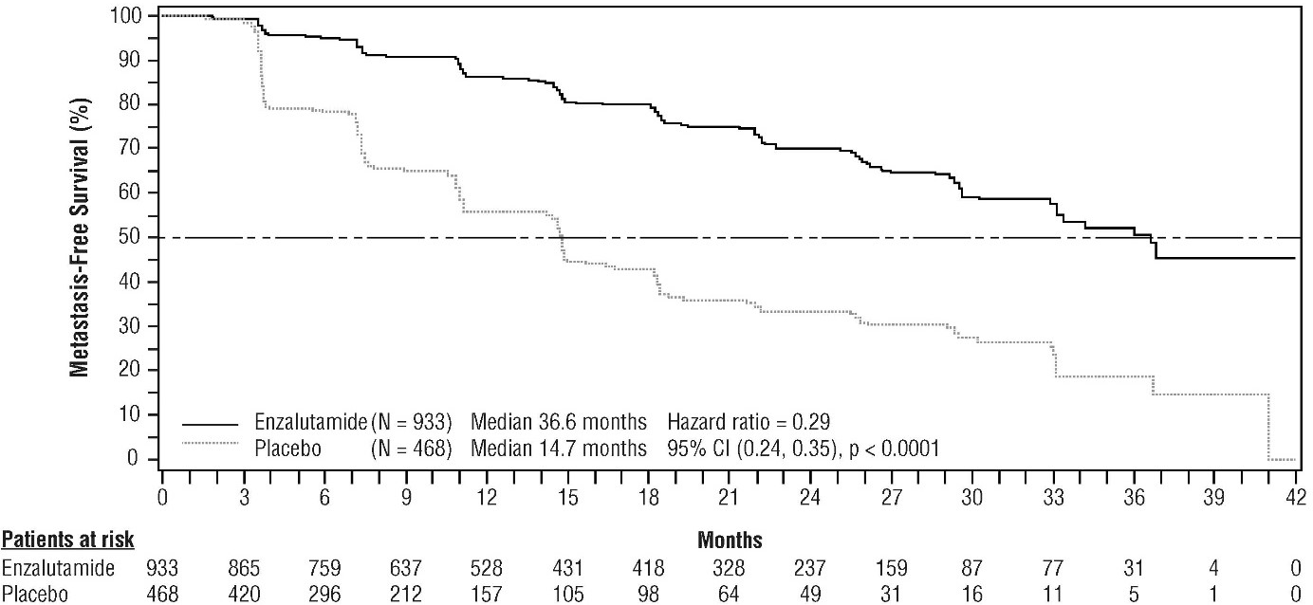

**Figure 5: Kaplan-Meier Curves of metastasis-free survival in the PROSPER study (intent-to- treat analysis)**

At the final analysis for overall survival, conducted when 466 deaths were observed, a statistically significant improvement in overall survival was demonstrated in patients randomised to receive enzalutamide compared with patients randomised to receive placebo with a 26.6% reduction in risk of death [hazard ratio (HR) = 0.734, (95% CI: 0.608; 0.885), p = 0.0011] (see Figure 6). The median follow-up time was 48.6 and 47.2 months for the enzalutamide and placebo groups, respectively.

Thirty-three percent of enzalutamide-treated and 65% of placebo-treated patients received at least one subsequent antineoplastic therapy that may prolong overall survival.

Ein Bild, das Text, Reihe, weiß enthält.

**Figure 6: Kaplan-Meier Curves of overall survival in the PROSPER study (intent-to-treat analysis)**

Enzalutamide demonstrated a statistically significant 93% reduction in the relative risk of PSA progression compared to placebo [HR = 0.07 (95% CI: 0.05, 0.08), p < 0.0001]. Median time to PSA progression was 37.2 months (95% CI: 33.1, NR) on the enzalutamide arm versus 3.9 months (95% CI: 3.8, 4.0) on the placebo arm.

Enzalutamide demonstrated a statistically significant delay in the time to first use of new antineoplastic therapy compared to placebo [HR = 0.21 (95% CI: 0.17, 0.26), p < 0.0001]. Median time to first use of new antineoplastic therapy was 39.6 months (95% CI: 37.7, NR) on the enzalutamide arm versus 17.7 months (95% CI: 16.2, 19.7) on the placebo arm (see Figure 7).



**Figure 7: Kaplan-Meier curves of time to first use of new antineoplastic therapy in the PROSPER study (intent-to-treat analysis)**

*MDV3100-09 (STRIVE) study (chemotherapy-naïve patients with non-metastatic/metastatic CRPC)*

The STRIVE study enrolled 396 non-metastatic or metastatic CRPC patients who had serologic or radiographic disease progression despite primary androgen deprivation therapy who were randomised to receive either enzalutamide at a dose of 160 mg once daily (N = 198) or bicalutamide at a dose of 50 mg once daily (N = 198). PFS was the primary endpoint defined as the time from randomisation to the earliest objective evidence of radiographic progression, PSA progression, or death on study.

Median PFS was 19.4 months (95% CI: 16.5, not reached) in the enzalutamide group versus 5.7 months (95% CI: 5.6, 8.1) in the bicalutamide group [HR = 0.24 (95% CI: 0.18, 0.32), p < 0.0001]. Consistent benefit of enzalutamide over bicalutamide on PFS was observed in all pre-specified patient subgroups. For the non-metastatic subgroup (N = 139) a total of 19 out of 70 (27.1%) patients treated with enzalutamide and 49 out of 69 (71.0%) patients treated with bicalutamide had PFS events (68 total events). The hazard ratio was 0.24 (95% CI: 0.14, 0.42) and the median time to a PFS event was not reached in the enzalutamide group versus 8.6 months in the bicalutamide group (see Figure 8).

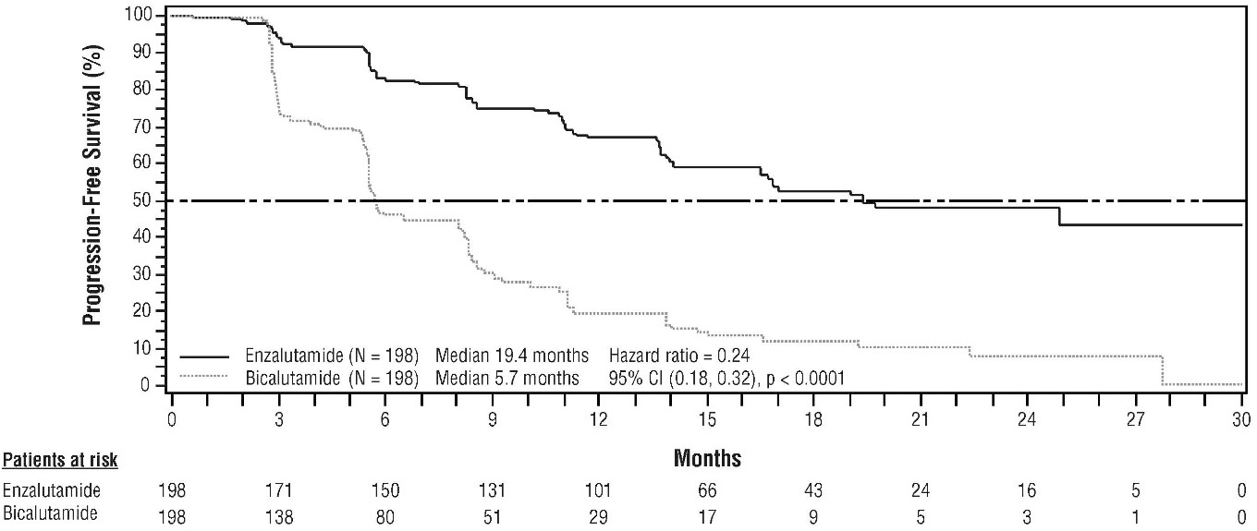

**Figure 8: Kaplan-Meier Curves of progression-free survival in the STRIVE study (intent-to-treat analysis)**

*9785-CL-0222 (TERRAIN) study (chemotherapy-naïve patients with metastatic CRPC)*

The TERRAIN study enrolled 375 chemo- and antiandrogen-therapy naïve patients with metastatic CRPC who were randomised to receive either enzalutamide at a dose of 160 mg once daily (N = 184) or bicalutamide at a dose of 50 mg once daily (N = 191). Median PFS was 15.7 months for patients on enzalutamide versus 5.8 months for patients on bicalutamide [HR = 0.44 (95% CI: 0.34, 0.57), p < 0.0001]. Progression-free survival was defined as objective evidence of radiographic disease progression by independent central review, skeletal-related events, initiation of new antineoplastic therapy or death by any cause, whichever occurred first. Consistent PFS benefit was observed across all pre-specified patient subgroups.

*MDV3100-03 (PREVAIL) study (chemotherapy-naïve patients with metastatic CRPC)*

A total of 1717 asymptomatic or mildly symptomatic chemotherapy-naïve patients were randomised 1:1 to receive either enzalutamide orally at a dose of 160 mg once daily (N = 872) or placebo orally once daily (N = 845). Patients with visceral disease, patients with a history of mild to moderate heart failure (NYHA Class I or II), and patients taking medicinal products associated with lowering the seizure threshold were allowed. Patients with a previous history of seizure or a condition that might predispose to seizure and patients with moderate or severe pain from prostate cancer were excluded. Study treatment continued until disease progression (evidence of radiographic progression, a skeletal- related event, or clinical progression) and the initiation of either a cytotoxic chemotherapy or an investigational agent, or until unacceptable toxicity.

Patient demographics and baseline disease characteristics were balanced between the treatment arms. The median age was 71 years (range 42 - 93) and the racial distribution was 77% Caucasian, 10% Asian, 2% Black and 11% other or unknown races. Sixty-eight percent (68%) of patients had an ECOG performance status score of 0 and 32% patients had an ECOG performance status of 1.

Baseline pain assessment was 0 - 1 (asymptomatic) in 67% of patients and 2 - 3 (mildly symptomatic) in 32% of patients as defined by the Brief Pain Inventory Short Form (worst pain over past 24 hours on a scale of 0 to 10). Approximately 45% of patients had measurable soft tissue disease at study entry, and 12% of patients had visceral (lung and/or liver) metastases.

Co-primary efficacy endpoints were overall survival and radiographic progression-free survival (rPFS). In addition to the co-primary endpoints, benefit was also assessed using time to initiation of cytotoxic chemotherapy, best overall soft tissue response, time to first skeletal-related event, PSA response (≥ 50% decrease from baseline), time to PSA progression, and time to FACT-P total score degradation.

Radiographic progression was assessed with the use of sequential imaging studies as defined by Prostate Cancer Clinical Trials Working Group 2 (PCWG2) criteria (for bone lesions) and/or Response Evaluation Criteria in Solid Tumors (RECIST v 1.1) criteria (for soft tissue lesions). Analysis of rPFS utilised centrally-reviewed radiographic assessment of progression.

At the pre-specified interim analysis for overall survival when 540 deaths were observed, treatment with enzalutamide demonstrated a statistically significant improvement in overall survival compared to treatment with placebo with a 29.4% reduction in risk of death [HR = 0.706 (95% CI: 0.60; 0.84), p < 0.0001]. An updated survival analysis was conducted when 784 deaths were observed. Results from this analysis were consistent with those from the interim analysis (Table 5). At the updated analysis 52% of enzalutamide-treated and 81% of placebo-treated patients had received subsequent therapies for metastatic CRPC that may prolong overall survival.

A final analysis of 5-year PREVAIL data showed a statistically significant increase in overall survival was maintained in patients treated with enzalutamide compared to placebo [HR = 0.835, (95% CI: 0.75, 0.93); p-value = 0.0008] despite 28% of patients on placebo crossing over to enzalutamide. The 5-year OS rate was 26% for the enzalutamide arm compared to 21% for the placebo arm.

**Table 5: Overall survival of patients treated with either enzalutamide or placebo in the PREVAIL study (intent-to-treat analysis)**

|  |  |  |
| --- | --- | --- |
|  | **Enzalutamide**  **(N = 872)** | **Placebo**  **(N = 845)** |
| Pre-specified interim analysis | | |
| Number of deaths (%) | 241 (27.6%) | 299 (35.4%) |
| Median survival, months (95% CI) | 32.4 (30.1, NR) | 30.2 (28.0, NR) |
| P-value*1* | p < 0.0001 | |
| Hazard ratio (95% CI)*2* | 0.71 (0.60, 0.84) | |
| Updated survival analysis | | |
| Number of deaths (%) | 368 (42.2%) | 416 (49.2%) |
| Median survival, months (95% CI) | 35.3 (32.2, NR) | 31.3 (28.8, 34.2) |
| P-value*1* | p = 0.0002 | |
| Hazard ratio (95% CI)*2* | 0.77 (0.67, 0.88) | |
| 5-year survival analysis | | |
| Number of deaths (%) | 689 (79) | 693 (82) |
| Median survival, months (95% CI) | 35.5 (33.5, 38.0) | 31.4 (28.9, 33.8) |
| P-value*1* | p = 0.0008 | |
| Hazard ratio (95% CI)*2* | 0.835 (0.75, 0.93) | |

NR = Not reached.

1. P-value is derived from an unstratified log-rank test.
2. Hazard Ratio is derived from an unstratified proportional hazards model. Hazard ratio < 1 favours enzalutamide.

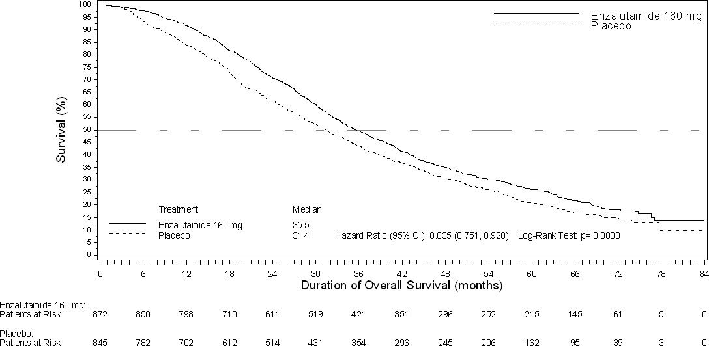

**Figure 9: Kaplan-Meier curves of overall survival based on 5-year survival analysis in the PREVAIL study (intent-to-treat analysis)**

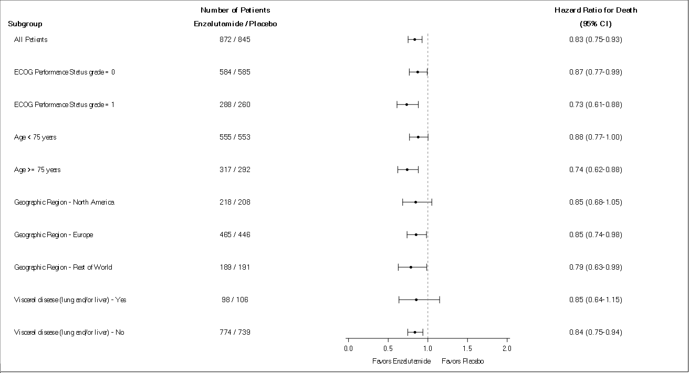

**Figure 10: 5-year overall survival analysis by subgroup: Hazard ratio and 95% confidence interval in the PREVAIL study (intent-to-treat analysis)**

At the pre-specified rPFS analysis, a statistically significant improvement was demonstrated between the treatment groups with an 81.4% reduction in risk of radiographic progression or death [HR = 0.19 (95% CI: 0.15, 0.23), p < 0.0001]. One hundred and eighteen (14%) enzalutamide-treated patients and 321 (40%) of placebo-treated patients had an event. The median rPFS was not reached (95% CI: 13.8, not reached) in the enzalutamide-treated group and was 3.9 months (95% CI: 3.7, 5.4) in the placebo- treated group (Figure 11). Consistent rPFS benefit was observed across all pre-specified patient subgroups (e.g. age, baseline ECOG performance, baseline PSA and LDH, Gleason score at diagnosis, and visceral disease at screening). A pre-specified follow-up rPFS analysis based on the investigator assessment of radiographic progression demonstrated a statistically significant improvement between the treatment groups with a 69.3% reduction in risk of radiographic progression or death [HR = 0.31 (95% CI: 0.27, 0.35), p < 0.0001]. The median rPFS was 19.7 months in the enzalutamide group and 5.4 months in the placebo group.

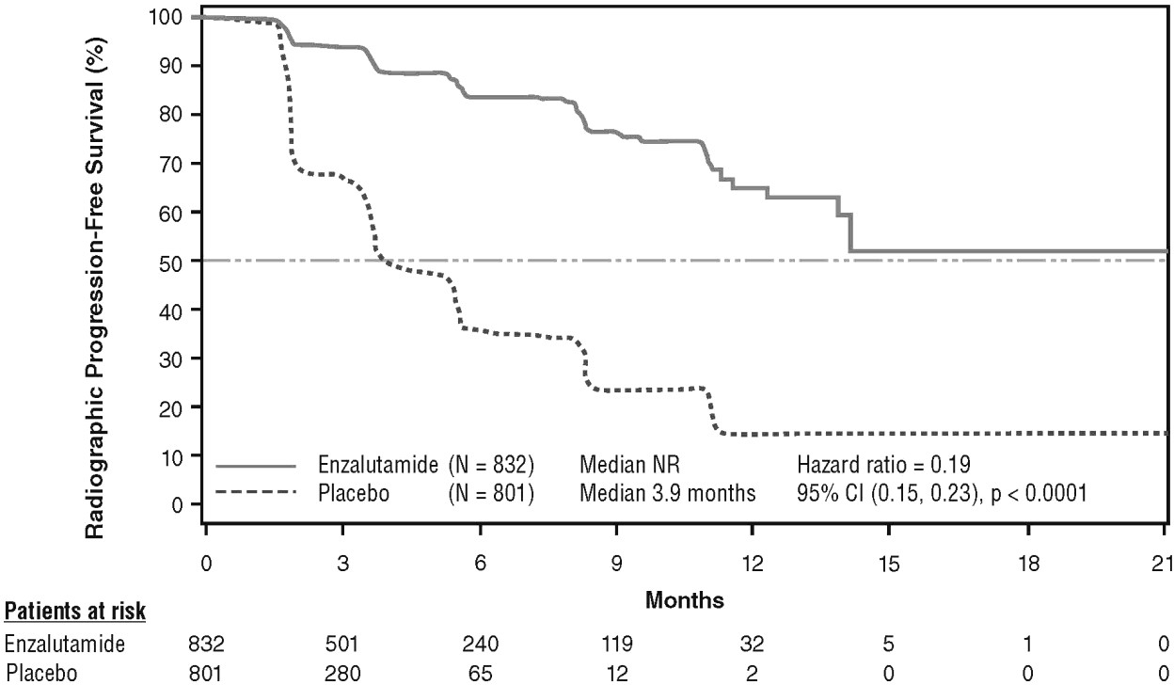

At the time of the primary analysis there were 1,633 patients randomised.

**Figure 11: Kaplan-Meier curves of radiographic progression-free survival in the PREVAIL study (intent-to-treat analysis)**

In addition to the co-primary efficacy endpoints, statistically significant improvements were also demonstrated in the following prospectively defined endpoints.

The median time to initiation of cytotoxic chemotherapy was 28.0 months for patients receiving enzalutamide and 10.8 months for patients receiving placebo [HR = 0.35 (95% CI: 0.30, 0.40), p < 0.0001].

The proportion of enzalutamide-treated patients with measurable disease at baseline who had an objective soft tissue response was 58.8% (95% CI: 53.8, 63.7) compared with 5.0% (95% CI: 3.0, 7.7) of patients receiving placebo. The absolute difference in objective soft tissue response between enzalutamide and placebo arms was [53.9% (95% CI: 48.5, 59.1), p < 0.0001]. Complete responses were reported in 19.7% of enzalutamide-treated patients compared with 1.0% of placebo-treated patients, and partial responses were reported in 39.1% of enzalutamide-treated patients versus 3.9% of placebo-treated patients.

Enzalutamide significantly decreased the risk of the first skeletal-related event by 28% [HR = 0.718 (95% CI: 0.61, 0.84), p < 0.0001]. A skeletal-related event was defined as radiation therapy or surgery to bone for prostate cancer, pathologic bone fracture, spinal cord compression, or change of antineoplastic therapy to treat bone pain. The analysis included 587 skeletal-related events, of which 389 events (66.3%) were radiation to bone, 79 events (13.5%) were spinal cord compression, 70 events (11.9%) were pathologic bone fracture, 45 events (7.6%) were change in antineoplastic therapy to treat bone pain, and 22 events (3.7%) were surgery to bone.

Patients receiving enzalutamide demonstrated a significantly higher total PSA response rate (defined as a ≥ 50% reduction from baseline), compared with patients receiving placebo, 78.0% versus 3.5% (difference = 74.5%, p < 0.0001). The median time to PSA progression per PCWG2 criteria was 11.2 months for patients treated with enzalutamide and 2.8 months for patients who received placebo [HR = 0.17 (95% CI: 0.15, 0.20), p < 0.0001].

Treatment with enzalutamide decreased the risk of FACT-P degradation by 37.5% compared with placebo (p < 0.0001). The median time to degradation in FACT-P was 11.3 months in the enzalutamide group and 5.6 months in the placebo group.

*CRPC2 (AFFIRM) study (patients with metastatic CRPC who previously received chemotherapy)*

The efficacy and safety of enzalutamide in patients with metastatic CRPC who had received docetaxel and were using a LHRH analogue or had undergone orchiectomy were assessed in a randomised, placebo-controlled, multicentre phase 3 clinical trial. A total of 1199 patients were randomised 2:1 to receive either enzalutamide orally at a dose of 160 mg once daily (N = 800) or placebo once daily (N = 399). Patients were allowed but not required to take prednisone (maximum daily dose allowed was 10 mg prednisone or equivalent). Patients randomised to either arm were to continue treatment until disease progression (defined as confirmed radiographic progression or the occurrence of a skeletal-related event) and initiation of new systemic antineoplastic treatment, unacceptable toxicity, or withdrawal.

The following patient demographics and baseline disease characteristics were balanced between the treatment arms. The median age was 69 years (range 41 - 92) and the racial distribution was 93% Caucasian, 4% Black, 1% Asian, and 2% Other. The ECOG performance score was 0 - 1 in 91.5% of patients and 2 in 8.5% of patients; 28% had a mean Brief Pain Inventory score of ≥ 4 (mean of patient’s reported worst pain over the previous 24 hours calculated for seven days prior to randomisation). Most (91%) patients had metastases in bone and 23% had visceral lung and/or liver involvement. At study entry, 41% of randomised patients had PSA progression only, whereas 59% of patients had radiographic progression. Fifty-one percent (51%) of patients were on bisphosphonates at baseline.

The AFFIRM study excluded patients with medical conditions that may predispose them to seizures (see section 4.8) and medicinal products known to decrease the seizure threshold, as well as clinically significant cardiovascular disease such as uncontrolled hypertension, recent history of myocardial infarction or unstable angina, New York Heart Association class III or IV heart failure (unless ejection fraction was ≥ 45%), clinically significant ventricular arrhythmias or AV block (without permanent pacemaker).

The protocol pre-specified interim analysis after 520 deaths showed a statistically significant superiority in overall survival in patients treated with enzalutamide compared to placebo (Table 6 and Figures 12 and 13).

**Table 6: Overall survival of patients treated with either enzalutamide or placebo in the AFFIRM study (intent-to-treat analysis)**

|  |  |  |
| --- | --- | --- |
|  | **Enzalutamide (N = 800)** | **Placebo (N = 399)** |
| Deaths (%) | 308 (38.5%) | 212 (53.1%) |
| Median survival (months) (95% CI) | 18.4 (17.3, NR) | 13.6 (11.3, 15.8) |
| P-value*1* | p < 0.0001 | |
| Hazard ratio (95% CI)*2* | 0.63 (0.53, 0.75) | |

NR = Not Reached.

1. P-value is derived from a log rank test stratified by ECOG performance status score (0-1 vs. 2) and mean pain score (< 4 vs. ≥ 4).
2. Hazard Ratio is derived from a stratified proportional hazards model. Hazard ratio < 1 favours enzalutamide.

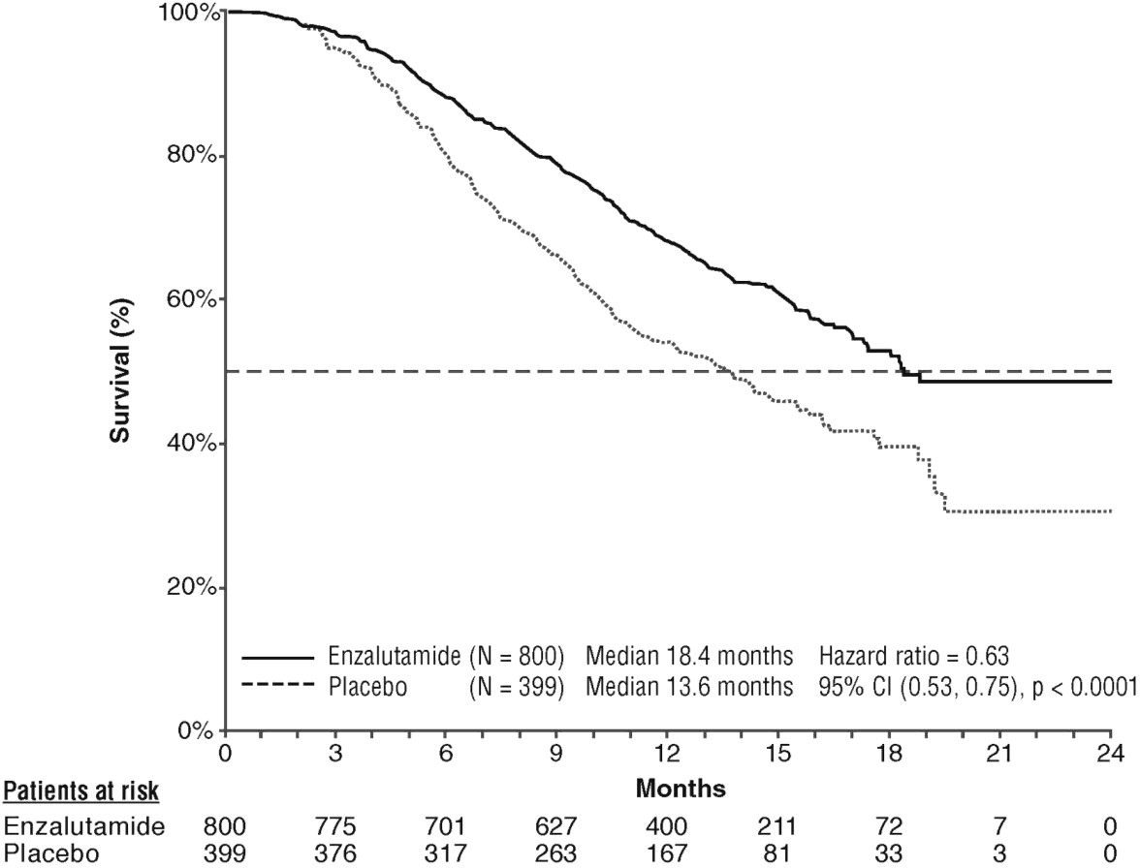

**Figure 12: Kaplan-Meier curves of overall survival in the AFFIRM study (intent-to-treat analysis)**

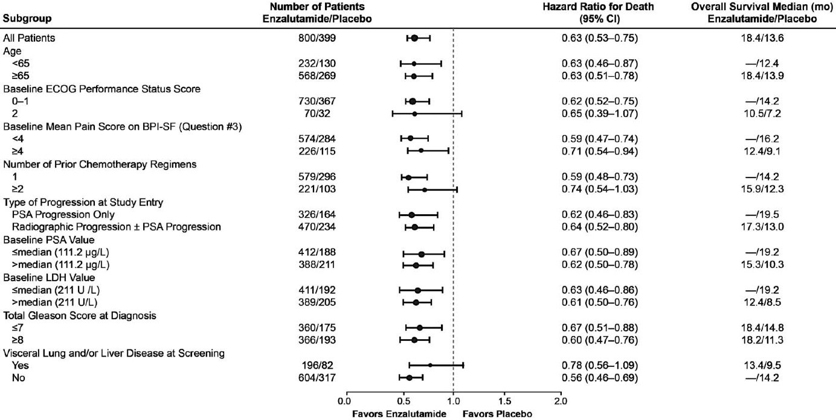

ECOG: Eastern Cooperative Oncology Group; BPI-SF: Brief Pain Inventory-Short Form; PSA: Prostate Specific Antigen

**Figure 13: Overall survival by subgroup in the AFFIRM study – Hazard ratio and 95% confidence interval**

In addition to the observed improvement in overall survival, key secondary endpoints (PSA progression, radiographic progression-free survival, and time to first skeletal-related event) favoured enzalutamide and were statistically significant after adjusting for multiple testing. Radiographic progression-free survival as assessed by the investigator using RECIST v 1.1 for soft tissue and appearance of 2 or more bone lesions in bone scan was 8.3 months for patients treated with enzalutamide and 2.9 months for patients who received placebo [HR = 0.40 (95% CI: 0.35, 0.47), p < 0.0001]. The analysis involved 216 deaths without documented progression and 645 documented progression events, of which 303 (47%) were due to soft tissue progression, 268 (42%) were due to bone lesion progression and 74 (11%) were due to both soft tissue and bone lesions.

Confirmed PSA decline of 50% or 90% were 54.0% and 24.8%, respectively, for patients treated with enzalutamide and 1.5% and 0.9%, respectively, for patients who received placebo (p < 0.0001). The median time to PSA progression was 8.3 months for patients treated with enzalutamide and 3.0 months for patients who received placebo [HR = 0.25 (95% CI: 0.20, 0.30), p < 0.0001].

The median time to first skeletal-related event was 16.7 months for patients treated with enzalutamide and 13.3 months for patients who received placebo [HR = 0.69 (95% CI: 0.57, 0.84), p < 0.0001]. A skeletal-related event was defined as radiation therapy or surgery to bone, pathologic bone fracture, spinal cord compression or change of antineoplastic therapy to treat bone pain. The analysis involved 448 skeletal-related events, of which 277 events (62%) were radiation to bone, 95 events (21%) were spinal cord compression, 47 events (10%) were pathologic bone fracture, 36 events (8%) were change in antineoplastic therapy to treat bone pain, and 7 events (2%) were surgery to bone.

*9785-CL-0410 study (enzalutamide post abiraterone in patients with metastatic CRPC)*

The study was a single-arm study in 214 patients with progressing metastatic CRPC who received enzalutamide (160 mg once daily) after at least 24 weeks of treatment with abiraterone acetate plus prednisone. Median rPFS (radiologic progression free survival, the study´s primary endpoint) was 8.1 months (95% CI: 6.1, 8.3). Median OS was not reached. PSA Response (defined as ≥ 50% decrease from baseline) was 22.4% (95% CI: 17.0, 28.6). For the 69 patients who previously received chemotherapy, median rPFS was 7.9 months (95% CI: 5.5, 10.8). PSA Response was 23.2% (95% CI: 13.9, 34.9). For the 145 patients who had no previous chemotherapy, median rPFS was 8.1 months (95% CI: 5.7, 8.3). PSA Response was 22.1% (95% CI: 15.6, 29.7).

Although there was a limited response in some patients from treatment with enzalutamide after abiraterone, the reason for this finding is currently unknown. The study design could neither identify the patients who are likely to benefit, nor the order in which enzalutamide and abiraterone should be optimally sequenced.

Elderly

Of the 5110 patients in the controlled clinical trials who received enzalutamide, 3988 patients (78%) were 65 years and over and 1703 patients (33%) were 75 years and over. No overall differences in safety or effectiveness were observed between these elderly patients and younger patients.

Paediatric population

The European Medicines Agency has waived the obligation to submit the results of studies with the reference medicinal product containing enzalutamide in all subsets of the paediatric population in prostate carcinoma (see section 4.2 for information on paediatric use).

**5.2 Pharmacokinetic properties**

Enzalutamide is poorly water soluble. The solubility of enzalutamide is increased by caprylocaproyl macrogolglycerides as emulsifier/surfactant. In preclinical studies, the absorption of enzalutamide was increased when dissolved in caprylocaproyl macrogolglycerides.

The pharmacokinetics of enzalutamide have been evaluated in prostate cancer patients and in healthy male subjects. The mean terminal half-life (t1/2) for enzalutamide in patients after a single oral dose is 5.8 days (range 2.8 to 10.2 days), and steady state is achieved in approximately one month. With daily oral administration, enzalutamide accumulates approximately 8.3-fold relative to a single dose. Daily fluctuations in plasma concentrations are low (peak-to-trough ratio of 1.25). Clearance of enzalutamide is primarily via hepatic metabolism, producing an active metabolite that is equally as active as enzalutamide and circulates at approximately the same plasma concentration as enzalutamide.

Absorption

Oral absorption of film-coated enzalutamide tablets was evaluated in healthy male volunteers after a single 160 mg dose of enzalutamide film-coated tablets, and pharmacokinetic modelling and simulation were used to predict the pharmacokinetic profile at steady state. Based on these predictions, as well as other supportive data, the median time to reach maximum plasma enzalutamide concentrations (Cmax) is 2 hours (range 0.5 to 6 hours), and the steady-state pharmacokinetic profiles of enzalutamide and its active metabolite are similar for the film-coated tablets and the enzalutamide soft capsules formulation.

Following oral administration of the soft capsule formulation (enzalutamide 160 mg daily) in patients with metastatic CRPC, the steady-state plasma mean Cmax values for enzalutamide and its active metabolite are 16.6 μg/mL (23% CV) and 12.7 μg/mL (30% CV), respectively.

Based on a mass balance study in humans, oral absorption of enzalutamide is estimated to be at least 84.2%. Enzalutamide is not a substrate of the efflux transporters P-gp or BCRP.

Food has no clinically significant effect on the extent of absorption. In clinical trials, enzalutamide was administered without regard to food.

Distribution

The mean apparent volume of distribution (V/F) of enzalutamide in patients after a single oral dose is 110 L (29% CV). The volume of distribution of enzalutamide is greater than the volume of total body water, indicative of extensive extravascular distribution. Studies in rodents indicate that enzalutamide and its active metabolite can cross the blood brain barrier.

Enzalutamide is 97% to 98% bound to plasma proteins, primarily albumin. The active metabolite is 95% bound to plasma proteins. There was no protein binding displacement between enzalutamide and other highly bound medicinal products (warfarin, ibuprofen and salicylic acid) *in vitro*.

Biotransformation

Enzalutamide is extensively metabolised. There are two major metabolites in human plasma:

N-desmethyl enzalutamide (active) and a carboxylic acid derivative (inactive). Enzalutamide is metabolised by CYP2C8 and to a lesser extent by CYP3A4/5 (see section 4.5), both of which play a role in the formation of the active metabolite. *In vitro*, N-desmethyl enzalutamide is metabolised to the carboxylic acid metabolite by carboxylesterase 1, which also plays a minor role in the metabolism of enzalutamide to the carboxylic acid metabolite. N-desmethyl enzalutamide was not metabolised by CYPs *in vitro.*

Under conditions of clinical use, enzalutamide is a strong inducer of CYP3A4, a moderate inducer of CYP2C9 and CYP2C19, and has no clinically relevant effect on CYP2C8 (see section 4.5).

Elimination

The mean apparent clearance (CL/F) of enzalutamide in patients ranges from 0.520 and 0.564 L/h.

Following oral administration of 14C-enzalutamide, 84.6% of the radioactivity is recovered by 77 days post dose: 71.0% is recovered in urine (primarily as the inactive metabolite, with trace amounts of enzalutamide and the active metabolite), and 13.6% is recovered in faeces (0.39% of dose as unchanged enzalutamide).

*In vitro* data indicate that enzalutamide is not a substrate for OATP1B1, OATP1B3, or OCT1; and N-desmethyl enzalutamide is not a substrate for P-gp or BCRP.

*In vitro* data indicate that enzalutamide and its major metabolites do not inhibit the following transporters at clinically relevant concentrations: OATP1B1, OATP1B3, OCT2, or OAT1.

Linearity

No major deviations from dose proportionality are observed over the dose range 40 to 160 mg. The steady-state Cmin values of enzalutamide and the active metabolite in individual patients remained constant during more than one year of chronic therapy, demonstrating time-linear pharmacokinetics once steady-state is achieved.

Renal impairment

No formal renal impairment study for enzalutamide has been completed. Patients with serum creatinine > 177 μmol/L (2 mg/dL) were excluded from clinical studies. Based on a population pharmacokinetic analysis, no dose adjustment is necessary for patients with calculated creatinine clearance (CrCL) values ≥ 30 mL/min (estimated by the Cockcroft and Gault formula). Enzalutamide has not been evaluated in patients with severe renal impairment (CrCL < 30 mL/min) or end-stage renal disease, and caution is advised when treating these patients. It is unlikely that enzalutamide will be significantly removed by intermittent haemodialysis or continuous ambulatory peritoneal dialysis.

Hepatic impairment

Hepatic impairment did not have a pronounced effect on the total exposure to enzalutamide or its active metabolite. The half-life of enzalutamide was however doubled in patients with severe hepatic impairment compared with healthy controls (10.4 days compared to 4.7 days), possibly related to an increased tissue distribution.

The pharmacokinetics of enzalutamide were examined in subjects with baseline mild (N = 6), moderate (N = 8) or severe (N = 8) hepatic impairment (Child-Pugh Class A, B or C, respectively) and in 22 matched control subjects with normal hepatic function. Following a single oral 160 mg dose of enzalutamide, the AUC and Cmax for enzalutamide in subjects with mild impairment increased by 5% and 24%, respectively, the AUC and Cmax of enzalutamide in subjects with moderate impairment increased by 29% and decreased by 11%, respectively, and the AUC and Cmax of enzalutamide in subjects with severe impairment increased by 5% and decreased by 41%, respectively, compared to healthy control subjects. For the sum of unbound enzalutamide plus the unbound active metabolite, the AUC and Cmax in subjects with mild impairment increased by 14% and 19%, respectively, the AUC and Cmax in subjects with moderate impairment increased by 14% and decreased by 17%, respectively, and the AUC and Cmax in subjects with severe hepatic impairment increased by 34% and decreased by 27%, respectively, compared to healthy control subjects.

Race

Most patients in the controlled clinical studies (> 75%) were Caucasian. Based on pharmacokinetic data from studies in Japanese and Chinese patients with prostate cancer, there were no clinically relevant differences in exposure among the populations. There are insufficient data to evaluate potential differences in the pharmacokinetics of enzalutamide in other races.

Elderly

No clinically relevant effect of age on enzalutamide pharmacokinetics was seen in the elderly population pharmacokinetic analysis.

**5.3 Preclinical safety data**

Enzalutamide treatment of pregnant mice resulted in an increased incidence of embryo-fetal deaths and external and skeletal changes. Fertility studies were not conducted with enzalutamide, but in studies in rats (4 and 26 weeks) and dogs (4, 13, and 39 weeks), atrophy, aspermia/hypospermia, and hypertrophy/hyperplasia in the reproductive system were noted, consistent with the pharmacological activity of enzalutamide. In studies in mice (4 weeks), rats (4 and 26 weeks) and dogs (4, 13, and 39 weeks), changes in the reproductive organs associated with enzalutamide were decreases in organ weight with atrophy of the prostate and epididymis. Leydig cell hypertrophy and/or hyperplasia were observed in mice (4 weeks) and dogs (39 weeks). Additional changes to reproductive tissues included hypertrophy/hyperplasia of the pituitary gland and atrophy in seminal vesicles in rats and testicular hypospermia and seminiferous tubule degeneration in dogs. Gender differences were noted in rat mammary glands (male atrophy and female lobular hyperplasia). Changes in the reproductive organs in both species were consistent with the pharmacological activity of enzalutamide and reversed or partially resolved after an 8-week recovery period. There were no other important changes in clinical pathology or histopathology in any other organ system, including the liver, in either species.

Studies in pregnant rats have shown that enzalutamide and/or its metabolites are transferred to fetuses. After oral administration of radiolabeled 14C-enzalutamide to rats on day 14 of pregnancy at a dose of 30 mg/kg (~ 1.9 times the maximum dose indicated in humans), the maximum radioactivity in the fetus was reached 4 hours after administration and was lower than that in the maternal plasma with tissue/plasma ratio of 0.27. The radioactivity in the fetus decreased to 0.08 times the maximum concentration at 72 hours after administration.

Studies in lactating rats have shown that enzalutamide and/or its metabolites are secreted in rat milk. After oral administration of radiolabeled 14C-enzalutamide to lactating rats at a dose of 30 mg/kg (~ 1.9 times the maximum dose indicated in humans), the maximum radioactivity in the milk was reached 4 hours after administration and was up to 3.54-fold higher than that in the maternal plasma. Study results also have shown that enzalutamide and/or its metabolites are transferred to infant rat tissues via milk and subsequently eliminated.

Enzalutamide was negative for genotoxicity in a standard battery of *in vitro* and *in vivo* tests. In a 6-month study in transgenic rasH2 mice, enzalutamide did not show carcinogenic potential (absence of neoplastic findings) at doses up to 20 mg/kg per day (AUC24h ~317 µg·h/mL), which resulted in plasma exposure levels similar to the clinical exposure (AUC24h ~322 µg·h/mL) in mCRPC patients receiving 160 mg, daily.

Daily dosing of rats for two years with enzalutamide produced an increased incidence of neoplastic findings. These included benign thymoma, fibroadenoma in the mammary glands, benign Leydig cell tumours in the testes and urothelium papilloma and carcinoma of urinary bladder in males; benign granulosa cell tumour in the ovaries in females and adenoma in the pars distalis of the pituitary in both sexes. The human relevance of thymoma, pituitary adenoma and mammary fibroadenoma as well as urothelium papilloma and carcinoma of urinary bladder cannot be ruled out.

Enzalutamide was not phototoxic *in vitro.*

**6. PHARMACEUTICAL PARTICULARS**

**6.1 List of excipients**

Tablet core

Methacrylic acid-ethyl acrylate copolymer (1:1) Type A (contains Sodium Lauryl sulfate and Polysorbate 80)

Silica, colloidal anhydrous (E551)

Cellulose, microcrystalline (E460)

Croscarmellose sodium (E468)

Magnesium stearate (E470b)

Tablet coating

Hypromellose 2910 (E464)

Macrogol 3350 (E1521)

Titanium dioxide (E171)

Iron oxide yellow (E172)

Talc (E553b)

**6.2 Incompatibilities**

Not applicable.

**6.3 Shelf life**

2 years.

**6.4 Special precautions for storage**

This medicinal product does not require any special storage conditions.

Do not remove oxygen absorbing canister from bottles.

**6.5 Nature and contents of container**

40 mg film-coated tablets

Each pack of Enzalutamide "Hexal" contains 112 film-coated tablets in Aluminium-OPA/Alu/PVC blisters, or 112 × 1 film-coated tablets in Aluminium-OPA/Alu/PVC perforated unit dose blisters.

Enzalutamide "Hexal" is also supplied in cardboard wallets incorporating Aluminium-OPA/Alu/PVC blisters of 28 film-coated tablets. Each carton contains 112 film-coated tablets (4 wallets).

Enzalutamide "Hexal" is also supplied in high density polyethylene (HDPE) bottles with white polypropylene (PP) oxygen absorbing canister, closed with a child resistant polypropylene (PP) closure, containing 112 film-coated tablets.

80 mg film-coated tablets

Each pack of Enzalutamide "Hexal" contains 56 film-coated tablets in Aluminium-OPA/Alu/PVC blisters, or 56 × 1 film-coated tablets in Aluminium-OPA/Alu/PVC perforated unit dose blisters.

Enzalutamide "Hexal" is also supplied in cardboard wallets incorporating Aluminium-OPA/Alu/PVC blisters of 14 film-coated tablets. Each carton contains 56 film-coated tablets (4 wallets).

Enzalutamide "Hexal" is also supplied in high density polyethylene (HDPE) bottles with white polypropylene (PP) oxygen absorbing canister, closed with a child resistant polypropylene (PP) closure, containing 56 film-coated tablets.

Not all pack sizes may be marketed.

**6.6 Special precautions for disposal and other handling**

Enzalutamide "Hexal" should not be handled by persons other than the patient or his caregivers. Based on the mechanism of action and embryo-fetal toxicity of enzalutamide observed in mice, Enzalutamide "Hexal" may harm a developing fetus. Women who are or may become pregnant should not handle broken or damaged Enzalutamide "Hexal" tablets without protection, e.g. gloves. See section 5.3 Pre-clinical safety data. The film-coated tablets should not be chewed, cut or crushed.

Any unused medicinal product or waste material should be disposed of in accordance with local requirements.

**7. MARKETING AUTHORISATION HOLDER**

Hexal A/S

Edvard Thomsens Vej 14

2300 København

**8. MARKETING AUTHORISATION NUMBER(S)**

40 mg: 69757

80 mg: 69758

**9. DATE OF FIRST AUTHORISATION**

14 November 2024

**10. DATE OF REVISION OF THE TEXT**

4. April 2025