

27 April 2026

SUMMARY OF PRODUCT CHARACTERISTICS

for

Epipen Neo, solution for injection in pre-filled pen 300 micrograms

0. D.SP.NO.
34011

1. NAME OF THE MEDICINAL PRODUCT
Epipen Neo

2. QUALITATIVE AND QUANTITATIVE COMPOSITION
1 ml contains 1000 microgram adrenaline (epinephrine).

Each pre-filled pen of 0.3 ml solution contains adrenaline tartrate equivalent to 300 microgram adrenaline (epinephrine).

Excipient with known effect:
Each pre-filled pen contains 0.3 mg of sodium metabisulphite.
For the full list of excipients, see section 6.1.

3. PHARMACEUTICAL FORM
Solution for injection in pre-filled pen (Auto-Injector)

Clear and colourless solution, free from visible particles.
The pH range is 2.8 – 4.5.

4. CLINICAL PARTICULARS

4.1 Therapeutic indications
Epipen Neo Auto-Injector (adrenaline) is indicated in the emergency treatment of severe allergic reactions (anaphylaxis) to e.g. insect stings or bites, foods, drugs and other allergens, as well as idiopathic or exercise induced anaphylaxis.

4.2 Posology and method of administration

Posology
As Epipen Neo Auto-Injector is designed as emergency treatment only, the patient should be advised to always seek medical help immediately. An initial dose should be administered as soon as symptoms of anaphylaxis are recognized.

In the absence of clinical improvement or if deterioration occurs, a second injection with an additional Epipen Neo Auto-Injector may be administered 5–15 minutes after the first injection. It is recommended that patients are prescribed two Epipen Neo Auto-Injector which they should carry at all times.

The patient must consult a physician after injection in order to have relevant actions taken for further evaluation and/or treatment.

The physician prescribing an Epipen Neo Auto-Injector must ensure that the patient understands the indications for use and the correct method of application. Therefore, the physician should discuss the patient information leaflet, the correct handling of the auto-injector and the possible symptoms of an anaphylactic shock in detail with the patient.

Adults
The usual dose is 300 microgram for intramuscular use.

Paediatric population
Usual paediatric dose is 0.01 mg/kg body weight. However, the prescribing physician has the option of prescribing more or less than these amounts based on careful assessment of each individual patient and recognizing the life-threatening nature of reactions for which this is being prescribed. A dosage below 150 microgram cannot be administered with Epipen Neo Auto-Injector. The physician should consider using other forms of injectable adrenaline if lower doses are felt to be necessary for small children.

Children and adolescents over 30 kg weight:
The usual dose is 300 microgram for intramuscular use.

Children between 15 kg and 30 kg in weight*:
The usual dose is 150 microgram for intramuscular use.
* For these patients Epipen Neo Auto-Injector containing 150 microgram adrenaline per dose is available. Epipen Neo 300 microgram is not suitable for children < 30 kg.

Children below 15 kg in weight:
The suitability of Epipen Neo has to be judged individually. The use in children weighing less than 7.5 kg is not recommended unless in a life-threatening situation and under medical advice.

Method of administration

For single use.

Epipen Neo Auto-Injector (adrenaline) is intended for immediate administration in patients with an increased risk for anaphylaxis, at the first signs of anaphylaxis.

Inject the delivered dose of the Epipen Neo Auto-Injector (0.3 ml equal to 300 microgram) intramuscularly into the anterolateral aspect of the thigh, not the buttock. Epipen Neo is designed to inject through clothing or directly through the skin. See detailed instructions for use, see section 6.6.

See section “4.4 Special warnings and precautions for use” and section “6.6 Special precautions for disposal and other handling”.
The patient/carer should be informed that following each use of Epipen Neo Auto-Injector:

- They should call for immediate medical assistance, ask for an ambulance and state “anaphylaxis” even if symptoms appear to be improving (see section 4.4).

- Conscious patients should preferably lie flat with feet elevated but sit up if they have breathing difficulties. Unconscious patients should be placed on their side in the recovery position.

- The patient should if possible remain with another person until medical assistance arrives.

4.3 Contraindications
There are no known absolute contraindications to the use of Epipen Neo during an allergic emergency.

4.4 Special warnings and precautions for use

Patient guidance

All patients who are prescribed Epipen Neo Auto-Injector should be thoroughly instructed to understand the indications for the use and the correct method of administration (see section 6.6). It is strongly advised also to educate the patient’s immediate associates (e.g. parents, caregivers, teachers) for the correct usage of the Epipen Neo Auto-Injector in case support is needed in the emergency situation.

The patient should be instructed to dial the local emergency number, ask for ambulance, state anaphylaxis to seek emergency medical assistance immediately after administering the first dose in order to have close monitoring of the anaphylactic episode and further treatment as required.

The Epipen Neo Auto-Injector should be injected into the anterolateral aspect of the thigh. Patients should be advised not to inject into the buttock.

In case of injection performed by a caregiver, immobilization of the patient’s leg should be ensured during injection to minimize the risk of leg laceration, bent needle or other injuries. In no case should the used needle be reinserted.

In patients with thick sub-cutaneous fat layer, there is a risk for adrenaline not reaching the muscle tissue resulting in a suboptimal effect (see section 5.2). A second injection with an additional Epipen Neo Auto-Injector may be needed (see section 4.2).

Patients should be warned regarding related allergens and should be investigated whenever possible so that their specific allergens can be characterised.

Accidental injection into hands or feet resulting in peripheral ischaemia has been reported. Patients may need treatment consisting of vasodilation following the accidental injection in addition to further appropriate treatment of anaphylaxis.

Patients with concomitant asthma may be at increased risk of developing severe anaphylactic reactions.

Concomittant diseases

Adrenaline is ordinarily administered with extreme caution to patients who have a heart disease. Adrenaline should only be prescribed to those patients, but also those suffering from diabetes, hyperthyroidism, hypertension and elderly individuals if the potential benefit justifies the potential risk.

There is a risk of adverse reactions following adrenaline administration in patients with high intraocular pressure, severe renal impairment, prostatic adenoma leading to residual urine, hypercalcaemia and hypokalaemia.

In patients with Parkinson’s disease, adrenaline may be associated with a transient worsening of Parkinson symptoms such as rigidity and tremor.

Excipient warnings

Epipen Neo Auto-Injector contains sodium metabisulphite which may rarely cause severe hypersensitivity reactions including anaphylactic symptoms and bronchospasm in susceptible people, especially those with a history of asthma. Patients with these conditions must be carefully instructed in regard to the circumstances under which Epipen Neo Auto-Injector should be used.

This medicinal product contains less than 1 mmol sodium (23 mg) per dose, i.e. essentially ‘sodium-free’.

4.5 Interaction with other medicinal products and other forms of interaction
Caution is indicated in patients receiving drugs that may sensitise the heart to arrhythmias, including digitalis and quinidine.

The effects of adrenaline may be potentiated by tricyclic antidepressants, monoamine oxidase inhibitors (MAO-inhibitors) and catechol-O-methyl transferase inhibitors (COMT inhibitors), thyroid hormones, theophylline, oxytocin, parasympatholytics, certain antihistamines (diphenhydramine, chlorpheniramine), levodopa and alcohol.

Adrenaline inhibits the secretion of insulin, thus increasing the blood glucose level. It may be necessary for diabetic patients receiving adrenaline to increase their dosage of insulin or oral hypoglycaemic drugs.

The vasoconstricting and hypertensive effects of adrenaline are antagonized by alpha-adrenergic blocking drugs, such as phentolamine. The cardiostimulating and bronchodilating effects of adrenaline are antagonized by beta-adrenergic blocking drugs, such as propranolol.

4.6 Fertility, pregnancy and lactation

Pregnancy
There are no adequate or well controlled studies of adrenaline in pregnant women. Adrenaline should only be used in pregnancy if the potential benefit justifies the potential risk to the foetus. Adrenaline may dramatically reduce placental blood flow, although anaphylactic shock will do this too. Adrenaline inhibits spontaneous or oxytocin induced contractions of the pregnant human uterus and may delay the second stage of labour.

Breast-feeding
Adrenaline is not orally bioavailable; any adrenaline excreted in breast milk would not be expected to have any effect on the nursing infant.

Fertility
As adrenaline is a substance that naturally occurs in the body, it is unlikely that this drug would have any detrimental effects on fertility.

4.7 Effects on ability to drive and use machines
No traffic warning.
It is not recommended that patients should drive or use machines following administration of adrenaline, since patients will be affected by symptoms of the anaphylactic shock.

4.8 Undesirable effects
Side effects associated with adrenaline’s alpha and beta receptor activity may include symptoms such as tachycardia and hypertension as well as undesirable effects on the central nervous system.

Within the system organ classes, adverse reactions are listed under heading of frequency (number of patients expected to experience the reaction), using the following categories:
- Very common (≥ 1/10)
- Common (≥ 1/100 to < 1/10)
- Uncommon (≥ 1/1 000 to < 1/100)
- Rare (≥ 1/10 000 to < 1/1 000)
- Very rare (< 1/10 000)
- Not known (Frequency cannot be estimated from the available data).

Organ System | Not Known | Rare
Infections and infestations | Injection site infection*
Psychiatric disorders | Anxiety
Nervous system disorders | Headache, dizziness, tremor
Cardiac disorders | Palpitations, ventricular fibrillation (sometimes fatal), angina pectoris, tachycardia, cardiac arrhythmia | Stress cardiomyopathy
Vascular disorders | Hypertension, pallor, peripheral ischaemia following accidental injection of the auto-injector in hands or feet
Respiratory, thoracic and mediastinal disorders | Respiratory difficulties
Gastrointestinal disorders | Nausea, vomiting
Skin and subcutaneous tissue disorders | Hyperhidrosis
General disorders and administration site conditions | Asthenia, accidental injections#
* rare cases of serious skin and soft tissue infections, including necrotizing fasciitis and myonecrosis caused by Clostridia (gas gangrene) are known from post-marketing experience
# adverse reactions experienced as a result of accidental injections may include increased heart rate, local reactions including injection site pallor, coldness and hypoesthesia or injury at the injection site resulting in bruising, bleeding, discoloration, erythema or skeletal injury.

Reporting of suspected adverse reactions
Reporting suspected adverse reactions after authorisation of the medicinal product is important. It allows continued monitoring of the benefit/risk balance of the medicinal product. Healthcare professionals are asked to report any suspected adverse reactions via:

Lægemiddelstyrelsen
Axel Heides Gade 1
DK-2300 København S
Website: www.meldenbivirkning.dk

4.9 Overdose
Overdose or inadvertent intravascular injection of adrenaline may cause cerebral haemorrhage resulting from a sharp rise in blood pressure. Fatalities may also result from pulmonary oedema because of peripheral vascular constriction together with cardiac stimulation.

Pulmonary oedema may be treated with α-blocking agents such as phentolamine.
In case of arrhythmias these may be treated with β-blocking agents.

4.10 Legal status
B

5. PHARMACOLOGICAL PROPERTIES

5.1 Pharmacodynamic properties
Pharmacotherapeutic group: Cardiac stimulants excl. cardiac glycosides, adrenergic and dopaminergic agents, ATC code: C01CA24.

Adrenaline is a catecholamine which stimulates the sympathetic nervous system (both alpha and beta receptors) by which cardiac rate, cardiac output and coronary circulation is raised.

Through its strong action on alpha-adrenergic receptors, adrenaline counters the vasodilation and high vascular permeability that occurs during an anaphylactic reaction that can lead to loss of intravascular fluid volume and hypotension. Through its action on beta-adrenergic receptors, adrenaline causes bronchial smooth muscle relaxation and helps alleviate bronchospasm, wheezing and dyspnea that may occur during anaphylaxis.

Adrenaline also helps to alleviate pruritus, urticaria, and angioedema, and may be effective in relieving gastrointestinal and genitourinary symptoms of anaphylaxis because of its relaxant effects on the smooth muscle of the stomach, intestine, and urinary bladder.

5.2 Pharmacokinetic properties
Adrenaline is a naturally occurring substance produced by the adrenal medulla and secreted in response to exertion or stress. It is rapidly inactivated in the body mostly by the enzymes COMT and MAO. The liver is rich in these enzymes and is an important, although not essential, tissue in the degradation process.

Much of the dose of adrenaline is accounted for by excretion of metabolites in the urine. The plasma half-life of adrenaline is about 2.5 min.

However, by subcutaneous or intramuscular routes, local vasoconstriction retards absorption, so that the effects occur insidious and last much longer than the half-life would predict. Gentle massage of the injection site is recommended.

In a pharmacokinetic study in 36 healthy subjects, grouped by varying degrees of thickness in the subcutaneous fat layer of the thigh, a single 0.3 mg/0.3 ml injection at the anterolateral aspect of the mid-thigh was made with a Epipen Neo 300 microgram and was compared in crossover design to a manual syringe-delivered dose with needles individualized for delivery to muscle layer. The results indicate that subjects with a thick sub-cutaneous fat layer (> 20 mm skin to muscle distance under maximum compression) had slower adrenaline absorption rate, reflected in a trend to lower plasma exposure in such subjects in the first 30 minutes following injection (see section 4.4). However, in this group, total adrenaline exposure was greater and prolonged with Epipen Neo 300 microgram compared to syringe delivery. For all other groups, overall adrenaline exposure from 0 to 30 min (AUC0-30min) of subjects receiving Epipen Neo 300 microgram exceeded exposures resulting from syringe delivery. Importantly, a trend to higher plasma adrenaline concentrations following Epipen Neo 300 microgram compared to manual intramuscular injection in healthy subjects who will have well perfused subcutaneous tissue cannot necessarily be extrapolated to patients in established anaphylactic shock in whom there may be diversion of blood from skin to leg muscles. The possibility of existing cutaneous vasoconstriction at the time of injection should be taken into consideration, therefore. Both inter-subject and intra-subject variability was however, high in this study and therefore robust conclusions cannot be drawn.

5.3 Preclinical safety data
There is no preclinical data of importance to the prescriber.

6. PHARMACEUTICAL PARTICULARS

6.1 List of excipients
Sodium metabisulphite (E223)
Sodium chloride
Disodium edetate
Hydrochloric acid (for pH adjustment)
Water for injections

6.2 Incompatibilities
Adrenaline and its salts are rapidly destroyed in solution with oxidising agents. The solution darkens in colour upon exposure to air or light.

In the absence of compatibility studies, this medicinal product must not be mixed with other medicinal products

6.3 Shelf life
2 years

6.4 Special precautions for storage
Keep the auto-injector in the outer carton in order to protect from light.
Do not store above 25°C.
Do not refrigerate or freeze.

6.5 Nature and contents of container
Epipen Neo Auto-Injector contains 0.3 ml solution in a glass syringe with a bromobutyl rubber plunger stopper and a stainless-steel staked needle with a polyisoprene rubber needle shield. The glass syringe is assembled into a plastic auto-injector pen. The auto-injector primary packaging includes a clear PC component with UV blocking additive which provides UV protection.

The needle length after activation is approximately 13.5 mm.

Packs of 1 or 2 pre-filled pens.
Not all pack sizes may be marketed.

6.6 Special precautions for disposal and other handling
For single use only. The auto-injectors must be discarded immediately after use.

Important Information - Before Use:

- The expiry date is indicated on the label and Epipen Neo Auto-Injector should not be used after this date. The auto-injector should be replaced by the expiration date or earlier if the solution is discoloured or contains a precipitate. The solution should be inspected periodically through the viewing window of the unit to make sure the solution is clear and colourless.
- A Epipen Neo Trainer is available for the Epipen Neo Auto-Injector. The Epipen Neo Trainer has a grey colour and contains no medicine and no needle.
- Patients should practice with a Epipen Neo Trainer periodically, but always carry the Epipen Neo Auto-Injectors in case of an allergic emergency (anaphylaxis).
- If administering Epipen Neo Auto-Injector to a young child, a healthcare provider should demonstrate how to properly hold the child's leg in place while administering a dose.
- The Epipen Neo Auto-Injector should not be taken apart.
- The Epipen Neo Auto-Injector should not be dropped. If the auto-injector is dropped, check for damage and leakage. Patients should contact their healthcare provider to replace the auto-injector if damage or leakage is noticed or suspected.
- Patients should keep the Epipen Neo Auto-Injector and all medicines out of the sight and reach of children.

The following instructions are to be conveyed to the patient/caregiver:

Directions for use
Before you ever need to use it, fully familiarise yourself with the Epipen Neo Auto-Injector (refer to the Diagram), when and how it should be used.

For Allergic Emergencies (Anaphylaxis)
Read this Instructions for Use carefully before you use your Epipen Neo Auto-Injector. Before you need to use your Epipen Neo Auto-Injector, make sure a healthcare provider shows you the right way to use it. Parents, caregivers, and others who may be in a position to administer Epipen Neo Auto-Injector should also understand how to use it as well.
If you have any questions, ask a healthcare provider.

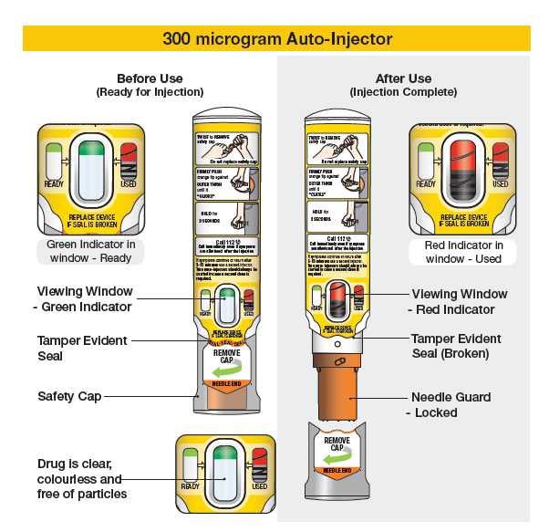

Follow these directions only when ready to use.

Inspect Your Epipen Neo Auto-Injector

- Check the medicine through the auto-injector viewing window (See Figure A) and make sure the medicine is clear, colourless and free of particles.  - Check the tamper evident seal (See Figure A), for signs of tampering. Replace the auto-injector if the seal is broken.  - Check the expiration date located in the black panel on the side of your Epipen Neo Auto-Injector. Replace the auto-injector if the expiration date has passed. | 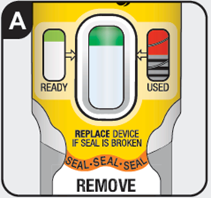
A dose of Epipen Neo Auto-Injector requires 2 tasks: Prepare and Administer

Prepare  - Remove auto-injector from carton.  - Read Instructions for Use on auto-injector label.  - Twist to remove safety cap (See Figure B).  Do not remove safety cap if not preparing for an injection. | 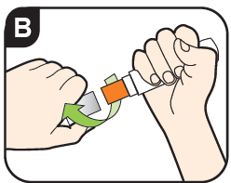

Note:
- The safety cap is made to fit tightly. Twist firmly to remove.
Do not replace the safety cap after it is removed.
- To avoid an accidental injection, never put your thumb, fingers or hand over the orange tip. If an accidental injection happens, get medical help right away.

Administer

- Hold leg firmly in place (if administering to a child).  (See figure C). | 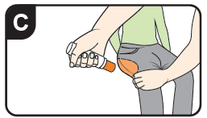
- Firmly push the auto-injector against the outer thigh until you hear a click (See Figure D). The click signals that the injection has started. The auto injector can be used through clothes/trousers. | 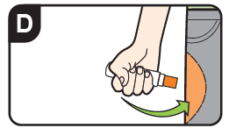
- Hold in place for 3 seconds (count slowly 1, 2, 3) (See Figure E). The injection is now complete. | 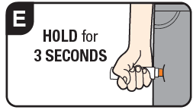
- Remove auto-injector from injection site (See Figure F). The orange tip will extend to cover the needle and block the viewing window with a red indicator. | 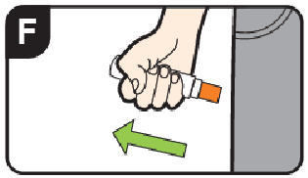
- Massage injection site for 10 seconds (See Figure G). | 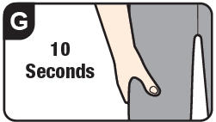

Call emergency services (112) immediately even if symptoms get better after the injection.

Remember you may need a second auto-injector.
- A second dose of adrenaline may be required if symptoms continue or return after 5 – 15 minutes. Repeat steps 1-8 if a second dose is required.
- Two auto-injectors should always be carried in case a second dose is required.

Important Information – After Use

- Epipen Neo Auto-Injector is a single-use injectable device that delivers a fixed dose of adrenaline.
- The auto-injector cannot be reused. Do not attempt to reuse Epipen Neo Auto-Injector after the auto-injector has been activated.
- After the auto-injector has been used, the safety cap cannot be replaced.
- The correct dose has been administered if the orange needle tip is extended and the viewing window is blocked with a red indicator.

Dispose and Replace:

- Tell a healthcare provider that you have received an injection of adrenaline. Show a healthcare provider where you received the injection.
- Take your used Epipen Neo Auto-Injector to a healthcare provider for inspection and proper disposal.
- After use ask for a replacement.

See section 4.2 for instructions to be conveyed to the patient/carer regarding actions to be taken following each use of Epipen Neo Auto-Injector.

7. MARKETING AUTHORISATION HOLDER
Viatris ApS
Borupvang 1
2750 Ballerup

8. MARKETING AUTHORISATION NUMBER(S)
71767

9. DATE OF FIRST AUTHORISATION
27 April 2026

10. DATE OF REVISION OF THE TEXT
-

