

**Date: 8 July 20201**

**SUMMARY OF PRODUCT CHARACTERISTICS**

**for**

**Galli Ad, radionuclide generator**

**1. NAME OF THE MEDICINAL PRODUCT**

Galli Ad

**2. QUALITATIVE AND QUANTITATIVE COMPOSITION**

The radionuclide generator contains germanium (68Ge) as mother nuclide which decays to the daughter nuclide gallium (68Ga).

The germanium (68Ge) used for the production of the (68Ge/68Ga) generator is carrierfree. The total radioactivity due to germanium (68Ge) and gamma-ray-emitting impurities is not more than 0.001%.

The Galli Ad 0.74 – 1.85 GBq radionuclide generator is a system for the elution of gallium (68Ga) chloride solution for radiolabelling in accordance with Ph. Eur 2464. This solution is eluted from a column on which the mother nuclide germanium (68Ge) , parent of gallium (68Ga) is fixed. The system is shielded. Physical characteristics of both mother and daughter nuclides are summarized in Table 1.

**Table 1: physical characteristics of 68Ge and 68Ga**

|  |  |  |
| --- | --- | --- |
|  | **Physical characteristics of** | |
| **68Ge** | **68Ga** |
| Half-live | 270.95 days | 67.71 minutes |
| Type of decay | Electron capture | Positron emission |
| X-rays | 9.225 (13.1 %)  9.252 (25.7 %)  10.26 (1.64 %)  10.264 (3.2 %)  10.366 (0.03 %) | 8.616 (1.37 %)  8.639 (2.69 %)  9.57 (0.55 %) |
| Gammas |  | 511 keV (178.28 %),  578.55 keV (0.03 %)  805.83 keV (0.09 %),  1077.34 keV (3.22 %)  1260.97 keV (0.09 %)  1883.16 keV (0.14 %) |
| beta+ |  | Energy max. Energy  352.60 keV 821.71 keV (1.20 %)  836.00 keV 1899.01 keV (87.94 %) |
| Data derived from nudat (www.nndc.bnl.gov) | | |

1.1 ml of the Galli Ad eluate contains a potential maximum of 1850 MBq 68Ga and 18.5 kBq 68Ge (0.001 % breakthrough). This corresponds to 1.2 ng 68Ga-gallium and 0.07 ng 68Ge-germanium.

The quantity of gallium (68Ga) chloride solution for radiolabelling Ph. Eur. that may be eluted from the generator is dependent on the quantity of germanium (68Ge) chloride present and the lapsed time since the previous elution. If mother and daughter nuclides are in equilibrium more than 60 % of the present gallium (68Ga) chloride can be eluted. A fixed volume of 1.1 mL (68Ga) chloride solution is eluted.

Table 2 summarizes the activity on the generator and obtained by elution at the start of the shelf-life and at the end of the shelf-life.

**Table 2: activity on the generator and obtained by elution**

|  |  |  |  |  |
| --- | --- | --- | --- | --- |
| Strength | Activity inside generator at the start of shelf-life | Activity inside generator at the end of shelf-life | Eluted activity at the start of shelf-life* | Eluted activity at the end of shelf-life* |
| 0.74 GBq | 0.74 GBq ± 10 % | 0.3 GBq ± 10 % | NLT 0.41 GBq | NLT 0.16 GBq |
| 1.11 GBq | 1.11 GBq ± 10 % | 0.4 GBq ± 10 % | NLT 0.61 GBq | NLT 0.22 GBq |
| 1.48 GBq | 1.48 GBq ± 10 % | 0.6 GBq ± 10 % | NLT 0.81 GBq | NLT 0.32 GBq |
| 1.85 GBq | 1.85 GBq ± 10 % | 0.7 GBq ± 10 % | NLT 1.02 GBq | NLT 0.40 GBq |

*NLT = not less than*

*\* in equilibrium*

More detailed explanations and examples for elutable activities at various time points are given in section 12.

For the full list of excipients, see section 6.1.

**3. PHARMACEUTICAL FORM**

Radionuclide generator

The generator is presented as a plastic case with an outlet port and a knob. The solution for elution is integrated inside the plastic case. The eluate can be collected at the outlet port or inserted directly into a synthesis apparatus.

**4. CLINICAL PARTICULARS**

**4.1 Therapeutic indications**

This medicinal product is not intended for direct use in patients.

The eluate from the radionuclide generator (gallium (68Ga) chloride solution) is indicated for *in vitro* radiolabelling of various kits for radiopharmaceutical preparation developed and approved for radiolabelling with such solution to be used for positron emission tomography (PET) imaging.

**4.2 Posology and method of administration**

This medicinal product is for use in designated nuclear medicine facilities only, and should only be handled by specialists experienced with *in vitro* radiolabelling.

Posology

The quantity of the eluate (gallium (68Ga) chloride solution) required for radiolabelling and the quantity of 68Ga-labelled medicinal product that is subsequently administered will depend on the medicinal product that is radiolabelled and its intended use. Refer to the Summary of Product Characteristics/package leaflet of the particular medicinal product to be radiolabelled.

One elution corresponds to a fixed volume of 1.1 mL.

Paediatric population

Please refer to the Summary of Product Characteristics/package leaflet of the 68Ga-labelled medicinal product for more information concerning its paediatric use.

Method of administration

The gallium (68Ga) chloride solution is not intended for direct use in patients but is used for *in vitro* radiolabelling of various kits for radiopharmaceutical preparation. The route of administration of the final medicinal product should be adhered to.

For instructions on extemporary preparation of the medicinal product before administration, see section 12.

**4.3 Contraindications**

Do not administer gallium (68Ga) chloride solution directly to the patient.

The use of 68Ga-labelled medicinal products is contraindicated in case of hypersensitivity to the active substance or to any of the excipients listed in section 6.1.

For information on contraindications to particular 68Ga-labelled medicinal products prepared by radiolabelling with gallium (68Ga) chloride solution, refer to the Summary of Product Characteristics/package leaflet of the particular medicinal product to be radiolabelled.

**4.4 Special warnings and precautions for use**

Gallium (68Ga) chloride solution is not to be administered directly to the patient but is used for *in vitro* radiolabelling of various kits for radiopharmaceutical preparation.

Individual benefit/risk justification

For each patient, the radiation exposure must be justifiable by the likely benefit.

The activity administered should in every case be as low as reasonably achievable to obtain the required effect.

General warnings

For information concerning special warnings and special precautions for use of 68Ga-labelled medicinal products refer to the Summary of Product Characteristics/package leaflet of the medicinal product to be radiolabelled.

**4.5 Interaction with other medicinal products and other forms of interaction**

No interaction studies of gallium (68Ga) chloride solution with other medicinal products have been performed, because it is for radiolabelling of medicinal products.

For information concerning interactions associated with the use of 68Ga-labelled medicinal products refer to the Summary of Product Characteristics/package leaflet of the medicinal product to be radiolabelled.

**4.6 Pregnancy and lactation**

Women of childbearing potential

When an administration of radioactive medicinal products to a woman of childbearing potential is intended, it is important to determine whether or not she is pregnant. Any woman who has missed a period should be assumed to be pregnant until proven otherwise. If in doubt about her potential pregnancy (if the woman has missed a period, if the period is very irregular etc.), alternative techniques not using ionising radiation (if there are any) should be offered to the patient.

Pregnancy

Radionuclide procedures carried out on pregnant women also involve radiation dose to the foetus. Only essential investigations should therefore be carried out during pregnancy, when the likely benefit far exceeds the risk incurred by the mother and foetus.

Breast-feeding

Before administering a radioactive medicinal product to a mother who is breast-feeding, consideration should be given to whether the investigation could be reasonably delayed until the mother has ceased breast-feeding. If the administration is considered necessary, breast-feeding should be interrupted for 12 hours and the expressed feeds discarded.

Further information concerning the use of a 68Ga-labelled medicinal product in pregnancy and breast-feeding is specified in the Summary of Product Characteristics/package leaflet of the medicinal product to be radiolabelled.

Fertility

Further information concerning the use of a 68Ga-labelled medicinal product concerning fertility is specified in the Summary of Product Characteristics/package leaflet of the medicinal product to be radiolabelled.

**4.7 Effects on ability to drive and use machines**

Effects on ability to drive and use machines following administration of 68Ga-labelled medicinal products will be specified in the Summary of Product Characteristics/package leaflet of the medicinal product to be radiolabelled.

**4.8 Undesirable effects**

Possible adverse reactions following the use of a 68Ga-labelled medicinal product, will be dependent on the specific medicinal product being used. Such information will be supplied in the Summary of product Characteristics/package leaflet of the medicinal product to be radiolabelled.

Reporting of suspected adverse reactions

Reporting suspected adverse reactions after authorisation of the medicinal product is important. It allows continued monitoring of the benefit/risk balance of the medicinal product. Healthcare professionals are asked to report any suspected adverse reactions via:

Lægemiddelstyrelsen

Axel Heides Gade 1

DK-2300 København S

Websted: [www.meldenbivirkning.dk](http://www.meldenbivirkning.dk)

**4.9 Overdose**

Accidental administration of the eluate consisting of 0.1 mol/l hydrochloric acid may cause local venous irritation and, in case of paravenous injection, tissue necrosis. The catheter or affected area should be irrigated with isotonic saline solution.

No toxic effects are to be expected from the free 68Ga after an inadvertent administration of the eluate. The administered free 68Ga decays almost completely to inactive 68Zn within a short time (97 % are decayed in 6 hours). During this time, 68Ga is mainly concentrated in the blood/plasma (bound to transferrin) and in the urine. The patient should be hydrated to increase the excretion of the 68Ga and forced diuresis as well as frequent bladder voiding is recommended.

Human radiation dose may be estimated using the information given in section 11.

**5. PHARMACOLOGICAL PROPERTIES**

**5.1 Pharmacodynamic properties**

Pharmacotherapeutic group: Other diagnostic radiopharmaceuticals, ATC code: V09X

The pharmacodynamic properties of 68Ga-labelled medicinal products prepared by radiolabelling with Galli Ad prior to administration will be dependent on the nature of the medicinal product to be labelled. Refer to the Summary of Product Characteristics/package leaflet of the product to be radiolabelled.

Paediatric population

The European Medicines Agency has waived the obligation to submit the results of studies with Galli Ad in all subsets of the paediatric population on grounds of lack of significant therapeutic benefit over existing treatments (see section 4.2 for information on paediatric use). This waiver does however not extend to any diagnostic or therapeutic uses of the product when linked to a carrier molecule.

**5.2 Pharmacokinetic properties**

Gallium (68Ga) chloride solution is not intended for direct use in patients but is used for *in vitro* radiolabelling of various kits for radiopharmaceutical preparation. Therefore, the pharmacokinetic properties of 68Ga-labelled medicinal products will depend on the nature of the medicinal product to be radiolabelled.

Although gallium (68Ga) chloride solution is not intended for direct use in patients, its pharmacokinetic properties were investigated in rats.

**5.3 Preclinical safety data**

The toxicological properties of 68Ga labelled medicinal products prepared by radiolabelling with gallium (68Ga) chloride solution, prior to administration, will depend on the nature of the medicinal product to be radiolabelled.

**6. PHARMACEUTICAL PARTICULARS**

**6.1 List of excipients**

* Matrix: Titanium dioxide.
* Integrated eluent: Sterile 0.1 mol/l hydrochloric acid.

**6.2 Incompatibilities**

Radiolabelling of carrier molecules with gallium (68Ga) chloride is very sensitive to the presence of trace metal impurities.

It is important that all glassware, syringe needles etc., used for the preparation of the radiolabelled medicinal product are thoroughly cleaned to ensure freedom from such trace metal impurities. Only syringe needles with proven resistance to dilute acid should be used to minimise trace metal impurity levels.

It is recommended not to use uncoated chlorobutyl stoppers for the elution evacuated vial as they may contain considerable amounts of zinc that is extracted by the acidic eluate. As a general rule, when available, it is recommended to use the vials provided with the non-radioactive tracer to be labelled or a material identical or equivalent to that provided as a starter kit with the generator (see section 6.5 “accessories supplied with the generator”).

**6.3 Shelf life**

Radionuclide generator: 12 months from calibration date.

The calibration date and the expiry date are stated on the label.

Gallium (68Ga) chloride eluate: After elution, immediately use the eluate.

**6.4 Special precautions for storage**

Radionuclide generator: Do not store above 25 °C.

Storage of radiopharmaceuticals should be in accordance with national regulations on radioactive materials.

**6.5 Nature and contents of container**

The column consists of a PEEK (polyetheretherketone) column which is attached to PEEK inlet and outlet lines via HPLC-style fittings. The inlet line is connected to the eluent container (PE/EVOH) via a dosing system (PE/EVA/PVC/PC/PTFE) and a C-flex line while the outlet line is connected to a union that pass through the outer case of the Galli Ad generator.

The column is contained within radiation shield assembly (Pb, W). The shield assembly and the eluent container are secured in a plastic outer box.

Accessories supplied with the generator

5×10 ml sterile evacuated vials ref: SVV-10A(Huayi).

5×sterile tubing ref: 1155.03 or 1155.05 (Vygon).

5×sterile needle 0.8×16mm 21G 5/8’’ ref: AN*2116R1 (Terumo).

5×male male luer-lock connector ref: 893.00 (Vygon).

Pack sizes

The radionuclide generators are supplied with the following 68Ge activity amounts at calibration date: 0.74 GBq, 1.11 GBq, 1.48 GBq, 1.85 GBq. The integrated eluent volume (610 mL) allows for 450 elutions.

Sectional view of the Galli Ad radionuclide generator

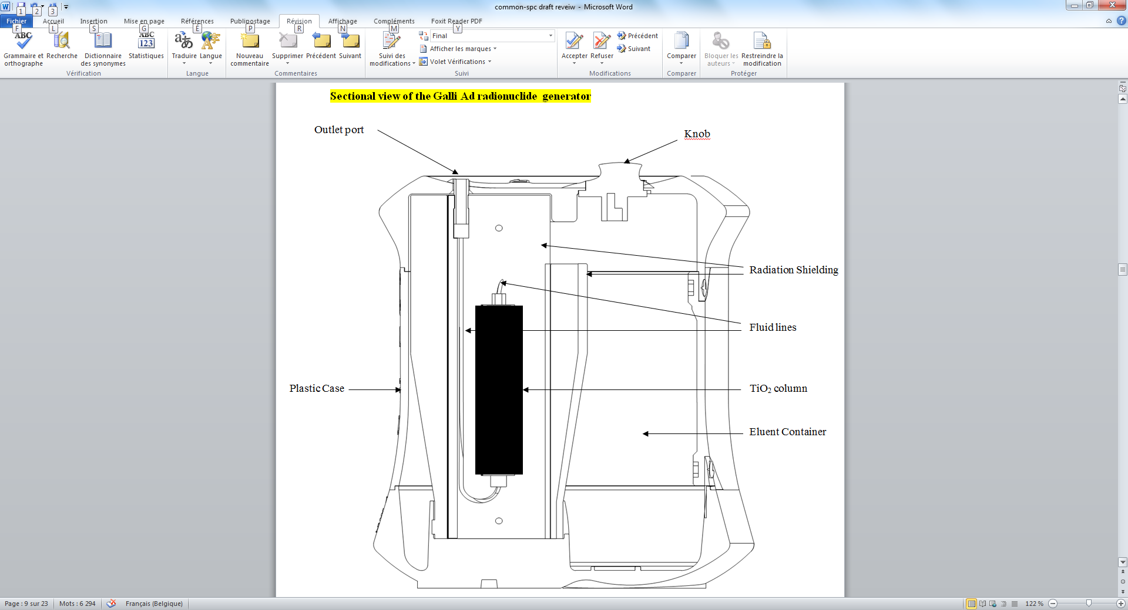

3D view of the Galli Ad radionuclide generator

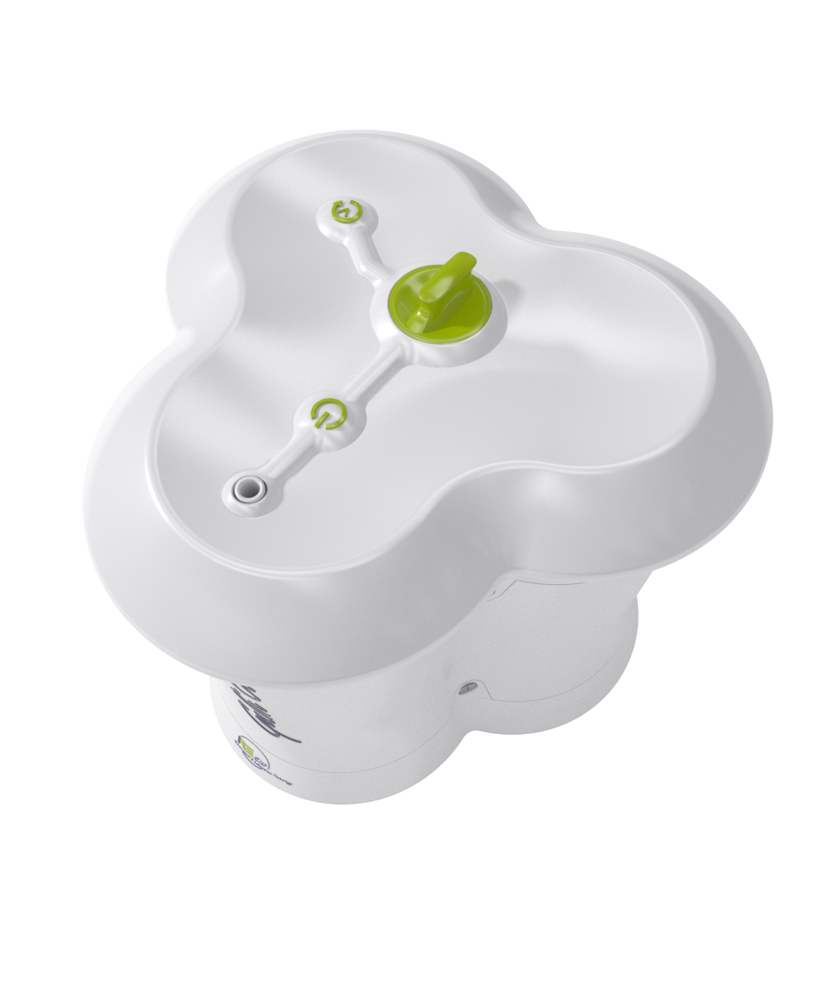**Size**

Outlet port

Plastic case

Knob

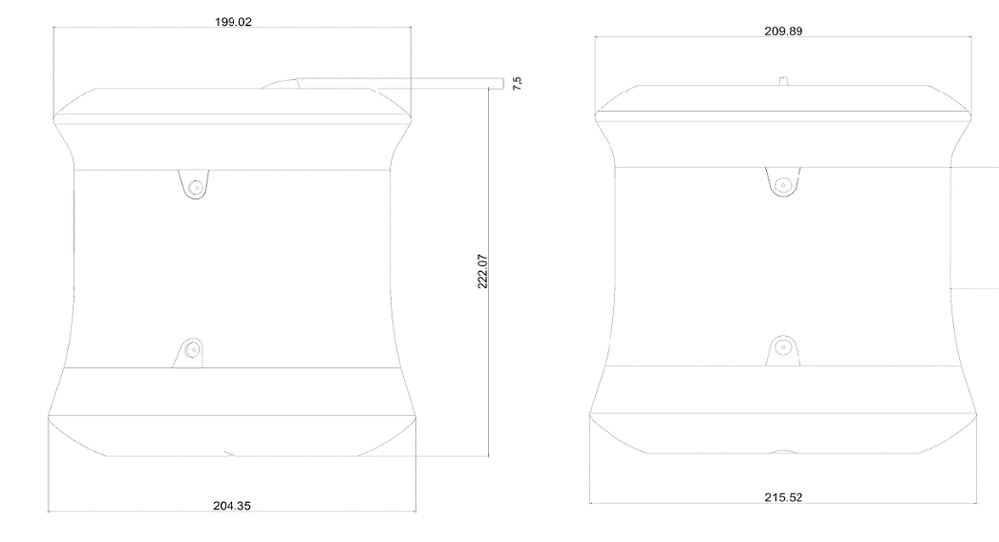

**Weight:** approximately 16.5 kg

**6.6 Special precautions for disposal and other handling**

General warnings

Radiopharmaceuticals should be received, used and administered only by authorised persons in designated clinical settings. Their receipt, storage, use, transfer and disposal are subject to the regulations and/or appropriate licenses of the competent official organisation.

Radiopharmaceuticals should be prepared in a manner which satisfies both radiation safety and pharmaceutical quality requirements. Appropriate aseptic precautions should be taken.

The generator must not be disassembled for any reason as this may damage the internal components and possibly lead to a leak of radioactive material. Also, disassembly of the casing will expose the lead shielding to the operator.

Administration procedures should be carried out in a way to minimize risk of contamination of the medicinal product and irradiation of the operators. Adequate shielding is mandatory.

The administration of radiopharmaceuticals creates risks for other persons from external radiation or contamination from spill of urine, vomiting, etc. Radiation protection precautions in accordance with national regulations must therefore be taken.

Expired generators must be returned to IRE-ELiT. The residual activity of the generator must be estimated before return.

Any unused medicinal product or waste material should be disposed of in accordance with local requirements.

**7. MARKETING AUTHORISATION HOLDER**

IRE-ELiT

Avenue de l’Espérance 1

B-6220 Fleurus

Belgien

**8. MARKETING AUTHORISATION NUMBER(S)**

58629

**9. DATE OF FIRST AUTHORISATION**

8 June 2018

**10. DATE OF REVISION OF THE TEXT**

8. July 2021

**11. DOSIMETRY**

The radiation dose received by the various organs following intravenous administration of a 68Ga-labelled medicinal product is dependent on the specific medicinal product being radiolabelled. Information on radiation dosimetry of each different medicinal product following administration of the radiolabelled preparation will be available in the Summary of Product Characteristics of the particular medicinal product.

The dosimetry tables 3 and 4 below are presented in order to evaluate the contribution of non-conjugated 68Ga to the radiation dose following the administration of 68Ga-labelled medicinal product or resulting from an accidental intravenous injection of gallium (68Ga) chloride solution.

The dosimetry estimates were based on a rat distribution study and the calculations were effected using OLINDA - Organ Level INternal Dose Assessment Code. Time points for measurements were 5 minutes, 30 minutes, 60 minutes, 120 minute, 180 minutes, and 360 minutes.

**Table 3: Absorbed dose per unit activity administered –inadvertent administration in women**

**Absorbed dose per unit radioactivity administered (mGy/MBq)**

|  |  |  |  |  |  |  |
| --- | --- | --- | --- | --- | --- | --- |
| **Organ** | **Adult**  **(57 kg)** | **15 years**  **(50 kg)** | **10 years**  **(30 kg)** | **5 years**  **(17 kg)** | **1 year**  **(10 kg)** | **Newborn**  **(5 kg)** |
| Adrenals | 0.0114 | 0.0112 | 0.0164 | 0.0238 | 0.0403 | 0.0782 |
| Brain | 0.0180 | 0.0159 | 0.0176 | 0.0206 | 0.0292 | 0.0667 |
| Breasts | 0.0059 | 0.0058 | 0.0110 | 0.0163 | 0.0269 | 0.0545 |
| Gallbladder Wall | 0.0096 | 0.0092 | 0.0127 | 0.0201 | 0.0390 | 0.0750 |
| LLI Wall | 0.0032 | 0.0032 | 0.0050 | 0.0077 | 0.0133 | 0.0292 |
| Small Intestine | 0.0039 | 0.0039 | 0.0062 | 0.0099 | 0.0178 | 0.0376 |
| Stomach Wall | 0.0057 | 0.0056 | 0.0088 | 0.0133 | 0.0250 | 0.0502 |
| ULI Wall | 0.0040 | 0.0039 | 0.0067 | 0.0104 | 0.0199 | 0.0425 |
| Heart Wall | 0.1740 | 0.1940 | 0.3010 | 0.4830 | 0.8730 | 1.7200 |
| Kidneys | 0.0385 | 0.0421 | 0.0600 | 0.0888 | 0.1600 | 0.4150 |
| Liver | 0.0972 | 0.0974 | 0.1480 | 0.2200 | 0.4270 | 0.9890 |
| Lungs | 0.1860 | 0.2240 | 0.3190 | 0.4930 | 0.9840 | 2.7100 |
| Muscle | 0.0073 | 0.0076 | 0.0131 | 0.0319 | 0.0622 | 0.0954 |
| Ovaries | 0.0188 | 0.0203 | 0.0566 | 0.0988 | 0.2250 | 0.4590 |
| Pancreas | 0.0187 | 0.0218 | 0.0406 | 0.0547 | 0.1120 | 0.3400 |
| Red Marrow | 0.0225 | 0.0256 | 0.0415 | 0.0777 | 0.1770 | 0.5710 |
| Osteogenic Cells | 0.1160 | 0.1140 | 0.1840 | 0.3100 | 0.7350 | 2.3500 |
| Skin | 0.0029 | 0.0029 | 0.0044 | 0.0067 | 0.0122 | 0.0271 |
| Spleen | 0.0055 | 0.0056 | 0.0086 | 0.0130 | 0.0238 | 0.0492 |
| Thymus | 0.0100 | 0.0102 | 0.0133 | 0.0190 | 0.0297 | 0.0570 |
| Thyroid | 0.2210 | 0.2980 | 0.4600 | 1.0200 | 1.9300 | 2.6300 |
| Urinary Bladder Wall | 0.0023 | 0.0022 | 0.0038 | 0.0063 | 0.0110 | 0.0222 |
| Uterus | 0.0792 | 0.0802 | 1.3400 | 2.0300 | 3.6900 | 1.4700 |
| Total Body | 0.0177 | 0.0178 | 0.0289 | 0.0468 | 0.0920 | 0.2340 |

**Effective Dose (mSv/MBq)** 0.0483 0.0574 0.1230 0.2090 0.4100 0.7170

**Table 4: Absorbed dose per unit activity administered – inadvertent administration in men**

**Absorbed dose per unit radioactivity administered (mGy/MBq)**

|  |  |  |  |  |  |  |
| --- | --- | --- | --- | --- | --- | --- |
| **Organ** | **Adult**  **(70 kg)** | **15 years**  **(50 kg)** | **10 years**  **(30 kg)** | **5 years**  **(17 kg)** | **1 year**  **(10 kg)** | **Newborn**  **(5 kg)** |
| Adrenals | 0.0093 | 0.0112 | 0.0165 | 0.0235 | 0.0377 | 0.0749 |
| Brain | 0.0134 | 0.0137 | 0.0148 | 0.0170 | 0.0241 | 0.0563 |
| Breasts | 0.0062 | 0.0074 | 0.0142 | 0.0213 | 0.0350 | 0.0725 |
| Gallbladder Wall | 0.0081 | 0.0096 | 0.0137 | 0.0213 | 0.0409 | 0.0803 |
| LLI Wall | 0.0015 | 0.0020 | 0.0031 | 0.0051 | 0.0091 | 0.0204 |
| Small Intestine | 0.0022 | 0.0029 | 0.0048 | 0.0080 | 0.0146 | 0.0309 |
| Stomach Wall | 0.0048 | 0.0066 | 0.0099 | 0.0153 | 0.0287 | 0.0560 |
| ULI Wall | 0.0027 | 0.0033 | 0.0058 | 0.0094 | 0.0182 | 0.0385 |

|  |  |  |  |  |  |  |
| --- | --- | --- | --- | --- | --- | --- |
| Heart Wall | 0.3030 | 0.3930 | 0.6110 | 0.9830 | 1.7800 | 3.4900 |
| Kidneys | 0.0198 | 0.0241 | 0.0345 | 0.0510 | 0.0911 | 0.2310 |
| Liver | 0.0766 | 0.1030 | 0.1570 | 0.2330 | 0.4500 | 1.0400 |
| Lungs | 0.1340 | 0.2000 | 0.2850 | 0.4390 | 0.8720 | 2.3800 |
| Muscle | 0.0051 | 0.0074 | 0.0129 | 0.0326 | 0.0636 | 0.0961 |
| Pancreas | 0.0187 | 0.0257 | 0.0480 | 0.0646 | 0.1310 | 0.4030 |
| Red Marrow | 0.0138 | 0.0154 | 0.0243 | 0.0441 | 0.0980 | 0.3110 |
| Osteogenic Cells | 0.0431 | 0.0558 | 0.0901 | 0.1510 | 0.3560 | 1.1300 |
| Skin | 0.0020 | 0.0024 | 0.0036 | 0.0057 | 0.0103 | 0.0232 |
| Spleen | 0.0041 | 0.0056 | 0.0084 | 0.0130 | 0.0227 | 0.0469 |
| Testes | 0.0011 | 0.0018 | 0.0075 | 0.0094 | 0.0138 | 0.0239 |
| Thymus | 0.0139 | 0.0158 | 0.0194 | 0.0276 | 0.0417 | 0.0794 |
| Thyroid | 0.1980 | 0.3250 | 0.5020 | 1.1200 | 2.1100 | 2.8800 |
| Urinary Bladder Wall | 0.0011 | 0.0013 | 0.0022 | 0.0039 | 0.0070 | 0.0152 |
| Total Body | 0.0115 | 0.0147 | 0.0237 | 0.0383 | 0.0748 | 0.1900 |

**Effective Dose (mSv/MBq)** 0.0338 0.0506 0.0756 0.1340 0.2600 0.5550

The effective dose resulting from an accidental intravenously injected activity of 250 MBq is 12.1 mSv for a 57-kg female adult and 8.45 mSv for a 70-kg male adult.

Data on the radiation dose to patients of gallium (68Ga) citrate listed in the table 5 below are from ICRP 53 and may be used to estimate distribution after inadvertent application of unbound gallium (68Ga) from the generator eluate, even though the data were obtained using a different salt.

Table 5: Absorbed dose per unit activity inadvertent administration of gallium (68Ga)-Citrate

**Absorbed dose per unit radioactivity administered of 68Ga-Citrate (mGv/MBq)**

|  |  |  |  |  |  |
| --- | --- | --- | --- | --- | --- |
| **Organ** | **Adult** | **15 years** | **10 years** | **5 years** | **1 year** |
| Adrenals | 0.034 | 0.044 | 0.064 | 0.088 | 0.140 |
| Bone surface | 0.037 | 0.048 | 0.080 | 0.140 | 0.310 |
| Breast | 0.014 | 0.014 | 0.023 | 0.037 | 0.074 |
| LLI Wall | 0.018 | 0.022 | 0.036 | 0.059 | 0.110 |
| Small Intestine | 0.064 | 0.080 | 0.140 | 0.230 | 0.450 |
| Stomach Wall | 0.014 | 0.017 | 0.027 | 0.044 | 0.084 |
| ULI Wall | 0.053 | 0.064 | 0.110 | 0.180 | 0.360 |
| Kidneys | 0.026 | 0.032 | 0.046 | 0.068 | 0.120 |
| Liver | 0.027 | 0.035 | 0.053 | 0.079 | 0.150 |
| Lungs | 0.013 | 0.016 | 0.025 | 0.041 | 0.080 |
| Pancreas | 0.014 | 0.018 | 0.029 | 0.047 | 0.089 |
| Red Marrow | 0.046 | 0.064 | 0.110 | 0.210 | 0.450 |
| Spleen | 0.036 | 0.051 | 0.080 | 0.130 | 0.240 |
| Testes | 0.013 | 0.015 | 0.024 | 0.039 | 0.077 |
| Thyroid | 0.012 | 0.015 | 0.025 | 0.042 | 0.081 |
| Urinary Bladder Wall | 0.014 | 0.016 | 0.026 | 0.044 | 0.081 |
| Other tissue | 0.013 | 0.015 | 0.025 | 0.041 | 0.080 |
|  |  |  |  |  |  |
| **Effective Dose (mSv/MBq)** | 0.027 | 0.034 | 0.056 | 0.095 | 0.190 |

External radiation exposure

The average surface or contact radiation for the (68Ge/68Ga) radionuclide generator is less than 0.054 µSv/h per MBq of 68Ge. For example, a 1.85 GBq generator will reach a maximum average surface dose rate of 100 µSv/h. It is generally recommended that the generator is stored within auxiliary shielding to minimize dose to operating personnel.

**12. INSTRUCTIONS FOR PREPARATION OF RADIOPHARMACEUTICALS**

Elution of the generator must be performed in premises complying with the national regulations concerning the safety of use of radioactive products.

**Elution should be performed under aseptic conditions.**

Unpacking of the generator

1. Check flight case for shipping damage. If damaged, perform radiation wipe survey of the damaged area. If the activity exceeds 40 becquerel per 100 cm2 , notify your Radiation Safety Officer.
2. Before opening the case, please refer to the arrow signs to make sure the shipping box is placed **in the right orientation**. Check that the security seals are not broken. Then cut the seals and open all toggle-type fasteners. Remove vertically the upper part of the flight case. Take out small removable foam dunnages from the lower part of the flight case in order to permit the extraction of the generator.
3. Carefully remove generator. Perform radiation survey.

CAUTION: Drop hazard: The Galli Ad generator weighs approximately 16.5 kg. Handle with care and firmly to avoid potential injuries. If generator is dropped or if shipping damage extends into the inner flight case, check for leaks and perform a wipe survey of the generator.

1. Perform wipe survey of box inserts and generator outer surface. If wipes exceed 40 becquerel per 100 cm2, notify your Radiation Safety Officer.
2. Check the whole casing and outlet port and sealfor damage.
3. Do not remove the port plug before installing the generator nor before being ready for elution.

Optimal positioning

1. Generator must always stand in a vertical position i.e. so that the green control button faces upwards.
2. When installing the Galli Ad radionuclide generator in its final position, i.e. with a synthesis device or for manual elutions, it is recommended to keep the outlet line as short as possible (maximum 50 cm) as the length of this tubing may influence the recovered yield in the receiving/reaction vial.
3. Local shielding is recommended (especially when performing an elution) and personal protective equipment, eye and hand protection, must be used.

Preparation

1. **Aseptic working technique must be applied when using the generator, especially when handling the elution port. This is critical for the maintenance of sterility.**

The attachment of tubing, elution needles, in the elution of the generator and other activities potentially exposing the internal surfaces of generator to the environment should be undertaken using aseptic technique in an appropriately clean environment according to current national requirements. In particular, use of gloves and sterile cleaning of the vials is mandatory before use. In case the vial is to be opened and closed, the stopper should be put upside down on the bench.

1. Unscrew manually the cap from the luer lock connector (fig. 1).

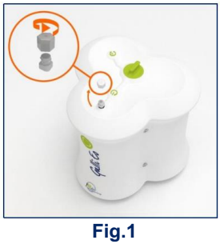

1. Connect manually a **sterile tubing** (extension line) to the luer lock connector (fig. 2). *For example, product number 1155.03 or 1155.05 from Vygon are*  
   *suitable*. *Other sterile polyethylene tubing intended for parenteral use is suitable provided void volume is not more than 1mL.*

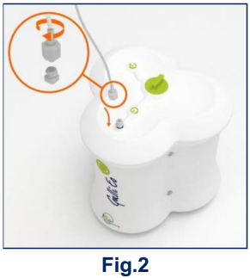

1. A. In case of use with a synthesis device, connect the other end of the tubing to the

synthesis device. Avoid hard bending or pinching of the line.

1. In case of manual elution, connect a sterile needleto the other end of the tubing using a male/male luer lock adapter(fig. 3). Avoid hard bending or pinching of the line.  
   *For example, product number AN*2116R1 0.8 X 16mm 21G $5/8$ from Terumo*  
   *and product number 893.00 from Vygon are suitable. Other sterile polyethylene tubing intended for parenteral use is suitable provided that the void volume is not more than 1mL.*

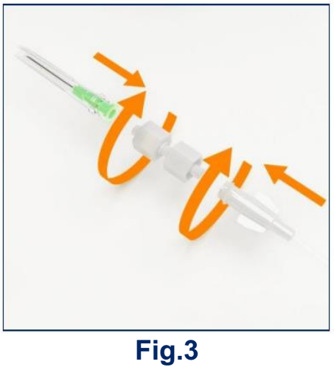

1. The Galli Ad generator is now ready for use.

Elution

1. Prepare additional necessary materials:

* Personal protective equipment: Elutions should be performed while wearing eye and hand protection and also appropriate laboratory cloth.
* Shielded receiving evacuated sterile 10 ml vial in case of manual elution. Avoid uncoated chlorobutyl stoppers as they may contain considerable amounts of zinc that is extracted by the acidic eluate. As a general rule, when available, it is recommended to use the vials provided with the non-radioactive tracer to be labelled or a material identical or equivalent to that provided as a starter kit with the generator. These accessories are:

5×10 ml sterile evacuated vials ref: SVV-10A(Huayi).

5× sterile tubing ref: 1155.03 or 1155.05 (Vygon).

5× sterile needle 0.8 X 16mm 21G 5/8’’ ref: AN*2116R1 (Terumo).

5× male male luer-lock connector ref: 893.00 (Vygon).

* In case of use of an automatic radiosynthesis module, it is recommended to place a single-use sterile check-valve between the male/male luer lock adapter and the automatic radiosynthesis unit. *For example, product number MX745-01 from*  
  *Smiths Medical is suitable.*

1. **Aseptic working technique must be maintained during the assembly process, especially when handling the ports. This is critical for the maintenance of sterility.**
2. Turn the green button by 90° to the loading position and wait for at least 10  
   seconds (fig.4).

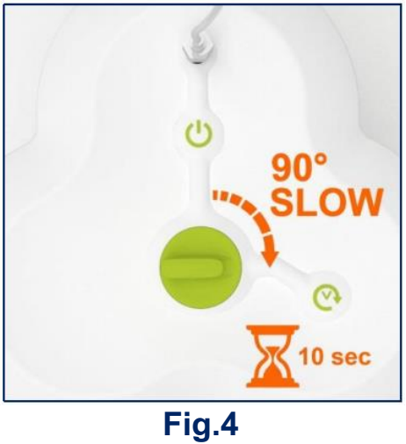

1. Then, turn back the button by 90° to its initial position (fig. 5).

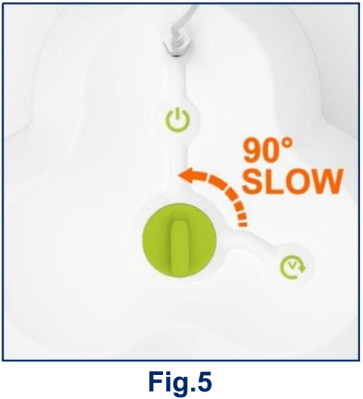

1. The generator is now ready for elution either manually or by a synthesis module. In the latter case please go directly to step 8 after the labelling has been performed by the synthesis module.
2. Remove the cap from the needle and quickly pierce vertically right in the  
   center of the septum of a shielded sterile evacuated elution vial (fig.6). Wait for at least 3 minutes for the elution process to take place (a fixed volume of 1.1 mL is eluted) and for the line to be drained by air. Please use local shielding or radioprotection mean as the activity will be transferred from the generator to the vial. Measure solution with a calibrated dose calibrator to determine the yield. Please decay correct the measured activity to the starting time of elution.

**CAUTION** :10 ml capacity sterile evacuated vials are suitable but it is recommended  
to avoid contact of the eluate with uncoated halobutyl stoppers as they may contain important amounts of zinc that might prevent a subsequent radiolabelling step.

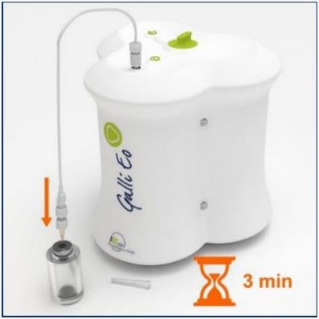



1. Remove the needle from the vial and place the cap (fig. 7 and 8).

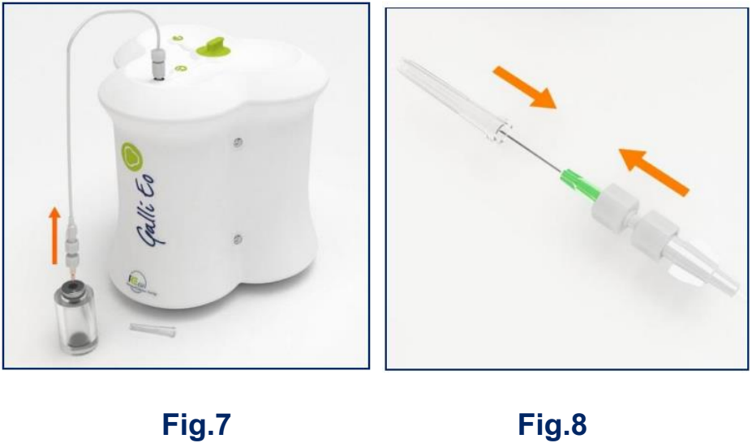

1. Disconnect manually the tubing from the luer lock connector and **place the**  
   **cap in order to obturate the generator outlet** (fig. 9 and 10).

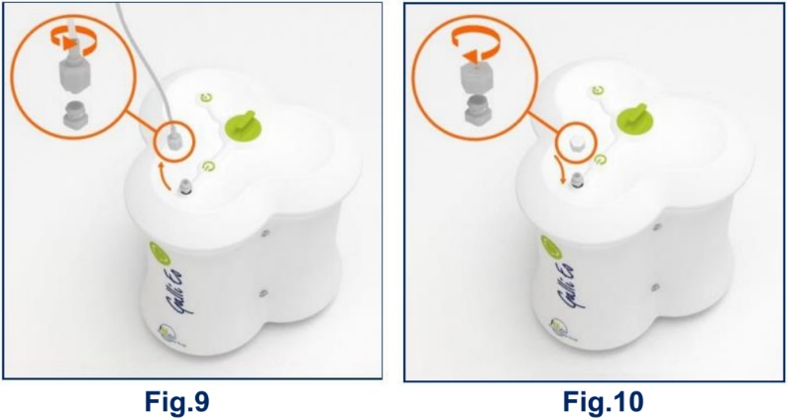

**IMPORTANT:** In case the button was not turned back to the elution position after having been put in the loading position for more than 6 hours, the eluate must be discarded.

First use of the generator

**IMPORTANT**: When using the generator for the first time, **a conditioning procedure**  
**must be performed** once before using it for radiolabeling purposes. It consists of **six consecutive discarded elutions to be carried-out within 24 hours.** These elutions can be performed in a row (one directly after the other) if desired. After that, the next generator eluates are suitable for radiolabeling purposes provided that they come from an elution performed within 24 hours since the last elution. **This conditions only applies to the first eluates intended for radiolabeling during the first four days (i.e. typically only during the first week of use of the generator).**

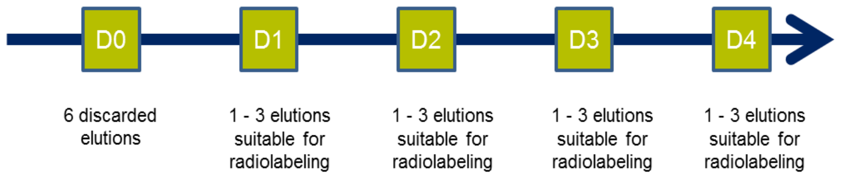

It is recommended to test the eluate for 68Ge breakthrough after the first 6 conditioning discarded elutions by comparing the activity level of the 68Ga and the 68Ge. For further details on the method, please refer to Ph. Eur. Monograph #2464. Breakthrough should be tested at the moment the generator comes into operation (after the foreseen 6 conditioning elutions), and after six months of use.

Continuous routine elution

During the shelf life of the generator, all eluates are suitable for direct radiolabeling provided that a previous elution has been performed **within the** **last 72 hours**. In case a radiolabeling is intended and the generator has not been eluted within that interval, it is recommended to perform one discardable elution beforehand.

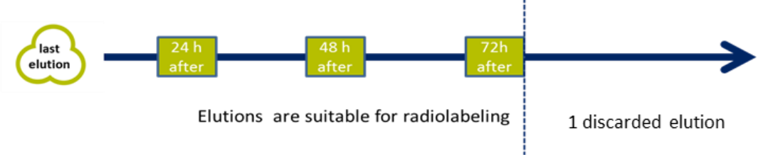

If the generator is not eluted for **more than a month**, **three consecutive discarded**  
**elution are to be performed** and the first eluate intended for radiolabeling should be extracted within the next 24 hours.

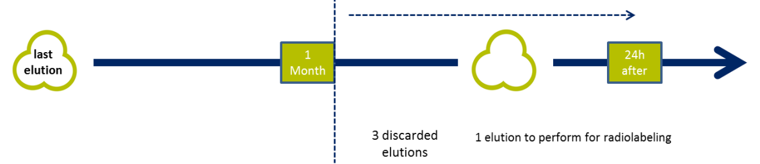

The solution eluted is a clear, sterile and colourless gallium (68Ga) chloride solution, with a pH between 0.5 and 2.0 and a radiochemical purity greater than 95 %. Check the clarity of the eluate before use and discard it if the solution is not clear.

**IMPORTANT:** In case the column has not been drained completely (due to e.g. unsatisfactory vacuum in the vial), a new vacuum vial can be connected to the generator outlet (via tubing, connector and needle) for one minute. In this case, the green button on the generator needs to be in the elution/standby position. This operation will finalize the draining. The content of the new vial can be used if it is used immediately. If not, it has to be discarded.

Galli Ad elution yield

The activity stated on the label of the Galli Ad generator is expressed in 68Ge available at the calibration date (12:00 CET). The available 68Ga activity depends on the 68Ge activity at the time of elution and the elapsed time since the previous elution.

A Galli Ad generator in full equilibrium yields more than 55 % of 68Ga.

The output will decrease with decay of the 68Ge parent over time. For example, after 9 months' decay (39 weeks), the 68Ge will be reduced by 50 % (see Table 6).

**Table 6: Decay Chart for 68Ge**

|  |  |  |  |
| --- | --- | --- | --- |
| **Elapsed Time**  **in weeks** | **Decay Factor** | **Elapsed Time**  **in weeks** | **Decay Factor** |
| 1 | 0.98 | 27 | 0.62 |
| 2 | 0.96 | 28 | 0.61 |
| 3 | 0.95 | 29 | 0.59 |
| 4 | 0.93 | 30 | 0.58 |
| 5 | 0.91 | 31 | 0.57 |
| 6 | 0.90 | 32 | 0.56 |
| 7 | 0.88 | 33 | 0.55 |
| 8 | 0.87 | 34 | 0.54 |
| 9 | 0.85 | 35 | 0.53 |
| 10 | 0.84 | 36 | 0.52 |
| 11 | 0.82 | 37 | 0.52 |
| 12 | 0.81 | 38 | 0.51 |
| 13 | 0.79 | 39 | 0.50 |
| 14 | 0.78 | 40 | 0.49 |
| 15 | 0.76 | 41 | 0.48 |
| 16 | 0.75 | 42 | 0.47 |
| 17 | 0.74 | 43 | 0.46 |
| 18 | 0.72 | 44 | 0.45 |
| 19 | 0.71 | 45 | 0.45 |
| 20 | 0.70 | 46 | 0.44 |
| 21 | 0.69 | 47 | 0.43 |
| 22 | 0.67 | 48 | 0.42 |
| 23 | 0.66 | 49 | 0.42 |
| 24 | 0.65 | 50 | 0.41 |
| 25 | 0.64 | 51 | 0.40 |
| 26 | 0.63 | 52 | 0.39 |

After an elution of the Galli Ad generator the 68Ga will be build up by the continuous decay of the parent 68Ge. The generator requires at least 7 hours to achieve almost full yield after being eluted, but in practice it is also possible to elute the generator after 3 hours.

Table 7 shows the build-up factor of activity of 68Ga which can be eluted after times varying from 0 to 410 minutes since the previous elution:

**Table 7: Build-up factors of 68Ga**

|  |  |  |  |
| --- | --- | --- | --- |
| **Elapsed Time**  **in minutes** | **Build-Up**  **Factor** | **Elapsed Time**  **in minutes** | **Build-Up**  **Factor** |
| 0 | 0.00 | 210 | 0.88 |
| 10 | 0.10 | 220 | 0.89 |
| 20 | 0.19 | 230 | 0.91 |
| 30 | 0.26 | 240 | 0.91 |
| 40 | 0.34 | 250 | 0.92 |
| 50 | 0.40 | 260 | 0.93 |
| 60 | 0.46 | 270 | 0.94 |
| 70 | 0.51 | 280 | 0.94 |
| 80 | 0.56 | 290 | 0.95 |
| 90 | 0.60 | 300 | 0.95 |
| 100 | 0.64 | 310 | 0.96 |
| 110 | 0.68 | 320 | 0.96 |
| 120 | 0.71 | 330 | 0.97 |
| 130 | 0.74 | 340 | 0.97 |
| 140 | 0.76 | 350 | 0.97 |
| 150 | 0.78 | 360 | 0.97 |
| 160 | 0.81 | 370 | 0.98 |
| 170 | 0.82 | 380 | 0.98 |
| 180 | 0.84 | 390 | 0.98 |
| 190 | 0.86 | 400 | 0.98 |
| 200 | 0.87 | 410 | 0.98 |

**Examples**

A 1.85 GBq generator is 12 weeks old. According to table 6, the activity of 68Ge on the column can be calculated as follows:

1.85 GBq x 0.81 = 1.499 GBq

In full equilibrium the activity of 68Ga on the column is also 1.499 GBq.

The generator is eluted and the collected 68Ga activity is 1.049 GBq which corresponds to a typical yield of 70 %.

The same generator is eluted 4 hours later. The 7 hours needed to reach the 68Ge / 68Ga-equilibrium have not elapsed and the 68Ga activity build up on the column can be calculated according to table 7 as follows:

1.499 GBq x 0.91 = 1.364 GBq

With a typical yield of 70 % 68Ga, the collected activity would be:

1.364 GBq x 0.70 = 955 MBq

Note:

The activity of 68Ga in the eluate can be measured to check the quality with regard to identity and content. The activity should be measured immediately after elution, but may also be measured up to 5 half-life periods after elution.

Due to the short half-time of 68Ga which is 67.71 minutes, the elapsed time between the elution and the measurement of the activity has to be decay corrected to determine the actual yield at the elution time with the decay chart of 68Ga, table 8.

**Example**

A new 1.85 GBq generator is eluted. The activity of 68Ga measured 10 minutes after the elution was 1.169 GBq.

The yield at the time of the elution can be obtained by dividing the measured activity by the corresponding factor of the elapsed time stated in table 8:

1.169 GBq / 0.903 = 1.295 GBq

This corresponds to a yield of 68Ga of 70 % at the time of the elution:

1.295 GBq / 1.85 GBq x 100 % = 70 %

**Table 8: Decay chart of 68Ga**

|  |  |  |  |
| --- | --- | --- | --- |
| **Elapsed Time**  **in minutes** | **Decay Factor** | **Elapsed Time**  **in minutes** | **Decay Factor** |
| 1 | 0.990 | 35 | 0.700 |
| 2 | 0.980 | 36 | 0.693 |
| 3 | 0.970 | 37 | 0.686 |
| 4 | 0.960 | 38 | 0.679 |
| 5 | 0.950 | 39 | 0.672 |
| 6 | 0.941 | 40 | 0.665 |
| 7 | 0.931 | 41 | 0.658 |
| 8 | 0.922 | 42 | 0.652 |
| 9 | 0.912 | 43 | 0.645 |
| 10 | 0.903 | 44 | 0.639 |
| 11 | 0.894 | 45 | 0.632 |
| 12 | 0.885 | 46 | 0.626 |
| 13 | 0.876 | 47 | 0.619 |
| 14 | 0.867 | 48 | 0.613 |
| 15 | 0.868 | 49 | 0.607 |
| 16 | 0.850 | 50 | 0.601 |
| 17 | 0.841 | 51 | 0.595 |
| 18 | 0.832 | 52 | 0.589 |
| 19 | 0.824 | 53 | 0.583 |
| 20 | 0.816 | 54 | 0.577 |
| 21 | 0.807 | 55 | 0.571 |
| 22 | 0.799 | 56 | 0.565 |
| 23 | 0.791 | 57 | 0.559 |
| 24 | 0.783 | 58 | 0.554 |
| 25 | 0.775 | 59 | 0.548 |
| 26 | 0.767 | 60 | 0.543 |
| 27 | 0.759 | 61 | 0.537 |
| 28 | 0.752 | 62 | 0.532 |
| 29 | 0.744 | 63 | 0.526 |
| 30 | 0.737 | 64 | 0.521 |
| 31 | 0.729 | 65 | 0.516 |
| 32 | 0.722 | 66 | 0.510 |
| 33 | 0.714 | 67 | 0.505 |
| 34 | 0.707 | 68 | 0.500 |

Quality control

Clarity as well as pH (≤2) of the solution and the radioactivity must be checked before radiolabelling.

68Ge breakthrough

A small amount of 68Ge is washed from the column with each elution. 68Ge breakthrough is expressed as a percentage of total 68Ga eluted from the column, corrected for decay. The 68Ge breakthrough is not more than 0.001 % of the eluted 68Ga activity. When used according to instructions here above, the breakthrough stays below 0.001 % for the entire shelf life of the generator (12 months). For testing the 68Ge breakthrough the activity level of the 68Ga and the 68Ge in the eluate should be compared. For further details please refer to the current version of the Ph. Eur. monograph 2464.

**Warning:** Breakthrough of 68Ge can increase above 0.001 % if the generator is not eluted for more than 72 hours. If the generator has not been used for 72 or more, it should be pre-eluted (1 discarded elution). If the generator has not been eluted for more than a month 3 discarded elutions are to be performed and the first eluate intended for radiolabeling should be extracted within the next 24 hours.