

**29 October 2024**

**SUMMARY OF PRODUCT CHARACTERISTICS**

**for**

**Galliapharm, radionuclide generator**

**1. NAME OF THE MEDICINAL PRODUCT**

Galliapharm

**2. QUALITATIVE AND QUANTITATIVE COMPOSITION**

The radionuclide generator contains germanium (68Ge) as mother nuclide, which decays to the daughter nuclide gallium (68Ga). The germanium (68Ge) used for the production of the 68Ge/68Ga-generator is carrier-free. The total radioactivity due to germanium (68Ge) and gamma-ray-emitting impurities is not more than 0.001%. The Galliapharm 0.74 – 1.85 GBq radionuclide generator is a system for the elution of gallium (68Ga) chloride solution for radiolabelling in accordance with Ph. Eur. 2464. This solution is eluted from a column on which the mother nuclide germanium (68Ge), parent of gallium (68Ga) is fixed. The system is shielded. Physical characteristics of both mother and daughter nuclides are summarized in table 1.

**Table 1: physical characteristics of germanium (68Ge) and gallium (68Ga)**

|  |  |  |
| --- | --- | --- |
|  | **Physical characteristics of** | |
| **68Ge** | **68Ga** |
| Half-life | 270.95 days | 67.71 minutes |
| Type of physical decay | Electron capture | Positron emission |
| X-rays | 9.225 keV (13.1 %)  9.252 keV (25.7 %)  10.26 keV (1.64 %)  10.264 keV (3.2 %)  10.366 keV (0.03 %) | 8.616 keV (1.37 %)  8.639 keV (2.69 %)  9.57 keV (0.55 %) |
| Gamma-rays |  | 511 keV (178.28 %)  578.55 keV (0.03 %)  805.83 keV (0.09 %)  1,077.34 keV (3.22 %)  1,260.97 keV (0.09 %)  1,883.16 keV (0.14 %) |
| beta+ |  | Energy max. Energy  352.60 keV 821.71 keV (1.20 %)  836.00 keV 1,899.01 keV (87.94 %) |
| Data derived from nudat (www.nndc.bnl.gov) | | |

5 ml of the eluate contains a potential maximum of 1850 MBq of 68Ga and 18.5 kBq of 68Ge (0.001 % breakthrough in the eluate). This corresponds to 1.2 ng of gallium and 0.07 ng of germanium.

The quantity of gallium (68Ga) chloride solution for radiolabelling Ph. Eur. that may be eluted from the generator is dependent on the quantity of germanium (68Ge) present, the volume of eluent used (typically 5 ml) and the lapsed time since the previous elution. If mother and daughter nuclides are in equilibrium more than 60 % of the present gallium (68Ga) can be eluted.

Table 2 summarizes the activity on the generator and the activity obtained by elution at the start of the shelf life and at the end of the shelf life.

**Table 2: activity on the generator and activity obtained by elution**

|  |  |  |  |  |
| --- | --- | --- | --- | --- |
| Strength | Activity inside the generator at the start of shelf life | Activity inside the generator at the end of shelf life | Eluted activity at the start of shelf life* | Eluted activity at the end of shelf life* |
| 0.74 GBq | 0.74 GBq ± 10 % | 0.3 GBq ± 10 % | NLT 0.45 GBq | NLT 0.18 GBq |
| 1.11 GBq | 1.11 GBq ± 10 % | 0.4 GBq ± 10 % | NLT 0.67 GBq | NLT 0.24 GBq |
| 1.48 GBq | 1.48 GBq ± 10 % | 0.6 GBq ± 10 % | NLT 0.89 GBq | NLT 0.36 GBq |
| 1.85 GBq | 1.85 GBq ± 10 % | 0.7 GBq ± 10 % | NLT 1.11 GBq | NLT 0.42 GBq |

*NLT = not less than * in equilibrium*

More detailed explanations and examples for elutable activities at various time points are given in section 12.

For the full list of excipients, see section 6.1.

**3. PHARMACEUTICAL FORM**

Radionuclide generator

The generator is presented as a stainless steel case with two handles and an inlet and an outlet port. The solution for elution is attached to the inlet port whereas the eluate can be collected at the outlet port or inserted directly into a synthesis apparatus.

**4. CLINICAL PARTICULARS**

**4.1 Therapeutic indications**

This medicinal product is not intended for direct use in patients.

The eluate from the radionuclide generator (gallium (68Ga) chloride solution) is indicated for *in vitro* labelling of specific carrier molecules developed and approved for radiolabelling with such solution to be used for positron emission tomography (PET) imaging.

**4.2 Posology and method of administration**

This medicinal product is for use in designated nuclear medicine facilities only, and should only be handled by specialists experienced with *in vitro* radiolabelling.

Posology

The quantity of the eluate gallium (68Ga) chloride solution required for radiolabelling and the quantity of 68Ga-labelled medicinal product that is subsequently administered will depend on the medicinal product that is radiolabelled and its intended use. Refer to the Summary of Product Characteristics/package leaflet of the particular medicinal product to be radiolabelled.

Paediatric population

Please refer to the Summary of Product Characteristics/package leaflet of the 68Ga-labelled medicinal product for more information concerning its paediatric use.

Method of administration

The gallium (68Ga) chloride solution is not intended for direct use in patients but is used for *in vitro* radiolabelling of various carrier molecules. The route of administration of the final medicinal product should be adhered to.

For instructions on extemporary preparation of the medicinal product before administration, see section 12.

**4.3 Contraindications**

Do not administer gallium (68Ga) chloride solution directly to the patient.

The use of 68Ga-labelled medicinal products is contraindicated in case of hypersensitivity to the active substance or to any of the excipients listed in section 6.1.

For information on contraindications to particular 68Ga-labelled medicinal products prepared by radiolabelling with gallium (68Ga) chloride solution, refer to the Summary of Product Characteristics/package leaflet of the particular medicinal product to be radio­labelled.

**4.4 Special warnings and precautions for use**

Gallium (68Ga) chloride solution is not to be administered directly to the patient but is used for *in vitro* radiolabelling of various carrier molecules.

Individual benefit/risk justification

For each patient, the radiation exposure must be justifiable by the likely benefit.

The activity administered should in every case be as low as reasonably achievable to obtain the required information.

General warnings

For information, concerning special warnings and special precautions for use of 68Ga-labelled medicinal products refer to the Summary of Product Characteristics/package leaflet of the medicinal product to be radiolabelled.

**4.5 Interaction with other medicinal products and other forms of interaction**

No interaction studies of gallium (68Ga) chloride solution with other medicinal products have been performed, because it is for radiolabelling of medicinal products.

For information, concerning interactions associated with the use of 68Ga-labelled medicinal products refer to the Summary of Product Characteristics/package leaflet of the medicinal product to be radiolabelled.

**4.6 Fertility, pregnancy and lactation**

Women of childbearing potential

When an administration of radioactive medicinal products to a woman of childbearing potential is intended, it is important to determine whether or not she is pregnant. Any woman who has missed a period should be assumed to be pregnant until proven otherwise. If in doubt about her potential pregnancy (if the woman has missed a period, if the period is very irregular etc.), alternative techniques not using ionising radiation (if there are any) should be offered to the patient.

Pregnancy

Radionuclide procedures carried out on pregnant women also involve radiation dose to the foetus. Only essential investigations should therefore be carried out during pregnancy, when the likely benefit far exceeds the risk incurred by the mother and foetus.

Breast-feeding

Before administering a radioactive medicinal product to a mother who is breast-feeding, consideration should be given to whether the investigation could be reasonably delayed until the mother has ceased breast-feeding. If the administration is considered necessary, breast-feeding should be interrupted and the expressed feeds discarded.

Further information concerning the use of a 68Ga-labelled medicinal product in pregnancy and breast-feeding is specified in the Summary of Product Characteristics/package leaflet of the medicinal product to be radiolabelled.

Fertility

Further information concerning the use of a 68Ga-labelled medicinal product concerning fertility is specified in the Summary of Product Characteristics/package leaflet of the medicinal product to be radiolabelled.

**4.7 Effects on ability to drive and use machines**

Effects on ability to drive and use machines following administration of 68Ga-labelled medicinal products will be specified in the Summary of Product Characteristics/package leaflet of the medicinal product to be radiolabelled.

**4.8 Undesirable effects**

Possible adverse reactions following the use of a 68Ga-labelled medicinal product will be dependent on the specific medicinal product being used. Such information will be supplied in the Summary of Product Characteristics/package leaflet of the medicinal product to be radiolabelled.

Reporting of suspected adverse reactions

Reporting suspected adverse reactions after authorisation of the medicinal product is important. It allows continued monitoring of the benefit/risk balance of the medicinal product. Healthcare professionals are asked to report any suspected adverse reactions via

Lægemiddelstyrelsen

Axel Heides Gade 1

DK-2300 København S

Website: [www.meldenbivirkning.dk](http://www.meldenbivirkning.dk)

**4.9 Overdose**

Accidental administration of the eluate consisting of 0.1 mol/l hydrochloric acid may cause local venous irritation and, in case of paravenous injection, tissue necrosis. The catheter or affected area should be irrigated with isotonic saline solution.

No toxic effects are to be expected from the free 68Ga after an inadvertent administration of the eluate. The administered free 68Ga decays almost completely to stable 68Zn within a short time (97 % are decayed in 6 hours). During this time, 68Ga is mainly concentrated in the blood/plasma (bound to transferrin) and in the urine. The patient should be hydrated to increase the excretion of the 68Ga and forced diuresis as well as frequent bladder voiding is recommended.

Human radiation dose may be estimated using the information given in section 11.

**5. PHARMACOLOGICAL PROPERTIES**

**5.1 Pharmacodynamic properties**

Pharmacotherapeutic group: Other diagnostic radiopharmaceuticals, ATC code: V09X

The pharmacodynamic properties of 68Ga-labelled medicinal products prepared by radiolabelling with the generator eluate prior to administration will be dependent on the nature of the medicinal product to be labelled. Refer to the Summary of Product Characteristics/package leaflet of the product to be radiolabelled.

Paediatric population

The European Medicines Agency has waived the obligation to submit the results of studies with Galliapharm in all subsets of the paediatric population on grounds of lack of significant therapeutic benefit over existing treatments (see section 4.2 for information on paediatric use). This waiver does however not extend to any diagnostic or therapeutic uses of the product when linked to a carrier molecule.

**5.2 Pharmacokinetic properties**

Gallium (68Ga) chloride solution is not intended for direct use in patients but is used for *in vitro* radiolabelling of various carrier molecules. Therefore, the pharmacokinetic properties of 68Ga-labelled medicinal products will depend on the nature of the medicinal product to be radiolabelled.

Although gallium (68Ga) chloride solution is not intended for direct use in patients, its pharmacokinetic properties were investigated in rats.

**5.3 Preclinical safety data**

The toxicological properties of 68Ga labelled medicinal products prepared by radiolabelling with gallium (68Ga) chloride solution, prior to administration, will depend on the nature of the medicinal product to be radiolabelled.

5 ml of the Galliapharm eluate contains a potential maximum of 1850 MBq 68Ga and 18.5 kBq 68Ge (0.001 % breakthrough). This corresponds to 1.2 ng gallium and 0.07 ng germanium.

Toxicological studies have demonstrated that with a single intravenous injection of 20-38 mg Ga/kg in rats or 15‑35 mg Ga/kg in rabbits, administered as gallium lactate, no deaths were observed. The dose at which no toxicity occurs after repeated administration has not been determined, but the LD50 is 67.5 mg Ga/kg in rats and 80 mg Ga/kg in mice with daily dosing of gallium nitrate for 10 days. This medicinal product is not intended for regular or continuous administration.

A study on the pharmacokinetic properties performed in rats has shown that following intravenous administration in rats, gallium (68Ga) chloride is slowly cleared from the blood with a biological half-life of 188 h in male and 254 h in female rats. This is because free Ga3+ behaves in a similar way as Fe3+. However, as the biological half-life is much longer than the physical half-life of 68Ga (67.71 min) at 188 h or 254 h almost all 68Ga has already decayed to inactive 68Zn. For example, in 6 h approx. 97 % of the initial 68Ga has decayed.

68Ga is excreted predominantly into the urine, with some retention in the liver and kidneys. The organs with the highest 68Ga radioactivity, other than blood, plasma and urine, are the liver (1.5% of the injected amount per gram in female rats and 0.8% IA/g in male rats after 60 min) and the lungs, spleen and bone (0.8‑1.1% IA/g in female rats and 0.5% IA/g in male rats after 60 min). In female rats, the 68Ga radioactivity in female genital organ, i.e. uterus and ovaries, is comparable to that seen in the lungs (1.1‑1.3 % IA/g). In male rats, the 68Ga radioactivity in the testes is very low (≤ 2% IA/g at any time).

The radioactivity resulting from 68Ge breakthrough is extremely low in rats, with the highest 68Ge radioactivity seen in the urine and liver (≤ 2x 10-4% of the injected dose per gram, 5 min to 3 h after injection).

Extrapolating from the female and male rat 68Ga data, the estimated effective dose for a 57 kg woman is 0.0483 mSv/MBq and for a 70 kg man 0.0338 mSv/MBq.

No teratogenic effects or major maternal toxicity were seen in hamsters administrated 30 mg Ga or 40 mg Ge per kg intravenously on day 8 of gestation.

The mutagenic or carcinogenic potential has not been investigated for this product.

Overall, effects in non-clinical studies were observed only at exposures considered sufficiently in excess of the maximum human exposure indicating little relevance to clinical use.

**6. PHARMACEUTICAL PARTICULARS**

**6.1 List of excipients**

* Column matrix: Titanium dioxide
* Solution for elution: Sterile ultrapure 0.1 mol/l hydrochloric acid

**6.2 Incompatibilities**

Radiolabelling of carrier molecules with gallium (68Ga) chloride is very sensitive to the presence of trace metal impurities.

It is important that all glassware, syringe needles etc., used for the preparation of the radiolabelled medicinal product are thoroughly cleaned to ensure freedom from such trace metal impurities. Only syringe needles (for example, non-metallic) with proven resistance to dilute acid should be used to minimise trace metal impurity levels.

It is recommended not to use uncoated chlorobutyl stoppers for the elution vial as they may contain considerable amounts of zinc that is extracted by the acidic eluate.

**6.3 Shelf life**

Radionuclide generator: 12 months from calibration date.

The calibration date and the expiry date are stated on the label.

Gallium (68Ga) chloride eluate: After elution, immediately use the eluate.

**6.4 Special precautions for storage**

Radionuclide generator: Do not store above 25 °C.

Storage of radiopharmaceuticals should be in accordance with national regulations on radioactive materials.

**6.5 Nature and contents of container**

The glass column consists of a borosilicate glass tube (Ph. Eur. type I) and PEEK (Polyetheretherketone) end plugs, which are attached to PEEK inlet and outlet lines via HPLC-style fingertight fittings. These lines are connected to two unions that pass through the outer case of the Galliapharm generator.

The column is contained within the lead shield assembly. The shield assembly is secured in a stainless steel outer box with two handles.

Accessories supplied with the generator:

1. 1 x PP - container with the eluent, 250 ml sterile ultrapure 0.1 mol/l hydrochloric acid (including a separate hanger for PP-bottles; PP = Polypropylene)
2. 1 x Vented spike (ABS = Acrylonitrile Butadiene Styrene/PE = Polyethylene)
3. 2 x Adapter 1/16“ to male LUER (PEEK)
4. 2 x Tubing 60 cm (PEEK)
5. 1 x Tubing 40 cm (PEEK)
6. 1 x Tubing 20 cm (PEEK)
7. 3 x Finger tight fitting 1/16” 10-32 (PEEK)
8. 1 x Finger tight fitting 1/16” M6 (PEEK)
9. 1 x Stopcock manifold (TPX = Polymethylpentene/HDPE = High Density Polyethylene)
10. 1 x Male LUER union (PP)

Pack sizes:

The radionuclide generators are supplied with the following 68Ge activity amounts at calibration date: 0.74 GBq, 1.11 GBq, 1.48 GBq, 1.85 GBq.

Sectional view of the Galliapharm radionuclide generator

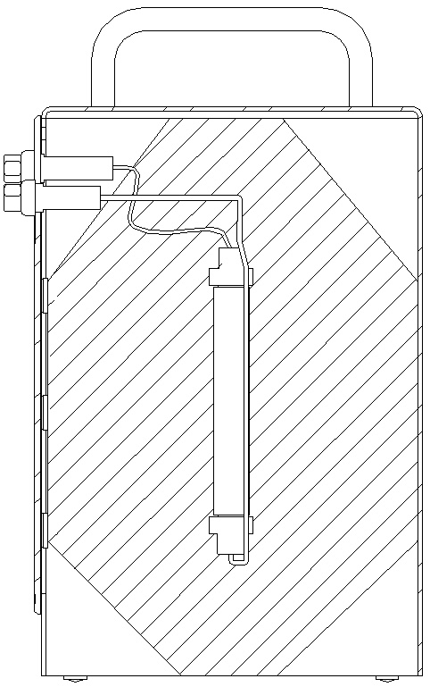

Fluid lines

TiO2 column

Inlet port

Outlet port

Front plate with inlet and outlet ports

Lead shielding

Stainless steel case

Handle

Front view of the Galliapharm radionuclide generator

Handles

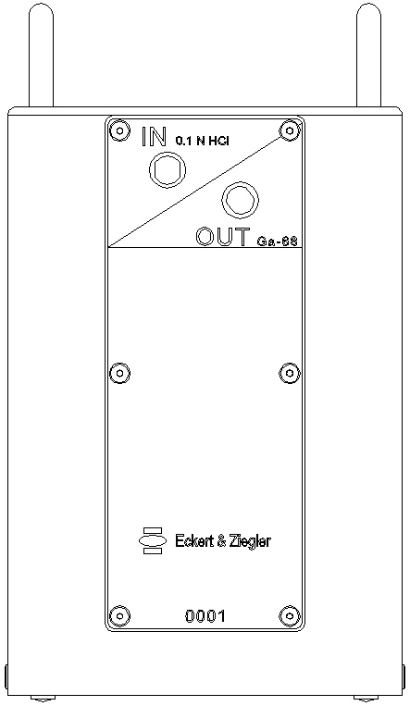

Stainless steel case

Inlet port

Outlet port

Front plate with inlet and outlet ports

**Size:** 230 mm × 132 mm × 133 mm (H × W × D)

**Weight:** approximately 14 kg

**6.6 Special precautions for disposal and other handling**

General warnings

Radiopharmaceuticals should be received, used and administered only by authorised persons in designated clinical settings. Their receipt, storage, use, transfer and disposal are subject to the regulations and/or appropriate licenses of the competent official organisation.

Radiopharmaceuticals should be prepared in a manner, which satisfies both radiation safety and pharmaceutical quality requirements. Appropriate aseptic precautions should be taken.

The generator must not be disassembled for any reason as this may damage the internal components and possibly lead to a leak of radioactive material. Also, disassembly of the casing will expose the lead shielding to the operator.

Administration procedures should be carried out in a way to minimize risk of contamination of the medicinal product and irradiation of the operators. Adequate shielding is mandatory.

The administration of radiopharmaceuticals creates risks for other persons from external radiation or contamination from spill of urine, vomiting, etc. Radiation protection precautions in accordance with national regulations must therefore be taken.

The residual activity of the generator must be estimated before disposal.

Any unused medicinal product or waste material should be disposed of in accordance with local requirements.

**7. MARKETING AUTHORISATION HOLDER**

Eckert & Ziegler Radiopharma GmbH

Robert-Rössle-Str. 10

13125 Berlin

Germany

**8. MARKETING AUTHORISATION NUMBER(S)**

52231

**9. DATE OF FIRST AUTHORISATION**

15 September 2014

**10. DATE OF REVISION OF THE TEXT**

29 October 2024

**11. DOSIMETRY**

The radiation dose received by the various organs following intravenous administration of a 68Ga-labelled medicinal product is dependent on the specific medicinal product being radiolabelled. Information on radiation dosimetry of each different medicinal product following administration of the radiolabelled preparation will be available in the Summary of Product Characteristics of the particular medicinal product.

The dosimetry tables 3 and 4 below are presented in order to evaluate the contribution of non-conjugated 68Ga to the radiation dose following the administration of 68Ga-labelled medicinal product or resulting from an inadvertent intravenous injection of gallium (68Ga) chloride solution.

The dosimetry estimates were based on a rat distribution study and the calculations were effected using OLINDA - Organ Level INternal Dose Assessment Code. Time points for measurements were 5 minutes, 30 minutes, 60 minutes, 120 minutes and 180 minutes.

Table 3: Absorbed dose per unit activity administered - inadvertent administration in women

|  |  |  |  |  |  |  |
| --- | --- | --- | --- | --- | --- | --- |
| **Absorbed dose per administered unit of activity (mGy/MBq)** | | | | | | |
| **Organ** | **Adult**  **(57 kg)** | **15 years**  **(50 kg)** | **10 years**  **(30 kg)** | **5 years**  **(17 kg)** | **1 year**  **(10 kg)** | **Newborn**  **(5 kg)** |
| Adrenals | 0.0114 | 0.0112 | 0.0164 | 0.0238 | 0.0403 | 0.0782 |
| Brain | 0.0180 | 0.0159 | 0.0176 | 0.0206 | 0.0292 | 0.0667 |
| Breasts | 0.0059 | 0.0058 | 0.0110 | 0.0163 | 0.0269 | 0.0545 |
| Gallbladder Wall | 0.0096 | 0.0092 | 0.0127 | 0.0201 | 0.0390 | 0.0750 |
| Lower large inestine Wall | 0.0032 | 0.0032 | 0.0050 | 0.0077 | 0.0133 | 0.0292 |
| Small Intestine | 0.0039 | 0.0039 | 0.0062 | 0.0099 | 0.0178 | 0.0376 |
| Stomach Wall | 0.0057 | 0.0056 | 0.0088 | 0.0133 | 0.0250 | 0.0502 |
| Upper large intestine Wall | 0.0040 | 0.0039 | 0.0067 | 0.0104 | 0.0199 | 0.0425 |
| Heart Wall | 0.1740 | 0.1940 | 0.3010 | 0.4830 | 0.8730 | 1.7200 |
| Kidneys | 0.0385 | 0.0421 | 0.0600 | 0.0888 | 0.1600 | 0.4150 |
| Liver | 0.0972 | 0.0974 | 0.1480 | 0.2200 | 0.4270 | 0.9890 |
| Lungs | 0.1860 | 0.2240 | 0.3190 | 0.4930 | 0.9840 | 2.7100 |
| Muscle | 0.0073 | 0.0076 | 0.0131 | 0.0319 | 0.0622 | 0.0954 |
| Ovaries | 0.0188 | 0.0203 | 0.0566 | 0.0988 | 0.2250 | 0.4590 |
| Pancreas | 0.0187 | 0.0218 | 0.0406 | 0.0547 | 0.1120 | 0.3400 |
| Red Marrow | 0.0225 | 0.0256 | 0.0415 | 0.0777 | 0.1770 | 0.5710 |
| Osteogenic Cells | 0.1160 | 0.1140 | 0.1840 | 0.3100 | 0.7350 | 2.3500 |
| Skin | 0.0029 | 0.0029 | 0.0044 | 0.0067 | 0.0122 | 0.0271 |
| Spleen | 0.0055 | 0.0056 | 0.0086 | 0.0130 | 0.0238 | 0.0492 |
| Thymus | 0.0100 | 0.0102 | 0.0133 | 0.0190 | 0.0297 | 0.0570 |
| Thyroid | 0.2210 | 0.2980 | 0.4600 | 1.0200 | 1.9300 | 2.6300 |
| Urinary Bladder Wall | 0.0023 | 0.0022 | 0.0038 | 0.0063 | 0.0110 | 0.0222 |
| Uterus | 0.0792 | 0.0802 | 1.3400 | 2.0300 | 3.6900 | 1.4700 |
| Total Body | 0.0177 | 0.0178 | 0.0289 | 0.0468 | 0.0920 | 0.2340 |
|  |  |  |  |  |  |  |
| **Effective Dose (mSv/MBq)** | 0.0483 | 0.0574 | 0.1230 | 0.2090 | 0.4100 | 0.7170 |

Table 4: Absorbed dose per unit activity administered – inadvertent administration in men

|  |  |  |  |  |  |  |
| --- | --- | --- | --- | --- | --- | --- |
| **Absorbed dose per administered unit of activity (mGy/MBq)** | | | | | | |
| **Organ** | **Adult**  **(70 kg)** | **15 years**  **(50 kg)** | **10 years**  **(30 kg)** | **5 years**  **(17 kg)** | **1 year**  **(10 kg)** | **Newborn**  **(5 kg)** |
| Adrenals | 0.0093 | 0.0112 | 0.0165 | 0.0235 | 0.0377 | 0.0749 |
| Brain | 0.0134 | 0.0137 | 0.0148 | 0.0170 | 0.0241 | 0.0563 |
| Breasts | 0.0062 | 0.0074 | 0.0142 | 0.0213 | 0.0350 | 0.0725 |
| Gallbladder Wall | 0.0081 | 0.0096 | 0.0137 | 0.0213 | 0.0409 | 0.0803 |
| Lower large intestine Wall | 0.0015 | 0.0020 | 0.0031 | 0.0051 | 0.0091 | 0.0204 |
| Small Intestine | 0.0022 | 0.0029 | 0.0048 | 0.0080 | 0.0146 | 0.0309 |
| Stomach Wall | 0.0048 | 0.0066 | 0.0099 | 0.0153 | 0.0287 | 0.0560 |
| Upper large intestine Wall | 0.0027 | 0.0033 | 0.0058 | 0.0094 | 0.0182 | 0.0385 |
| Heart Wall | 0.3030 | 0.3930 | 0.6110 | 0.9830 | 1.7800 | 3.4900 |
| Kidneys | 0.0198 | 0.0241 | 0.0345 | 0.0510 | 0.0911 | 0.2310 |
| Liver | 0.0766 | 0.1030 | 0.1570 | 0.2330 | 0.4500 | 1.0400 |
| Lungs | 0.1340 | 0.2000 | 0.2850 | 0.4390 | 0.8720 | 2.3800 |
| Muscle | 0.0051 | 0.0074 | 0.0129 | 0.0326 | 0.0636 | 0.0961 |
| Pancreas | 0.0187 | 0.0257 | 0.0480 | 0.0646 | 0.1310 | 0.4030 |
| Red Marrow | 0.0138 | 0.0154 | 0.0243 | 0.0441 | 0.0980 | 0.3110 |
| Osteogenic Cells | 0.0431 | 0.0558 | 0.0901 | 0.1510 | 0.3560 | 1.1300 |
| Skin | 0.0020 | 0.0024 | 0.0036 | 0.0057 | 0.0103 | 0.0232 |
| Spleen | 0.0041 | 0.0056 | 0.0084 | 0.0130 | 0.0227 | 0.0469 |
| Testes | 0.0011 | 0.0018 | 0.0075 | 0.0094 | 0.0138 | 0.0239 |
| Thymus | 0.0139 | 0.0158 | 0.0194 | 0.0276 | 0.0417 | 0.0794 |
| Thyroid | 0.1980 | 0.3250 | 0.5020 | 1.1200 | 2.1100 | 2.8800 |
| Urinary Bladder Wall | 0.0011 | 0.0013 | 0.0022 | 0.0039 | 0.0070 | 0.0152 |
| Total Body | 0.0115 | 0.0147 | 0.0237 | 0.0383 | 0.0748 | 0.1900 |
|  |  |  |  |  |  |  |
| **Effective Dose (mSv/MBq)** | 0.0338 | 0.0506 | 0.0756 | 0.1340 | 0.2600 | 0.5550 |

The effective dose resulting from an accidental intravenously injected activity of 250 MBq is 12.1 mSv for a 57-kg female adult and 8.45 mSv for a 70-kg male adult.

Data on the radiation dose to patients of gallium (68Ga) citrate can listed in the table 5 below are from ICPR 53 and may be used to estimate distribution after inadvertent application of unbound 68gallium from the generator eluate, even though the data were obtained using a different salt.

Table 5: Absorbed dose per unit activity inadvertent administration of gallium (68Ga) citrate

|  |  |  |  |  |  |
| --- | --- | --- | --- | --- | --- |
| **Absorbed dose per administered unit of activity(mGy/MBq)** | | | | | |
| **Organ** | **Adult** | **15 years** | **10 years** | **5 years** | **1 year** | |
| Adrenals | 0.034 | 0.044 | 0.064 | 0.088 | 0.140 | |
| Bone surface | 0.037 | 0.048 | 0.080 | 0.140 | 0.310 | |
| Breast | 0.014 | 0.014 | 0.023 | 0.037 | 0.074 | |
| Lower large intestine Wall | 0.018 | 0.022 | 0.036 | 0.059 | 0.110 | |
| Small Intestine | 0.064 | 0.080 | 0.140 | 0.230 | 0.450 | |
| Stomach Wall | 0.014 | 0.017 | 0.027 | 0.044 | 0.084 | |
| Upper large intestine Wall | 0.053 | 0.064 | 0.110 | 0.180 | 0.360 | |
| Kidneys | 0.026 | 0.032 | 0.046 | 0.068 | 0.120 | |
| Liver | 0.027 | 0.035 | 0.053 | 0.079 | 0.150 | |
| Lungs | 0.013 | 0.016 | 0.025 | 0.041 | 0.080 | |
| Pancreas | 0.014 | 0.018 | 0.029 | 0.047 | 0.089 | |
| Red Marrow | 0.046 | 0.064 | 0.110 | 0.210 | 0.450 | |
| Spleen | 0.036 | 0.051 | 0.080 | 0.130 | 0.240 | |
| Testes | 0.013 | 0.015 | 0.024 | 0.039 | 0.077 | |
| Thyroid | 0.012 | 0.015 | 0.025 | 0.042 | 0.081 | |
| Urinary Bladder Wall | 0.014 | 0.016 | 0.026 | 0.044 | 0.081 | |
| Other tissue | 0.013 | 0.015 | 0.025 | 0.041 | 0.080 | |
|  |  |  |  |  |  | |
| **Effective Dose (mSv/MBq)** | 0.027 | 0.034 | 0.056 | 0.095 | 0.190 | |

External radiation exposure

The average surface or contact radiation for the (68Ge/68Ga) radionuclide generator is less than 0.14 µSv/h per MBq of 68Ge. For example, a 1.85 GBq generator will reach a maximum surface dose rate of 260 µSv/h. It is generally recommended that the generator is stored within auxiliary shielding to minimize dose to operating personnel.

**12. INSTRUCTIONS FOR PREPARATION OF RADIOPHARMACEUTICALS**

The general handling, the attachment of tubing, the exchange of the sterile ultrapure 0.1 mol/l hydrochloric acid container, the elution of the generator and other activities potentially exposing the Galliapharm to the environment should be undertaken using aseptic technique in an appropriately clean environment according to current national legislation. Additionally, all these handling steps must be performed in premises complying with the national regulations concerning the safety of use of radioactive products.

Unpacking of the generator

1. Check outer shipping package for shipping damage. If damaged, perform radiation wipe survey of the damaged area. If counts exceed 40 counts per second per 100 cm2 notify your Radiation Safety Officer.
2. Cut security seal on top of shipping package. Remove the inner foam support from the shipping package. Separate the foam halves carefully.
3. Carefully remove generator. Perform radiation survey.

**CAUTION**: Drop hazard: The Galliapharm generator weighs approximately 14 kg. Handle with care to avoid potential injuries. If generator is dropped or if shipping damage extends into the shipping package, check for leaks and perform a wipe survey of the generator. Also check for internal damage by slowly tilting the generator 90°. Listen for broken/loose parts.

1. Perform wipe survey of shipping package inserts and generator outer surface. If wipes exceed 40 counts per second per 100 cm2, notify your Radiation Safety Officer.
2. Check sealed inlet and outlet ports for damage. Do not remove the port plugs before the elution lines are prepared and ready for installation.

Optimal positioning:

1. When installing the Galliapharm radionuclide generator in its final position, i.e. with a synthesis device or for manual elutions, it is recommended to keep the outlet line as short as possible as the length of this tubing may influence the recovered yield in the receiving/reaction vial. For this reason, Galliapharm is supplied with three different length of tubing to choose the appropriate length.
2. Use auxiliary shielding when positioning the Galliapharm generator.

Preparation:

1. Accessories supplied with the generator:

* 1 x PP - Container with the eluent, 250 ml sterile ultrapure 0.1 mol/l hydrochloric acid (including a separate hanger for PP-bottles; PP = Polypropylene)
* 1 x Vented spike (ABS/PE)
* 2 x Adapter 1/16“ to male LUER (PEEK)
* 2 x Tubing 60 cm (PEEK)
* 1 x Tubing 40 cm (PEEK)
* 1 x Tubing 20 cm (PEEK)
* 3 x Fingertight fitting 1/16” 10-32 (PEEK) for outlet port and adapters
* 1 x Fingertight fitting 1/16” M6 (PEEK) for inlet port
* 1 x Stopcock manifold (TPX/HDPE)
* 1 x Male LUER union (PP)

Wear gloves to assemble the lines and to connect the eluent solution to the generator using aseptic technique in an appropriately clean environment.

1. Inlet port and line: Please note: the inlet port has a customized thread to avoid misconnection. Only the special fingertight fitting 1/16” M6 will fit into this port. For assembling the inlet line connect the vented spike to one end of the stopcock manifold. On the other end of the stopcock manifold connect the 1/16” to male LUER adapter. Attach one of the 60 cm long PEEK tubing with 1/16” 10-32 fingertight fitting. Push the special 1/16” M6 fingertight fitting on the line, but do not connect yet.
2. Outlet port and line: For assembling the outlet line chose the appropriate length of tubing (20 cm, 40 cm, or 60 cm) for your local setting. Please use the shortest line possible. Attach the chosen PEEK line to the second 1/16” to LUER adapter using the 1/16” 10-32 fingertight fitting. Push the third 1/16” 10-32 fingertight fitting on the prepared outlet line, but do not connect yet.

Picture of assembled elution accessories before connected to the Galliapharm generator.

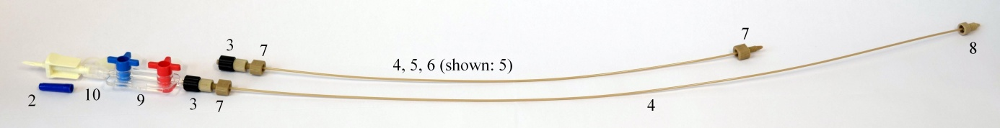

1. Hang the container with the 250 ml sterile ultrapure 0.1 mol/l hydrochloric acid close to the inlet port but above the Galliapharm generator.
2. Turn the valves at the stopcock manifold in the appropriate direction that no liquid can enter through the spike. Push spike into the container connection; then slowly remove all air from the stopcock valves and the attached inlet line and fill with sterile ultrapure 0.1 mol/l hydrochloric acid. When manifold and line are filled, close valves at the stopcock to stop flow.
3. Remove the plug from the Galliapharm generator inlet port and connect prepared and filled inlet line with the special 1/16” M6 fingertight fitting. Avoid hard bending or pinching of the line.
4. Remove plug from outlet port of the Galliapharm generator and connect prepared outlet line with the 1/16” 10-32 fingertight fitting. Avoid hard bending or pinching of the line.
5. The Galliapharm generator is now ready for the first elution.
6. The generator is designed not to drain itself, when no lines are connected to the inlet and outlet ports, but it is not recommended to leave the ports open. When the container with the sterile ultrapure 0.1 mol/l hydrochloric acid is connected and the fluid path is open, then the Galliapharm generator will be eluted by gravity, therefore it is necessary to take care about the inlet and outlet lines and also about the positions of the stopcock valves.

Picture of assembled Galliapharm generator ready for elution:

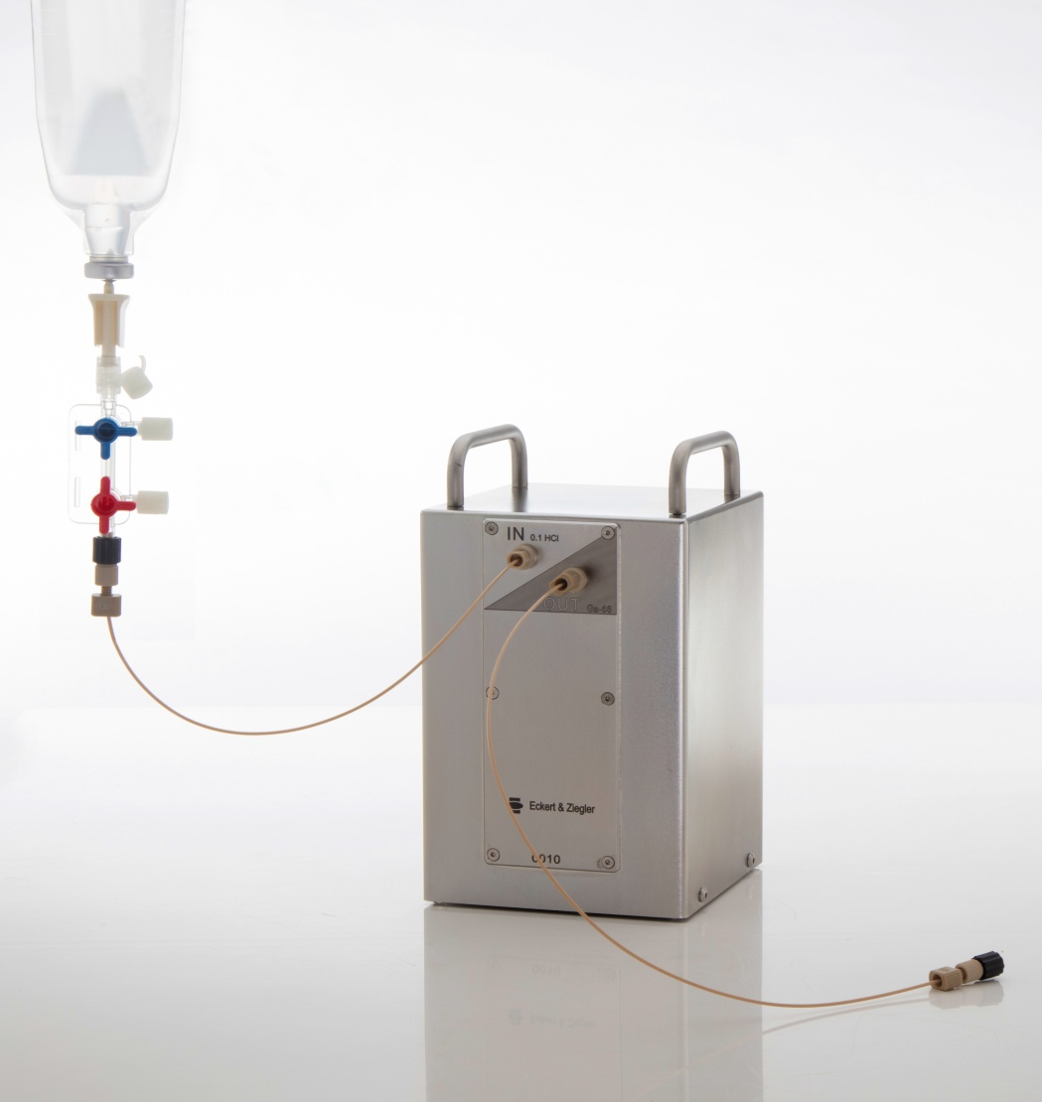

First elution:

1. When installing the Galliapharm radionuclide generator in its final position, i.e. with a synthesis device or for manual elutions, it is recommended to keep the outlet line as short as possible as the length of this tubing may influence the recovered yield in the receiving/reaction vial.
2. Aseptic working technique must be maintained during the assembly process, especially when handling the ports. This is critical for the maintenance of sterility.
3. Prepare additional necessary materials:

* Personal protective equipment: elutions should be performed while wearing eye and hand protection and also appropriate laboratory cloth.
* Sterile syringe with 10 ml volume.
* Shielded receiving vial or vessel with 10 ml or larger volume. Avoid uncoated chlorobutyl stoppers as they may contain considerable amounts of zinc that is extracted by the acidic eluate.

1. Attach the syringe to the upper side port of the stopcock manifold and fill with 10 ml of sterile ultrapure 0.1 mol/l hydrochloric acid from the container, but avoid any air inside the syringe.
2. Connect the vial or other receiving vessel to the outlet line using the appropriate connector. The vessel must have sufficient capacity to accept the eluate volume.
3. Turn valve of stopcock manifold where the syringe is connected towards the inlet port of the generator. Push the 10 ml sterile ultrapure 0.1 mol/l hydrochloric acid at a rate no greater than 2 ml/minute. Eluting at a faster rate may reduce the life of the generator. 5 ml of eluent will fully elute the generator, but for the first elution it is recommended to use 10 ml. If high resistance is encountered, do not force solution into generator. If a peristaltic pump is used for elution it should be set to a volume rate of not more than 2 ml/minute. The user should also verify that eluent is flowing without unusual resistance. If high resistance is noticed, discontinue elution.

**CAUTION:**

* Be sure to introduce eluent through the inlet port; do not elute the Galliapharm generator in reverse direction.
* Elution efficiency (68Ga yield) may be reduced if air is introduced into the generator column.

1. Collect eluate in shielded receiving vessel and measure solution with a calibrated dose calibrator to determine the yield. If less than 5 ml of eluate has been collected, measurement may not represent the total potential yield of generator. Please decay correct the measured activity to the starting time of the elution. For optimal yield of the generator in its final position it is recommended to determine the elution peak by collecting small fractions of 0.5 ml.
2. It is recommended to discard the first eluate due to the potential 68Ge breakthrough in this eluate.
3. It is recommended to test the eluate for 68Ge breakthrough after the first elutions by comparing the activity level of the 68Ga and the 68Ge. For further details, please refer to Ph. Eur. monograph 2464.

Continuous routine elution:

1. Repeat the steps of the first elution but use only 5 ml for the continuous routine elution. The Galliapharm generator is designed to elute all of the available 68Ga activity in a volume of 5 ml.
2. Elute the Galliapharm radionuclide generator at every working day with 5 ml sterile ultrapure 0.1 mol/l hydrochloric acid.
3. The solution eluted is a clear, sterile and colourless gallium (68Ga) chloride solution, with a pH between 0.5 and 2.0 and a radiochemical purity greater than 95 %. Check the clarity of the eluate before use and discard it if the solution is not clear.
4. If the generator has not been used for a period of 3 days or more, free 68Ge ions accumulate within the column over time. Therefore, it is recommended that the column is eluted once at least 7 - 24 hours prior to eluting for labelling. This elution should be done using 10 ml of sterile ultrapure 0.1 mol/l hydrochloric acid to fully wash the impurities from the column.
5. It is recommended to test the eluate for 68Ge breakthrough during routine elutions by comparing the activity level of the 68Ga and the 68Ge. For further details please refer to Ph. Eur. monograph 2464.

**CAUTION:**

* If fluid leaks are observed at any time, immediately stop eluting and attempt to contain the leaking fluid.

The 68Ge/68Ga-generator is supplied with 250 ml of sterile ultrapure 0.1 mol/l hydrochloric acid. This amount is usually sufficient for at least 40 elutions. The 68Ge/68Ga-generator should only be eluted with sterile ultrapure 0.1 mol/l hydrochloric acid supplied by the marketing authorization holder. Additional containers may be purchased as consumables from the marketing authorisation holder.

Exchange of sterile ultrapure 0.1 mol/l hydrochloric acid container

**CAUTION:**

Aseptic technique is critical for maintenance of sterility and must be used during the exchange procedure.

1. When the sterile ultrapure 0.1 mol/l hydrochloric acid is almost consumed, it can be replaced by a new sterile ultrapure 0.1 mol/l hydrochloric acid container.
2. **CAUTION:** No air should enter the 68Ge/68Ga-generator. Before disconnecting the empty container, close all valves at the stopcock manifold that no air can enter into the manifold and spike. Disconnect the container from the spike. It is recommended to use a new sterile spike for each sterile ultrapure 0.1 mol/l hydrochloric acid container.
3. Hang the new container with the 250 ml sterile ultrapure 0.1 mol/l hydrochloric acid close to the inlet port but above the Galliapharm generator.
4. Push the spike into the container stopper; carefully check for air bubbles and slowly remove all air from the stopcock manifold using the valves. It is not necessary to detach the attached inlet line from the Galliapharm generator or from the stopcock manifold. Entering of air into the 68Ge/68Ga-generator should be avoided.
5. When manifold and line are filled, close valves to stop flow. The generator is now ready for further use.

Galliapharm elution yield

The activity stated on the label of the Galliapharm generator is expressed in 68Ge available at the calibration date (12:00 CET). The available 68Ga activity depends on the 68Ge activity at the time of elution and the elapsed time since the previous elution.

A Galliapharm generator in full equilibrium yields more than 60 % of 68Ga using an elution volume of 5 ml sterile ultrapure 0.1 mol/l hydrochloric acid.

The output will decrease with decay of the 68Ge parent over time. For example, after 9 months' decay (39 weeks), the 68Ge will be reduced by 50 % (see table 6).

**Table 6: Decay Chart for 68Ge**

|  |  |  |  |
| --- | --- | --- | --- |
| **Elapsed Time**  **in weeks** | **Decay Factor** | **Elapsed Time**  **in weeks** | **Decay Factor** |
| 1 | 0.98 | 27 | 0.62 |
| 2 | 0.96 | 28 | 0.61 |
| 3 | 0.95 | 29 | 0.59 |
| 4 | 0.93 | 30 | 0.58 |
| 5 | 0.91 | 31 | 0.57 |
| 6 | 0.90 | 32 | 0.56 |
| 7 | 0.88 | 33 | 0.55 |
| 8 | 0.87 | 34 | 0.54 |
| 9 | 0.85 | 35 | 0.53 |
| 10 | 0.84 | 36 | 0.52 |
| 11 | 0.82 | 37 | 0.52 |
| 12 | 0.81 | 38 | 0.51 |
| 13 | 0.79 | 39 | 0.50 |
| 14 | 0.78 | 40 | 0.49 |
| 15 | 0.76 | 41 | 0.48 |
| 16 | 0.75 | 42 | 0.47 |
| 17 | 0.74 | 43 | 0.46 |
| 18 | 0.72 | 44 | 0.45 |
| 19 | 0.71 | 45 | 0.45 |
| 20 | 0.70 | 46 | 0.44 |
| 21 | 0.69 | 47 | 0.43 |
| 22 | 0.67 | 48 | 0.42 |
| 23 | 0.66 | 49 | 0.42 |
| 24 | 0.65 | 50 | 0.41 |
| 25 | 0.64 | 51 | 0.40 |
| 26 | 0.63 | 52 | 0.39 |

After an elution of the Galliapharm generator the 68Ga will be built up by the continuous decay of the parent 68Ge. The generator requires at least 7 hours to achieve almost full yield after being eluted, but in practice it is also possible to elute the generator after 4 hours.

Table 7 shows the build-up factor of activity of 68Ga which can be eluted after times varying from 0 to 410 minutes since the previous elution:

**Table 7: Build-up factors of 68Ga**

|  |  |  |  |
| --- | --- | --- | --- |
| **Elapsed Time**  **in minutes** | **Build-Up**  **Factor** | **Elapsed Time**  **in minutes** | **Build-Up**  **Factor** |
| 0 | 0.00 | 210 | 0.88 |
| 10 | 0.10 | 220 | 0.89 |
| 20 | 0.19 | 230 | 0.91 |
| 30 | 0.26 | 240 | 0.91 |
| 40 | 0.34 | 250 | 0.92 |
| 50 | 0.40 | 260 | 0.93 |
| 60 | 0.46 | 270 | 0.94 |
| 70 | 0.51 | 280 | 0.94 |
| 80 | 0.56 | 290 | 0.95 |
| 90 | 0.60 | 300 | 0.95 |
| 100 | 0.64 | 310 | 0.96 |
| 110 | 0.68 | 320 | 0.96 |
| 120 | 0.71 | 330 | 0.97 |
| 130 | 0.74 | 340 | 0.97 |
| 140 | 0.76 | 350 | 0.97 |
| 150 | 0.78 | 360 | 0.97 |
| 160 | 0.81 | 370 | 0.98 |
| 170 | 0.82 | 380 | 0.98 |
| 180 | 0.84 | 390 | 0.98 |
| 190 | 0.86 | 400 | 0.98 |
| 200 | 0.87 | 410 | 0.98 |

**Examples**

A 1.85 GBq generator is 12 weeks old. According to table 6, the activity of 68Ge on the column can be calculated as follows:

1.85 GBq × 0.81 = 1.499 GBq

In full equilibrium the activity of 68Ga on the column is also 1.499 GBq.

The generator is eluted and the collected 68Ga activity is 1.049 GBq, which corresponds to a typical yield of 70 %.

The same generator is eluted 4 hours later. The 7 hours needed to reach the 68Ge / 68Ga-equilibrium have not elapsed and the 68Ga activity built up on the column can be calculated according to table 7 as follows:

1.499 GBq × 0.91 = 1.364 GBq

With a typical yield of 70 % 68Ga, the collected activity would be:

1.364 GBq × 0.70 = 955 MBq

**Note:**

The activity of 68Ga in the eluate can be measured to check the quality with regard to identity and content. The activity should be measured immediately after elution, but may also be measured up to 5 half-life periods after elution.

Due to the short half-time of 68Ga which is 67.71 minutes, the elapsed time between the elution and the measurement of the activity has to be decay corrected to determine the actual yield at the elution time with the decay chart of 68Ga, table 8.

**Example**

A new 1.85 GBq generator is eluted. The activity of 68Ga measured 10 minutes after the elution was 1.169 GBq.

The yield at the time of the elution can be obtained by dividing the measured activity by the corresponding factor of the elapsed time stated in table 8:

1.169 GBq / 0.903 = 1.295 GBq

This corresponds to a yield of 68Ga of 70 % at the time of the elution:

1.295 GBq / 1.85 GBq × 100 % = 70 %

**Table 8: Decay chart of 68Ga**

|  |  |  |  |
| --- | --- | --- | --- |
| **Elapsed Time**  **in minutes** | **Decay Factor** | **Elapsed Time**  **in minutes** | **Decay Factor** |
| 1 | 0.990 | 35 | 0.700 |
| 2 | 0.980 | 36 | 0.693 |
| 3 | 0.970 | 37 | 0.686 |
| 4 | 0.960 | 38 | 0.679 |
| 5 | 0.950 | 39 | 0.672 |
| 6 | 0.941 | 40 | 0.665 |
| 7 | 0.931 | 41 | 0.658 |
| 8 | 0.922 | 42 | 0.652 |
| 9 | 0.912 | 43 | 0.645 |
| 10 | 0.903 | 44 | 0.639 |
| 11 | 0.894 | 45 | 0.632 |
| 12 | 0.885 | 46 | 0.626 |
| 13 | 0.876 | 47 | 0.619 |
| 14 | 0.867 | 48 | 0.613 |
| 15 | 0.868 | 49 | 0.607 |
| 16 | 0.850 | 50 | 0.601 |
| 17 | 0.841 | 51 | 0.595 |
| 18 | 0.832 | 52 | 0.589 |
| 19 | 0.824 | 53 | 0.583 |
| 20 | 0.816 | 54 | 0.577 |
| 21 | 0.807 | 55 | 0.571 |
| 22 | 0.799 | 56 | 0.565 |
| 23 | 0.791 | 57 | 0.559 |
| 24 | 0.783 | 58 | 0.554 |
| 25 | 0.775 | 59 | 0.548 |
| 26 | 0.767 | 60 | 0.543 |
| 27 | 0.759 | 61 | 0.537 |
| 28 | 0.752 | 62 | 0.532 |
| 29 | 0.744 | 63 | 0.526 |
| 30 | 0.737 | 64 | 0.521 |
| 31 | 0.729 | 65 | 0.516 |
| 32 | 0.722 | 66 | 0.510 |
| 33 | 0.714 | 67 | 0.505 |
| 34 | 0.707 | 68 | 0.500 |

Quality control

Clarity of the solution, pH and the radioactivity must be checked before radiolabelling.

68Ge breakthrough

A small amount of 68Ge is washed from the column with each elution. 68Ge breakthrough is expressed as a percentage of total 68Ga eluted from the column, corrected for decay. The 68Ge breakthrough is not more than 0.001 % of the eluted 68Ga activity. The breakthrough for this generator typically begins as low as 0.0001 % at the point of release and may rise slightly with the number of elutions. To keep the breakthrough low, the generator should be eluted at least once per working day. When used according to these instructions, the breakthrough should stay below 0.001 % for 12 months. For testing the 68Ge breakthrough the activity level of the 68Ga and the 68Ge in the eluate should be compared. For further details please refer to Ph. Eur. monograph 2464.

**Warning:** Breakthrough of 68Ge can increase above 0.001 % if the generator is not eluted for more than 2 days. If the generator has not been used for 3 days or more, it should be pre-eluted with 10 ml of sterile ultrapure 0.1 mol/l hydrochloric acid 7 - 24 hours prior to the intended use.

Any unused medicinal product or waste material should be disposed of in accordance with local requirements.