

**27 March 2025**

**SUMMARY OF PRODUCT CHARACTERISTICS**

**for**

**Cepralock Vet., intramammary suspension**

**0. D.SP.NO.**

31941

**1. NAME OF THE VETERINARY MEDICINAL PRODUCT**

Cepralock Vet. 2.6 g Intramammary Suspension for Cattle

**2. QUALITATIVE AND QUANTITATIVE COMPOSITION**

Each 4 g intramammary syringe contains:

**Active substance:**

bismuth subnitrate 2.6 g

(equivalent to bismuth 1.9 g)

**Excipients:**

|  |
| --- |
| **Qualitative** **composition of excipients and other constituents** |
| Liquid paraffin |
| Aluminium stearate |
| Silica, colloidal anhydrous |

White to slightly yellow, homogeneous suspension.

**3. CLINICAL INFORMATION**

**3.1 Target species**

Cattle (dairy cows at drying off).

**3.2 Indications for use for each target species**

Prevention of new intramammary infections throughout the dry period.

In cows considered likely to be free of sub-clinical mastitis, the veterinary medicinal product can be used on its own in dry cow management and mastitis control.

**3.3 Contraindications**

Do not use the veterinary medicinal product alone in cows with sub-clinical mastitis at drying off.

Do not use in cows with clinical mastitis at drying off.

Do not use in lactating cows. See section 3.7.

Do not use in cases of hypersensitivity to the active substance or to any of the excipients.

**3.4 Special warnings**

Selection of cows for treatment with the veterinary medicinal product should be based on veterinary clinical judgement. Selection criteria may be based on the mastitis and cell count history of individual cows, or recognized tests for the detection of sub-clinical mastitis or bacteriological sampling.

**3.5 Special precautions for use**

Special precautions for safe use in the target species:

It is good practice to observe dry cows regularly for signs of clinical mastitis. If a sealed quarter develops clinical mastitis, the affected quarter should be stripped out manually before appropriate therapy is instituted.

To reduce the risk of contamination, do not immerse the syringe in water.

Use the syringe only once.

It is important to observe strict aseptic technique for the administration of the veterinary medicinal product, because the veterinary medicinal product does not have antimicrobial activity.

Do not administer any other intramammary product following administration of the veterinary medicinal product.

In cows that may have sub-clinical mastitis, the veterinary medicinal product may be used following administration of a suitable dry cow antibiotic treatment to the infected quarter.

Special precautions to be taken by the person administering the veterinary medicinal product to animals:

This veterinary medicinal product may cause skin and eye irritation. Avoid contact with skin or eyes.

Should skin or eye contact occur, wash the affected area thoroughly with water.

Bismuth salts have been associated with hypersensitivity reactions. People with known hypersensitivity to bismuth salts should avoid contact with the veterinary medicinal product. If you develop symptoms following exposure, seek medical advice and show the package leaflet or the label to the physician.

Wash hands after use.

Disinfectant wipes:

The disinfectant wipes may cause skin and eye irritation due to the presence of isopropyl alcohol. Avoid eye contact. Avoid prolonged contact with skin. Avoid inhalation of the vapour.

The wearing of gloves may prevent skin irritation.

Wash hands after use.

Special precautions for the protection of the environment:

Not applicable.

**3.6 Adverse events**

None known.

Reporting adverse events is important. It allows continuous safety monitoring of a veterinary medicinal product. Reports should be sent, preferably via a veterinarian, to either the marketing authorisation holder or its local representative or the national competent authority via the national reporting system. See the package leaflet for respective contact details.

**3.7 Use during pregnancy, lactation or lay**

Pregnancy:

As the veterinary medicinal product is not absorbed following intramammary infusion, it can be used in pregnant animals. At calving, the seal may be ingested by the calf. Ingestion of the veterinary medicinal product by the calf is safe and produces no adverse effects.

Lactation:

The veterinary medicinal product is indicated for use in dry cows. If accidentally used in a lactating cow, a small (up to 2-fold) transient rise in somatic cell count may be observed. In such an event, strip out the seal manually, no additional precautions are necessary.

**3.8 Interaction with other medicinal products and other forms of interaction**

In clinical trials, the compatibility of a comparable teat seal formulation containing bismuth subnitrate has only been shown with a cloxacillin-containing dry cow preparation.

See also section 3.5.

**3.9 Administration routes and dosage**

Intramammary use.

The veterinary medicinal product has a dual tip nozzle. The cap of the syringe can be partially or fully removed. It is recommended to pinch the teat at the teat base as it aids in positioning the paste in the teat cistern, sealing the teat canal from the top.

Short tip option: The short tip option allows for a partial insertion technique so that the syringe only needs to be inserted in the teat end.

Long tip option: The long tip option may be used for treatment convenience for example to prevent the tip from flipping out due to a moving or nervous cow.

Step 1: Removal of the breakable cap Step 2: Long or short tip insertion

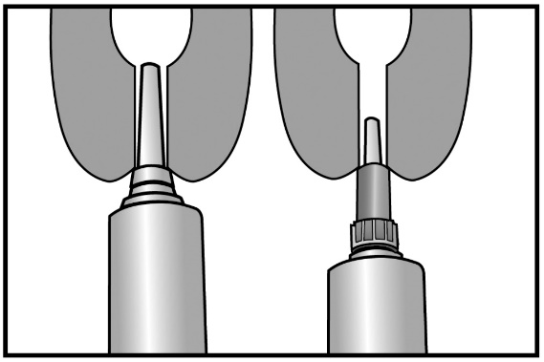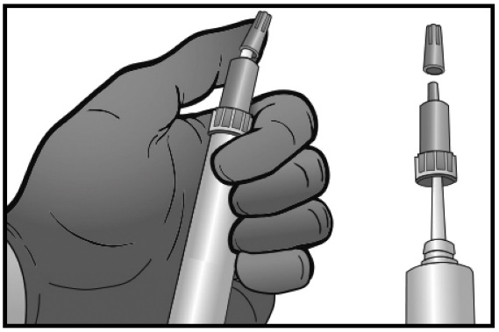

Infuse the content of one syringe of the veterinary medicinal product into each udder quarter immediately after the last milking of the lactation (at drying off). Do not massage the teat or udder after infusion of the veterinary medicinal product because it is important that the sealant stays in the teat itself and does not enter the udder.

Care must be taken not to introduce pathogens into the teat in order to reduce the risk of post-infusion mastitis.

It is essential that the teat is thoroughly cleaned with the alcoholic disinfectant wipes provided.   
The teats should be wiped until there is no visible dirt collected on the wipe. Teats should be allowed to dry prior to infusion. Infuse aseptically and take care to avoid contamination of the syringe nozzle. Following infusion, it is advisable to use an appropriate teat dip or spray.

Under cold conditions the veterinary medicinal product may be warmed to room temperature in a warm environment, to aid syringeability.

**3.10 Symptoms of overdose (and where applicable, emergency procedures and antidotes)**

Twice the recommended dose has been administered to cows with no clinical adverse effects.

**3.11 Special restrictions for use and special conditions for use, including restrictions on the use of antimicrobial and antiparasitic veterinary medicinal products in order to limit the risk of development of resistance**

Not applicable.

**3.12 Withdrawal periods**

Meat and offal: Zero days.

Milk: Zero hours.

**4. PHARMACOLOGICAL INFORMATION**

**4.1 ATCvet code:** QG52X.

**4.2 Pharmacodynamics**

Infusion of the veterinary medicinal product into each udder quarter produces a physical barrier against the entry of bacteria thereby reducing the incidence of new intramammary infections during the dry period.

The veterinary medicinal product is sterile and has no antimicrobial activity.

**4.3 Pharmacokinetics**

Bismuth subnitrate is not absorbed from the mammary gland, but resides as a seal in the teat until physically removed (shown in cows with a dry period up to 100 days).

**5. PHARMACEUTICAL PARTICULARS**

**5.1 Major incompatibilities**

Not applicable.

**5.2 Shelf life**

Shelf life of the veterinary medicinal product as packaged for sale: 3 years

**5.3 Special precautions for storage**

This veterinary medicinal product does not require any special storage conditions.

**5.4 Nature and composition of immediate packaging**

A single dose LDPE intramammary syringe closed with a breakable LDPE cap containing 4 g of suspension.

Package sizes:

Carton box of 24 syringes and alcoholic disinfectant wipes.

Plastic bucket of 144 syringes and alcoholic disinfectant wipes.

Not all pack sizes may be marketed.

**5.5** **Special precautions for the disposal of unused veterinary medicinal products or waste materials derived from the use of such products**

Medicines should not be disposed of via wastewater or household waste.

Use take-back schemes for the disposal of any unused veterinary medicinal product or waste materials derived thereof in accordance with local requirements and with any national collection systems applicable to the veterinary medicinal product concerned.

**6. NAME OF THE MARKETING AUTHORISATION HOLDER**

Intervet International BV

Wim de Körverstraat 35

5831 AN Boxmeer

Holland

Representative

MSD Animal Health A/S

Havneholmen 25

1561 København V

**7. MARKETING AUTHORISATION NUMBER(S)**

63928

**8. DATE OF FIRST AUTHORISATION**

Date of first authorisation: 04/08/2021

**9. DATE OF THE LAST REVISION OF THE SUMMARY OF THE PRODUCT**

**CHARACTERISTICS**

26 March 2025

**10. CLASSIFICATION OF VETERINARY MEDICINAL PRODUCTS**

Veterinary medicinal product subject to prescription.

Detailed information on this veterinary medicinal product is available in the Union Product Database (<https://medicines.health.europa.eu/veterinary>).