

**22 May 2024**

**SUMMARY OF PRODUCT CHARACTERISTICS**

**for**

**Clavusan, tablets 250 mg/62.5 mg**

**0. D.SP.NO.**

33404

**1. NAME OF THE VETERINARY MEDICINAL PRODUCT**

Clavusan

Pharmaceutical form: Tablets

Strength(s): 250 mg/62.5 mg

**2. QUALITATIVE AND QUANTITATIVE COMPOSITION**

Each tablet contains:

**Active substances:**

Amoxicillin (as amoxicillin trihydrate) 250 mg

Clavulanic acid (as potassium clavulanate) 62.5 mg

**Excipients:**

|  |
| --- |
| **Qualitative** **composition of excipients and other constituents** |
| Crospovidone |
| Povidone |
| Sodium starch glycolate type A |
| Cellulose microcrystalline |
| Silica colloidal hydrated |
| Magnesium stearate |
| Saccharin sodium |
| Vanilla flavour |

White to slightly yellow, round and convex tablet with a cross-shaped break line on one side.

The tablets can be divided into 2 or 4 equal parts.

**3. CLINICAL INFORMATION**

**3.1 Target species**

Dogs and cats.

**3.2 Indications for use for each target species**

For treatment of infections caused by bacteria susceptible to amoxicillin and clavulanic acid including: skin disease (including deep and superficial pyodermas); soft tissue infections (abscesses and anal sacculitis); dental infections (e.g. gingivitis); urinary tract infections; respiratory disease (involving upper and lower respiratory tract); enteritis.

**3.3 Contraindications**

Do not use in rabbits, guinea pigs, hamsters, gerbils or chinchillas.

Do not use in known cases of hypersensitivity to the active substances, to other antimicrobials of the β-lactam group or to any of the excipients.

Do not use in animals with serious dysfunction of the kidneys accompanied by anuria and oliguria.

Do not use in ruminants and horses.

**3.4 Special warnings**

None.

**3.5 Special precautions for use**

Special precautions for safe use in the target species

Use of the product should be based on identification and susceptibility testing of the target pathogen(s). If this is not possible, therapy should be based on epidemiological information and knowledge of susceptibility of the target pathogens at local/regional level. Use of the product should be in accordance with official, national and regional antimicrobial policies.

An antibiotic with a lower risk of antimicrobial resistance selection (lower AMEG category) should be used for first line treatment where susceptibility testing suggests the likely efficacy of this approach. The association of amoxicillin/clavulanic acid should be reserved for the treatment of clinical conditions which have responded poorly to other classes of antimicrobials or narrow spectrum penicillins.

Cross-resistance has been shown between amoxicillin/clavulanic acid and β-lactam antibiotics. Use of the product should be carefully considered when susceptibility testing has shown resistance to β-lactam antibiotics because its effectiveness may be reduced.

Use of the product deviating from the instructions given in the SPC may increase the prevalence of bacteria resistant to amoxicillin/clavulanic acid and may decrease the effectiveness of treatment with β-lactam antibiotics due to the potential for cross-resistance.

Caution is advised when using the product in small herbivores, other than those which have been contraindicated in section 3.3.

In animals with hepatic and renal dysfunction, the dosing regimen should be carefully evaluated.

Special precautions to be taken by the person administering the veterinary medicinal product to animals

Penicillins and cephalosporins may cause hypersensitivity (allergy) following injection, inhalation, ingestion or skin contact. Hypersensitivity to penicillins may lead to cross-reaction to cephalosporins and *vice versa.* Allergic reactions to these substances may occasionally be serious.

Do not handle this product if you know you are sensitised, or if you have been advised not to work with such preparations.

Handle this product with great care to avoid exposure, taking all recommended precautions.

If you develop symptoms following exposure such as a skin rash, you should seek medical advice and show the doctor this warning. Swelling of the face, lips or eyes or difficulty with breathing, are more serious symptoms and require urgent medical attention.

Wash hands after use.

To avoid accidental ingestion, particularly by a child, unused part-tablets should be returned to the open blister space, inserted back into the outer packaging and kept in a safe place out of the sight and reach of children.

Special precautions for the protection of the environment

-

**3.6 Adverse events**

Dogs and cats:

|  |  |
| --- | --- |
| Very rare  (<1 animal / 10,000 animals treated, including isolated reports): | Gastrointestinal disorders (vomiting, diarrhoea, anorexia). |
| Undetermined frequency (cannot be estimated from the available data) | Allergic reactions (skin reactions, anaphylaxis)*. |

* In these cases, administration should be discontinued and a symptomatic treatment given.

Reporting adverse events is important. It allows continuous safety monitoring of a veterinary medicinal product. Reports should be sent, preferably via a veterinarian, to either the marketing authorisation holder or its local representative or the national competent authority via the national reporting system. See also section “Contact Details” of the package leaflet for respective contact details.

**3.7 Use during pregnancy, lactation or lay**

Can be used during pregnancy and lactation.

**3.8 Interaction with other medicinal products and other forms of interaction**

Chloramphenicol, macrolides, sulfonamides and tetracyclines may inhibit the antibacterial effect of penicillins because of the rapid onset of bacteriostatic action. Consider potential cross allergies with other penicillins. Penicillins can increase the effect of aminoglycosides.

**3.9 Administration routes and dosage**

For oral administration.

The recommended dose is 12.5 mg/kg body weight (10 mg amoxicillin/2.5 mg clavulanic acid per kg body weight), twice daily.

The following table is intended as a guide to dispensing the tablets at the recommended dose.

To ensure a correct dosage body weight should be determined as accurately as possible to avoid underdosing.

|  |  |  |  |
| --- | --- | --- | --- |
|  | **Number of tablets twice daily**  (dosage rate: 12.5 mg/kg b.w.) | | |
| **Body weight**  (kg) | Amoxicillin/clavulanic acid  50 mg + 12.5 mg | Amoxicillin/clavulanic acid  250 mg + 62.5 mg | Amoxicillin/clavulanic acid  500 mg + 125 mg |
| 1-1.25 | ¼ | - | - |
| >1.25-2.5 | ½ | - | - |
| >2.5-3.75 | ¾ | - | - |
| >3.75-5 | 1 | - | - |
| >5-6.25 | 1 ¼ | ¼ | - |
| >6.25-12.5 | - | ½ | ¼ |
| >12.5-18.75 | - | ¾ | - |
| >18.75-25 | - | 1 | ½ |
| >25-31.25 | - | 1 ¼ | - |
| >31.25-37.5 | - | 1 ½ | - |
| >37.5-50 | - | - | 1 |
| >50-62.5 | - | - | 1 ¼ |
| >62.5-75 | - | - | 1 ½ |

 = ¼ tablet = ½ tablet = ¾ tablet = 1 tablet



Tablets can be divided into 2 or 4 equal parts to ensure accurate dosage.

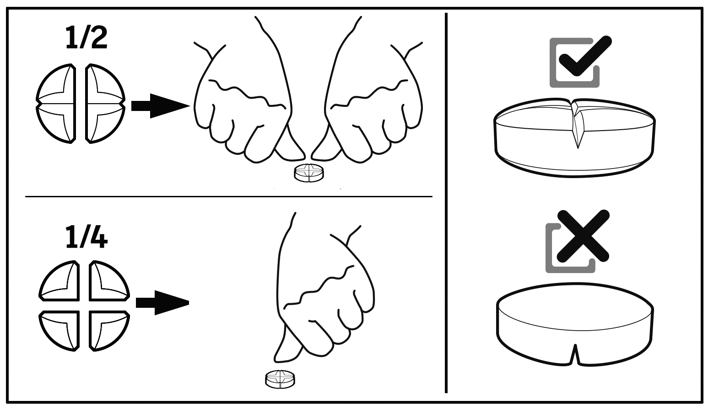

The minimum treatment duration is 5 days with the majority of routine cases responding after between 5 and 7 days therapy.

In chronic or refractory cases, a longer course of therapy may be required e.g. chronic skin disease 10 - 20 days, chronic cystitis 10 - 28 days, respiratory disease 8 - 10 days.

In such circumstances overall treatment length is at the clinician's discretion, but should be long enough to ensure complete resolution of the bacterial disease.

**3.10 Symptoms of overdose (and where applicable, emergency procedures and antidotes)**

Mild gastrointestinal symptoms (diarrhoea and vomiting) may occur more frequently after overdose of the product.

**3.11** **Special restrictions for use and special conditions for use, including restrictions on the use of antimicrobial and antiparasitic veterinary medicinal products in order to limit the risk of development of resistance**

Not applicable.

**3.12 Withdrawal periods**

Not applicable.

**4. PHARMACOLOGICAL INFORMATION**

**4.1 ATCvet-code**

QJ01CR02

**4.2 Pharmacodynamic information**

Amoxicillin, like the other β-lactam antibiotics, acts by inhibiting the synthesis of bacterial cell walls through interference with the final stage of peptidoglycan synthesis. This bactericidal action causes lysis of growing cells only.

Clavulanic acid is a β-lactamase inhibitor and improves the antibacterial spectrum of amoxicillin.

Amoxicillin in combination with clavulanic acid has a wide range of activity which includes ß-lactamase producing strains of both Gram-positive and Gram-negative aerobes, facultative anaerobes and obligate anaerobes, including:

Gram-positive:

*Clostridium* spp.

*Corynebacterium* spp.

*Peptostreptococcus* spp.

*Staphylococcus* spp. (including β-lactamase producing strains)

*Streptococcus* spp.

Gram-negative:

*Bacteroides* spp.

*Escherichia coli* (including most β-lactamase producing strains)

*Campylobacter* spp.

*Fusobacterium necrophorum*

*Pasteurella* spp.

*Proteus* spp.

Resistance is shown among *Enterobacter* spp., *Pseudomonas aeruginosa* and methicillin-resistant *Staphylococcus aureus*. A trend in resistance of *E. coli* is reported.

Susceptibility and resistance patterns can vary with geographical area and bacterial strain, and may change over time.

Amoxicillin/clavulanate breakpoints (CLSI VET 01S ED5:2020)

*E. Coli* (dog): sensitive MIC ≤ 8/4 µg/ml

*Staphylococcus* spp. (dog; cat): sensitive MIC ≤ 0.25/0.12 µg/ml, resistant: ≥ 1/0.5 µg/ml

*Streptococcus* spp. (cat): sensitive MIC ≤ 0.25/0.12 µg/ml, resistant: ≥ 1/0.5 µg/ml

*Pasteurella multocida* (cat): sensitive MIC ≤ 0.25/0.12 µg/ml, resistant: ≥ 1/0.5 µg/ml

The main mechanisms of resistance to amoxicillin/clavulanic acid are:

Inactivation by those bacterial beta-lactamases that are not themselves inhibited by clavulanic acid.

Modification of Penicillin-Binding Proteins (PBP), which reduce the affinity of the antibacterial agent for the target proteins (methicillin resistant *S. aureus*, MRSA and *S. pseudintermedius*, MRSP).

Impermeability of bacteria or efflux pump mechanisms may cause or contribute to bacterial resistance, particularly in Gram-negative bacteria. Resistance genes can be located on chromosomes (mecA, MRSA) or plasmids (LAT, MIR, ACT, FOX, CMY family beta-lactamases) and a variety of resistance mechanisms have emerged.

**4.3 Pharmacokinetic information**

Dogs:

- Amoxicillin

After dosing of 10 mg/kg amoxicillin, maximum plasma concentrations are reached within 1.0 to 2.0 hours (tmax) with a mean half-life of 1.0-1.5 hours. Cmax of 8223 ng/ml and AUC0-last of 22490 ng.h/ml are observed.

- Clavulanic acid

After dosing of 2.5 mg/kg clavulanic acid, maximum plasma concentrations are reached within 0.50 to 1.75 hours (tmax) with a mean half-life of 0.5 – 0.6 hours. Cmax of 3924 ng/ml and AUC0-last of 5284 ng.h/ml are observed.

Cats:

- Amoxicillin

After dosing of 10 mg/kg amoxicillin, maximum plasma concentrations are reached within 1.3 to 3.0 hours (tmax) with a mean half-life of 1.0 to 1.3 hours. Cmax of 9843 ng/ml and AUC0-last of 37283 ng.h/ml are observed

- Clavulanic acid

After dosing of 2.5 mg/kg clavulanic acid, maximum plasma concentrations are reached within 0.3 to 2.0 hours (tmax) with a mean half-life of 0.6 – 0.7 hours. Cmax of 4945 ng/ml and AUC0-last of 8266 ng.h/ml are observed.

Amoxicillin is well-absorbed following oral administration. Amoxicillin (pKa 2.8) has a relatively small apparent distribution volume, a low plasma protein binding (34% in dogs) and a short terminal half-life due to active tubular excretion via the kidneys. Following absorption, the highest concentrations are found in the kidneys (urine) and the bile, and then in liver, lungs, heart and spleen. The distribution of amoxicillin to the cerebrospinal fluid is low unless the meninges are inflamed.

Clavulanic acid (pKa 2.7) is also well-absorbed following oral administration. The penetration to the cerebrospinal fluid is poor. The plasma protein binding is approximately 25% and the elimination half-life is short. Clavulanic acid is mainly eliminated by renal excretion (unchanged in urine).

**5. PHARMACEUTICAL PARTICULARS**

**5.1 Major incompatibilities**

Not applicable.

**5.2 Shelf life**

Shelf life of the veterinary medicinal product as packaged for sale: 30 months

Any unused part-tablet should be returned to the blister and used within 36 hours

**5.3 Special precautions for storage**

Do not store above 30 ºC.

Store in the original package.

**5.4 Nature and composition of immediate packaging**

oPA/Alu/PVC - PVC/Alu heat sealed blister containing 10 tablets each.

Package sizes:

Cardboard box of 10, 30, 50, 100 or 250 tablets.

Not all pack sizes may be marketed.

**5.5 Special precautions for the disposal of unused veterinary medicinal product or waste materials derived from the use of such products**

Medicines should not be disposed of via wastewater or household waste.

Use take-back schemes for the disposal of any unused veterinary medicinal product or waste materials derived thereof in accordance with local requirements and with any national collection systems applicable to the veterinary medicinal product concerned.

**6. NAME OF THE MARKETING AUTHORISATION HOLDER**

Alfasan Nederland B.V.

Kuipersweg 9

3449 JA Woerden

Holland

**7. MARKETING AUTHORISATION NUMBER(S)**

69339

**8. DATE OF FIRST AUTHORISATION**

22 May 2024

**9. DATE OF THE LAST REVISION OF THE SUMMARY OF THE PRODUCT CHARACTERISTICS**

-

**10. CLASSIFICATION OF VETERINARY MEDICINAL PRODUCTS**

B

Detailed information on this veterinary medicinal product is available in the Union Product Database (https://medicines.health.europa.eu/veterinary).